
ECT Programme – How to use school-led materials Year 1
Year 1
These self-study materials are intended for use by those who design and deliver school induction as part of a school-led programme for early career teachers and mentors.







Introduction
Thank you for choosing to use these school-led materials from the National Institute of Teaching’s ECT Programme to support the induction of early career teachers in your school. This forms part of their overall Early Career Teacher Entitlement (ECTE).
The intention is for schools or trusts to use these materials to design and plan content for both early career teachers and mentors.

Content
Programme overview | Page 3
Using the NIoT school-led materials | Page 6
Next steps | Page 10
Appendix | Page 11

Programme overview
In each year of the programme, ECTs will study 6 modules each, 1 per half term, underpinned by the domains in the ITTECF. Each module, is made up of one core self-study and 5 elective self-studies. Each half-term, ECTs complete one core self-study that revisits the evidence and theory that they first explored as an initial teacher trainee.
Having completed their core self-study each term, ECTs will undertake a personal reflection and mentor discussion. This will guide them to select 3 elective self-studies (except for the first module, where they will select only 2 electives. This is to give them more time to get settled into the new school year). The electives will support ECTs’ understanding of how to put the theory into action in their own classroom practice.
Here's an overview of the structure of the programme in year 1:
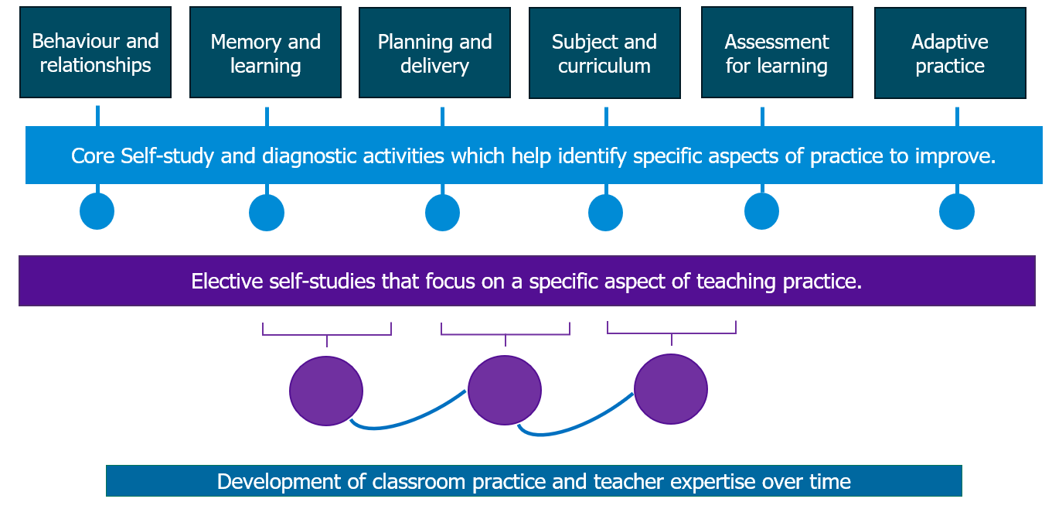
Year 1 modules
In year 1 of the ECT programme, the modules are:
- Behaviour and relationships
- Memory and learning
- Planning and delivery
- Subject and curriculum
- Assessment for learning
- Adaptive practice
The first module that all ECTs will complete in year 1 is ‘Behaviour and relationships’. This will support ECTs to establish a positive, structured learning environment that fosters pupil engagement, wellbeing, and academic success at the very start of the academic year. You can see a list of the focus areas within each module here.
A flexible approach
In response to feedback from the education sector, our ECT programme offers schools or trusts a choice in which ECTs complete the subsequent 5 modules in year 1. This flexibility enables schools and trusts to align ECTs’ study and personal development with their own professional development priorities. This can further increase the overall impact of the programme.

Example of a flexible sequence
Here is an example of an adapted module sequence and the school’s rationale behind their selection.
School A is part of a MAT where adaptive teaching has been prioritised as an area for whole-school professional development for the next academic year. Therefore, they have adapted the sequence of modules so that all ECTs, trust-wide, will complete the ‘Adaptive practice’ module in Autumn half term 2.
The Induction Lead has previously raised concerns that some early career teachers lack confidence in planning and teaching, particularly in using assessment to guide their future planning. Therefore, in the Spring, ECTs will begin by studying ‘Planning and delivery’ before moving on to ‘Assessment for Learning’.
In the final term, all ECTs will explore ‘Memory and Learning’ before finishing the year with ‘Subject and Curriculum’. This will align with a whole-staff professional development package already planned around long-term curriculum planning and subject enhancement.
Following consultation between the MAT’s Teaching and Learning Lead and Induction Lead, a decision has been made to adapt the sequence as follows:

Autumn Half term 1 | Autumn Half term 2 | Spring Half term 1 | Spring Half term 2 | Summer Half term 1 | Summer Half term 2
Behaviour and relationships | Adaptive practice | Planning and delivery | Assessment for learning | Memory and learning | Subject and curriculum

Schools or trusts with multiple ECTs
In schools or trusts where there is more than one ECT, we recommend that all participants complete the modules in the same sequence. This will ensure a consistent school or trust-wide approach and provide opportunity for peer-support. This consistency also allows induction leads and mentors to deepen their expertise in key topics, streamline discussions, and tailor guidance more precisely. If you work in a multi-academy trust, you may need to liaise with colleagues to clarify whether the module sequence is being agreed at a whole-trust or whole-school level.
Live seminars
Our materials include outlines for live seminars for you to create in-person sessions should you wish. If used, these should be delivered in the same sequence as they are not explicitly linked to the individual modules in year 1 of the programme. The seminars are designed to be delivered to groups. However you can adapt the content for 1:1 delivery.
Our holistic approach to seminar-design means the content of each session will support the development of all ECTs regardless of their sequence of self-study modules or choice of electives.
By working through a range of thought-provoking scenarios, ECTs integrate multiple elements of teaching. This helps them develop adaptive expertise, supporting better-informed decisions in real time and making their teaching more responsive to individual needs.
For example, while seminar 1 focuses on ‘Ensuring safe and predictable learning environments’, ECTs will also be supported to draw on and deepen their understanding of the role that planning and formative assessment has in achieving this goal.
Seminars in year 1
Autumn half term 1 | Autumn half term 2 | Spring half term 1 | Spring half term 2 | Summer half term 1 | Summer half term 2
Ensuring safe and predictable learning environments | Planning effective lessons | Working in partnership with stakeholders | Checking prior knowledge and addressing misconceptions | Assessment literacy and analysis to inform teaching and learning | Integrating technology into classroom practice to support adaptive teaching

Return to Content page

Using the NIoT school-led materials
What materials do we provide?
The following materials have been provided to help you design your own induction programme for ECTs in the first year of their Early Career Teaching Entitlement.
- Introductory materials comprising 1 self-study and 1 live seminar outline
- Core self-study – 1 per module
- Elective self-studies – 5 per each of the 6 modules
- Live seminar outlines – one per half term
For mentors, we have provided introductory materials as well as optional support materials for mentors of Early Career Teachers in year 1 of the ECT Programme.
How do I use them?
Documents are provided in editable versions which should be downloaded. You can then edit or adapt the materials to meet your own school or trust needs. The careful design of the NIoT materials means that the contents provide full coverage of the ITTECF. For this reason, we suggest that schools only edit or adapt content where relevant opportunities have been signposted throughout the materials. This will avoid any unintentional gaps in framework coverage.
Introductory Materials
A self-study and live seminar outline for both early career teachers and mentors has been provided. These provide an overview of the Early Career Teacher Programme. You should edit these to reflect how the programme will be implemented in your school or trust. Prompts are provided within the materials to indicate where you should do this.
Early Career Teacher self-study content
Here is a reminder of the how ECTs will complete their self-study for each half term:
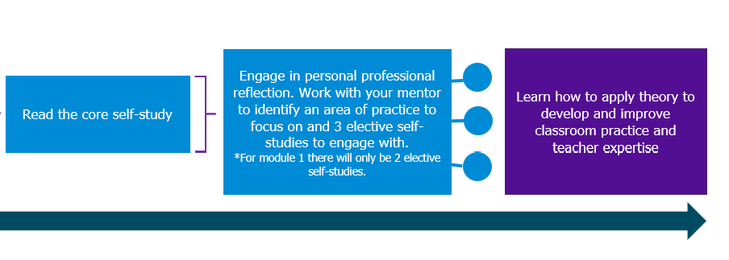

- Core self-study
ECTs will complete one core self-study per module. This will take approximately 60 minutes to complete per half-term.
There are limited opportunities for schools to adapt the core self-studies. This is intentional because the core self-study acts a refresher to the knowledge ECTs will have gained in that specific element of teaching during their initial teacher training. Each core-study is rooted in the ITTECF evidence base and provides the underpinning theory that all ECTs must learn as part of their entitlement.
- Elective self-studies
Having completed their core self-study and reflection activities, ECTs then select 3 elective self-studies per module. Each elective self-study will take approximately 45 minutes to complete. Each of these is focused on a more granular aspect of the broader topic and this is where ECTs are able to see how the theory looks in practice. For half-term 1, they only need to complete 2 elective self-studies to give them more time to get settled into the new school year.
The half-termly structure gives ECTs approximately two weeks to plan, implement and reflect on the reading they have completed. The intention is to make their workload more manageable and it's likely that they will revisit the self-study content throughout the fortnight to guide their next steps with their mentor.
- Scenario-based approach
Each elective self-study uses a scenario-based approach for ECTs to consider as they progress through the content. They should select the most relevant one for them. This will allow ECTs to consider how they will apply their learning in their own practice. You may wish to adapt the scenarios to align with practices in your school or trust, however you should ensure that any changes still allow ECTs an opportunity to apply what they have learned. There is no expectation for ECTs to look at them all and you may wish to remove scenarios that are not relevant to your school.
- Active ingredients
Each section of the elective self-study includes a short review of the evidence and an outline of what this could look like in practice. This is followed by a list of ‘active ingredients’ (the components) that make particular elements of practice effective. The active ingredients should not be edited or amended as these reflect how the theory is enacted in the classroom. They are the bridge between theory and practice.
- Examples
For each section of the elective self-study, you should provide examples for ECTs to see what the theory looks like in practice. This will be clearly signposted in the materials. Examples embedded within the content could include:
- Video recordings
- Artefacts or resources
- Transcripts
You may also support ECTs’ asynchronous study with examples that include:
- Live observations of others
- Modelling (for example live demonstrations)
It is crucial that the examples used demonstrate how the active ingredients are put in practice through an explanation or analysis. ECTs should not be left to make this connection themselves.
- ECT weekly actions
Elective self-studies include suggested action steps to support ECTs in applying the theory into practice, following discussion with their mentor at their weekly meeting. You can edit or adapt these to align with practices in your school or trust. However, these should still enable ECTs to enact the active ingredients so we recommend that you consider keeping the suggestions as outlined in the NIoT materials.
ECT Personal professional reflections
Having completed their core self-study, ECTs should be guided to use their personal reflections from the study, along with their Career Entry Development Profile (CEDP) or other targets from their ITT, to guide a discussion with their mentor. Each elective self-study has a suggested framework to help guide this conversation. Together, they will identify the priority focus areas for development within a module. This should take around 30 minutes.
Live seminar outlines
Outlines of live seminars have been provided in Word format. The outlines can be used to create slideshows or other content to use in live sessions with ECTs. Live seminars should last 90 minutes with one per half-term. The outlines include an overview of the underpinning theory for each section of the session. Suggested activities are highlighted in the outlines.
Mentor support materials
Optional materials are provided to help mentors to support their ECTs’ development. For each core and elective self-study, there is an associated mentor self-study. These take 15 minutes per week or 90 minutes per term to read. These provide:
- Overview of the ECT materials
- Active ingredients (elective self-studies)
- Suggested weekly actions (elective self-studies)
- Template for weekly ECT mentoring session
We suggest that any exemplification used in ECT content, is shared with mentors to ensure a shared understanding.

Return to Content page

Next steps
- Discuss with relevant colleagues whether modules 2-6 will be delivered in a revised sequence. Agree on the sequence you will follow to guide your planning of the programme delivery.
- Download the content required from the NIoT website. The following are available now:
- Introductory materials for ECTs
- Introductory materials for mentors
- ECT self-study materials for Module 1: Behaviour and relationships
- Support materials for mentor for Module 1: Behaviour and relationships
- Outlines for all 6 live seminars

Content for modules 2 – 6 will be available from 1st July 2025.
- Review the content, making adaptations and additions where required.
- Use the materials to design your ECT programme.

Return to Content page

Appendix
Modules and associated self-studies
Module | Elective self-studies in this module
Behaviour and relationships | 1 | Communicating belief in pupils' academic potential
Behaviour and relationships | 2 | Establishing effective routines and expectations
Behaviour and relationships | 3 | Creating a positive, predictable, and safe learning environment
Behaviour and relationships | 4 | Building effective relationships
Behaviour and relationships | 5 | Motivating pupils
Memory and learning | 1 | How the memory works
Memory and learning | 2 | The role of pupils’ prior knowledge
Memory and learning | 3 | Managing cognitive load
Memory and learning | 4 | Understanding and addressing pupil misconceptions
Memory and learning | 5 | Retrieval, revisiting and reviewing information
Planning and delivery | 1 | Explanations, modelling and examples
Planning and delivery | 2 | Scaffolding and increasing challenge
Planning and delivery | 3 | Planning effective practice, including homework
Planning and delivery | 4 | Questioning as an essential tool for teachers
Planning and delivery | 5 | Fostering classroom talk and peer collaboration
Subject and curriculum | 1 | Delivering a carefully sequenced curriculum
Subject and curriculum | 2 | Anticipating misconceptions
Subject and curriculum | 3 | Building increasingly complex mental models
Subject and curriculum | 4 | Developing early literacy
Subject and curriculum | 5 | Enhancing all pupils' literacy
Assessment for learning | 1 | Designing effective assessment
Assessment for learning | 2 | Checking prior knowledge and understanding
Assessment for learning | 3 | Providing high-quality feedback
Assessment for learning | 4 | Making marking and feedback manageable
Assessment for learning | 5 | Developing your practice in relation to assessment and feedback
Adaptive practice | 1 | Understanding different pupil needs
Adaptive practice | 2 | Providing opportunities for all pupils to succeed
Adaptive practice | 3 | Meeting individual needs without creating unnecessary workload
Adaptive practice | 4 | Effective grouping and deployment of teaching assistants (TAs)
Adaptive practice | 5 | Developing your knowledge in special educational needs and disabilities (SEND)

Return to Modules overview

Return to Content page

