
ECT Programme Introduction
Year 1
​This document is intended for those who design and deliver a school-led Early Career Teacher Entitlement (ECTE) programme. It provides materials to introduce the programme to ECTs. Opportunities for schools to add details relevant to their context have been identified.

Suggested time to complete: 90 minutes







Introduction
Welcome to the National Institute of Teaching’s (NIoT) Early Career Teacher (ECT) programme which forms part of your Early Career Teacher Entitlement (ECTE).
Who are the NIoT?
Founded by four of the country’s most respected school trusts, The National Institute of Teaching is a teacher and leader training and development provider. We design and deliver Initial Teacher Training, the Early Career Teacher Programme and National Professional Qualifications.
Our professional development programmes are delivered across England from our NIoT campuses as well as our Associate Colleges, a growing network of successful school trusts, enabling us to serve 1 in 10 of every school in the country.
Our aim is to boost the quality of teacher and leader development by generating and interpreting research, applying the insights to the design and delivery of our programmes, and sharing this with the sector.
Why do we exist?
We exist because of a powerful fact: the quality of teaching is the biggest in-school factor influencing children’s educational success. And this effect is even greater for children experiencing the highest levels of disadvantage.
But quality teaching is not evenly distributed across the English school system. The sector doesn’t know enough about the best ways to develop it and it is hampered by persistent challenges with teacher retention and recruitment.
In practice, this means that the children whose lives can be most positively affected by great teaching too often miss out. The National Institute of Teaching exists to change this. Our research will help us get closer to the classroom, give voice to multiple perspectives from within the school system, and help do what all teachers and leaders want: deliver what works for children.
Schools may wish to add their vision and aims here

Overview
In this introduction, you will have the opportunity to learn more about the following in the Year 1 ECT programme:
Content
The ITTECF and Teacher Standards
The ECT programme from the NIoT
The safe and ethical use of artificial intelligence
Programme Structure – Year 1
ECT Roles and responsibilities
Actions
Further reading and resources

The Initial Teacher Training and Early Career Framework and Teacher Standards
The new ITTECF combines two previous frameworks:
- the Core Content Framework (CCF), used in Initial Teacher Training and
- the Early Career Framework (ECF) used for the two years following Initial Teacher Training.
The Initial Teacher Training and Early Career Framework (ITTECF) supports you as a new teacher through your training and early years in teaching. It underpins your one year of Initial Teacher Training (ITT) and your two years of Early Career Teacher (ECT) training (or part-time equivalent). It sets out the evidence-informed knowledge, skills and behaviours that leads to effective teaching.
Whichever provider you train with, the ITTECF will guide your development across a 3-year programme. You’ll cover the ITTECF in full during your initial teacher training and also during the two-year ECT programme. This is an intentional decision by the Department for Education to ensure the knowledge, skills and behaviours gained during Initial Teacher Training can be re-visited and consolidated. The new combined ITTECF will support a more cohesive and continuous professional development journey for new teachers as they progress through their early teaching career.
How does the ITTECF link to the Teachers’ Standards?
You’ll be familiar with the 8 Teachers’ Standards from your ITT. The 8 strands of the ITTECF are closely aligned to the Teachers’ Standards. However, it’s important to understand that the ITTECF is neither an assessment tool nor a curriculum but an entitlement for all Initial Teacher Trainees and Early Career Teachers. Its purpose is to support your development against the Teachers’ Standards and for this reason they are intentionally interweaved. As an ECT, your Induction Tutor and your mentor will work with you to monitor and review your progress against the Teachers’ Standards. They will report this to your Appropriate Body (see ‘Who will support me?’).

You can see how the ITTECF and the Teachers’ Standards align here:
The ITTECF Framework | Teacher Standards
- High expectations | - Set high expectations
- How pupils learn | - Promote good progress
- Subject and curriculum | - Demonstrate good subject and curriculum knowledge
- Classroom practice | - Plan and teach well-structured lessons
- Adaptive teaching | - Adapt teaching
- Assessment | - Make accurate and productive use of assessment
- Managing behaviour | - Manage behaviour effectively
- Professional behaviours | - Fulfil wider professional responsibilities

Each strand of the ITTECF framework contains a series of ‘Learn that…’ and ‘Learn how to…’ statements that underpin the weekly activities and action steps that you, as an ECT, will undertake over the two-year ECT programme. Here is an example of some of these statements, taken from the Adaptive Teaching strand:
Adaptive Teaching (Standard 5 – Adapt Teaching)
Learn that… | Learn how to…
- Adapting teaching in a responsive way, including by providing targeted support to pupils who are struggling, is likely to increase pupil success. | Meet individual needs without creating unnecessary workload, by:  k) Making use of well-designed resources (e.g. textbooks, manipulatives).  l) Planning to connect new content with pupils' existing knowledge or providing additional pre-teaching if pupils lack critical knowledge.

Further information regarding the frameworks can be found at:
Initial Teacher Training and Early Career Framework
Teachers’ Standards guidance (publishing.service.gov.uk)

Click to return to Content page

The ECT programme from the NIoT
The ITTECF sets out what you, as an ECT, are entitled to learn about and learn how to do when starting out in your career as part of your early career teacher entitlement.
The ECT programme provides the opportunity for you to:
- engage in a fully funded two-year programme
- have ongoing support from an ECT mentor who will help you adapt what you learn to your specific context
Schools may wish to add any additional elements that their programme design will offer, for example, live seminars or conferences.

In this two-year ECT programme, you will use the content of the National Institute of Teaching’s programme for ECTs. This material intentionally builds on the training that you will have received during your ITT course. This is to support you to build confidence, expertise and a deeper understanding of how to apply key evidence to develop great practice.
The programme will focus on the following modules in year 1 with one area addressed each half term:
- Behaviour and relationships
- Memory and learning
- Planning and delivery
- Subject and curriculum
- Assessment for learning
- Adaptive practice
For full time early career teachers each module lasts a half term.
Schools/trusts may wish to deliver the modules in a different sequence to align with the school or trust’s professional development priorities. However, all ECTs must start with ‘Behaviour and relationships’ to support them to establish a positive, structured learning environment that fosters pupil engagement, wellbeing, and academic success at the very start of the academic year.

Developing your inclusive practice
Inclusive practice promotes the high standards and fulfilment of potential for all pupils by removing barriers to learning and ensuring that pupils receive an education appropriate to their needs (EEF, n.d). For this reason, each module on the NIoT’s ECT programme will be also explored through the lens of inclusive practice, ensuring that you will consider strategies to meet the diverse needs of all pupils in every element of your training.
Scenario-based learning
The content of the ECT programme provides an opportunity to for you to reflect on the learning from your ITT from a new perspective as a qualified teacher. You’ll have the opportunity to engage with different scenarios throughout year one of the programme. This will enable you draw on your previous experience and apply your knowledge and skills to consider how the learning applies in real-school contexts.

Click to return to Content page

The safe and ethical use of artificial intelligence in education
The technology available to facilitate great teaching and support pupil success is constantly evolving. Consequently, the ITTECF framework does not focus on specific technological innovations. Teachers must remain conversant with technological developments throughout their careers, particularly those that evidence suggests can improve pupil outcomes (Initial Teacher Training and Early Career Framework).
The rapid progress of Artificial Intelligence (AI), however, is unprecedented and may have significant implications for teaching practices. Therefore, the programme will provide opportunities for you to critically explore the judicious use of AI and its possible opportunities —both in supporting pupil progress and enhancing your own working practices. It will also encourage you to critically consider any unintended consequences that may arise from the use of AI.

Click to return to Content page

Programme structure - Year 1
Programme overview
Each module, is made up of one core self-study and 5 elective self-studies. Each half-term, you’ll complete one core self-study that revisits the evidence and theory that you first explored as an initial teacher trainee. A diagnostic activity will then guide you to select 3 further elective self-studies (except for the first module, where you will select only 2 electives. This is to give you more time to get settled into the new school year). The electives will support your understanding of how to put the theory into action in your own classroom practice. You’ll learn more about these later in this programme introduction.
Here's an overview of the structure of the programme in year 1:
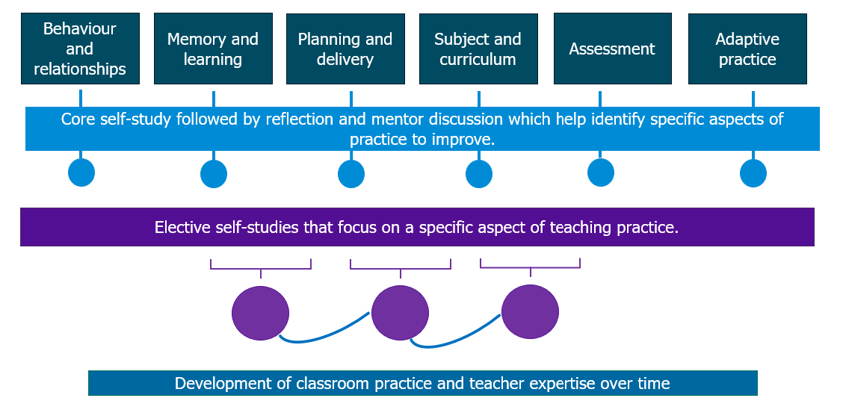

Onboarding
Schools should provide details about any onboarding process they offer which introduces early career teachers to the ECT programme. NIoT materials for a live seminar also are available or schools may wish to provide their own.

Mentoring
Schools should outline how weekly interactions between ECTs and mentors will take place including observations and feedback. They should ensure that this aligns with the minimum entitlement set out in the statutory guidance found here Induction for early career teachers (England) statutory guidance.
Schools should also outline the role of mentors within their own school setting or trust.
You may wish to include:
- details regarding mentor observations including timings and frequency
- any specific observation model being used
- an outline of the purpose and structure of mentor meetings
- how the mentor will support ECTs with pastoral or wellbeing needs

Self-study materials
Schools should outline here how ECTs will access their self-study materials

Core self-study
You will complete one core self-study per module. The core self-study acts as a refresher to the knowledge you will have gained in that specific element of teaching during your initial teacher training. This will take approximately 60 minutes to complete and you’ll have one each half-term.
Elective self-studies
Selection process
Having completed your core self-study, you’ll use the reflections along with your Career Entry Development Profile (CEDP) or other targets from your ITT, to guide a discussion with your mentor. Together, you will identify the priority focus areas for development within a module.
You’ll then select 3 elective self-studies per module – each focused on a more granular aspect of the broader topic. However, for half-term 1 you will only need to complete 2 elective self-studies. This is to give you more time to get settled into the new school year.
Each elective self-study will take approximately 45 minutes to complete. This structure gives you approximately two weeks to plan, implement and reflect on the reading you have done at the start of each elective self-study. This will help you to manage your workload and it's likely you'll revisit the self-study content throughout the fortnight to guide your next steps with you mentor.
You’ll learn about the ‘active ingredients’ (the components) that make particular elements of practice effective and reflect on how this might inform your own teaching through the use of context-specific scenarios.
Elective self-studies also include suggested action steps to support you in putting the theory into practice, following discussion with your mentor at your weekly meeting.
Example of self-study in a typical module
This diagram illustrates the structure of your self-study over a half-term:
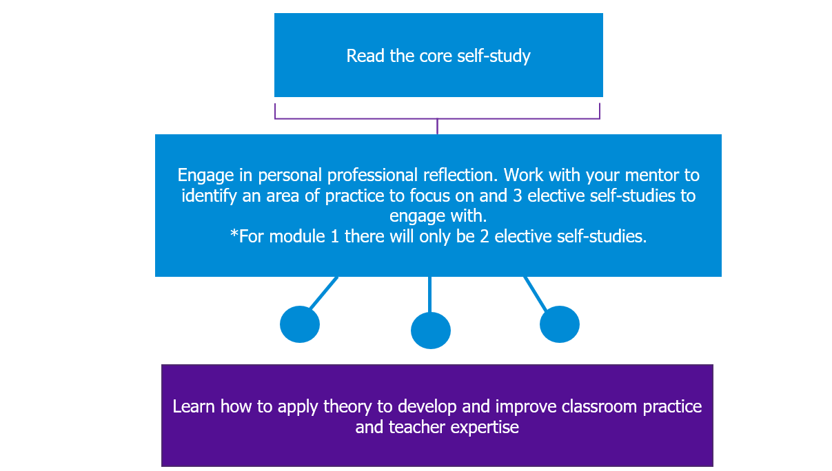

Here, you can see how each self-study element is broken down within a typical module. Remember, for the first module of the programme, you only need to complete 2 elective self-studies. For all other modules you’ll complete 3.
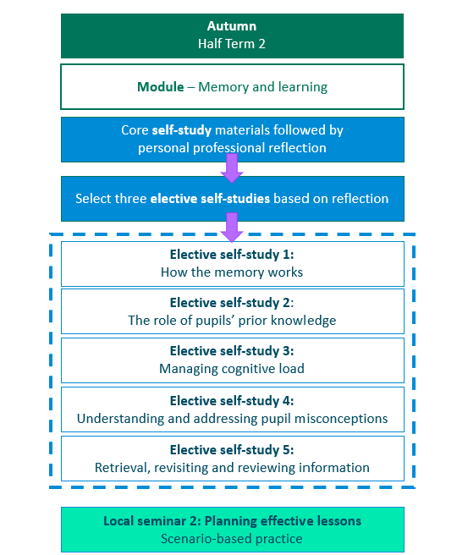

Live seminars
If they are being offered to ECTs, schools should add details here about the structure of live seminars or sessions. The live seminar outlines are available to support you with the planning of these.

If you are using the NIoT seminar materials, you may wish to include the information below.

Live seminars will adopt a scenario-based approach in which you will have the opportunity to connect different aspects of your teaching—such as planning, assessment, and behaviour management—into a more cohesive and effective practice. By integrating these elements, you’ll develop your adaptive expertise. This will help you make better-informed decisions in real time and make your teaching more responsive to individual needs.

ECT programme – how your time will be spent
Schools may wish to provide an overview of how early career teachers’ time will be allocated in year 1. This could include mentoring activities, observing colleagues, self-study and attending any seminars.

Ensure that this aligns with the minimum entitlement outlined in the statutory guidance for early career teachers. More information can be found here (pp. 9 and 12): Induction for early career teachers (England) statutory guidance

Part-time ECTs
Schools should add details here about how the programme will be adapted for part-time ECTs.

Click to return to Content page

ECT Roles and Responsibilities
Roles - Who will support me?
Your early career training entitlement provides you with a number of support roles. You will work more closely with some than others, for example, your mentor, however they will all play a key role to support your induction process.
Schools may wish to add named individuals below where appropriate

Mentor – Mentors provide you with tailored support, applied to address the specific challenges of your school setting and your specific needs. They will help you to navigate your induction period and to develop the skills and knowledge needed for long-term success as a skilled classroom teacher.
This includes meeting regularly to provide support and feedback
providing or arranging mentoring and coaching around specific phases and subject areas.
Induction tutor – This role has different responsibilities to a mentor. These include providing or coordinating your induction programme and carrying out assessments and regular progress reviews. In some cases, for example in smaller schools or settings, the induction tutor may also be the mentor.
Headteacher or Principals – Headteachers and principals have various roles, many of which focus on ensuring compliance. They will oversee your overall induction, ensuring both your induction tutor and mentor have the time and ability to support you effectively. They are also responsible for appointing an appropriate body and making the recommendations to them regarding your performance against the Teachers’ Standards. See below.
Lead Provider – Lead Providers are responsible for designing and delivering impactful and tailored training for ECTs and their mentors based on the Initial Teacher Training and Early Career Framework (ITTECF). The training can also be delivered by schools themselves and this is known as a ‘school-led route’. Your Early Career Teaching Entitlement falls into this category.
Delivery Partners - Educational institutions that are approved to facilitate high quality training to ECTs and their mentors. This can include schools, MATs, hubs, charities, organisations. Their local expertise contributes to the overall improvement of teaching practice within the local community.
Appropriate Body – The appropriate body is responsible for quality assurance within the induction process, ensuring that all aspects are correctly enacted. Your headteacher or principal will report to them on your progress and performance against the Teachers’ Standards throughout your two-year induction. Depending on where you work, the appropriate body could be:
- Teaching School Hubs (TSHs)
- Multi-Academy Trusts (MATs) (if authorised)
- Appropriate Body Services from the Independent Schools Teacher Induction Panel (ISTIP) (for independent schools)
You can find out more about each role in Section 5 here: Induction for early career teachers (England) statutory guidance

ECT Entitlement
ECTs have specific entitlements to support their induction. One of these is a reduced timetable. In the first year, you must not teach more than 90% of the timetable of experienced teachers on the main pay range. In your second year on the programme this should be no more than 95% (or the equivalent for part-time ECTs).
This reduction is in addition to the standard planning, preparation and assessment (PPA) time all teachers receive. The allocated time off-timetable is specifically for ECTs to engage in induction activities such as mentor meetings, completing self-study work or observing colleagues. You can check what this means for you by speaking to your Induction Tutor.

Your responsibilities as an ECT
Schools may wish to outline their expectations ECTs here in order to maximise the impact of the programme. This could include:
- reading and engaging with self-study materials
- weekly mentor observations
- attending mentor meetings and actively engaging with them
- reflecting and responding to feedback to develop their practice

Click to return to Content page
Actions
As you reflect on the content of this programme introduction, you may wish to consider the following action steps moving forward:
- Have you scheduled appropriate time within your timetable to engage with the content of the self-study each week?
- Have you set out a time in your timetable to meet with your mentor each week?
- Have you reviewed the targets from your ITT as outlined in your Career Entry Development Profile (CEDP) or other personal development framework?
Schools may wish to adapt the list of following questions to suit their own context and phase

- You may wish to spend some time in your first meeting with your mentor or induction tutor finding out the answers to some of the following questions:
- What are the different platforms that the school uses to take the register and record lunch choices? How do I use them?
- How do you communicate with parents and carers?
- What systems do you use for rewards and sanctions?
- What happens if I have an IT issue during the lesson?
- How often will I be on duty? What do I do if there's an issue?
- Where do I find the resources I need to plan and adapt my lessons?
- What is the process for morning drop off and pick up at the end of the day?
- What are the working hours? What time do staff have to be in the building?
- How do I find out if any pupils have SEND or medical needs?
- What time can staff leave at the end of the day?
- How do I make a call out to SLT or my Head of Department if I need a member of staff to come to my room?
- Where do I find school policies and which ones should I prioritise reading?

You may wish to take moment to note any other questions you may wish to ask your mentor.

Congratulations! You have now completed your programme introduction self-study.
Next steps Schools may wish to adapt this list but it could include:
- Speak to your Induction Tutor to confirm your module sequence for year 1
- Begin your self-study for the module on Behavior and relationships
- You may also wish to arrange a time to meet with your mentor to discuss any questions you may have
Click to return to Content page

Further reading and resources
You can read more about the Initial Teacher Training and Early Career Framework here: Initial Teacher Training and Early Career Framework

References
- Department for Education, (2024). Available online at: https://assets.publishing.service.gov.uk/media/661d24ac08c3be25cfbd3e61/Initial_Teacher_Training_and_Early_Career_Framework.pdf. Accessed 20 February 2025
- EEF, (n.d), Support school attendance. Available online at: https://educationendowmentfoundation.org.uk/education-evidence/leadership-and-planning/supporting-attendance/build-a-culture-of-community-and-belonging-for-pupils. Accessed 20 February 2025

Click to return to Content page

