
ECT Programme Y1 – Core self-study
Behaviour and relationships
Estimated time to complete: 60 minutes

A further 30 minutes should be allocated for ECTs to complete a reflection or other diagnostic task to identify areas for development in this area. See Programme Guidance for further details.

These self-study materials are intended for use by those who design and deliver a school-led Early Career Teacher (ECT) programme. Opportunities for schools or trusts to add detail relevant to their context have been identified.







Introduction
Approximate time to complete: 3 minutes
Welcome to your first module on the Early Career Teacher Programme (ECTP).
In this first module you’ll build on the knowledge and understanding you developed during your initial teacher training (ITT) relating to ‘Behaviour and relationships. The Early Career Teacher Programme is undertaken by all teachers working across a wide range of settings in England and the programme content is written this this diversity in mind. You’ll be prompted to reflect on your current practice and to draw on what you already know and have experienced during your ITT as you progress through your personalised pathway and consider its application to your own context.
Once you have completed reading this self-study, you should take some time to reflect on the contents and your current practice. [Schools may wish to add details of reflection activities that ECTs could undertake as part of this process.].
You’ll use the outcomes from your personal reflection along with your targets from your ITT and discussion with your mentor, to select 2 elective self-studies relating to different aspects of ‘Behaviour and relationships’.
Elective self-studies
The elective self-studies will enable you to engage more deeply with the evidence and support your application of theory to your classroom practice.
Listen to Lewis as he explains why it’s important to be evidence-informed as an ECT.

The benefits of evidence-informed practice
Lewis highlights the importance of closing the theory-to-practice gap as novice teacher. In doing this, you’ll continue to develop your adaptive expertise. Adaptive expertise refers to a teacher’s ability to apply a specific pedagogical approach in different ways, in different contexts, across different topics and with different cohorts of pupils (Evidence Based Education, 2024) and this lies at the very heart of what your ECTP aims to achieve over its 2-year duration. This, in turn, will help you to maximise the impact on the pupils you teach by ensuring your teaching is inclusive and tailored to meet their different needs.
Here’s a reminder of how each of the self-studies fit into year one of the ECT programme:
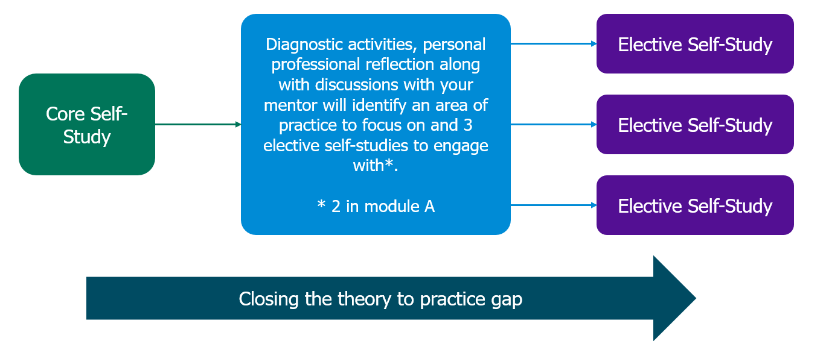

Each elective self-study contains suggested action steps to guide your developing practice and you will work on these steps each week with your mentor.
What you will focus on in this core self-study
A learning environment that fosters positive behaviours and relationships is key to achieving successful learning outcomes for all pupils. This core self-study aims to build on what you learned during your initial teaching training on the importance of creating a learning environment, driven by high expectations, that challenges and supports all pupils. To support you in this, this study will explore what the evidence and research tells us in relation to the following:
- Communicating belief in pupils' academic potential
- Establishing effective routines and expectations
- Creating a positive, predictable, and safe learning environment
- Building effective relationships
- Motivating pupils
This self-study contains reflection points and you may wish to have a pen and notebook to hand to record your thoughts.

Content
Section 1: Communicating belief in pupils' academic potential | Page 5
Section 2: Establishing effective routines and expectations | Page 11
Section 3: Creating a positive, predictable, and safe learning environment | Page 16
Section 4: Building effective relationships | Page 29
Section 5: Motivating pupils | Page 33
Summary | Page 38
Next steps | Page 40
ITTECF statements addressed | Page 41
Further reading and references | Page 45

- Communicating belief in pupils' academic potential
Approximate time to complete: 10 minutes
What the evidence says
Teachers are role models
As you’ll probably know from your initial teacher training, your everyday interaction with pupils matters. Have you ever wondered why? In one study, pupils included teachers as one of their key role models along with their parents and friends (Johnson et al. (2016). In particular, young people cited ‘character-related qualities’ as what prompted them to look up to their teachers (Johnson et al., 2016, p.139).
You’ll also know that your words and actions create the climate in your learning environment. This, in turn, has the power to influence your pupils’ attitudes to learning, their behaviour and even their wellbeing (Rathmann et al., 2018) . The potential for the positive impact you can have on pupils’ lives may even have been one of the reasons you wanted to become a teacher. In one research study, 95% of participants cited this as the reason they decided to teach (Davies and Hughes, 2018).
Activity
Take a moment to watch this video that was used to promote teacher training in 2022 and how it focuses on teacher and pupil relationships. As you watch, reflect on the following:
- In what ways have you been a positive role model to pupils since you started teaching?
- How many interactions have you had this week where you may have influenced a pupils’ motivation, behaviour or wellbeing?

‘Every lesson shapes a life – Tuesday’, Department of Education, 2022
Make a note of your reflections and share them with your mentor at your next meeting.
‘The Pygmalion Effect’
As a role model, the expectations you have of your pupils can impact their progress and outcomes. Research has shown that when teachers have high expectations for their pupils, their outcomes are better (Hattie, 2008; Rubie Davies et al, 2014). In fact, teacher expectations for pupils are so significant that they can create self-fulfilling prophecies, in which pupils perform in line with the expectations that teacher have for them, leading to a phenomenon known as the ‘The Pygmalion Effect’ (Murdock-Perriera & Sedlacek, 2018).
There is also some evidence that these effects may be stronger for certain groups of students based on demographic factors such as socio-economic background, ethnicity, or gender (Jussim and Harber, 2005, p.143). Despite this research being 20 years old, current research suggests that teacher expectations continue to be influenced by pupils’ backgrounds (EEF, 2021a). It is important, therefore, that you understand your role as part of the wider school responsibility in which high expectations and aspirations are in place for all pupils.
Communicating your high expectations
Simply holding high expectations is not enough – it is crucial that your belief in pupils’ academic potential is effectively communicated to them. In communicating high expectations for all, teachers can also demonstrate the values and expectations of the school for all of its pupils.
You can share your belief in your pupils’ academic potential through what you do and say (Marzano, 2010). One way this can be achieved is by setting appropriately challenging goals for all pupils. Although simply raising aspirations without providing pupils with the necessary skills and knowledge to achieve them won’t be effective. Instead, a more holistic approach that includes improving self-efficacy, motivation, as well as providing academic support, is crucial. You’ll explore more on this throughout this self-study.
High expectations for contributions and participation
Do you have equal expectations for all pupils to contributions to your lessons? Do you have higher expectations for some to do this more than others? Another way in which teachers can demonstrate belief in pupils’ academic potential is to have high expectations for all pupils to contribute and participate in lessons. Maintaining these high expectations is crucial as this is likely to have a greater impact on their outcomes over time (Rubie-Davies et al., 2014). It is therefore important to establish a culture of high participation in your classroom. This is where your influence as a role model who sets the climate for learning comes in!
Participation ratio
Doug Lemov’s (2021) think and participation ratio framework can help teachers to enact Rubie-Davies et al’s (2014) research. Take a moment to look at the graph. Think ratio refers to the level of rigour and thinking that pupils are expected to do. The participation ratio refers to the number of pupils participating in the lesson at any one time. Lemov suggests that the aim here is for all pupils to be engaged and participating.
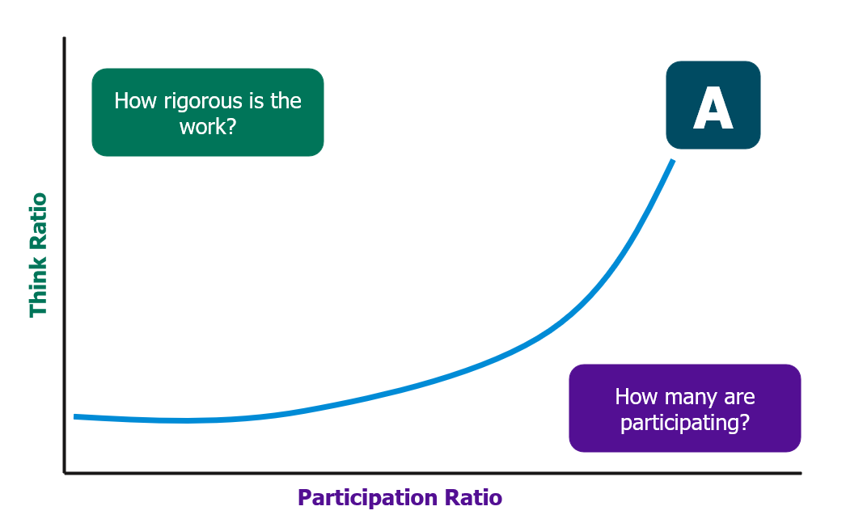
Whilst this might not be possible at all stages, the intention is that that through careful planning and teaching that is both responsive and adaptive, teachers will reach point A where all pupils are engaged and participating and ultimately experiencing success.
Some of the strategies that can be used to increase pupil participation include:
- Use of timers and countdowns
- Maintaining high expectations for pupils to contribute using strategies such as ‘No Opt Out’ in which all pupils are expected to contribute
- Create a ‘Culture of Error’ where making mistakes is part of the norm and acknowledged as a key component of learning.
- Marking the beginning and end of activities e.g. by using established phrases such as “Let’s go!” or “All eyes on me!”
- Providing prompts and hints to scaffold and support pupils to contribute, for example “We looked at this earlier in the lesson…” or “Have a look in your book to help you answer this…”
[Schools may wish to highlight any of these strategies that are used in their context]
Careful consideration is needed to ensure that the strategies used to increase pupil participation meet the needs of all pupils and some of these strategies will be explored further in elective self-study 1.
Using feedback to demonstrate belief in pupils’ academic potential
Provide timely feedback
Another way in which teachers can demonstrate their belief in pupils’ academic potential is to give timely feedback during lessons (EEF, 2021b). As a teacher, you play a pivotal role in shaping your pupils' learning journeys. Can you imagine focusing all of your live feedback on just one group of pupils in a lesson? How valued would it make the rest of the learners feel? Whilst the evidence linking timing of feedback and academic outcomes is inconclusive (EEF, 2021b, p.19), teachers should aim to provide timely, targeted feedback that goes beyond generic praise and instead conveys a genuine belief in each pupil's capacity to be successful. Let’s explore that next.
Use targeted feedback
Targeted feedback is used to move learning forward, targeting specific learning gaps identified through your formative assessments. This ensures teachers can share their high expectations for every pupil to progress and succeed. The feedback may link to the lesson objectives or perhaps directly to a pupils’ individual learning goals or education plan. To ensure the feedback is impactful, instead of offering general comments, you may provide precise guidance related to the task, the subject area, or the pupil's self-regulation strategies. (EEF, 2021b). This might involve suggesting improvements to a specific paragraph in an essay, prompting the use of subject-specific terminology, or encouraging reflection on study habits.
Share the purpose of feedback
Remember, how pupils receive feedback is as crucial as the feedback itself. Pupil motivation, self-confidence, and their trust in you as their teacher can all influence how they internalise and act on your feedback (Black and Wiliam, 1998). By openly discussing the purpose of feedback, emphasising its role as a tool for growth rather than criticism, modelling its effective use, and providing clear and concise feedback tailored to individual needs, you create a learning environment where all pupils feel supported, valued, and empowered to succeed.
By building these principles into your teaching practice, you not only provide valuable guidance but also cultivate a classroom culture where high expectations and a belief in every pupil's potential to succeed are palpable and transformative.
Now check your understanding!
Which of the following is the most effective approach to communicating high expectations for pupils? Select the correct answer.
a) Telling pupils that you have high expectations for them and reminding them of this throughout the lesson.
b) Using positive praise to demonstrate your high expectations and motivate pupils to learn.
c) Combining high expectations with improving self-efficacy, motivation, and academic support.
The correct answer is C. Combining high expectations with improving self-efficacy, motivation, and academic support.
Explanation:
As this section highlights, simply having high expectations is not enough. It's crucial to communicate these expectations effectively and provide pupils with the tools they need to achieve them.
Option c) aligns with this holistic approach by emphasising the importance of self-efficacy, motivation, and academic support alongside high expectations.
Whilst using regular, positive praise may be associated with positive re-enforcement and initially motivate pupils, excessive use of generic phrases such as “well done” or “great work” can become less meaningful over time and does not communicate high expectations in a focused way.
Time to reflect
Consider the content of this section and reflect on the following:
- How do you currently communicate your belief in pupils’ academic potential? How does this differ from when you were an initial teacher trainee?
- How has your understanding of the impact of communicating this belief developed since your initial teacher training? Can you identify an occasion where it had a positive impact in the classroom?
- What might the ‘Participation Ratio’ in your class suggest about pupils’ contributions to your lessons?

Note your responses and share them with your mentor at your next meeting. You may also wish to use these notes when completing your reflection.
Click here to return to Content page
2. Establishing effective routines and expectations
Approximate time to complete: 10 minutes
What the evidence says
Routines benefit all pupils
Routines are the building blocks of the classroom culture (Bennett, 2016). This is because establishing routines helps minimise distractions, create a predictable and secure classroom environment (Grossman et al., 2009), and reduce opportunities for misbehaviour (Ofsted, 2014, p.24). While a predictable environment benefits all pupils, it is especially valuable for those with special educational needs (EEF, 2021b).
As an early career teacher, implementing routines that align with your school’s ethos can save time and help pupils focus more effectively on their learning. Building on Bennett’s (2016) assertion that routines shape classroom culture, Mccrea (2020) highlights that this is achieved through a shared understanding of the school’s expectations and standards.
However, one common challenge experienced by those starting their early career teacher journey is having to swiftly learn the routines and expectations in a different school setting to the one in which they completed their initial teacher training. You may have even experienced this yourself. This challenge is to be expected but consistency is crucial and therefore it is important therefore to talk to your mentor or other school leaders, such as Behaviour Leads, to seek any support and clarify expectations if you are unsure.
Routines support pupils to self-regulate
Well-established routines play a crucial role in developing pupils’ emotional self-regulation: the ability to manage their emotions (Blakemore, 2018). When pupils can control their emotional responses, they can better concentrate and engage in learning, which positively impacts their success in school and beyond. Classroom routines and rules help pupils manage emotions like boredom or frustration, redirect their focus, and reduce stress (Ursache, Blair & Raver, 2012). Therefore, investing time in establishing and reinforcing routines is essential for creating an effective learning environment in the long run as it leaves more time for learning (Kern and Clemens, 2007).
Teaching and Practising Routines
As you know, pupils do not instinctively know the routines in each classroom and this may vary from teacher to teacher. Whilst they may be aware of the wider school’s values and expectations for behaviour, it is important for teachers to clarify what this looks like in their own classroom. This means that pupils will need to be explicitly taught the routines.
Listen as Dan Bellanfante, Vice Principal at a secondary school in the north of England as he explains why explicitly teaching and practising routines is essential and how it helps to drive improvement by creating a safe and predictable environment for all pupils.


Click here to play video - Why we should teach pupils routines

How to Teach Effective Routines
As you may already know from your initial teaching training, teaching and embedding effective routines can take time and it can be tempting to rush into the curriculum. However, as Dan outlines, teaching routines is so important that it should that teaching the curriculum cannot begin until this is done.
That means taking time to plan and teach routines. Take a look at this 3-step approach for teaching routines:

Let’s explore each step in a bit more detail.
1. Be precise
When teaching a routine, be specific about the ‘why’ and the ‘what’. Plan your instructions in advance and ensure they are:
- Specific and Observable: Expectations should be clear and visible so you can monitor compliance and address this as needed. For instance, “Pencils down, everyone looking at me,” is clear, whereas “Listen to me,” is vague and not easily monitored.
- Sequential: Provide instructions in the order you want them followed. It can help to use ordinal numbers here too and even use of non-verbal gestures such as holding up one finger for ‘first’. For example, “First, put your pens down, second, close your books, and third, look at me.”
- Manageable: Use concise language to make instructions easier for pupils to understand and remember.

2. Teach and Model
Teachers should model routines by breaking them into manageable steps and teaching each step clearly. Model the behaviour as you describe it, helping pupils create a mental model of the routine. This explicit guidance increases their chances of success.
3. Practise
Practising routines at the start of the year, along with providing guidance and feedback, helps pupils master them. However, you may want to introduce different routines over a few weeks to ensure pupils are not overwhelmed (Archer and Hughes, 2011). Use positive feedback to encourage pupils and reinforce routines.
As you may have experienced during your initial teaching training, over time, it is possible that routines may begin to slip and therefore it is important to reinforce your high expectations by revisiting and practising them as needed.
Listen again to Dan Bellanfante explaining why it’s important to reinforce routines and high expectations.

Click here to play video - reinforcing behaviour routines
Dan highlights that consistent and positive reinforcement, along with high expectations, is key to maintaining high-quality, efficient routines. Therefore, the model for teaching, practising and maintaining routines in the classroom becomes more of an ongoing cycle:

Adapted from Archer and Hughes (2011), Bennett (2020) and Lemov (2021)
You will know that the specific needs of all pupils should be taken into consideration when you plan how to teach and model routines. You may wish to work with other colleagues such as your mentor or SENDCO to ensure that approaches are tailored, where necessary, to support all pupils to be successful.
Elective self-study 2 provides further examples on how to establish effective routines.
Now check your understanding!
What is the most important reason to explicitly teach routines in the classroom? Select the correct answer.
- Over time, it will make the teacher's job easier and reduce their workload.
b) To help pupils develop emotional self-regulation, improve concentration, and reduce stress.
c) To ensure pupils understand the wider school values and expectations for behaviour.
Correct Answer: b) To help pupils develop emotional self-regulation, improve concentration, and reduce stress.
Explanation:
B is the correct answer because well-established routines support pupils in managing their emotions and behaviour, leading to better concentration and engagement in learning.
While routines can contribute to a well-managed classroom, option a) focuses on the teacher's benefit, not the pupils' learning.
Option c), while related to classroom management, does not directly address the core reasons for teaching routines, as outlined in the self-study.

Time to reflect
Consider the content of this section and reflect on the following:
- Which routines have you prioritised to practice and establish in your classroom?
- How are you planning to teach and practice these with pupils?
Note your responses and share them with your mentor at your next meeting. You may also wish to use when completing your reflection.

Click here to return to Content page
3. Creating a positive, predictable, and safe learning environment
Approximate time to complete: 12 minutes
Positive classroom environments benefit all pupils
The extent to which pupils perceive their classroom climate as being positive can impact their wellbeing (Rathmaaan et al., 2018). In studies where pupils report feeling a ‘connection’ to school, there is also a significant reduction in incidents of so called ‘risk-taking’ behaviour that may negatively impact on their outcomes both short and long-term for example, taking up smoking or underage drinking (Chapman et al., 2013). As seen earlier in this self-study, predictable environments benefit all pupils but especially those with SEND (EEF, 2021c) and it is therefore important to consider how you will take practical steps to achieve this in your classroom.
Positive learning environments, however, do not simply create themselves, rather they are comprised of multiple components that are consistently put into practice. This includes:
- promoting positive interactions with pupils and between pupils
- boosting pupil motivation
- creating and maintaining high expectations for all pupils
(Coe et al., 2020)
In this section of the self-study, you will explore different ways in which teachers can create a positive, predictable and safe learning environment.
Teaching and embedding learning behaviours
What are learning behaviours?
A learning behaviour is defined as ‘a behaviour that is necessary in order for a person to learn effectively in the group setting of the classroom’ (Ellis and Tod, 2018). The EEF (2021d) group these into three categories:
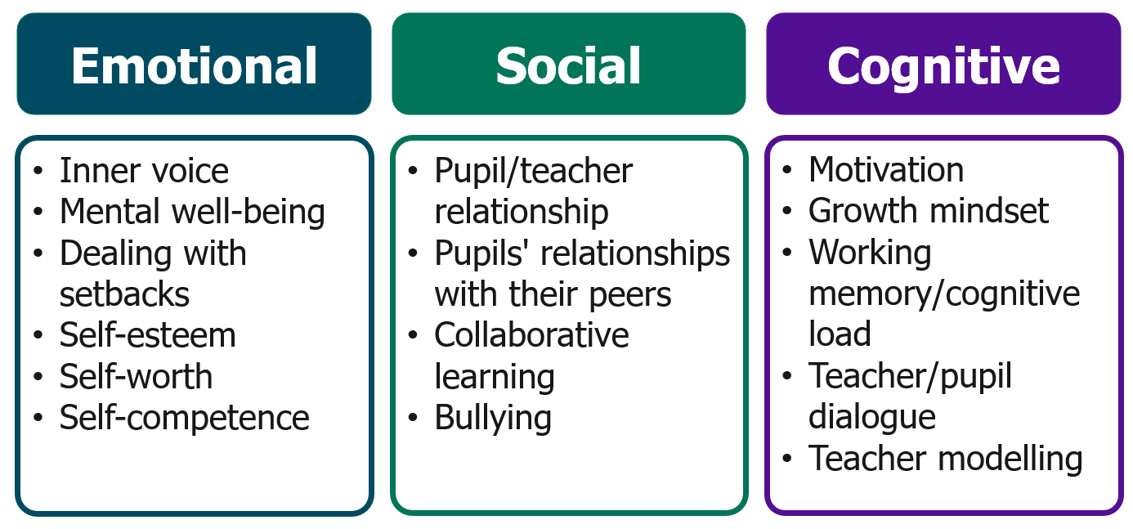
Adapted from Improving Behaviour in Schools Guidance Report, EEF, 2021d, p.17
Why should we explicitly teach learning behaviours?
You may have experienced lessons in which minimal behaviour intervention is needed and noted how these often seem to occur when the classroom environment is calm and positive. Several studies have indicated that explicitly teaching learning behaviours can help create a more positive and safe learning environment due to the reduced level of teacher intervention required to manage behaviour (EEF, 2021d, p.16). This is because when pupils have a great awareness of how to self-regulate their behaviour, they are less likely to misbehave.
Social and emotional skills
You may be familiar with the term ‘social and emotional learning’ (SEL). SEL refers to the way in which pupils learn how to understand and manage their own emotions, have empathy for others, have positive relationships with those around them and make responsible choices (EEF, 2021f). Take a look at the diagram which outlines 5 core skills that encompass SEL.
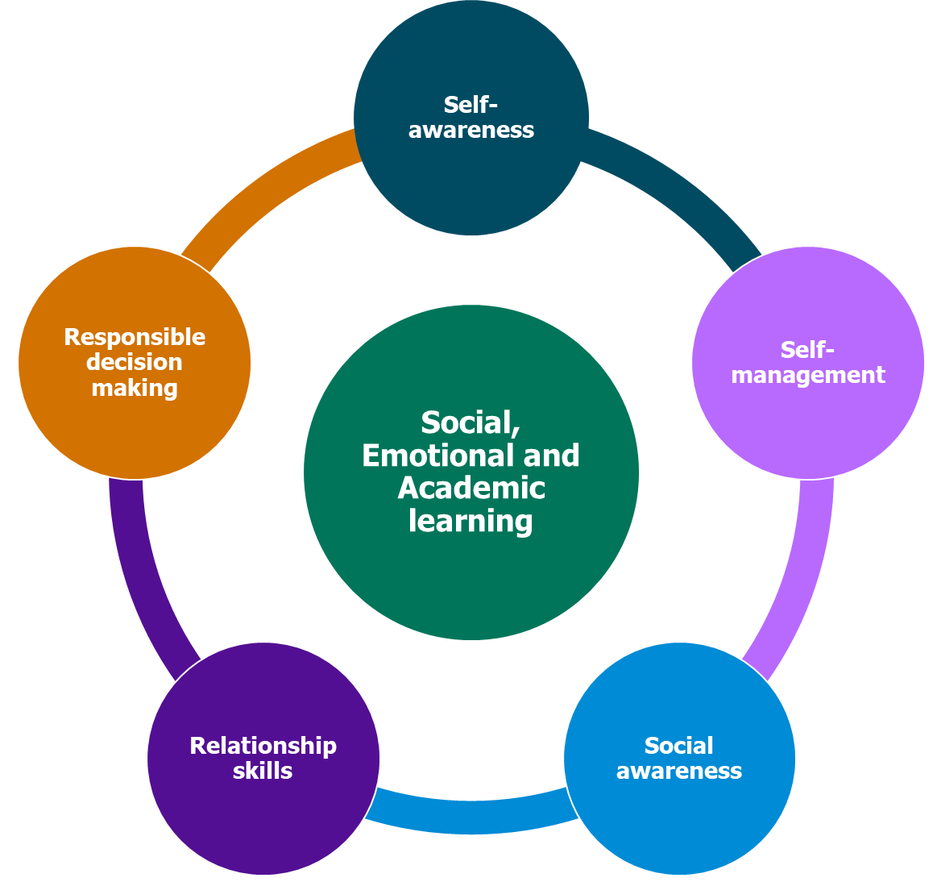
Adapted from Casel, 2017 cited in EEF, 2021f, p.4

You will notice that there is some overlap between these core competencies and some of the learning behaviours outlined by the EEF (2021d) for example, relationship skills (EEF, 2021f) and pupils’ relationships with their peers and teacher and pupil relationship (EEF, 2021d).
Why do pupils need to learn social and emotional skills?
SEL is particularly important to develop in younger pupils as research demonstrates that stronger social and emotional skills are associated with better outcomes both in school and beyond (EEF, 2021f). Social and emotional learning can be especially beneficial to pupils from disadvantaged backgrounds who tend to have poor social and emotional skills than their peers (EEF, 2021f). Explicit teaching of social skills may also support some pupils with SEND who may struggle with social interactions.
Self-regulation
Underpinning all of these learning behaviours is the ability to self-regulate; knowing when and how to manage each of them. You’ll know from your initial teaching training that self-regulation is a critical skill that underpins positive behaviour and academic success, helping pupils manage their emotions, thoughts, and actions to engage more effectively with learning. Supporting pupils in developing self-regulation can lead to notable improvements in both behaviour and learning outcomes, as it equips them with strategies to stay focused, adapt to challenges, and work well with others (EEF, 2021d).

The role of teachers in developing self-regulation
Teachers play a crucial role in supporting their pupils to develop their self-regulation. One way they can do this is by anticipating scenarios and discussing them beforehand with pupils. This can help them visualise and rehearse positive behaviours, making them feel more achievable in real situations. This may be done discretely as part of a personal, social, health and economic (PHSE) or social and emotional learning (SEL) curriculum. It could also be part of a tailored approach to support individual pupils with specific needs.
[Schools may wish to reference how this is taught in their own context here].
This proactive approach supports children in building self-awareness and equips them with strategies for responding calmly and appropriately. Additional support through the use of visual or verbal cues to act as gentle reminders can help to reinforce expectations without needing direct correction, ultimately empowering pupils to self-monitor.
Learning behaviours and pupils with SEND
The number of pupils with SEND attending mainstream state and independent schools is rising (NAO, 2024, p.7) and as you know, there is a legal obligation for schools to ensure the needs of all pupils are met and with special education provision in place for those who need them (Children and Families Act Part 3, 2014). Therefore, it is important to understand what learning behaviours may look like in children with some kind of SEND. For example, children who do not make direct eye-contact or move while listening are not necessarily off-task. In these circumstances, the role of the SENCO and their teams is important in building a shared understanding, through the use of pupil profiles, for example.
You will explore more about learning behaviours throughout the programme and elective self-study 3 shares examples of how teachers can teach and embed these in the classroom.
Using praise to create positive learning environments
Teaching learning behaviours is one way to build a positive and predictable learning environment in which all pupils can thrive. These can take time to develop however and benefit all pupils but especially those with SEND (EEF, 2021c) and it is therefore important to consider how you will take practical steps to achieve this in your classroom.
Praising pupils and thereby focusing on the positive behaviours that pupils exhibit can be one way to boost their intrinsic motivation (Henderlong and Lepper, 2002).

Praise and acknowledgement
Although it can be tempting to praise pupils to encourage motivation and create a positive learning environment, you should use praise with caution. Overuse can appear inauthentic and thus decrease the impact. An example of this would be if pupils are praised for complying with expected norms such as standing behind their desks on arrival. In instances such as this, an acknowledgement of the positive behaviours can be sufficient to reinforce the high expectation. For example:
“Thank you for standing behind your chairs, 9L”.
“Well done for coming into the classroom so quietly Class 5”.
“Great to see you getting straight on with your starter task, Year 12.”
“Thank you for putting away everything so neatly, Blue Group. You have helped to keep our classroom organised and safe and ready for our next activity.”
This signifies to pupils that their compliance has been recognised and is more likely to embed the positive behaviours.
Praise, on the other hand is often reserved for when pupils exhibit great effort in their work. This does not necessarily mean they have been successful overall but rather that their hard work and effort has meant they have made good progress. Praise is at its most powerful when it is precise so that pupils know exactly why they are receiving it. For example:
“That is super writing, Freya. You have used all of today’s success criteria to create a really powerful paragraph.”
“Hanza, that is wonderful resilience. You realised your drawing of the horse was too big for the page and you started again and took your time to get it right”.
“Sophie and Natalie – great teamwork and communication during those passes with the netball”.
“Great collaboration on that independent research, Tom and Charlie.”

Addressing low-level behaviour
The use of established routines combined with high teacher expectations creates a foundation for good behaviour but despite reward systems and teaching learning behaviours, off-task and other undesirable behaviours cannot be totally eradicated (EEF, 2021d, p.16). This can create a potential risk to the safe and predictable environment that teachers strive to achieve. It is therefore important to understand how to address low-level and persistent and challenging behaviour in the classroom effectively and to restore a calm learning environment as swiftly as possible, avoiding escalation.
Teachers should consider what is appropriate for the cognitive stage of the pupils in their class when addressing low-level behaviours. You can explore this further in elective self-study 3.
The use of rewards and sanctions
You’ll be familiar with the use of rewards and sanctions from your initial teacher training. It’s possible that your experience suggests that this is the most effective way to manage behaviour and create and maintain positive learning environments. After all, most, if not all, schools will have specific policies and expectations outlining how these are used to support the management of behaviour both at classroom and at whole school level. Despite this, evidence for the impact of the use of rewards and sanctions remains inconclusive in terms of improving behaviour (EEF, 2021d) although they do appear to be an effective tool to motivate pupils.
Rewards systems function primarily as an extrinsic motivating factor where the goal is to earn a reward and avoid a sanction. More desirable are approaches that draw on intrinsic motivating factors in which pupils make conscious choices to adjust and correct their behaviour because their understand that this in inherently the right thing to do.
Let’s take a moment to recap the difference between extrinsic and intrinsic factors:
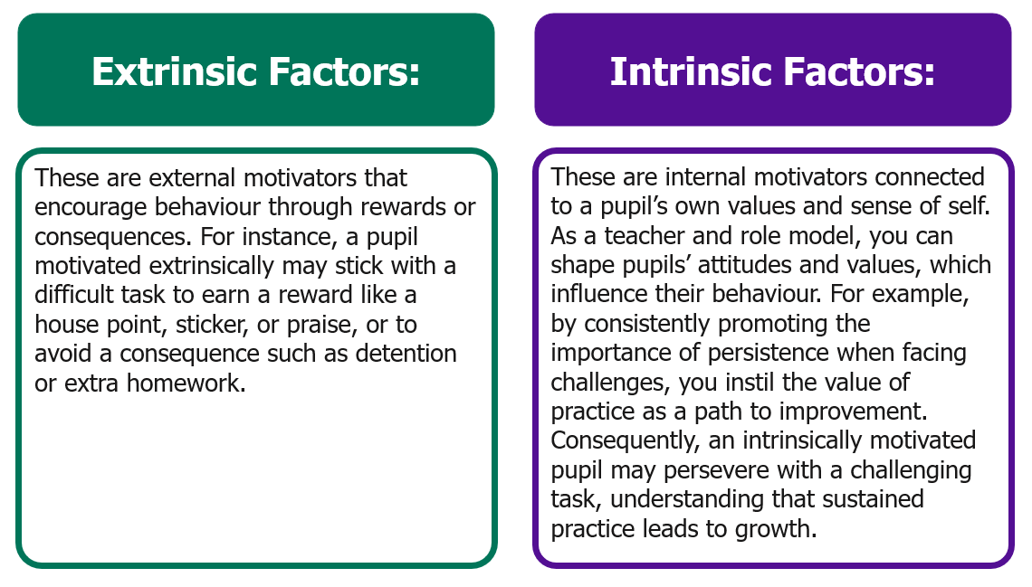
Building on the EEF's (EEF, 2021d) focus on intrinsic motivating factors, Mccrea (2020) highlights that while both extrinsic and intrinsic motivators can achieve well-behaved pupils, intrinsic motivation is more likely to lead to lasting behavioural change, as it fosters self-regulation without dependence on external rewards. You will explore more about motivating pupils later in this self-study. You will explore more about motivating pupils later in this self-study.

Using the least intrusive strategies
As noted by the EEF (2021d, p.16), undesirable behaviours cannot be completely eliminated, making it essential to have effective strategies to manage them. When addressing low-level behaviours, one approach to restoring a positive learning environment is Doug Lemov's (2021) concept of ‘least intrusive strategies’. This approach can be effective when managing undesirable behaviour as it reduces the likelihood of escalation and avoids the pupil feeling targeted, humiliated, or challenged.
In ‘Teach Like A Champion’ (2021), Doug Lemov shares six strategies that align with this principle:
In each of these strategies, the aim remains the same – to minimise further disruption and correct the misbehaviour quickly. You can see examples of these in practice and explore what makes them effective in elective self-study 3.
Ultimately any strategies used to address low-level behaviour should align with the school’s culture and its policies, prioritising the safety of all pupils and restoring calm learning environment that enables all pupils to thrive (DfE, 2024, p.15).
[If schools use any of the listed strategies, they may wish to highlight this here].

Addressing persistent and challenging behaviour
Some pupils may require a tailored approach
Universal behaviour systems work for the majority of pupils, however for some pupils further support may be needed (EEF, 2021d). This may take the form of a tailored approach which may include targeted interventions implemented by teachers with additional training. It may also involve teachers reflecting on their whole classroom management, which may benefit pupils with more individualised needs (EEF, 2021d, p.28).

Ensuring alignment with whole school approaches
Managing the behaviour of pupils with greater needs can be challenging, especially where positive teacher-pupil relationships have not yet been established, for example at the beginning of the school year. This emphasises the importance of building positive relationships quickly. Any adaptions to existing behaviour routines should continue to align with the whole-school approach and expectations should remain consistently high for all pupils (EEF, 2021d, p.28). Dr. John Cornwall recognises the challenge faced by teachers in implementing ‘a flexible but consistent approach’ which he says ‘requires considerable resilience in the adults who are trying to support and teach young people immersed in their own difficulties’ (EEF, 2021d, p.28).

Consequences
Where least intrusive strategies have not had the desired effect, that is to say they have not stopped the misbehaviour and restored the calm and positive learning environment, sanctions may need to be used. Your school’s behaviour policy will outline how these should be implemented.

Depersonalise consequences
You learned during your initial teaching training that when issuing consequences, it is important that they are depersonalised – separating the behaviour from the individual. This helps with the restoration of positive relationships after the event and, crucially, demonstrates the teacher’s belief that the pupil has the capacity to correct the behaviour rather as opposed to them being labelled as inherently ‘naughty’. The labelling of pupils as ‘bad’ or ‘naughty may create long-term cycles of low teacher expectancy which are potentially transmitted from teacher to teacher. This can impact how pupils see themselves and reduce their motivation and self-esteem, ultimately impacting their academic outcomes (Murdock and Perriera, 2018).

Having issued consequences, it is important that a positive teacher-pupil relationship is quickly restored and you will learn more about this later in this self-study.
Consistency
The behaviour policy of your school will outline the range of sanctions and any escalation. When addressing both low-level behaviour and more persistent and challenging behaviour consistency is crucial. This is to ensure that all pupils – and their parents - understand the consequences of their actions and know that they will be treated fairly in line with school policy. Listen to what Dan Bellanfante says about the importance of a consistency:

Click here to play video - Consistent approaches to create safe, predictable environments
[Schools may wish to highlight where ECTs can access the behaviour policy or any key points here].
As Dan highlights, adopting a consistent approach for all pupils in which high expectations are maintained at all times, contributes to a predictable classroom culture where pupils know what is expected and that they will be treated fairly.

Understanding different needs

Earlier in the self-study, you considered how a range of influences can impact the learning behaviours of pupils. However, it is important to recognise that where a pupil is unable to comply with a universal behaviour system, or meet the expectations of the teacher, this does not necessarily indicate a special educational need (EEF, 2021d, p.29). Conversely, where a pupil with SEND has misbehaved, schools should not make the assumption that the cause is their SEND (DfE, 2024, p.18).

Managing the behaviour of pupils SEND can be highly nuanced and teachers should work with their SENCO or other leaders in their school, as well as parents/carers to ensure that any approaches align with the school’s policy whilst ensuring the needs of individual pupils are met. Ultimately, a consistent and positive approach to behaviour management within an inclusive learning environment will benefit all pupils but particularly those with SEND (EEF, 2021c)

Now check your understanding!
True or false?
If a least intrusive strategy doesn't immediately stop misbehaviour, it's ineffective and teachers should move directly to consequences.
Answer: False
Explanation: While the evidence highlights the importance of using the least intrusive strategies initially, it does not suggest these strategies should be abandoned immediately if they don't have an immediate effect. The focus is on minimising disruption and correcting the misbehaviour quickly and it may take time for these strategies to work. However, consistency is key.
Consistency in behaviour management means treating all pupils exactly the same, regardless of individual circumstances.
Answer: False
Explanation: While the sources stress the importance of consistency in applying the school’s behaviour policy, they also acknowledge that a tailored approach may be needed for some pupils. For example, students with some kind of SEND may require different strategies. The key is to ensure fairness and that expectations remain high for all pupils within a consistent framework.

Time to reflect

Consider the content of this section and reflect on the following:
- To what extent do you currently teach learning behaviours in your classroom? OR
- How effective do you consider the rewards systems in your own classroom to be at managing pupils’ behaviour? What could you change to focus more on intrinsic motivating factors?
- What strategies do you use to address low-level behaviour? Consider how many can be considered as least intrusive.

Note your responses and share them with your mentor at your next meeting. You may also wish to use these notes when completing your personal professional reflection.
Click here to return to Content page
4. Building effective relationships
Approximate time to complete: 10 minutes
In this core self-study, you have already considered the importance of establishing effective routines and how to use a range of strategies to manage behaviour in order. These both help teachers to create a safe and predictable learning environment and fosters a climate in which expectations are high for all pupils. In this section, you will explore the key role that effective relationships with pupils contributes to a positive learning environment and, crucially, what you can do when relationships are at risk of breaking down.
What the evidence says
Research indicates that a teacher and pupil relationship rooted in trust and respect is critical for pupils’ enjoyment of school and for their wider emotional wellbeing (Rathman et al., 2018). There are implications for academic outcomes too: one study (PISA, 2015) suggested that teacher-pupil relations can reduce absence or late arrivals and impacted on improved performances in Maths, however there are implications for all subjects and phases. The study found that having positive relationships with pupils can help to motivate them and foster a sense of belonging in which they can thrive. In addition, effective teacher-pupil relationships can support behaviour management (EEF, 2021d) which means that it’s crucial to get this right from the beginning of the year. As you may already have experienced, developing positive teacher-pupil relationships can take time; however, the long-term benefit to both teachers and pupils is worth the investment.
Some simple but effective ways to communicate your respect for pupils in a way that makes them feel valued and recognised, include:
- knowing and using their names
- greeting them at the door at the start of the lesson
- enquiring about a key event in their life or interest they have
- giving pupils your full attention when they are talking to you
- using positive body language including facial expressions
- demonstrating empathy

Authenticity is important
It is important that teachers use these and any other strategies in a way is perceived as authentic by pupils. Where actions or words are seen to be inauthentic this may demotivate and disengage pupils thereby undermining the intention to build positive relationships. By adopting a consistent approach and embedding these strategies into daily life in the classroom, pupils are more likely to respond positively and view these actions as authentic.
Of course, the provision of high quality and adaptive teaching that meets the needs of all pupils underpins positive teacher-pupil relationships. High quality teaching demonstrates respect for pupils by showing that you value their time, that you understand their individual needs and that you have belief in their ability to be successful.
Let’s look a little more closely at one approach to cultivating and maintaining positive relationships.
Establishing, maintaining and restoring relationships
You may be familiar with the strategy, Establish-Maintain-Restore (EMR) (EEF, 2021d) which outlines different stages of the teacher-pupil relationship including, importantly, how to restore relationships when things break down.
 | Establish | Maintain | Restore
Definition | Intentional practices to cultivate a positive relationship with each pupil (i.e. build trust, connection & understanding) | Proactive efforts to prevent relationship quality from diminishing over time (i.e. ongoing positive interactions) | Intentionally repairing harm to the relationship after a negative interaction (i.e. reconnecting with pupil)
Practical  strategies | Set aside window of time to check in with the pupil during lesson.  Inquire about pupils’ interests.  Communicate positively:  - Open ended questions  - Affirmations  - Reflexive listening  - Validation  - Reference pupil info  - Deliver constructive feedback | Greet pupils at the door.  Relationship check-in (e.g. asking how things are going).  5-to-1 ratio of positive to negative interactions.  Positive notes home (you may have a department or school approach to this). | R3 = Reconnect, Repair, Restore  Discuss the cause of any negative interactions.  Try to understand why the challenge may have occurred.  Communicate your care for the pupil and their education.  Engaging in mutual problem solving.  Let go of the previous incident & start fresh.
Listen to Lewis, a history teacher in a Post-16 setting, outline some of the strategies he uses to build and maintain positive relationships with pupils in a way that shows they are valued and recognised. Have you used any of these?
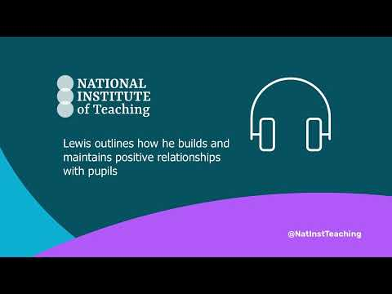
Click here to listen

The EMR framework can provide a useful tool to foster positive relationships and sustain them over time, however, the ways in which teachers implement them will depend heavily on their own context. Factors to consider include:
- the age of the pupils
- the class size
- the school culture
- the individual needs of the pupils
Ultimately, having a good knowledge of your pupils and their individual needs lies at the heart of establishing and maintaining long-term positive relationships. This includes understanding some of the factors that may influence their behaviour. This may involve collaborating with colleagues such as pastoral leads or SENCOs and their teams. Learning about the ‘bigger picture’ and building strong relationships with families can take time, especially if you are new to a school, however it is something that you should actively seek to do.
Factors that influence pupils’ behaviour
The influences that might provoke pupils’ behaviour, particularly more challenging behaviour, can come from many different sources (EEF, 2021d). Sometimes these factors are within the teacher’s control: a pupil might be using misbehaviour to mask struggles with academic work and require more support, for example, or they might be experiencing inconsistent expectations from different teachers.
Bullying
Another key influence that can impact behaviour is bullying which is linked to pupil attainment (EPI, 2018). Effective class management, such as establishing routines and encouraging pupils’ self-regulation, can reduce bullying (EEF, 2021d) however teachers should be alert to potential signs of bullying. As you have already learned, having positive relationships with pupils builds reciprocal trust and respect and nurtures an environment where pupils feel more able to confide in teachers or other members of staff.
In-school factors can have a significant influence on young people’s behaviour inside and outside of school (Chapman et al, 2013). By identifying the factors driving the behaviour within school, teachers are more able to adapt, where necessary, their environment or tailor a strategy to address it (Institute of Education Sciences, 2008).
External influences
As you will know, sometimes the influences on pupils are more complex and have their roots beyond the school gates. Young people might be witnessing domestic abuse in the home, or they might have a parent in prison, or be involved with county lines; they could have experienced abuse or neglect as a young child; they might be the victim of cyber bullying by peers; or they might have experienced a bereavement.
These adverse childhood experiences or ‘ACEs’ fall beyond the control of teachers and schools and research into the how pupils can be supported is still relatively limited (EEF, 2021d). However, even if they cannot remedy the negative influences on a young person, teachers can act to increase the positive influences on them (EEF, 2021d), for example supporting them to maintain strong in-school relationships and reinforcing their sense of school connectedness.
Know your pupils and their families
The way in which pupils respond to influences and the subsequent impact on their behaviour varies from pupil to pupil. This can make identifying the root cause and putting support in place more challenging for teachers however “being in an informed position where staff can be aware of negative influences starting or continuing to affect a pupil’s life is key to building understanding and to identifying the most effective behaviour management approach” (EEF, 2021d, p.9). You will explore more about influences on behaviour in your next live seminar.
Working in partnership with parents and carers
Parents, families and teachers all have a shared interest in their children achieving their potential (EEF, 2021e, p.4) and working in partnership with them improves the chances of challenging behaviours being effectively addressed (DfE, 2018, p.24)
Shared approaches between home and school
Collaborating with parents, carers and families around behaviour can be very effective. The key to this is taking a shared approach at home and at school: agreeing on shared goals, adopting consistent strategies to respond to children’s behaviour, and communicating regularly about progress. This kind of collaborative approach can build families’ understanding, self-efficacy and buy in and make it more likely that young people experience a unified response to their behaviour. For example, the use of a daily report card, on which teachers log the pupil’s performance against key targets so that the adults at home receive a regular update on progress, can build a strong sense of team and enable families to celebrate the good days and reinforce key messages when targets aren’t met (EEF, 2021e).
Effective communication
Your school will have a structure in place to share key policies and expectations with parents and families and through a teachers’ more regular interactions with parents and carers the schools’ expectations can be consistently re-iterated. In addition, a chat at the school gate or a note in a planner can be enormously important for learning what is going on in young people’s lives, sharing updates on pupils’ successes and struggles at school, and reinforcing key messages about how to support at home. Perhaps most importantly, it is through these day-to-day moments that teachers build trust with young people’s families and genuinely get to know them.
[Schools may wish to highlight their mechanism for home/school communications here].

Now check your understanding!
PICK TWO
According to the EMR framework, which TWO of the following are practical strategies teachers can use to establish positive relationships with pupils?
a) Using a seating plan so that pupils are sitting next to peers they get along with
b) Providing constructive feedback
c) Setting aside time to check in with pupils during the lesson
d) Creating a visually stimulating classroom environment
The correct answers are b) and c).
Explanation:
Providing constructive feedback that is developmental rather than critical, supports the building of a trusting relationship in which pupils feel valued and respected. Furthermore, it demonstrates teacher investment in the individual progress of each pupil.
Setting aside time to check in with pupils during the lesson is included in the 'Establish, Maintain, Restore (EMR)' framework as an intentional practice to cultivate positive relationships with each pupil.
Whilst seating plans are useful behaviour management tools, they do not help to establish positive relationships by themselves. Likewise, creating a visually stimulating classroom may support pupils’ learning and make the classroom environment appear more pleasant, however this in itself does not help to build positive teacher-pupil relationships.

Time to reflect

Consider the content of this section and reflect on the following:
- Would you describe your classroom environment as trusting and respectful? If so, why? If not, why not?
- What steps have you already taken to develop a climate built on trust and respect in your classroom?

Note your responses and share them with your mentor at your next meeting. You may also wish to use these notes when completing your personal professional reflection.

Click here to return to Content page
- Motivating pupils
Approximate time to complete: 10 minutes
What the evidence says
Why motivation matters
Earlier in the self-study, you considered how rewards systems can be used to extrinsically motivate pupils by offering an incentive to behave in school or class. However intrinsic motivation – or self- motivation – is the pathway to resilient, goal-driven pupils who are more likely to behave in the classroom (EEF, 2021d, p.18).
Building on Lazowski and Hulleman’s (2016) findings that motivated pupils are more likely to be attentive learners and achieve successful academic outcomes, Peps Mccrea (2020) defines motivation as a system for allocating attention, emphasising its role in directing focus and engagement in learning. As the evidence suggests, motivation plays a significant role in fostering a positive learning environment in which all pupils thrive.
If you want a quick reminder of the differences between extrinsic and intrinsic motivation, click here.
Extrinsic and intrinsic motivating factors
Earlier we highlighted the focus on the importance of intrinsic motivation in fostering goal-driven pupils (EEF, 2021d). This is reinforced by Mccrea (2020), who highlights the need for teachers to develop pupils’ intrinsic motivation to help them thrive without excessive reliance on external rewards. While extrinsic motivators can have value, relying too heavily on them risks suggesting that learning lacks inherent value or that tasks are overly challenging, making it crucial to strike a careful balance.
How to boost pupils’ intrinsic motivation
Experiences of success can increase pupils’ confidence and motivate them to invest effort to achieve further successes (Coe et al., 2014; Gutman & Schoon, 2013). Building on this idea, Mccrea (2020) suggests that motivation is shaped by emotional responses to experiences rather than being a fixed character trait, offering a perspective for understanding how success can influence pupils’ engagement and behaviour in the classroom.
Activity
Monique Boekaert (2010), formulated eight ‘Principles of Motivation’, which outline how motivation operates in the classroom and how prior experiences - of success or failure, satisfaction or frustration – affect pupils' investment in learning. Mccrea (2020) built on this work and mapped out five drivers for motivation in the classroom. Take a moment to read this. Note down what each driver looks like in your own classroom. Reflect on what this looked like during your initial teaching training and how it looks currently.

Nature of driver | Driver
Economic - how pupils appraise the value, expectancy and cost of the opportunity | Secure success – creating opportunities for pupils to achieve success through effective teaching practices
 | Run routines – teaching and embedding routines that make the process of learning easy while keeping content challenging
Social - how the attitudes and actions of others influence pupils’ economic appraisals | Nudge norms – ensure desirable norms are visible, explain what pupils should and should not do, recognising when pupils are getting it right
 | Build belonging – create a positive learning environment with a shared sense of purpose, strong relationships and a culture of trust.
Metacognitive- how teachers can cater for preferences of autonomy within the structured context of the school | Boost buy-in – make learning meaningful by explaining to pupils the choices you have made in what you are teaching and how it is beneficial to pupils and their long-term goals.
The fiver core drivers of motivation for learning adapted from Mccrea (2020)

You have already explored some of these drivers in this self-study. You considered the impact of establishing effective routines and how to ‘nudge norms’ through modelling, practice and use of rewards. You also looked at how to ‘build belonging ‘ by establishing effective relationships in the classroom. Let’s look now at two other drivers that Mccrea shares.
Secure success
As a teacher, you can influence your pupils’ resilience and beliefs about their ability to succeed, by ensuring all pupils can experience meaningful success.
Success drives motivation
As you know, you are much more likely to want to engage in an activity if you have previously experienced success with it as opposed to failure. Therefore, you can motivate pupils by helping them to experience success when learning. However, there is a careful balance to strike when doing this. If a problem or activity is too tricky or too easy, pupils are unlikely to get the same sense of achievement (Willingham, 2009). Therefore, it is important that you strive to set your pupils challenging but achievable tasks. This is sometimes referred to as ‘desirable difficulty’ (Bjork & Bjork, 2011) meaning that pupils are able to successfully complete tasks but the process requires sufficient effort on their part to achieve this. Teachers should address the feeling of discomfort head-on with pupils. The better pupils understand that this discomfort is a sign that they are learning, the more likely they are to engage in it without losing motivation.
However, making tasks achievable can be tricky. The curriculum consists of a great deal of challenging content that pupils might find difficult to master, but it isn’t always possible or beneficial to pupils to overly simplify this content. Instead, to support pupils to achieve meaningful success, Willingham (2009) suggests you can help to make the thinking easier. Willingham suggests this can be achieved by paying attention to pupils’ cognitive load when planning and delivering lessons. He also highlights the need to spark pupils’ curiosity by asking “What is the question that will engage students and make them want to know the answer?” (Willingham, 2009, p.12)
Boost buy-in
Offering choice
Whilst curriculum content and sequences of teaching are, for the most part, something over which pupils have limited control, there is scope to provide autonomy for pupils by incorporating their interests when planning lessons and offering a range of ways to present work. When pupils feel a sense of autonomy and ownership of their learning, and when they understand how time in the classroom relates to their wider goals, they tend to feel more intrinsically motivated and tend to be willing to engage in activities they find less interesting (Ryan & Deci, 2013).
Developing metacognitive skills
Building on Ryan and Deci’s idea that pupils are intrinsically motivated when they feel a sense of autonomy, Peps Mccrea (2020) highlights that autonomy must be paired with responsibility. To support this, teachers should help pupils develop metacognitive skills, enabling them to make informed choices that lead to successful outcomes. For example, a pupil may prefer to present their work using a specific app on a computer however, the teacher knows that they are unfamiliar with the software and that this approach will impact on their ability to complete the work within the timeframe. The teacher would play a key role in this instance in supporting the pupil to reflect on their choice and what they know about themselves as learners to evaluate this decision. Teaching metacognition takes time and you will explore this further in other modules.

Using positive language
Teachers are role models for their pupils and they can influence attitudes, behaviours and values (Epstein et al., 2008). Therefore, what teachers say about learning and how they say it can be hugely influential on pupils’ motivation and their buy-in (Boekarts, 2010).
Activity
Consider the following phrases in relation to your subject or phase and how they may impact pupils’ intrinsic motivation:
“This is a tricky sound to learn, some of you may find it quite challenging.”
“I know we all find this World War I content a bit boring but we have to do it as it’s on the curriculum.”
“This might be difficult because you find numbers hard. Just do your best to get through it.”
“I’ve always found algebra hard too!”
“I appreciate Shakespeare isn’t everyone’s favourite playwright…”
Whilst phrases such as these may be meant with good intention and possibly even intended to suggest a shared experience of learning between teacher and pupils, research has shown the importance of teachers fostering positive attitudes with pupils in relation to maths (Ma and Kishor, 1997) and STEM (science, technology, engineering and mathematics) subjects (Gladstone and Cimpian, 2021).
Look again at how a shift in language can promote more positive attitudes to learning:
“We have a new sound to learn today and I know you are all going to do a brilliant job at using it in your writing and reading!”
“Today we are starting a really important new topic as it links to what we have previously learnt about the causes of World War I last year.”
“We have a really great number challenge to complete together now. I’ll be here to help you do it step-by-step!”
“This week we are exploring algebra! It’s a bit like being a maths detective and we are going to work through it together and solve the puzzles.”
“Shakespeare’s style of writing differs from modern playwrights but his influence on our language today and on much modern literature is really fascinating”.

As you can see, having secure subject knowledge is crucial to enable teachers to share realistic and accurate representations of the learning. You will explore this in more depth later in the programme. Equally important is knowing your pupils well so that you can frame the positive language in a way that will be most likely to inspire, motivate and boost buy-in.
Now check your understanding!
True or false?
Teachers can only influence pupils' extrinsic motivation, as intrinsic motivation is entirely self-driven. Select the correct answer
a) True
b) False

Answer: False. Teachers can influence intrinsic motivation by fostering positive attitudes and values that boost self-motivated learning such as securing success, providing more autonomy for pupils and positive framing.

Time to reflect
Now consider the content of this section and reflect on the following:
- Reflecting on the earlier activity, how do you currently boost pupils’ motivation in your class?
- Are there some strategies that are more successful than others? Consider why this may be the case.
- How do you increase your pupils’ intrinsic motivation?

Note your responses and share them with your mentor at your next meeting. You may also wish to use these notes when completing your personal professional reflection.

Click here to return to Content page
Summary
Approximate time to complete: 2 minutes
Teacher expectations significantly impact pupils’ progress and outcomes. Research consistently shows that when teachers hold high expectations for their pupils, those pupils tend to achieve better results (Rubie Davies et al., 2014). This phenomenon, termed the 'Pygmalion Effect,' (Murdock-Perriera, 2018) demonstrates that pupils’ performance often aligns with the expectations their teachers have for them. Notably, this effect is more pronounced in groups susceptible to stereotyping or bias, highlighting the need for equitable and high expectations for all students.
Simply holding high expectations is insufficient; teachers must effectively communicate their belief in their pupils’ academic potential. This can be achieved through consistent interactions, actions, and language that convey confidence in pupils’ abilities. It is crucial to accompany raised aspirations with the provision of necessary skills, knowledge, and academic support. A holistic approach that combines high expectations with practical strategies empowers pupils to reach their full potential.
One practical way to demonstrate belief in pupil potential is by setting and maintaining high expectations for contributions and participation in lessons. Establishing a classroom culture where active participation is the norm can significantly impact pupil outcomes over time; however, it is crucial to select strategies that cater to the diverse needs of all pupils.
Another key aspect of demonstrating belief in pupil potential is providing timely and targeted feedback during lessons. While research on the precise timing of feedback's impact on academic outcomes is inconclusive, the sources stress the importance of providing feedback that goes beyond generic praise. Feedback should be specific, actionable, and convey genuine belief in each student's capacity to succeed.
The manner in which feedback is delivered is as important as the feedback itself. Pupil motivation, self-confidence, and trust in the teacher all influence how feedback is received and acted upon. By fostering a classroom culture where feedback is viewed as a tool for growth and improvement, and by modelling effective feedback practices, teachers can create a supportive learning environment that empowers pupils to succeed.
Learning behaviours are essential for effective learning in a group setting (Ellis & Tod, 2018). The EEF (2021d) categorises them into social-emotional skills, self-regulation, and relationships. Explicitly teaching these behaviours fosters a positive learning environment, reducing the need for behaviour interventions. Social-emotional learning (SEL) supports all pupils, especially those with SEND or disadvantaged backgrounds. Self-regulation underpins learning behaviours, helping pupils manage emotions and actions. Teachers play a key role in developing these skills through proactive strategies, scaffolding, and tailored support.
Teachers can boost pupils' motivation by ensuring they experience meaningful success through challenging but achievable tasks, known as ‘desirable difficulty’. This helps pupils view discomfort as a sign of learning. Incorporating pupil interests and offering choices fosters autonomy, promoting intrinsic motivation. Teachers must support metacognitive development to guide effective decision-making. Using positive language and modelling constructive attitudes further enhances pupils’ resilience, engagement, and belief in their ability to succeed.
Click here to return to Content page
Next steps
Approximate time to complete: 2 minutes
Congratulations! You have now completed the core study for this module on ‘Behaviour and relationships’. Please look carefully at your next steps.
Personal professional reflection
Schools should plan some form of reflection activity for early career teachers to complete, possibly in collaboration with their mentors. They should have the opportunity to reflect on the content of the core self-study and identify any possible areas for development. This should take around 30 minutes for ECTs to complete. It could include mentor discussion, reviewing notes, referring to their career entry development profile (CEDP) or other ITT targets. They should use the outcomes to select two further elective self-studies to read for this module.
Elective self-study
Following your personal professional reflection, choose 2 elective self-studies from a choice of five each relating to different aspects of ‘Behaviour and relationships’. These will provide further examples on how to establish and maintain high expectations in the classroom along with insights into what makes this practice so effective. Each elective self-study contains suggested action steps to help develop your practice and you will work on these steps with your mentor.
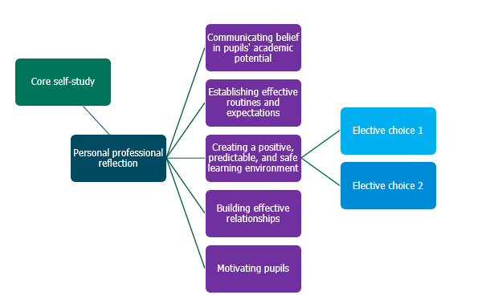
Click here to return to Content page
Initial Teacher Training and Early Career Framework statements addressed
High Expectations
Learn that…
1.1 Teachers have the ability to affect and improve the wellbeing, motivation and behaviour of their pupils.
1.2 Teachers are key role models, who can influence the attitudes, values and behaviours of their pupils.
1.3 Teacher expectations can affect pupil outcomes; setting goals that challenge and stretch pupils from their starting points is essential
1.4 Setting clear expectations can help communicate shared values that improve classroom and school culture.
1.5 A culture of mutual trust and respect supports effective relationships.
1.6 High quality teaching has a long-term positive effect on pupils’ life chances, particularly for pupils from disadvantaged backgrounds.
1.7 High quality teaching is underpinned by positive interactions between pupils, their teachers and their peer
1.8 Pupils’ experiences of school and their readiness to learn can be impacted by their home life and circumstances, particularly for EAL pupils, young carers, and those living in poverty
Learn how to…
Communicate a belief in the academic potential of all pupils, by:
- 1.a. Using intentional and consistent language that promotes challenge and aspiration.
- 1.b. Setting tasks that stretch pupils, but which are achievable, within a challenging curriculum.
- 1.c. Creating a positive environment where making mistakes and learning from them and the need for effort and perseverance are part of the daily routine.
- 1.d. Seeking opportunities to engage parents and carers in the education of their children (e.g. proactively highlighting successes) and consider how this engagement changes depending on the age and development stage of the pupil.
Demonstrate consistently high behavioural expectations, by:
- 1.e Creating a culture of inclusion, respect and trust in the classroom that supports all pupils to succeed (e.g. by modelling the types of courteous behaviour expected of pupils).
- 1.f Teaching and rigorously maintaining clear behavioural expectations (e.g. for contributions, volume level and concentration).
- 1.g Applying rules, sanctions and rewards consistently in line with school policy, including where individual pupils have an agreed tailored approach, escalating behaviour incidents as appropriate.
Managing Behaviour
Learn that…
7.1 Establishing and reinforcing routines, including through positive reinforcement, can help create an effective learning environment.
7.2 A predictable and secure environment benefits all pupils, including younger pupils, but is particularly valuable for pupils with special educational needs.
7.3 The ability to self-regulate one’s emotions affects pupils’ ability to learn, success in school and future lives.
7.4 Teachers can influence pupils’ resilience and beliefs about their ability to succeed, by ensuring all pupils have the opportunity to experience meaningful success.
7.5 Building effective relationships is easier when pupils believe that their feelings will be considered and understood.
7.6 Pupils are motivated by intrinsic factors (related to their identity and values) and extrinsic factors (related to reward).
7.7 Pupils’ investment in learning is also driven by their prior experiences and perceptions of success and failure.
7.8 Teaching and modelling a range of social and emotional skills (e.g. how to recognise and understand feelings, manage emotions, and sustain positive relationships) can support pupils’ social and emotional development.
7.9 Teaching typically expected behaviours will reduce the need to manage misbehaviour.
7.10 Pupils who need a tailored approach to support their behaviour do not necessarily have SEND and pupils with SEND will not necessarily need additional support with their behaviour
7.11 A key influence on a pupil’s behaviour in school is being the victim of bullying.
Learn how to…
Develop a positive, predictable and safe environment for pupils, by:
- 7.a. Establishing a supportive and inclusive environment with a predictable system of reward and sanction in the classroom.
- 7.b. Working alongside colleagues as part of a wider system of behaviour management (e.g. recognising responsibilities and understanding the right to assistance and training from senior colleagues particularly where pupils exhibit unacceptable behaviours).
- 7.c. Giving manageable, specific and sequential instructions.
- 7.d. Checking pupils’ understanding of instructions before a task begins.
- 7.e. Using consistent language and non-verbal signals for common classroom directions.
- 7.f. Using early and least-intrusive interventions as an initial response to low level disruption
- 7.g. Responding quickly to any behaviour or bullying that threatens physical or emotional safety.
Establish effective routines and expectations, by:
- 7.h. Creating and explicitly teaching routines in line with the school ethos that maximise time for learning (e.g. setting and reinforcing expectations about key transition points).
- 7.i. Practising school and classroom routines at the beginning of the school year.
- 7.j. Reinforcing established school and classroom routines (e.g. by articulating the link between time on task and success).
- 7.k. Working with the SENCO, other SEND specialists or expert colleagues if a pupil needs more intensive support with their behaviour to understand how the approach may need to be adapted to their individual needs.
Build trusting relationships, by:
- 7.l. Liaising with parents, carers and colleagues to better understand pupils’ individual circumstances and how they can be supported to meet high academic and behavioural expectations.
- 7.m. Consistently applying the school’s behaviour policy, including where individual pupils have an agreed tailored approach.
Motivate pupils, by:
- 7.n. Supporting pupils to master challenging content, which builds towards long-term goals.
- 7.o. Providing opportunities for pupils to articulate their long-term goals and helping them to see how these are related to their success in school.
- 7.p. Helping pupils to journey from needing extrinsic motivation to being motivated to work intrinsically.
Develop pupils’ self-regulation by:
- 7.q. Helping pupils to think through scenarios before they occur and using cues to help them recall agreed upon behaviours.
- 7.r. Providing new opportunities to exercise self-regulation and for the youngest pupils to practice impulse control.
Professional Behaviours
Learn that…
8.3. Teachers can make valuable contributions to the wider life of the school in a broad range of ways, including by supporting and developing effective professional relationships with colleagues.
8.4. Building effective relationships with parents, carers and families can improve pupils’ motivation, behaviour and academic success.
8.6. SENCOs, pastoral leaders, careers advisors and leaders and other specialist colleagues also have valuable expertise and can ensure that appropriate support is in place for pupils.
Learn how to…
Build effective working relationships, by:
- 8.f. Contributing positively to the wider school culture and developing a feeling of shared responsibility for improving the lives of all pupils within the school.
- 8.g. Seeking ways to support individual colleagues and working as part of a team.
- 8.h. Communicating with parents and carers proactively and making effective use of parents’ evenings to engage parents and carers in their children’s schooling.
- 8.l.Knowing who to contact with any safeguarding, or any pupil mental health concerns.
Manage workload and wellbeing, by
- 8.n. Understanding the right to support (e.g. to deal with misbehaviour, or support pupils with SEND).

Click here to return to Content page
Further reading
- Australian Education Research Organisation, 2023, Classroom Management Explainer: Teaching routines. Available at AERO Classroom management explainer – Teaching routines (edresearch.edu.au) [Accessed 7 October 2024].

References
- Archer, A. L., & Hughes, C. A. (2011). Explicit instruction: Effective and efficient teaching. Guildford Press. (pp. 121–129)
- Bennett, T., (2016)., The Beginning Teacher’s Behaviour Toolkit: A Summary. Available at: Tom_Bennett_summary.pdf [Accessed 2 December 2024].
- Bennett, T. (2020). Running the room: The teacher’s guide to behaviour. John Catt Educational. (pp. 161–205).
- Bjork, E. L., & Bjork, R. A. (2011). Making things hard on yourself, but in a good way: Creating desirable difficulties to enhance learning. In M. A. Gernsbacher, R. W. Pew, L. M. Hough, & J. R. Pomerantz (Eds.), Psychology and the real world: Essays illustrating fundamental contributions to society (pp. 56–64). Worth Publishers.
- Black, P., and Wiliam, D. (1998) Inside the Black Box: Raising Standards through Classroom Assessment. Phi Delta Kappan, 80, 139-148.
- Blakemore S (2018) Inventing Ourselves: The Secret Life of the Teenage Brain. London: Penguin Random House.
- Boekaerts, M. (2010). The Crucial Role of Motivation and Emotion in Classroom Learning. In The Nature of Learning: Using Research to Inspire Practice. OECD. Available at: https://read.oecd-ilibrary.org/education/the-nature-of-learning_9789264086487-en#page93 [Accessed 2 December 2024].
- Burtonshaw, S. and Dorrell, E. (2023) Listening to, and learning from, parents in the attendance crisis. Published by Public First. Available online at: ATTENDANCE-REPORT-V02.pdf [Accessed 17 March 2025].
- Chapman, R. L., Buckley, L., Sheehan, M., & Shochet, I. (2013). School-based programs for increasing connectedness and reducing risk behavior: A systematic review. Educational Psychology Review, 25, 95-114. Available at: School-Based Programs for Increasing Connectedness and Reducing Risk Behavior: A Systematic Review | Educational Psychology Review
- Coe, R., Rauch, C. J., Kime, S., & Singleton, D. (2020). Great Teaching Toolkit: Evidence Review. Evidence Based Education. Available https://www.cambridgeinternational.org/Images/584543-great-teaching-toolkit-evidence-review.pdf. [Accessed 2 December 2024].
- Coe, R., Aloisi, C., Higgins, S., & Major, L. E. (2014). What makes great teaching? Review of the underpinning research. Durham University: UK. Accessible from: What-Makes-Great-Teaching-REPORT.pdf [Accessed 2 December 2024].
- Davies, G. and Hughes, S. (2018). Why I chose to become a teacher and why I might choose not to become one. A survey of student teachers’ perceptions of teaching as a career. Accessible from: https://insight.cumbria.ac.uk/id/eprint/3870/1/Davies_WhyIChoseTo.pdf. [Accessed 17 March 2025].
- Ellis, S. and Tod, J. (2018) ‘Behaviour for Learning: Promoting Positive Relationships in the Classroom’, Routledge.
- Gutman, L. & Schoon, L. (2013). The impact of non-cognitive skills on the outcomes of young people. [Online] Accessible from: (PDF) The impact of non-cognitive skills on outcomes for young people. A literature review [Accessed 6 December 2024].
- Ryan, R. and Deci, E. (2013). Toward a Social Psychology of Assimilation: Self Determination Theory in Cognitive Development and Education. In: B. Sokol, F. Grouzet and U. Müller, eds., Self Regulation and Autonomy: Social and Developmental Dimensions of Human Conduct, 1st ed. Cambridge, MA: Cambridge University Press.
- Department for Education., (2018). Mental Health and behaviour in schools. Available at: Mental health and behaviour in schools [Accessed 2 December 2024].
- Department for Education., (2024).Behaviour in Schools. Advice for headteachers and school staff. Available online at: Behaviour in Schools - Advice for headteachers and school staff Feb 2024 [Accessed 2 December 2024].
- Department for Education., (2025). The link between attendance and attainment in an assessment year. Available online at: The link between attendance and attainment in an assessment year [Accessed 17 March 2025].
- Education Endowment Foundation Teaching and Learning Toolkit, (2021a)., ‘Setting and Streaming’. Available online at: Setting and streaming | EEF
- Education Endowment Foundation, (2021b)., Teacher Feedback to Improve Pupil Learning guidance report. Available online at: Teacher Feedback to Improve Pupil Learning | EEF
- Education Endowment Foundation, (2021c)., Special Educational Needs in Mainstream Schools guidance report. Available online at: Special Educational Needs in Mainstream Schools | EEF
- Education Endowment Foundation, (2021d).,Improving Behaviour in School guidance report. Available online at: Improving Behaviour in Schools | EEF [Accessed 2 December 2024].
- Education Endowment Foundation, (2021e). Working with parents to support children’s learning guidance report. Available online at: EEF_Parental_Engagement_Guidance_Report.pdf [Accessed 2 December 2024].
- Education Endowment Foundation, (2021f). Improving Social and Emotional Learning in Primary Schools guidance report. Available online at: Improving Social and Emotional Learning in Primary Schools | EEF [Accessed 18 March 2025].
- Education Endowment Foundation, (2022). The impact of the Covid-19 pandemic on children’s socioemotional wellbeing and attainment during the Reception Year. Available online: The impact of the COVID-19 pandemic on children’s… | EEF [Accessed 17 March 2025]
- Ellis, S. and Tod, J. (2018) ‘Behaviour for Learning: Promoting Positive Relationships in the Classroom’, Routledge
- Education Policy Institute (2018). Bullying: A review of the evidence. Available at: https://epi.org.uk/ publications-and-research/bullying-a-review-of-the evidence/ [Accessed 2 December 2024].
- Education Policy Institute (2025). Breaking down the gap. The role of school absence and pupil characteristics. Available at: https://epi.org.uk/wp-content/uploads/2025/03/Breaking-down-the-gap.pdf [Accessed 17 March 2025].
- Epstein, M., Atkins, M., Cullinan, D., Kutash, K., & Weaver, R. (2008). Reducing Behavior Problems in the Elementary School Classroom. IES Practice Guide. NCEE 2008-012. What works clearinghouse. Available at: ERIC - ED502720 - Reducing Behavior Problems in the Elementary School Classroom. IES Practice Guide. NCEE 2008-012, What Works Clearinghouse, 2008-Sep [Accessed 2 December 2024].
- Evidence Based Education (2024) ‘Developing Adaptive Expertise’. Available online at Developing Adaptive Expertise - Evidence Based Education [Accessed 2 December 2024].
- Gladstone, J. R., & Cimpian, A. (2021). Which role models are effective for which students? A systematic review and four recommendations for maximizing the effectiveness of role models in STEM. International journal of STEM education, 8, 1-20.Available at: Which role models are effective for which students? A systematic review and four recommendations for maximizing the effectiveness of role models in STEM | International Journal of STEM Education [Accessed 2 December 2024].
- Grossman P, Hammerness K and McDonald M (2009) Redefining teaching, re-imagining teacher education. Teachers and Teaching: Theory and Practice 15(2): 273–289.
- Henderlong, J., & Lepper, M. R. (2002). The effects of praise on children's intrinsic motivation: a review and synthesis. Psychological bulletin, 128(5), 774. Available at: The effects of praise on children's intrinsic motivation: A review and synthesis. [Accessed 2 December 2024]
- Institute of Education Sciences (2008). Reducing Behavior Problems in the Elementary School Classroom. [Online] Accessible from https://ies.ed.gov/ncee/wwc/PracticeGuide/4 [Accessed 2 December 2024]
- Jussim, L. & Harber, K., (2005) Teacher Expectations and Self-Fulfilling Prophecies: Knowns and Unknowns, Resolved and Unresolved Controversies, Personality and Social Psychology Review 2005, Vol. 9, No. 2, 131–1557. Available at: https://doi.org/10.1207/s15327957pspr0902_3.
- Kern, L. and Clemens, N.H. (2006) Antecedent strategies to promote appropriate classroom behaviour. Psychology in the Schools, 44(1).
- Lazowski, R. A., & Hulleman, C. S. (2016) Motivation Interventions in Education: A Meta-Analytic Review. Review of Educational Research, 86(2), 602–640. Available at: https://doi.org/10.3102/0034654315617832.
- Lemov, D. (2021). Teach like a champion 3.0: 63 techniques that put students on the path to college. John Wiley & Sons.
- Ma, X., & Kishor, N. (1997). Assessing the relationship between attitude toward mathematics and achievement in mathematics: A meta-analysis. Journal for research in mathematics education, 26-47. Available at: Assessing the Relationship between Attitude toward Mathematics and Achievement in Mathematics: A Meta-Analysis on JSTOR [Accessed 2 December 2024].
- Marzano, R. (2010). High Expectations for All. Educational Leadership, 68(1).
- Mccrea, P., (2020). Motivated Teaching, Brighton. Self-published.
- Murdock-Perriera, L. A., & Sedlacek, Q. C. (2018) Questioning Pygmalion in the twentyfirst century: the formation, transmission, and attributional influence of teacher expectancies. Social Psychology of Education, 21(3), 691–707. Available at: https://doi.org/10.1007/s11218-018-9439-9.
- National Audit Office., Department for Education., (2024) Support for children and young people with special educational needs. Available at: Support for children and young people with special educational needs [Accessed 2 December 2024]
- OFSTED, (2014) ‘Below The Radar – Low Level Disruption in the country’s classrooms’. Available at: Below the radar - low-level disruption in the countrys classrooms [Accessed 2 December 2024].
- PISA. (2015) PISA in Focus: Do teacher-student relations affect students’ well-being at school? Available at: 5js391zxjjf1-en.pdf [Accessed 2 December 2024].
- Powell S, Tod J (2004) ‘A systematic review of how theories explain learning behaviour in school contexts’. In: Research Evidence in Education Library. London: EPPI-Centre, Social Science Research Unit, Institute of Education
- Rathmann K., Herke M., Hurrelmann K., & Richter M. (2018) Perceived class climate and school-aged children’s life satisfaction: The role of the learning environment in classrooms. PloS ONE, 13(2): e0189335. Available at: Perceived class climate and school-aged children's life satisfaction: The role of the learning environment in classrooms [Accessed 2 December 2024].
- Rubie-Davies, C. M., Weinstein, R. S., Huang, F. L., Gregory, A., Cowan, P. A., & Cowan, C. P. (2014) Successive teacher expectation effects across the early school years. Journal of Applied Developmental Psychology, 35(3), 181–191. Available at: https://doi.org/10.1016/j.appdev.2014.03.006
- UK Government (2014). Children and Families Act 2014 (legislation.gov.uk). Available at: Children and Families Act 2014 (legislation.gov.uk) [accessed 8 April 2024].
- Ursache, A., Blair, C., & Raver, C. C. (2012). The promotion of self‐regulation as a means of enhancing school readiness and early achievement in children at risk for school failure. Child Development Perspectives, 6(2), 122-128.
- Willingham, D. T. (2009). Why don't pupils like school? A cognitive scientist answers questions about how the mind works and what it means for the classroom. Jossey-Bass/Wiley. [Online] Extract available at: https://www.aft.org/sites/default/files/WILLINGHAM%282%29.pdf [Accessed 3 December 2024].

Click here to return to Content page

