
ECT Programme Y1 Core self-study
Memory and learning
Estimated time to complete: 60 minutes
A further 30 minutes should be allocated for ECTs to complete a reflection or other diagnostic task to identify areas for development in this area. See Programme Guidance for further details.

These self-study materials are intended for use by those who design and deliver school induction as part of a school-led programmes for early career teachers. Opportunities for schools or Trusts to add detail relevant to their context have been identified.






Introduction
Approximate time to complete: 3 minutes
In this module you’ll build on the knowledge and understanding you developed during your initial teacher training (ITT) relating to ‘Memory and learning’. You’ll be prompted to reflect on your current practice and to draw on what you already know and have experienced during your ITT as you progress through your personalised pathway and consider its application to your own context.
Once you have completed reading this self-study, you should take some time to reflect on the contents and your current practice. [Schools may wish to add details of reflection activities that ECTs could undertake as part of this process.].
You’ll use the outcomes from your personal reflection along with your targets from your ITT and discussion with your mentor, to select 3 elective self-studies relating to different aspects of ‘Memory and learning’.
Here’s a reminder of how each of the self-studies fit into year one of the ECT programme:
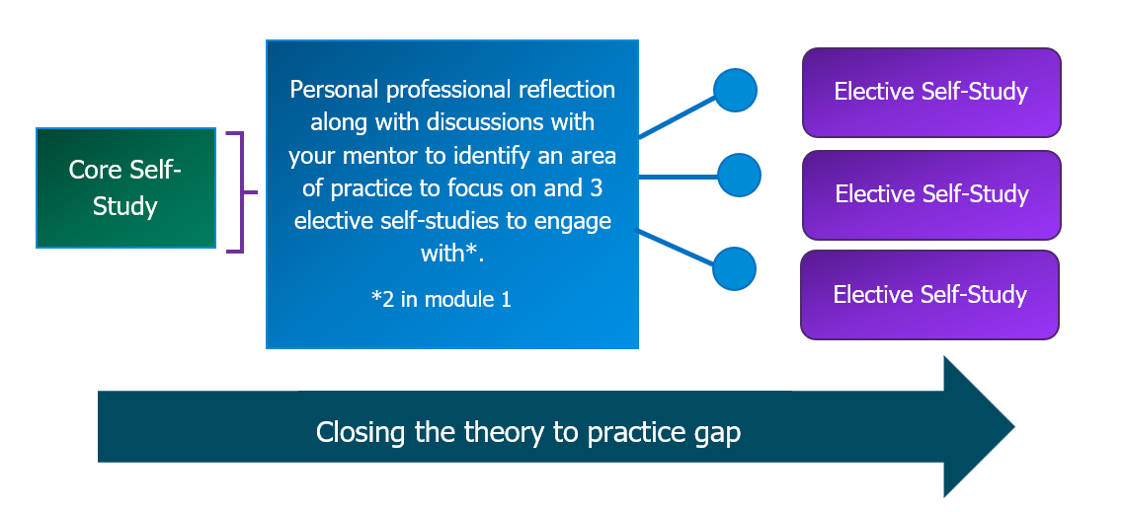
Each elective self-study contains suggested action steps to guide your developing practice and you will work on these steps each week with your mentor.
What you will focus on in this core self-study
This core self-study aims to build on what you learned during your initial teaching training on the importance of understanding how memory works and applying this to classroom pedagogy. To support you in this, this study will explore what the evidence and research tells us in relation to the following:
- How memory works
- Introducing new learning
- Managing cognitive load
- Retrieval, revisiting and reviewing information
- Practice to strengthen retrieval
This self-study contains reflection points, and you may wish to have a pen and notebook to hand to record your thoughts.
There is no expectation for you to complete all of the content in one go – it has been designed so that you can work through one section at a time, if you choose. This will help you to manage your study at a time to suit you.

Content
Section 1: How memory works | Page 5
Section 2: Introducing new learning | Page 12
Section 3: Manging cognitive load | Page 18
Section 4:Retrieval, revisiting and reviewing information | Page 25
Section 5:Practice to strengthen retrieval | Page 32
Summary | Page 37
Next steps | Page 39
Related Initial Teacher Training and Early Career Framework statements | Page 40
Further reading and references | Page 42

Schools may need to update the page numbers in this Content table as they may have altered when content is added.

Section 1: How memory works
Approximate time to complete: 11 minutes
What the evidence says
Memory underpins learning and if nothing has changed in long term memory, nothing has been learned (Sweller, 2011). It is therefore important to be able to use an understanding of both working and long-term memory to shape the instructional techniques we use every day in the classroom.
Facilitating long-term learning
It may sound obvious to say that learning involves a lasting change in capability or understanding. Temporary changes in performance can look so similar to learning that it is easy for teachers to mistake one for the other.
‘Performance’ and ‘Learning’
We can think of the difference between temporary and lasting change as the difference between ‘performance’ and ‘learning’ (Bjork & Bjork, 2011).
‘Performance’ is what we observe pupils doing during the learning process; ‘learning’ is the deep, enduring change we are aiming for.
Pupils may quickly and easily recall new information, but this may be because it is fresh, or because of prompts or cues in the environment. Performance in the moment is not necessarily a good predictor of lasting learning. Temporary change is an important stepping stone to lasting change, but it can give teachers and pupils an over-inflated view of how much learning has occurred.
A paradox for teachers and pupils alike is that experiences that generate rapid improvements in performance often don’t lead to long-term learning, whereas experiences that are more challenging, and where the rate of progress seems slower, are often far more effective (Bjork & Bjork, 2011). We will return to this idea later in the self-study.
The primary goal of teaching should be to facilitate long-term learning; that is to create relatively permanent changes in comprehension, understanding and skills of the types that will support long-term retention and transfer (Soderstrom and Bjork, 2015). In addition, effective teaching should support both retention and transfer. Retention refers to keeping something in one’s long-term memory, while transfer means being able to move knowledge from long-term memory back into our working memory, in different contexts, as and when required (Willingham, 2009).

Working and long-term memory
A useful way to think about memory is as a complex filing system, comprised of two components: long-term memory and working memory.
This diagram shows the relationship between working and long-term memory, with information being recalled from long-term to working memory when needed and processed into long-term for storage. Environmental factors also input into working memory.
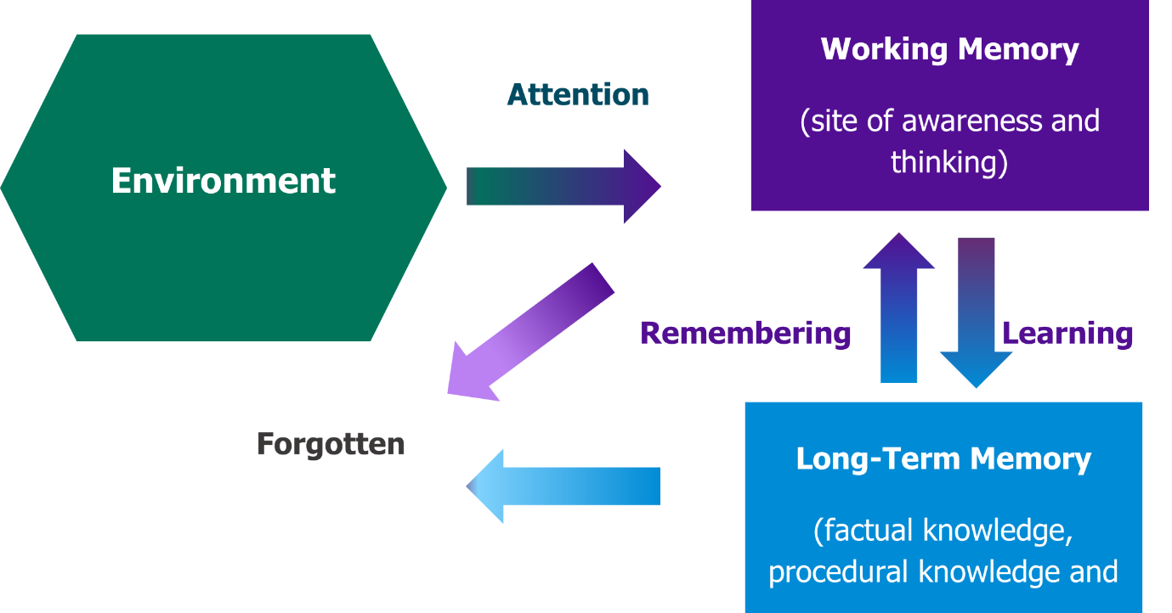
Adapted from Willingham (2009)
Working memory is the memory system where small amounts of information are stored for a very short duration (Peterson & Peterson 1959).
Working memory roughly equates with what we are conscious of at any one time. Clark, Kirschner and Sweller call it ‘the limited mental “space” in which we think’ (2012, p. 8). Research suggests that an average person can only hold about four chunks of information in their working memory at one time (Cowan 2001), although there is evidence to indicate differences in working memory capacity between individuals (see, for example, Barrett, Tugade & Engel 2004).
Long-term memory is the memory system where large amounts of information are stored semi-permanently (Atkinson & Shiffrin 1968; Tulving 1972).
Clark, Kirschner and Sweller call long-term memory ‘that big mental warehouse of things (be they words, people, grand philosophical ideas, or skateboard tricks) we know’ (2012, p. 8).
Long-term memory can be considered a store of knowledge that changes and grows as pupils learn. The knowledge remains in the long-term memory until it is needed, when it enters the working memory. For example, if you were asked the question how many legs a spider has, you would remember that the answer is eight. This knowledge has been drawn into your working memory from your long-term memory.
Working memory is the site of awareness and thinking, where we hold information that is being actively processed by our mind. The working memory draws upon both the environment and long-term memory to process things. It is very small in capacity and, unlike long-term memory, its capacity cannot be changed.
It is important to note that pupils with a learning difficulty that affects their working memory may have a smaller capacity still (Gathercole, 2008) and therefore may benefit from information being provided in small steps (Rosenshine, 2012).
The limitations of the working memory
Managing the limited capacity of working memory is a key challenge for teachers, as it affects everything from how we plan lessons and introduce ideas to how we structure and sequence the curriculum (Kirschner et al, 2006; Pashler et al, 2008).
The information working memory holds is easily lost through distraction or overload (Gathercole, 2008). The more crowded it becomes, the harder it is to think. Holding multiple steps in mind to solve a problem, for example, reduces the thinking capacity to tackle each of those steps (Willingham, 2009).
Teachers want pupils to learn a lot fast. But to achieve this they need to design learning so that it reflects and respects the way memory works. In the attempt to cover a lot of material in a short time, it is easy to overload pupils with unconnected facts, multistep instructions, or complex explanations (Willingham, 2009).
Avoiding cognitive overload
As you will be aware teachers need to remember that pupils can only hold a limited amount of information in their minds at once – and that placing additional strain on working memory does not make learning more valuable or enduring. The reverse is true: when they are cognitively overloaded, pupils are less likely to successfully achieve goals and encode new concepts in long-term memory.
Reducing cognitive overload
It is not difficult to reduce cognitive overload. At its simplest, it involves teachers slowing their pace and providing memory aids (for example: displaying instructions, prompts or a worked example) so that pupils need to hold less information in working memory while they tackle a problem (Willingham, 2009). This will be explored in further detail later in this self-study.
The fact that the working memory is limited in its capacity has profound implications for teaching and learning. To experience the limitations of the working memory, try to work out the maths calculations below without writing anything down.
2 x 3
6 x 7
12 x 15
183 x 587
1983 x 1874

As the questions became more complex, it is likely that you did not know the answer and couldn’t therefore retrieve it from your long-term memory. You would have attempted to hold some information in your working memory and manipulate it. As the numbers got larger still, you may well have tried to remember and manipulate more than your working memory could handle. If this was the case, you would have experienced working memory overload and either become frustrated or given up, feeling that it was impossible to complete.
Supporting pupils with poor working memory
Working memory capacity differs substantially across individuals. About ten per cent of pupils have poor working memory, which can severely hamper their learning (Gathercole, 2008).
Most teachers are not aware of this issue and may interpret low working memory capacity as inattentiveness, poor behaviour or wider learning challenges. This is unsurprising as poor working memory can generate these outcomes: the more learning opportunities pupils miss due to poor working memory, the more delayed they become in their learning and the more additional challenges they face.
The signs of poor working memory tend to be (Gathercole, 2008):
- poor academic progress in reading and mathematics;
- difficulty with learning activities that involve storing and processing information;
- difficulty keeping their place;
- abandoning tasks midway;
- incomplete recall of new information;
- failure to follow instructions;
- appearing inattentive or distractible; and
- appearing reserved in group activities, despite having normal social relationships with peers.
These characteristics tend not to fluctuate from day to day. Poor working memory affects slightly more males than females, but the gender split is fairly even.
To support pupils with poor memory, teachers should adopt the following principles (Gathercole, 2008):
- be alert for signs of poor working memory;
- monitor pupils closely if they seem to have issues with working memory;
- when planning a learning activity, consider the load it places on working memory (length and complexity of instructions, amount of unfamiliar information);
- design activities to reduce the demands on working memory (reduce the amount of information pupils need to remember; increase the amount of familiar material; simplify or restructure complex instructions);
- repeat key information throughout a learning activity;
- provide, and encourage the use of, memory aids (for example: wall charts, posters, instruction cards, templates, dictionaries, number lines or other specific tools); and
- develop pupils’ own strategies for overcoming limitations to their working memory (for example: note-taking, asking for help, place-keeping and organisational strategies).
Young people with poor working memory can be effectively supported to learn as briskly as their peers, but teachers need to be able to spot and address the issue.
Now check your understanding!
Which of the following strategies is the most effective way for a teacher to reduce cognitive overload and support pupils with limited working memory?
a) Covering more material at a quicker pace to increase exposure, ensuring pupils have more opportunities to engage with new information.
b) Providing memory aids such as worked examples, instruction cards, and prompts to reduce the amount of information pupils need to hold in their working memory.
c) Encouraging pupils to tackle complex, multistep tasks independently so they can develop strategies to manage their working memory more effectively.
The correct answer is B: Providing memory aids such as worked examples, instruction cards, and prompts to reduce the amount of information pupils need to hold in their working memory.
Explanation: This strategy is the most effective because it directly addresses the limitations of working memory. The text emphasises that "it is not difficult to reduce cognitive overload" and that "providing memory aids" helps ensure pupils do not have to hold too much information at once (Willingham, 2009). By reducing the cognitive load, pupils can focus on solving problems and encoding knowledge into long-term memory.
Answer A is not correct. While exposure to more material may seem beneficial, the evidence warns that trying to cover too much too quickly can lead to cognitive overload, making it harder for pupils to retain and process information.
Answer C is not correct. Encouraging pupils to develop their own memory strategies is important, but the evidence notes that pupils with poor working memory "can severely hamper their learning" and that they benefit most when teachers "design activities to reduce the demands on working memory" rather than increasing them (Gathercole, 2008). Complex, multistep tasks without support can lead to frustration and disengagement rather than improved memory skills.

Time to reflect
Take a moment now to consider the content of this section and reflect on the following:
- How has your understanding of the role of both working and long-term memory developed since your initial teacher training?
- Thinking about your current practice, how do you plan learning taking into consideration the limitations of working memory?

Note your responses and share them with your mentor at your next meeting. You may also wish to use these notes when completing your personal professional reflection.

Click here to return to Content page
Section 2: Introducing new learning
Approximate time to complete: 10 minutes
What the evidence says
Once you have considered what pupils need to know in order to access a topic, you can start to consider how to introduce new information to your pupils. The most effective way to introduce new ideas is to break complex material into smaller steps and teach these steps one-by-one. This can be considered at a topic level, whereby the teacher breaks down the different knowledge and skills required, teaches them discretely across the topic or unit, then brings them together once pupils are proficient at each. This is explored further in the subject and curriculum module.
It can also be considered from the perspective of a single explanation. This refers to breaking down complex ideas or tasks into smaller steps. This supports the amount of information being handled by the working memory as it reduces the number of ‘slots’ you are filling with new information to process. It also supports you as the teacher to assess pupils’ understanding after each step. If pupils have not understood, you can reteach or modify the explanation as required.
Building on prior knowledge
As you will know from your initial teacher training pupils learn new ideas by linking those ideas to existing knowledge. Prior knowledge in long-term memory is stored in schemas: a schema is a pattern of thought that organises categories of information and the links between them (Perry et. al., 2021).
Ausubel (1968), claimed that “the most important single factor influencing learning is what the learner knows already”. Since then, memory researchers have demonstrated that the content of long-term memory affects how new information is processed in working memory and encoded in long-term memory (Simonsmeier, 2018). This is why prior knowledge plays such an important role in learning (Deans for Impact, 2015).
Where prior knowledge is strong – that is, where pupils have committed key ideas to their long-term memory – they will find it easier to make new links and learn more complex ideas. If pupils have limited prior knowledge and are asked to consider a complex problem, it is more likely that their working memory will become overloaded and they will find it difficult to learn (EEF, 2021b).
Almost nothing predicts achievement better than a pupil’s level of prior knowledge in that area (Simonsmeier et al, 2018). Its significance, and the advantage it confers, cannot be overstated.

Prior knowledge and the ‘Matthew effect’
Pupils with relevant prior knowledge are more likely to acquire new knowledge. This new knowledge enables them to make new connections and further expands their store of prior knowledge. This makes them more likely to gain even more new knowledge in the future.
There is a compounding effect here. Pupils with the richest store of knowledge learn more than peers with lower prior knowledge. This can create a ‘Matthew effect’, where ‘the rich get richer and the poor get poorer’ (Simonsmeier et al, 2018).
This Matthew effect is particularly apparent for instruction with a high cognitive demand. Differing levels of prior knowledge are less consequential when pupils are doing simpler tasks (for example: memorising facts, practising routine problems, following known procedures). But it becomes much more significant – and the Matthew effect becomes much more visible – when pupils are doing more cognitively demanding work. Those with lower prior knowledge can find themselves at a significant disadvantage (Simonsmeier et al, 2018).
Assessing prior knowledge
Where prior knowledge is weak, pupils are more likely to develop misconceptions, particularly if the new ideas are introduced too quickly.
It is important that we ask ourselves when assessing the prior knowledge of our pupils, what prior knowledge do we wish to assess and what methods would be best to achieve this. There are various approaches that could be used to assess prior knowledge, including:
- multiple choice questions
- open questions
- free recall
- self-assessment
- true/false misconception tests
The selection of a strategy should be considered in the context of what prior knowledge you want to assess and the ability of the pupils in your class. For example, free recall can be a great way of gathering a full picture of the knowledge pupils have about a topic, but it can be ineffective with pupils that have poor literacy skills and are therefore unable to demonstrate their knowledge effectively.
Much of the research suggest using a combination of methods. Further examples will be explored in elective self-study 2.
The positive and negative consequences of prior knowledge
Simonsmeier et al., (2018) point out that prior knowledge can have both positive and negative consequences. These can include:
Positive effects of prior knowledge | Negative effects of prior knowledge
- Guide pupils’ attention.​  - Help pupils to access new information.​  - Help pupils to chunk new information into schema.​  - Support pupils in problem-solving.  - Help pupils evaluate the credibility of sources and the plausibility of new information. | - Misconceptions and incomplete knowledge may hamper new learning. ​  - Pupils may pay selective attention to new material. ​  - They may have inflexible behaviours due to extended practice in the past.  - Their additional knowledge about a topic may interfere with the new material they are learning.  - They may have correct knowledge from one domain that hampers learning in another.
An awareness of both the positive and potentially negative effects of prior knowledge is essential for teachers when planning both lessons and units of work to ensure that they are effectively making use of it to support the development of pupil understanding and learn more complex ideas.
Addressing misconceptions
Misconceptions arise when pupils hold prior knowledge which conflicts with new material that is being taught (Chi, 2009). As such, pupils with weak prior knowledge are more likely to develop misconceptions, particularly if new ideas are introduced too quickly (Simonsmeier et al, 2018; Rosenshine, 2012).
Chi (2009) distinguishes misconceptions from situations where pupils have little or no prior knowledge, outlining three different ‘prior knowledge conditions’ that teachers will encounter:
- No prior knowledge of the concepts to be learned. Learning consists of adding new knowledge.
- Incomplete prior knowledge of the concepts to be learned. Learning consists of filling gaps.
- Incorrect prior knowledge that conflicts with the concepts to be learned. Learning consists of changing misconceived prior knowledge.
This model is a useful tool for teachers when considering the amount and kind of prior knowledge pupils are bringing to the classroom. These three different conditions of prior knowledge require different responses: introducing a whole new concept in the first case, identifying and filling gaps in the second, and addressing misconceptions in the third.
Misconceptions are best addressed directly through careful lesson and task design. Anticipating and addressing them is a core part of effective teaching and will be explored further in this programme when you complete the module on ‘Subject and curriculum’.
Breaking material down into smaller steps
As you will already be aware breaking down complex ideas into smaller steps is a difficult task and requires both strong subject and pedagogical knowledge; you need to consider what the logical steps are for the subject matter and the amount of information that your pupils will be able to handle.
As explored earlier in this self-study, learning occurs when connections are made between new ideas and what pupils already know, with effective teachers activating that prior knowledge, reinforcing it and connecting new ideas to it (Coe et al, 2020).
Effective guided instruction depends on a well-sequenced curriculum so that pupils always have the prior knowledge they need to learn new material (Deans for Impact, 2015). Teachers should introduce this new material in small steps to reduce the risk of cognitive overload and begin each sequence of learning with a short review of the prior knowledge on which they are building (Rosenshine, 2012).
The example below, taken from Doug Lemov’s book ‘Teach Like a Champion 2.0’ (2015) highlights how a complex idea could be broken into smaller steps.
When teaching pupils to round numbers to a given place value, the following steps can be used in this question in which pupils need to round a number to the nearest tenth:
- Underline the digit in the place you are rounding it 2.45
- Circle the digit to the right of the underlined digit 2.45
- If the circled digit is four or less, the underlined digit remains the same; if the circled digit is five or more, the underlined digit increases to one more. In this case, it is five or more, so the 4 is increased to a 5 which gives an answer of 2.5
- All the digits to the left of the underlined digit stay the same.
- All the digits to the right of the underlined digit become zero.
Adapted from Lemov (2015)
This is likely to take longer than introducing the material in one chunk, however it is important not to rush through this crucial phase: pupils need to see how new material links to existing knowledge, and they need to approach new material one step at a time to avoid cognitive overload.
Now check your understanding!
Which of the following is the most effective initial strategy when introducing a new and complex topic to pupils?
a) Present a brief overview of the entire topic to provide context and develop initial curiosity before breaking it down into smaller parts.
b) Focus primarily on the new material, as too much emphasis on prior knowledge may slow down learning and limit pupils' exposure to new concepts.
c) Begin with a short review of prior knowledge and introduce the new material in small, manageable steps.
The correct answer is C: Begin with a short review of prior knowledge and introduce the new material in small, manageable steps.
Explanation: The evidence strongly supports starting with a review of prior knowledge and then breaking down complex ideas into smaller steps. This approach helps pupils connect new information to what they already know, which is crucial for effective learning. Introducing new material in small steps also reduces the risk of cognitive overload, allowing pupils to process and understand each component before moving on.
Answer A is not correct. While providing an overview can seem like a good way to give pupils the "big picture," the evidence emphasise the importance of avoiding cognitive overload. Introducing the entire complex topic at once, even briefly, may still be overwhelming for pupils before they have grasped the foundational concepts.
Answer B is not correct. Prior knowledge is not just helpful, it is critical to learning. The evidence emphasises that it "plays such an important role in learning" (Deans for Impact, 2015) and is one of the strongest predictors of pupil achievement (Simonsmeier et al., 2018). Skipping or minimising its role in favour of focusing on new content can make it harder for pupils to process and retain information, particularly when tackling complex material.

Time to reflect
Take a moment now and consider the content of this section and reflect on the following:
- How has your understanding of the importance of building upon prior knowledge developed since your initial teacher training?
- What strategies are you currently using to break down new and complex information into smaller, manageable steps? Which ones have been the most effective and why?

Note your responses and share them with your mentor at your next meeting. You may also wish to use them when completing your personal professional reflection.

Click here to return to Content page
Section 3: Managing cognitive load
Approximate time to complete: 10 minutes
What the evidence says
As we read earlier working memory has a finite capacity, processing roughly 3-5 different items at a time, though this number will vary depending on a pupil's prior knowledge of content or the complexity of the material being taught (Kirschner et al., 2018).
Any task that exceeds the limit of the working memory will result in cognitive overload and this increases the possibility that the content may be misunderstood and not effectively encoded in the long-term memory (EEF, 2018).
Cognitive Load Theory
As you will know Sweller’s Theory of Cognitive Load (1988) builds on what we understand about the memory, both the long-term and working memories, and seeks to use this knowledge to consider the most efficient methods of teaching new knowledge.
Cognitive Load Theory assumes that knowledge is stored in long-term memory in the form of schemas. A schema organises elements of information according to how they will be used. Schemas provide several important functions that are relevant to learning. First, they enable us to organise and store knowledge, a little like a filing system. Second, and crucially for Cognitive Load Theory, they reduce working memory load. This is because, although there are a limited number of elements that can be held in working memory at one time, a schema constitutes only a single element in working memory, imagine it like a large file that holds multiple documents. In this way, a high-level schema, with potentially infinite informational complexity, can effectively bypass the limits of working memory (Sweller et al., 1998, p. 255).
Implications for teaching
Without understanding the limits of working memory, teaching may overwhelm the working memory’s capacity. This can result in cognitive overload; an experience that impairs learning and where too many demands are placed on working memory at once.
When pupils are cognitively overloaded, they are less likely to successfully achieve goals and encode new concepts in long-term memory. Cognitive overload is draining and frustrating, whereas having the cognitive bandwidth to solve difficult problems can be enjoyable and satisfying.

Types of cognitive load
Type | Cause | Effect on learning | Example
Intrinsic | The inherent complexity of the material and the prior knowledge of the learner | Necessary to learning (but potentially harmful if too high, because it can cause cognitive overload) | Learning how to solve the mathematical equation a / b = c, solve for a. Learning this equation might have a high intrinsic load for a novice maths student, but would have a low intrinsic load for an expert mathematician
Extraneous | Poorly designed instruction that does not facilitate schema construction and automation | Harmful because it does not contribute to learning | The student is required to figure out how to solve the equation themselves, with minimal guidance from the teacher. This imposes a high cognitive load, but does little to encourage schema construction because the student’s attention is focused on solving the problem rather than on learning the technique
Germane | Well-designed instruction that directly facilitates schema construction and automation | Helpful because it directly contributes to learning | The student is explicitly taught how to solve the problem and given lots of worked examples demonstrating how to do it. This imposes a lower cognitive load on the student, enabling them to learn and remember how to solve the problem when faced with it again
Adapted from Centre for Education Statistics and Evaluation, 2017, p.3
As a teacher, you can use cognitive load theory to support your choice and use of instructional techniques in the classroom.

Reducing distractions to maximise learning
Managing cognitive load does not mean minimising cognitive load, it means optimising it, removing unnecessary strain and ensuring working memory is focused on the most relevant information (EEF, 2021a).
Reduce Extraneous Load
- Declutter learning materials and limit multitasking: Avoid excessive text, irrelevant images, or overly complex layouts in slides and worksheets.
- Minimise background noise: Ensure a quiet and focused learning environment.
- Use clear, concise instructions: Avoid long-winded explanations, break content into small, digestible steps.
Optimise Intrinsic Load
- Chunk information: Break down complex topics into smaller, manageable parts.
- Worked examples: Provide step-by-step solutions before asking pupils to solve problems independently.
- Sequence learning appropriately: Introduce fundamental concepts before moving to advanced topics.
Support Germane Load
- Encourage schema development: Help pupils connect new information to prior knowledge.
- Use dual coding: Combine relevant images with text.
- Provide scaffolding: Gradually reduce support as pupils gain confidence.
Create a Focused Learning Environment
- Establish Clear Routines: Reduce decision-making fatigue by setting predictable classroom structures.
- Promote Active Engagement: Encourage pupils to take notes, summarise key points, or use self-explanation to reinforce learning.
By applying Cognitive Load Theory, you help learners focus on what truly matters, ensuring that cognitive resources are used efficiently for deep understanding rather than wasted on unnecessary distractions.
Combining verbal and graphical representations
Another way to support learning that uses what we know about the memory is by combining verbal explanations and graphical representations. You may hear this referred to in educational research as the principle of dual coding.

Why is this a useful strategy when introducing new knowledge to pupils?
Combining a verbal explanation with a relevant diagram or visual representation reduces the load on the working memory as it makes use of both the visual and auditory paths in the brain. It is particularly useful when the concept is hierarchical, such as an organisational structure, or has organisations and connections that are not linear (Caviglioli, 2019).
Using worked and partially completed examples to support learning
At its simplest, a worked example is a step-by-step demonstration of a new process (Deans for Impact, 2015). It is ‘the epitome of strongly guided instruction’ because of the way pupils’ attention is directed at the specific ‘moves’ they need to tackle a problem, rather than trying to work out those moves themselves (Kirschner et al., 2006, p.80).
Worked examples should be used after new concepts have been introduced and explained, as a way of showing how to put a new process into practice. For example, after a teacher has introduced the imperfect tense in French, explained when and why it is used, and demonstrated how to conjugate it, they might then provide a worked example, showing, step by step, how pupils can use it to write a short paragraph about the things they liked doing when they were small children.
Worked examples and cognitive load
Worked examples can help to reduce cognitive load (Kirschner et al., 2006) by directing a pupil’s attention to the essential components of a process without the involvement of extraneous detail. When pupils have the bandwidth to engage with how a procedure works, they can begin to construct and embed their own problem-solving frameworks (Wittwer & Renkl, 2010).
Teachers must take care to keep worked examples simple and to make each step of the process explicit. The risk, otherwise, is that these examples, which are intended to support learning, create such a heavy cognitive load that they inhibit it (Kirschner et al., 2006).
The components of a good worked example
A good worked example tends to include three components (Wittwer & Renkl, 2010):
- A simply stated, specific problem that needs to be solved;
- An explicit explanation of each of the steps required to solve that problem; and
- The solution to the problem.
Worked examples show pupils the end product they are aiming for and the process for getting there. Examples must be high quality, otherwise they risk generating new misconceptions (EEF, 2021a).
Teachers should present many examples (Rosenshine, 2012), alternating them with opportunities for pupils to solve problems on their own, and should reduce the amount of worked examples as pupils gain expertise, shifting the balance further towards independent problem solving (Pashler et al., 2008).
To increase the effectiveness of worked examples, teachers should invite pupils to explain what they are doing; this consolidates understanding and supports pupils to transfer the process to new problems (Wittwer & Renkl, 2010).
Faded worked examples
Worked examples should be adapted as pupils grow in confidence. Teachers might (EEF, 2021a):
- reduce the amount of explanation on offer
- provide an incorrect example
- invite pupils to identify errors
‘Faded worked examples’ (EEF, 2021a) can be an effective way of doing this. In this approach, teachers provide multiple worked examples, removing a step of the process in each successive example until the pupil is left to complete the entire process independently.
The expert reversal effect
Teachers need to be aware that worked examples can become redundant, or even detrimental, if they continue to be provided after pupils have grasped a process. This is known as the ‘expert reversal’ effect (EEF, 2021a; Kalyuga, 2007). Teachers should withdraw their support once pupils gain expertise to enable them to engage in fruitful independent practice.

Now check your understanding!

Which of the following is not a strategy to reduce cognitive load when teaching a new concept?
- After introducing a new process in maths, the teacher provides a clear, step-by-step worked example on the board, talking through each stage while pupils follow along.
- In a science lesson, the teacher gives pupils several worked examples with decreasing levels of support, eventually asking them to complete the final example independently.
- During an English lesson, the teacher gives pupils a complex, multi-step essay task without modelling, encouraging them to figure out the process themselves to develop resilience.
The correct answer is C. During an English lesson, the teacher gives pupils a complex, multi-step essay task without modelling, encouraging them to figure out the process themselves to develop resilience.
Explanation: This approach does not reduce cognitive load. Asking pupils to complete a complex task without any modelling places a high demand on their working memory, especially when the process is unfamiliar. This can overload their cognitive capacity, leading to frustration and poor understanding. While resilience is important, it should be built gradually, not by throwing pupils into unstructured problem-solving too early (Kirschner et al., 2006).
Answer A is not correct. This is a textbook example of using a worked example, which directs pupil attention to the steps of a process and reduces extraneous cognitive load. It supports learning by focusing only on what is essential.
Answer B is not correct. This describes the use of faded worked examples, which gradually reduce support as pupils gain confidence. This scaffolding approach is proven to reduce cognitive load early on while promoting independence over time.

Time to reflect
Take a moment now. Consider the content of this section and reflect on the following:
- How has your knowledge and understanding of cognitive load theory developed since your initial teacher training?
- To what extent do you make use of worked examples in your classroom? How effective are they? What adaptations might you make to these to enhance their use?

Note your responses and share them with your mentor at your next meeting. You may also wish to use them when completing your personal professional reflection.
Click here to return to Content page
Section 4: Retrieval, revisiting and reviewing information
Approximate time to complete: 10 minutes
What the evidence says
As you will be aware by recalling facts and information, pupils strengthen the connections of the material in their brain, making it easier for them to recall the information at subsequent times. Once this knowledge is effortlessly recalled, pupils have become fluent. This supports learners as it frees up working memory, preventing working memory overload and leaving more capacity for learning new material. This enables pupils to be more successful in their learning which is a key factor in developing intrinsic motivation.
Retrieval practice
Retrieval practice is the “act of attempting to recall information from memory” and it is a powerful way of consolidating learning. Calling information to mind does not just demonstrate learning, it is itself “a potent new learning opportunity” and actively strengthens the memory of what has been learnt, far more so than restudying or rereading (Pan & Rickard, 2018, p.1).
Activity
As you will be aware retrieval practice can take many forms (EEF, 2021a). Look at the list below and consider which forms you use the most and whether there are some you feel are more effective than others. Discuss these with your mentor in your next meeting.
Retrieval practice can take many forms (EEF, 2021a):
- multiple choice questions
- short factual questions
- true/false questions
- filling in a retrieval grid
- short problem-solving exercises
- labelling diagrams
- recognising images
- providing a definition
Hints, cues and scaffolds can be provided as required, but teachers should not recap or invite pupils to revise knowledge before retrieval practice (EEF, 2021a).
Retrieval practice should be uncomfortable but doable. Calibrating the challenge is the key task for teachers. Pupils should be able to retrieve at least some of the knowledge they are being asked about (EEF, 2021a).
Retrieval practice can be used at all phases of education and can take many different forms (Adesope et al., 2017). It is not just useful for factual recall; teachers can also ask questions that require pupils to think deeply and to make connections between different pieces of knowledge (Coe et al., 2020). Retrieval practice can be particularly effective for pupils with lower working memory capacity and ‘may serve to level the playing field’ for those pupils (Agarwal et al., 2017, p.7).
Roediger and Butler (2011) found that retrieval practice, whilst it is effective without feedback, is enhanced by the provision of feedback. They also found that the use of retrieval practice promotes the increased flexibility of that knowledge in applying to different situations and contexts.
Supporting pupils with SEND with retrieval
Most pupils with SEND (particularly those with cognition and learning needs) have more limited working memory than pupils with no SEND (Agarwal, 2017). They are also more likely to have fewer ‘items’ or ‘schemata’ in their long-term memory, due to the greater challenge of transfer from working memory; this has a cumulative effect and means that it is even more important that we use retrieval practice strategies in as effective way as possible for our pupils with SEND.
Retrieval practice is a learning strategy, not an assessment tool. Ensuring a level of success is a good starting point i.e. with any practice, start with something that you know ALL pupils, including those with SEND, know. It is necessary to include material that pupils might not know yet however if we only use this material, there is likely to be a sense of failure or frustration which may impede learning.
Retrieval versus storage strength
How quickly a piece of knowledge can be recalled when needed depends on two factors:
- Its retrieval strength - retrieval strength refers to how easily you can retrieve a piece of knowledge from your long-term memory.
- Its storage strength - storage strength is how embedded or connected a memory is in your mind.
Your aim would be to support pupils to have knowledge that has a high retrieval strength and a high storage strength. This means that pupils would be quick to recall knowledge when asked a question about it (high retrieval strength) and would be able to remember it in two months’ time when they needed to use the knowledge again (high storage strength).
An example of a memory that has high retrieval and high storage strength is your current address. Regardless of when or where you were asked for your address, you would be able to tell someone what it was without hesitation.
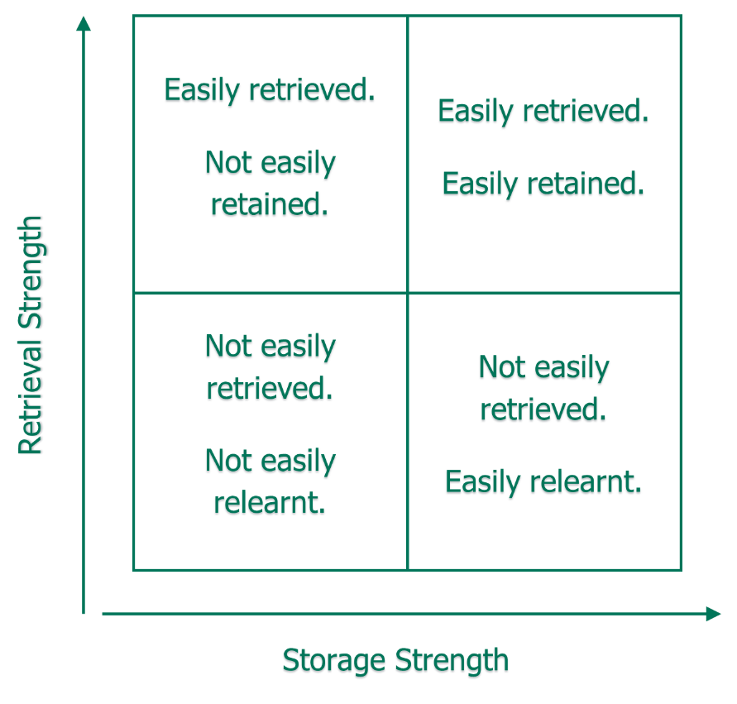

Adapted from Bjork and Bjork (1992)
Retrieval strength and storage strength are related with respect to learning. When we study information, both retrieval strength and storage strength increase. After studying that information, the higher the storage strength, the slower the loss of retrieval strength, in other words, slower forgetting. When restudying information, how much storage strength increases is inversely related to the current retrieval strength: the lower the retrieval strength at that moment, the greater the boost in storage strength, in other words, learning.
When learning feels easy, this is often because retrieval strength is high. But retrieval strength may be high because:
- this information is already very well learned, and therefore, there isn’t much more to be gained with respect to storage strength. Why focus study on something that you already know very well?
- cues in your present environment have brought that information to mind (for example: if you just studied it) - in this case, even relatively new information will not gain much storage strength
In other words, when retrieval strength is high, regardless of the underlying storage strength, relatively little learning is happening. When retrieval strength is low, however, there is the greatest potential for making learning gains.

In the classroom you may teach a lesson on a concept or topic and assess it at the end of the lesson with a large success rate. A couple of weeks later, the same assessment is likely to lead to a much lower success rate. The memory that the pupils have of the learning had an initially high retrieval strength, but it was not thoroughly embedded in the long-term memory and therefore had a low storage strength.
The importance of forgetting
The Ebbinghaus Forgetting Curve (Ebbinghaus, 1885; Murre and Dros, 2015) illustrates the importance of understanding the science and limitations of human memory. The Ebbinghaus curve shows that retention of newly learned knowledge decreases hugely with time.
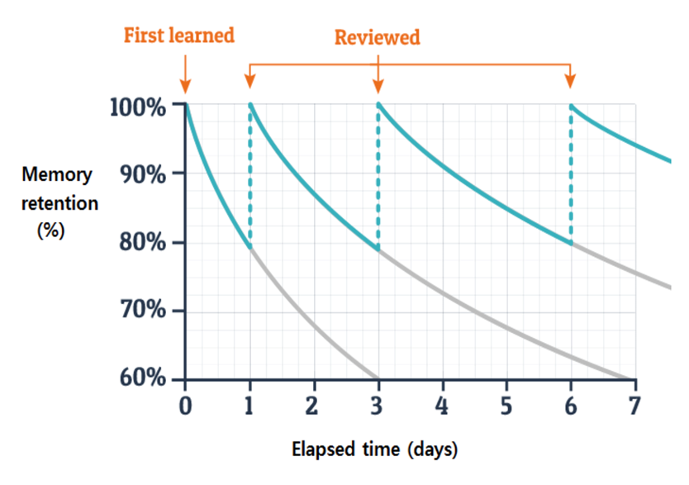
Adapted from Ebbinghaus (1885) and Murre and Dros (2015)
Retrieval practice combats this forgetting, but it needs to be spaced out over an extended period if pupils are to embed new knowledge and skills in long-term memory (Bjork and Bjork, 1992).
How practice is spaced is key. Teachers should leave a lag between studying and testing, and schedule retests at regular intervals (Dunlosky et al, 2013; Deans for Impact, 2015). Bjork and Landauer (1978) have shown that progressively increasing the time between retrieval activities leads to improved recall. This is because pupils learn best when they struggle to access the knowledge and as recall improves, so the time between the activities needs to increase.
Spaced practice
You may already have used spaced practice within your teaching. It is an antidote to highly sequential modes of teaching, in which material is covered and then not revisited until a high-stakes assessment weeks or months later (EEF, 2021a).
Spaced practice recognises that learning is unlikely to be embedded in long-term memory by one-off inputs. Pupils need to retrieve information from memory multiple times over an extended period to embed durable, flexible knowledge. Spaced practice can also take place within a single lesson, but it should not be limited to this.
Spacing practice over days, weeks or months
Spaced practice takes advantage of the fact that pupils need to cover a lot of different information across a sequence of learning, giving pupils time to begin to forget knowledge before inviting them to retrieve it and strengthen the memory (EEF, 2021a).
Spaced practice does not need to be complicated; the challenge for teachers is planning it in and remembering to do it. Teachers can feel that the pressure to cover a lot of material within a limited time restricts the scope for spaced practice (EEF, 2021a). This is a false economy. Spaced practice can consolidate and embed previous learning; without it the likelihood of forgetting is high.
Spacing practice within lessons
What differentiates spaced practice within lessons from massed practice is that teachers deliberately focus pupils’ attention elsewhere for short intervals (for example: ten minutes) before asking them to retrieve the knowledge taught earlier in the same session (EEF, 2021a).
Spacing within lessons is less common than spacing practice across a longer time scale and requires slightly more intricate planning.
The enduring appeal of massed practice
Massed practice can appear very effective and feel highly satisfying, with pupils appearing to achieve high levels of fluency and embedded knowledge, even though it tends not to be effective for long-term retention. Massed practice can be seductive, pupils and teachers alike can be fooled by its seeming effectiveness (Bjork & Bjork, 2011).

Now check your understanding!
Which of the following best describes the relationship between retrieval strength and storage strength in memory, as explained by the research?
a) Retrieval strength refers to how easily knowledge can be recalled, and storage strength refers to how deeply embedded or connected the knowledge is in long-term memory. For long-term retention, both retrieval and storage strengths need to be high.
b) Retrieval strength refers to how well knowledge is recalled from memory in the short term, while storage strength refers to how well knowledge is recalled over the long term. Teachers should focus on frequent retrieval practices to maintain both.
c) Retrieval strength is the ease with which knowledge can be recalled in the moment, while storage strength relates to how often knowledge is practiced over time. High storage strength is more important for recall than high retrieval strength.
The correct answer is A: Retrieval strength refers to how easily knowledge can be recalled, and storage strength refers to how deeply embedded or connected the knowledge is in long-term memory. For long-term retention, both retrieval and storage strengths need to be high.
Explanation: Retrieval strength refers to how easily knowledge can be recalled from long-term memory in a given situation, whereas storage strength refers to how embedded and connected that knowledge is in memory. For knowledge to be recalled quickly, both retrieval strength and storage strength need to be high. For example, knowing your address is an example of high retrieval and storage strength because it is both easily recalled and deeply embedded in memory.
Answer B is not correct. The distinction between retrieval and storage strength is not entirely accurate. Retrieval strength focuses on how easily knowledge is recalled from memory, which can be short-term or long-term, depending on the embeddedness of the information (storage strength). It is not solely about short-term recall. Both retrieval and storage strength benefit from regular, spaced practice over time.
Answer C is not correct. This incorrectly implies that storage strength is more important than retrieval strength for memory recall, and it wrongly states that storage strength relates to the frequency of practice. While frequent practice helps improve storage strength, the ability to retrieve knowledge easily is just as crucial for both short-term and long-term recall.
Time to reflect
Take a moment now. Consider the content of this section and reflect on the following:
- Think of a recent lesson where you have used retrieval practice to review learning. How much consideration had you given to the space between the teaching and the revisiting of the content? Is this an area for further consideration?
- How well do pupils respond to the use of spaced practice? Can you see an impact of this in their retention of information?
Note your responses and share them with your mentor at your next meeting. You may also wish to use them when completing your personal professional reflection.

Click here to return to Content page
Section 5: Practice to strengthen retrieval
Approximate time to complete: 9 minutes
What the evidence says
As you will be aware from your ITT pupils need practice to be guided by the teacher so they can master the various components of the new material. Then, as they grow in competence and confidence, they need opportunities to practise independently so they can embed understanding and develop automaticity. This is sometimes referred to as ‘overlearning’, defined by Coe et al., (2020) as continuing to practice after performance has reached a specified standard.
The importance of guided practice
The most effective teachers introduce a small amount of information at a time, then immediately guide pupil practice of that material.
Depending on the nature of the material, this might involve the teacher asking questions that require pupils to rephrase, elaborate or summarise new knowledge. Or it might involve the teacher modelling the steps of a new skill and providing close supervision and feedback as pupils practise these steps themselves. During this process, effective teachers provide additional explanations, lots of examples and continually check for understanding (Rosenshine, 2012).
Although most teachers provide pupils with some guided practice, the most successful teachers do more guided practice, ask more questions, and spend more time checking for understanding and correcting errors. If guided practice is too short, pupils are less likely to be ready for independent practice and more likely to make errors at that stage (Rosenshine, 2012).
Teachers should support pupils to practise new knowledge and skills in relation to existing knowledge. Guided practice should help to deepen understanding and make connections, not treat new concepts as isolated units of information.
Planning for regular review and practice
Moving from guided practice to independent practice
The move from guided practice to independent practice involves a gradual transfer of responsibility from teacher to pupil.
The process of moving from guided to independent practice looks like this (Gersten et al., 2009):
- initially teacher and pupils should solve problems together, with the teacher available and playing an active role;
- teachers should gradually withdraw their support as pupil expertise increases;
- teachers should ask pupils to speak aloud the strategies they are using to complete each step of the process;
- pupils should proceed to independent practice when they can solve problems with little or no teacher support;
- teachers should ask pupils to explain their solutions; and
- teachers should give specific feedback and provide opportunities for pupils to correct errors.
Effective practice does not involve pupils doing the same thing over and over again; it involves them proceeding through a series of carefully planned steps, moving from guided teacher support to independence.
Practice testing
Dunlosky et al., (2013), in their review of effective learning techniques, cite practice testing and spaced practice as high utility methods of improving pupil learning. Deans for Impact (2016) suggest that the use of regular low or no-stakes quizzes for pupils on previously taught content will aid retrieval of key information.
Practice testing is an approach that builds on the wide body of evidence that testing, in low or no stakes conditions, improves learning and is more effective than other restudy techniques. The more tests pupils take, the better their retention and recall will be (Dunlosky et al., 2013).
To maximise the benefits of retrieval practice, teachers should explain why they are doing it - that the very act of trying to remember something strengthens a memory. If pupils know why they are doing retrieval practice, not to be judged, but to better embed their learning, they are more likely to engage in it without anxiety (EBE, 2023). Teachers could also show pupils how they can use self-testing independently to embed their learning (Deans for Impact, 2015). It is a powerful transferable skill that they can apply both to academic learning and to learning in other spheres of life.
Varying the conditions of practice
You may recall that providing pupils with both familiar and varied conditions for practice tasks helps pupils to transfer their knowledge to solve new and novel problems (Sweller et al., 1998). Varying the conditions of practice can include changing the question format or requiring pupils to apply their knowledge to new and unfamiliar problems.
Varying the conditions of practice can include changing the question format or requiring pupils to apply their knowledge to new situations. Practice could therefore be planned to deliberately decontextualise the knowledge; this increases the level of challenge for pupils, thereby increasing the retrieval strength of the knowledge.
Desirable Difficulty
As discussed, every item of information in long-term memory has a retrieval strength and a storage strength (Bjork & Bjork, 1992). Bjork and Bjork, (2011) suggest that varying the conditions of practice can create what they refer to as ‘desirable difficulties’, that improve both the retrieval and storage strength of new knowledge and skills, so they can be easily accessed in future and flexibly applied to different contexts.
Here it is important to focus on the word ‘desirable’. Many difficulties are undesirable, often occurring where pupils do not have sufficient prior knowledge and understanding to successfully respond to tasks; desirable difficulties on the other hand, trigger encoding and retrieval processes that support understanding, comprehension and remembering (Bjork & Bjork, 1992).
Retrieval practice and spaced practice are not comfortable forms of learning. It is much more comfortable to be reminded of previously learnt material than to retrieve it from memory, but far less valuable (EEF, 2021a).
Some pupils might be reluctant to engage in purposeful practice for this reason. Teachers should address this feeling of discomfort head-on. If pupils understand that discomfort can be a sign that they are learning, they are more likely to engage in it without losing motivation.
Pupils need to learn how their memory works and how memory can be strengthened. Our memory is not like an audio or video recorder. Seeing and hearing material lots of times is not an effective way to build strong memories, and yet pupils frequently revise by copying or rereading notes (Bjork & Bjork, 2011).
Teachers should teach pupils how to use retrieval practice independently and support them to understand the limitations of more comfortable, appealing techniques like re-reading ensuring that pupils spend a significant portion of their time retrieving and generating information and experiencing ‘desirable difficulties’ (Bjork & Bjork, 2011).

Now check your understanding!
Which of the following best reflects a key criterion of ‘desirable difficulties’ as described by Bjork & Bjork (2011) when varying the conditions of practice tasks?
a) Pupils encounter different situations, improving their ability to retrieve knowledge in diverse contexts.
b) The difficulties introduced support deeper encoding and flexible application of knowledge, enhancing both retrieval and storage strength.
c) Task variety helps maintain pupil engagement and motivation, leading to improved retention over time.
The correct answer is B: The difficulties introduced support deeper encoding and flexible application of knowledge, enhancing both retrieval and storage strength.
Explanation: This answer aligns directly with Bjork & Bjork’s (2011) concept of “desirable difficulties.” These are challenges introduced during learning that may slow performance in the short term but improve long-term retention and transfer. Varying practice conditions is a classic example of a desirable difficulty. By requiring learners to adapt to different contexts or formats, it encourages flexibility and deeper learning, even if it feels harder during practice.
Answer A is not correct. While it's partly true that encountering different situations can help with retrieval in varied contexts, this answer focuses more on context generalisation than on the deeper mechanisms of learning. It misses the core idea of cognitive effort and the trade-off between short-term difficulty and long-term gain that defines desirable difficulties.
Answer C is not correct. This option shifts the focus to motivation and engagement, which are important in learning, but they’re not central to the theory of desirable difficulties. Bjork & Bjork emphasise that difficulties are only “desirable” if they enhance learning, not just if they make learning more enjoyable or varied.

Time to reflect
Take a moment now and consider the content of this section and reflect on the following:
- To what extent do you vary the conditions of practice within your classroom? What impact does it have on pupil learning?
- How do you currently ensure that your pupils experience ‘desirable difficulty’?

Note your responses and share them with your mentor at your next meeting. You may also wish to use them when completing your personal professional reflection.
Click here to return to Content page
Summary
Approximate time to complete: 2 minutes
Memory is fundamental to learning, as knowledge must be retained over time. Teachers must understand working memory and long-term memory to structure effective lessons. Managing working memory is crucial, as it can only hold a few pieces of information at once. Overloading it with too much content, complex instructions, or distractions can hinder learning. Supporting pupils with poor working memory is essential, as difficulties can manifest as inattentiveness or low academic performance.
To effectively introduce new information, teachers should break complex material into smaller steps, teaching each step sequentially. This helps manage cognitive load, ensuring pupils can process information without becoming overwhelmed. At both a topic and individual explanation level, this approach allows teachers to assess understanding and reteach if necessary.
Prior knowledge plays a crucial role in learning, as new ideas build on existing schemas. Strong prior knowledge enables pupils to grasp complex concepts more easily, while weaker prior knowledge can lead to cognitive overload and misconceptions.
Cognitive Load Theory explains how memory works to optimise learning and can be categorised into intrinsic (complexity of material), extraneous (poor instruction), and germane (supporting schema construction). Teachers can minimise extraneous load by decluttering materials and simplifying instructions, while optimising intrinsic load through chunking and sequencing. Germane load is enhanced by scaffolding and dual coding, combining visuals with explanations. Worked examples, where pupils observe step-by-step solutions, reduce cognitive load and aid problem-solving.
Reviewing previous learning strengthens knowledge and builds fluency, helping pupils recall information effortlessly and freeing up working memory for new learning (Rosenshine, 2012). Retrieval practice, actively recalling information, enhances memory retention more effectively than rereading and can take various forms, such as multiple-choice questions, problem-solving, and diagram labelling. Feedback further strengthens recall and application. Retrieval strength (ease of recall) and storage strength (long-term retention) determine how well knowledge is retained.
Practice testing and spaced practice improve retention (Dunlosky et al., 2013), with low-stakes quizzes enhancing recall. Varying practice conditions, such as changing question formats or applying knowledge in new contexts, strengthens memory and promotes flexible thinking (Bjork & Bjork, 2011), as well as promoting ‘desirable difficulty’ - challenging but achievable tasks which support learning by triggering deeper cognitive processing.
Click here to return to Content page
Next steps
Approximate time to complete: 2 minutes
Congratulations! You have now completed the module relating to Memory and learning. Please look carefully at your next steps.
Personal professional reflection
Schools should plan some form of reflection activity for early career teachers to complete, possibly in collaboration with their mentors. They should have the opportunity to reflect on the content of the core self-study and identify any possible areas for development. This should take around 30 minutes for ECTs to complete. It could include mentor discussion, reviewing notes, referring to their career entry development profile (CEDP) or other ITT targets. They should use the outcomes to select two further elective self-studies to read for this module.
Elective self-study
Following your personal professional reflection, you should choose 3 elective self-studies from a choice of 5 each relating to different aspects of ‘Memory and learning’. These will provide further examples to ensure you deliver a coherent, well-sequenced curriculum that enables all pupils to build and develop secure and deep subject knowledge. Each elective self-study contains suggested action steps to help develop your practice and you will work on these steps with your mentor.
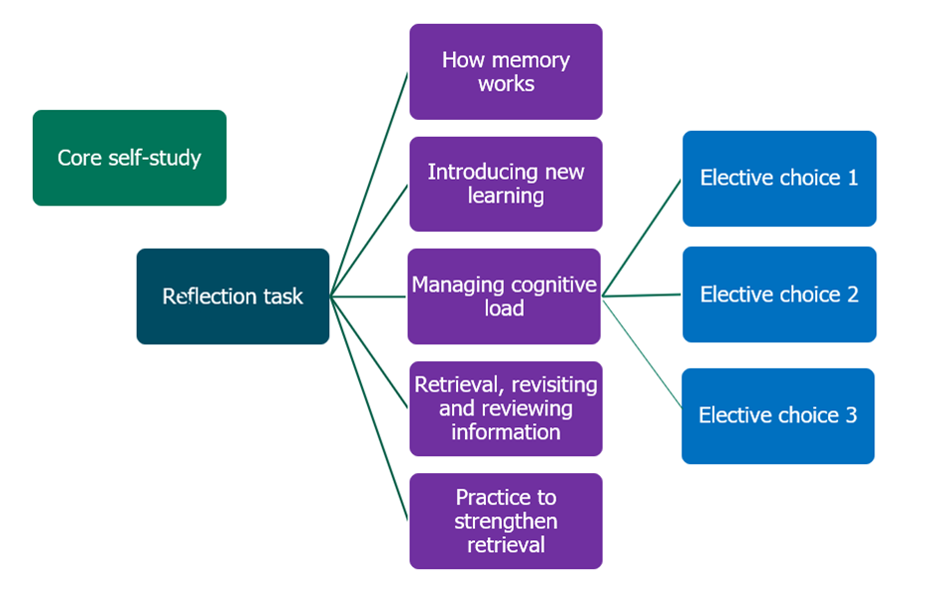
Click here to return to Content page
Related Initial Teacher Training and Early Career Framework statements
How pupils learn
Learn that…
2.1. Learning involves a lasting change in pupils’ capabilities or understanding.
2.2. Prior knowledge plays an important role in how pupils learn; committing some key facts to their long-term memory is likely to help pupils learn more complex ideas.
2.3. An important factor in learning is memory, which can be thought of as comprising two elements: working memory and long-term memory.
2.4. Working memory is where information that is being actively processed is held, but its capacity is limited and can be overloaded.
2.5. Long-term memory can be considered as a store of knowledge that changes as pupils learn by integrating new ideas with existing knowledge.
2.6. Pupils have different working memory capacities; some pupils with SEND may have more limited working memory capacity than their peers without SEND.
2.7. Where prior knowledge is weak, pupils are more likely to develop misconceptions, particularly if new ideas are introduced too quickly.
2.8. Regular purposeful practice of what has previously been taught can help consolidate material and help pupils remember what they have learned.
2.9. Requiring pupils to retrieve information from memory, and spacing practice so that pupils revisit ideas after a gap are also likely to strengthen recall.
2.10. Worked examples that take pupils through each step of a new process are also likely to support pupils to learn.
Classroom practice
4.2. Effective teachers introduce new material in steps, explicitly linking new ideas to what has been previously studied and learned.
4.8. Practice is an integral part of effective teaching; ensuring pupils have repeated opportunities to practise, with appropriate guidance and support, increases success.
Learn how to…
Avoid overloading working memory, by:
2.a. Taking into account pupils’ prior knowledge when planning how much new information to introduce.
2.b. Breaking complex material into smaller steps (for example: using partially completed examples to focus pupils on the specific steps).
2.c. Reducing distractions that take attention away from what is being taught (for example: keeping the complexity of a task to a minimum, so that attention is focused on the content).
Build on pupils’ prior knowledge, by:
2.d. Identifying possible misconceptions and planning how to prevent these forming.
2.e. Linking what pupils already know to what is being taught (for example: explaining how new content builds on what is already known).
2.f. Sequencing lessons so that pupils secure foundational knowledge before encountering more complex content.
2.g. Encouraging pupils to share emerging understanding and points of confusion so that misconceptions can be addressed.
Increase likelihood of material being retained, by:
2.h. Balancing exposition, repetition, practice and retrieval of critical knowledge and skills.
2.i. Planning regular review and practice of key ideas and concepts over time (for example: through carefully planned use of structured talk activities).
2.j. Designing practice, generation and retrieval tasks that provide just enough support so that pupils experience a high success rate when attempting challenging work.
2.k. Increasing challenge with practice and retrieval as knowledge becomes more secure (for example: by removing scaffolding, lengthening spacing or introducing interacting elements).

Click here to return to Content page
References

- Adesope, O. O., Trevisan, D. A., & Sundararajan, N. (2017). Rethinking the Use of Tests: A Meta-Analysis of Practice Testing. Review of Educational Research, 87(3), 659–701.
- Agarwal, P. K., Finley, J. R., Rose, N. S., & Roediger, H. L. (2017). Benefits from retrieval practice are greater for students with lower working memory capacity. Memory, 25(6), 764–771.
- Atkinson, R. C., & Shiffrin, R. M. (1968). Human memory: A proposed system and its control processes. The Psychology of Learning and Motivation: Advances in Research and Theory, 2, 89–195.
- Barrett, L. F., & Tugade, M. M. (2004). Individual differences in emotional reactivity. Emotion, 4(3), 268–286.
- Bjork, R. A., & Bjork, E. L. (1992). A new theory of disuse and an old theory of stimulus fluctuation. In A. F. Healy, S. M. Kosslyn, & R. M. Shiffrin (Eds.), From learning processes to cognitive processes: Essays in honour of William K. Estes (Vol. 2, pp. 35–67). Hillsdale, NJ: Erlbaum.
- Bjork, E. L., & Bjork, R. A. (2011). Making things hard on yourself, but in a good way: Creating desirable difficulties to enhance learning. In M. A. Gernsbacher, R. W. Pew, L. M. Hough, & J. R. Pomerantz (Eds.), Psychology and the real world: Essays illustrating fundamental contributions to society (pp. 56–64). Worth Publishers.
- Caviglioli, O. (2019). Dual Coding with Teachers. Crown House Publishing.
- Centre for Education Statistics and Evaluation (2017). Cognitive Load Theory: Research that teachers need to understand. New South Wales Government. [Online] Available at: https://education.nsw.gov.au/about-us/educational-data/cese/publications/literature-reviews/cognitive-load-theory [Accessed 7 July 2023].
- Chi, M.T.H. (2009). Three types of conceptual change: Belief revision, mental model transformation, and categorical shift. In S. Vosniadou (Ed.), Handbook of research on conceptual change (pp. 61-82). Hillsdale, NJ: Erlbaum.
- Coe, R., Rauch, C. J., Kime, S., & Singleton, D. (2020). Great Teaching Toolkit: Evidence Review. Evidence Based Education. Available https://www.cambridgeinternational.org/Images/584543-great-teaching-toolkit-evidence-review.pdf. [Accessed 2 December 2024].
- Cowan, N. (2008). What are the differences between long-term, short-term, and working memory? Progress in brain research, 169, 323-338.
- Deans for Impact (2015). The Science of Learning. [Online] Available at: https://deansforimpact.org/resources/the-science-of-learning/ [Accessed 7 July 2023].
- Dunlosky, J., Rawson, K. A., Marsh, E. J., Nathan, M. J., & Willingham, D. T. (2013). Improving students’ learning with effective learning techniques: Promising directions from cognitive and educational psychology. Psychological Science in the Public Interest, Supplement, 14(1), 4–58.
- Education Endowment Foundation (2021a). Cognitive Science Approaches in the Classroom: A Review of the Evidence. [Online] Available at: https://educationendowmentfoundation.org.uk/education-evidence/evidence-reviews/cognitive-science-approaches-in-the-classroom [Accessed 7 July 2023].
- Education Endowment Foundation (2021b). Metacognition and self-regulated learning: Guidance Report. [Online] Available at: Metacognition and Self-regulated Learning | EEF (educationendowmentfoundation.org.uk) [Accessed 7 July 2023].
- Education Endowment Foundation, (2021b)., Teacher Feedback to Improve Pupil Learning guidance report. Available at: Teacher Feedback to Improve Pupil Learning | EEF
- Education Endowment Foundation, (2021c)., Special Educational Needs in Mainstream Schools guidance report. Available at: Special Educational Needs in Mainstream Schools | EEF
- Education Endowment Foundation (EEF). (2019). Improving Mathematics in Key Stages 2 and 3. Education Endowment Foundation. Retrieved from https://educationendowmentfoundation.org.uk
- Gathercole, S., (2008). Working memory in the classroom. The Psychologist, vol 21 no 5. Available at: https://www.bps.org.uk/psychologist/working-memory-classroom (Accessed 30 March 2023).
- Gersten, R., Beckmann, S., Clarke, B., Foegen, A., Marsh, L., Star, J. R., & Witzel, B. (2009). Assisting students struggling with mathematics: Response to intervention (RtI) for elementary and middle schools (NCEE 2009-4060). Washington, DC: National Center for Education Evaluation and Regional Assistance, Institute of Education Sciences, U.S. Department of Education.
- Kalyuga, S. (2007). Expertise reversal effect and its implications for learner-tailored instruction. Educational Psychology Review, 19(4), 509-539.
- Kirschner, P., Sweller, J., & Clark, R. E. (2006). Why Minimal Guidance During Instruction Does Not Work: An Analysis of the Failure of Constructivist, Discovery, Problem-Based, Experiential, and Inquiry-Based Teaching. Educational Psychologist, 41(2), 75–86. [Online] Available at: https://www.tandfonline.com/doi/abs/10.1207/s15326985ep4102_1 [Accessed 7 July 2023].
- Landauer, T. K., & Bjork, R. A. (1978). Optimum rehearsal patterns and name learning. Practical Aspects of Memory, 625–632.
- Lemov, D. (2015). Teach Like a Champion 2.0: 62 Techniques that Put Students on the Path to College. Jossey-Bass.
- Murre, M. J., Dros, J. (2015). Replication and Analysis of Ebbinghaus’ Forgetting Curve. https://journals.plos.org/plosone/article?id=10.1371/journal.pone.0120644
- Pan, S. C., & Rickard, T. C. (2018). Transfer of test-enhanced learning: Meta-analytic review and synthesis. Psychological Bulletin, 144(7), 710–756.
- Pashler, H., Mcdaniel, M., Rohrer, D., & Bjork, R. (2008). Learning Styles: Concepts and Evidence. Psychological Science in the Public Interest, 9(3).
- Pashler, H., Bain, P., Bottge, B., Graesser, A., Koedinger, K., McDaniel, M., and Metcalfe, J. (2007) Organizing Instruction and Study to Improve Student Learning (NCER 2007-2004). Washington, DC: National Center for Education Research, Institute of Education Sciences, U.S. Department of Education. [Online] Available at: https://files.eric.ed.gov/fulltext/ED498555.pdf [Accessed 7 July 2023].
- Perry (2021): Perry, N. (2021). Metacognition and Learning: A Guide for Students and Educators. Routledge.
- Peterson, L., & Peterson, M. J. (1959). Short-term retention of individual verbal items. Journal of Experimental Psychology, 58(3), 193–198. https://doi.org/10.1037/h0049234
- Roediger, H.L. and Butler, A.C. (2011) The Critical Role of Retrieval Practice in Long-Term Retention. Trends in Cognitive Sciences, 15, 20-27.
https://doi.org/10.1016/j.tics.2010.09.003
- Rosenshine, B. (2012). Principles of Instruction: Research-based strategies that all teachers should know. American Educator, 36, 12–20. https://www.aft.org/sites/default/files/periodicals/Rosenshine.pdf [Accessed: 24 Jan 2023].
- Simonsmeier, B.A., Maja Flaig, Anne Deiglmayr, Lennart Schalk & Michael Schneider (2018). Domain-specific prior knowledge and learning: A meta-analysis, Educational Psychologist, DOI: 10.1080/00461520.2021.1939700.
- Soderstrom, N. C., & Bjork, R. A. (2015). Learning Versus Performance: An Integrative Review. Perspectives on Psychological Science, 10(2), 176–199.
- Sweller, J., van Merrienboer, J.J.G. & Paas, F.G.W.C. (1998). Cognitive Architecture and Instructional Design. Educational Psychology Review 10, 251–296.
- Sweller, J. (2016). Cognitive load theory, evolutionary educational psychology, and instructional design. In D. C. Geary & D. B. Berch (Eds.), Evolutionary perspectives on child development and education (pp. 291–306). Springer International Publishing/Springer Nature.
- Tulving, E. (1972). Episodic and semantic memory. In E. Tulving & W. Donaldson (Eds.), Organization of Memory (pp. 381–403). New York: Academic Press.
- Willingham, D. T. (2009). Why don't pupils like school? A cognitive scientist answers questions about how the mind works and what it means for the classroom. Jossey-Bass/Wiley. [Online] Extract available at: https://www.aft.org/sites/default/files/WILLINGHAM%282%29.pdf [Accessed 3 December 2024].
- Wittwer, J., & Renkl, A. (2010). How Effective are Instructional Explanations in Example-Based Learning? A Meta-Analytic Review. Educational Psychology Review, 22(4), 393–409.

Click here to return to Content page

