
ECT Programme Y1 Core self-study
Subject and curriculum
Estimated time to complete: 60 minutes
A further 30 minutes should be allocated for ECTs to complete a reflection or other diagnostic task to identify areas for development in this area. See Programme Guidance for further details.

These self-study materials are intended for use by those who design and deliver a school-led Early Career Teacher (ECT) programme. Opportunities for schools or trusts to add detail relevant to their context have been identified.






Introduction
Approximate time to complete: 3 minutes
In this module you’ll build on the knowledge and understanding you developed during your initial teacher training (ITT) relating to ‘Subject and curriculum’. You’ll be prompted to reflect on your current practice and to draw on what you already know and have experienced during your ITT as you progress through your personalised pathway and consider its application to your own context.
Once you have completed reading this self-study, you should take some time to reflect on the contents and your current practice. [Schools may wish to add details of reflection activities that ECTs could undertake as part of this process.].
You’ll use the outcomes from your personal reflection along with your targets from your ITT and discussion with your mentor, to select 3 elective self-studies relating to different aspects of ‘Subject and curriculum’.
Here’s a reminder of how each of the self-studies fit into year one of the ECT programme:
Personal professional reflection along with discussions with your mentor to identify an area of practice to focus on and 3 elective self-studies to engage with*.
*2 in module 1
Elective Self-Study

Elective Self-Study
Core Self-Study

Elective Self-Study

Closing the theory to practice gap

Each elective self-study contains suggested action steps to guide your developing practice and you will work on these steps each week with your mentor.
What you will focus on in this core self-study
This core self-study aims to build on what you learned during your initial teaching training on the importance of a carefully sequenced curriculum underpinned by knowledge of how pupils learn. To support you in this, this study will explore what the evidence and research tells us in relation to the following:
- Delivering a carefully sequenced curriculum
- Anticipating misconceptions
- Building increasingly complex mental models
- Developing early literacy
- Enhancing all pupil’s literacy
This self-study contains reflection points, and you may wish to have a pen and notebook to hand to record your thoughts.
There is no expectation for you to complete all of the content in one go – it has been designed so that you can work through one section at a time, if you choose. This will help you to manage your study at a time to suit you.

Content
Delivering a carefully sequenced curriculum | Page 5
Anticipating misconceptions | Page 13
Building increasingly complex mental models | Page 17
Developing early literacy | Page 24
Enhancing all pupil’s literacy | Page 33
Summary | Page 43
Next steps | Page 44
Related Early Career Framework statements | Page 46
Further reading and references | Page 49

Schools may need to update the page numbers in this Content table as they may have altered when content is added.

- Delivering a carefully sequenced curriculum
Approximate time to complete: 10 minutes
What the evidence says
As you will know from your initial teacher training, a coherent, well-designed curriculum is critical to pupils successfully learning and remembering knowledge, skills and concepts of each subject, at every key stage. If a curriculum lacks coherence, pupils will struggle to develop, connect and retain new knowledge over time. Effective curriculum design will consider the core knowledge, key vocabulary to be explicitly taught and logical sequencing of knowledge and skills over time enabling pupils to form strong mental models
Subject curricula
Within subject disciplines, a coherent curriculum ensures that content is arranged in an order that considers age-related progression. In addition, it will ensure the individual components such as content, assessment, pedagogy, teacher training and resources are prepared and aligned in order for staff to deliver the intended curriculum (Oates, 2011).
As well as respecting the distinctiveness of each subject discipline, a curriculum should enable pupils to see and appreciate the connections and overlaps across subjects.
Defining ‘secure subject knowledge’
You may have heard colleagues, mentors or tutors during your initial teaching training saying that teachers need to have ‘secure subject knowledge’.
Of course, teachers need to know their subjects well as ‘teachers cannot help children learn things they themselves do not understand’ (Ball, 1991, p.5). They need deep knowledge of the content being taught (Coe et al., 2014), including the key ideas within the subject and the ‘most efficient ways’ of thinking (Coe et al., 2014, p.21) within the discipline.
Pedagogical content knowledge
But ‘secure subject knowledge’ refers to more than the content of the curriculum. We’re not just talking about knowing more higher-level French grammar or more complex mathematical processes. Secure subject knowledge also incorporates what we call pedagogical content knowledge. You could think of this as a special type of professional knowledge that ensures that teachers know how to teach content not just what to teach. It’s what makes great teachers really great (Shulman, 1987).
Good pedagogical knowledge means understanding the principles of the subject and why some topics are more central to a discipline than others (Ball et al., 2008). For example, being a good sportsperson does not automatically make you a good PE teacher (Ball et al, 2008).
Ball et al (2008) use a diagram to try to explain this. They split subject knowledge into two areas: ‘subject matter knowledge’ and ‘pedagogical content knowledge’ and then into further subcategories.
Activity
Take a moment to explore the way in which Ball et al. represent the different forms of understanding that are at play in effective teaching. The definitions for each area are just below.
Consider your own subject as you review the definitions for each area.
- What did this interplay look like during your initial teacher training?
- What does it look like in your current practice?
- What areas might you need to develop?
Make a note of your thoughts and share them with your mentor at your next meeting.
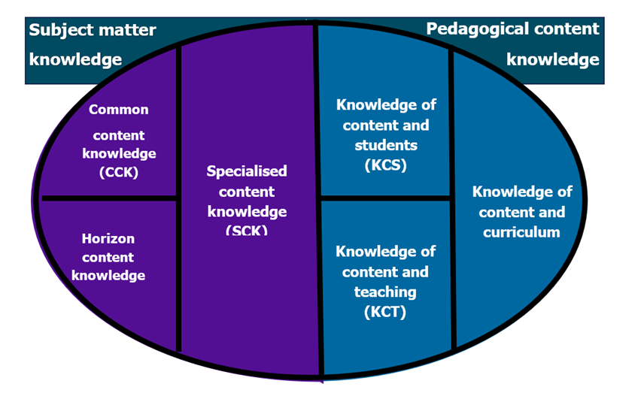

Domains of Knowledge for Teaching (Ball et al, 2008)
- Common Content Knowledge (CCK): This is your basic subject knowledge. It's about being able to understand the content and recognise when an answer is incorrect. For example, you need to be able to solve a subtraction problem like 307-168.
- Specialised Content Knowledge (SCK): This is the special knowledge you need for teaching a subject. It's about understanding why pupils make mistakes and being able to spot different ways of solving problems. For example, if a pupil answers 261, instead of 139, for 307-168, you need to understand why they got that answer.
- Knowledge of Content and Students (KCS): This means knowing how pupils think about your subject and predicting what they will find tricky or interesting and motivating. For instance, knowing that they often think plants are not living because they don’t move in the same way as humans.
- Knowledge of Content and Teaching (KCT): This is about how you teach the subject. It's about choosing the right examples and knowing what teaching methods are most effective for your pupils. For example, how to show the direction that light travels by using a torch and a piece of string.
- Horizon content knowledge (HCT): This is knowing what your pupils will learn over time, not just what you're teaching right now. It’s concerned with the ‘big picture’ for your subject. For example, how the rise of Nazism connects to prior historical events and how it laid the groundwork for later developments.
Explicit teaching of skills is important
Once you’ve got the subject knowledge in place it’s time to consider how to ensure you share this in a way that ensures your pupils learn it!
You have almost certainly taught a lesson in which you explicitly taught specific skills to pupils, for example how to use column addition or different techniques for cutting in DT. Explicit instruction is a cornerstone of effective teaching, particularly when developing pupils’ skills across various subjects. Many skills that might be assumed to develop naturally in pupils actually require deliberate and direct teaching. This is especially true for pupils with lower prior attainment, who may benefit even more from explicit instruction (EEF, 2022).
Teachers need to know that key skills for learning, such as metacognition and self-regulation, need to be taught within the context of a specific subject, rather than regarding them as generic abilities (EEF, 2021c). This involves the teacher clearly modelling their own thinking processes to help pupils develop both metacognitive and cognitive skills, often using worked examples to make their thought processes explicit (EEF, 2022).
So what do we mean by explicit instruction?
Explicit instruction includes:
- teaching skills and concepts in small steps
- using examples and non-examples
- using clear and unambiguous language
- anticipating and planning for common misconceptions and
- highlighting essential content and removing distracting information (EEF, 2021c)
You may be familiar with some of these and even already be using them in your teaching. Let’s consider this further now and explore what this means for subject disciplines.

Subject specific explicit instruction
A good curriculum focuses on the knowledge and skills pupils need to succeed within a particular subject discipline. This requires explicitly introducing pupils to the skills and metacognitive strategies that experts within each subject discipline use (Kirschner et al., 2006).
Whilst specific skills being taught might vary according to the subject, effective explicit instruction normally starts with a teacher explanation followed by opportunities for guided pupil practice before progressing to independent practice (EEF, 2021c). You may have used this approach already under the ‘I do, we do, you do’ approach.
Whilst explicit instruction benefits all pupils, it is especially beneficial for pupils with SEN (EEF, 2021c). However, teachers should consider the individual needs of their pupils and how these strategies need to be tailored in order to be responsive to need (EEF, 2021c p.27).
What do we mean by ‘foundational knowledge’?
Just as a house needs strong foundations to stay standing, subject disciplines have foundational knowledge that act in the same way. This diagram illustrates the range of components that make up foundational knowledge:

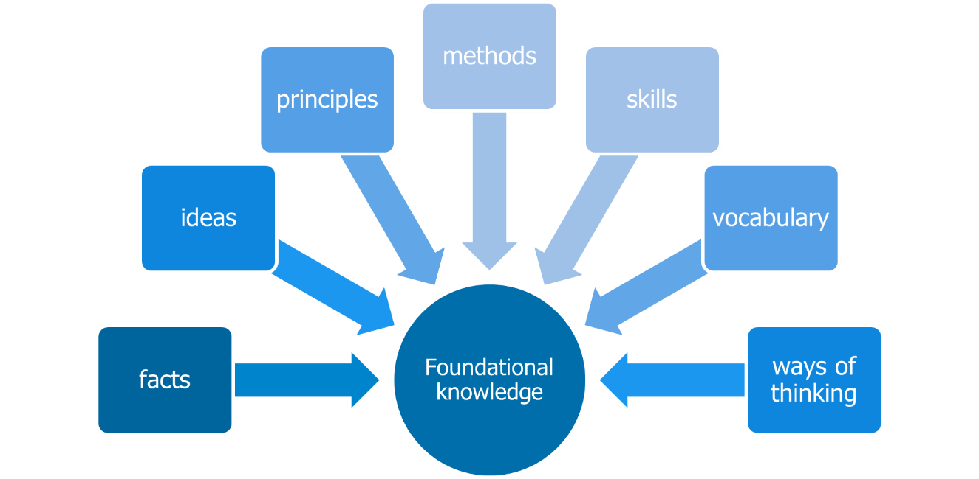

Support pupils to master foundational concepts and skills
[Schools may wish to add a talking head style video clip lasting 2-3 minutes here to illustrate the importance of mastering foundational concepts. This might be a school leader or a subject leader].
It’s crucial to identify the starting point when planning a curriculum is to identify the foundational skills, knowledge or concepts in a subject discipline. You may already have had an opportunity to do this with colleagues or your mentor. The next step is to consider how to ensure that pupils have the opportunity to return to the same core knowledge over time but with added complexity as they progress through a subject. You’ll learn a bit more about how to sequence this progression later in this self-study.
Mastering foundational knowledge before you move on
A well-designed curriculum will consider its sequence in depth, taking into consideration the cognitive principles that underpin how pupils learn. We know that that pupils learn new ideas in relation to ideas they already know (Deans for Impact, 2015). This enables them to develop increasingly complex mental models and allowing knowledge to cumulatively build over time, supporting the development of schema. You may recall from your ITT that a schema is a pattern of thought that organises categories of information, and the links between them (EEF, 2021). You’ll read more on this in section 3.
Harlen and James (1997) suggest that when planning and sequencing pupils' learning, we should ensure it:
- progressively develops in terms of ‘big ideas’ within a subject or discipline
- is constructed on the basis of prior knowledge and previous teaching
- provides opportunities to apply knowledge in contexts other than those in which it was originally taught
- is owned by the pupil and becomes a fundamental part of the way they understand the world - not simply knowledge that may be memorised for recall in examinations and subsequently forgotten
Whilst this research is almost 30 years old, the underpinning principles are still relevant and can be used to inform curriculum planning.
Working with colleagues
One of the most valuable resources you have to hand are your colleagues, including your mentor, your induction lead and your subject or phase lead. They are there to support you and they will be able to share curriculum planning and materials with you. They will be able to share the rationale for the curriculum design to help you better understand how each of the building blocks fit together.
Resources
[Schools may wish to adapt this section to align with their own school systems for resources but without changing the intent of this section: that ECTs should work with colleagues to see what resources are available.]
Whether you are new to your current school or trust, or not, it’s important to also establish what resources are already available to help your pupils master each foundational skill effectively.
There is a growing number of on-line resources available at the touch of a button. It can be tempting to use technology, such as generative artificial intelligence (gen AI) or websites, to create new and engaging materials. However, you should take time to work with colleagues to establish what already exists. This can help both manage your workload and ensure your resources are consistent with the wider school curriculum.
A reminder that if you are are using gen AI, it is essential to check the accuracy of the resources that are created. Consider whether they are appropriate for the needs of all your pupils. Ensure the content is correct and doesn’t contain any misconceptions or errors. For further information regarding safe and ethical use of gen AI in education, see https://www.gov.uk/government/collections/using-ai-in-education-settings-support-materials

Now check your understanding!
You’re planning lessons for the term. Considering the content from this section, which of the following approaches would be MOST beneficial in supporting pupil’s learning?
a) To plan each lesson to ensure that the content is engaging and accessible to all pupils in the class, adapting resources to suit the needs of individual learners, but allow the sequence of learning to be determined by the interests of the class.
b) To carefully plan a sequence of lessons that builds on prior learning, revisiting foundational concepts over time with increasing complexity, while making explicit links between what is taught in each lesson, but remain flexible in the pace of teaching to allow for the needs of all learners.
c) To plan a series of engaging lessons, focusing on the content from the school's scheme of work for the relevant term, ensuring that each lesson is well-resourced and delivered to a high standard, but remain flexible to allow for the pupils to lead the learning.
The correct answer is B. To carefully plan a sequence of lessons that builds on prior learning, revisiting key concepts over time with increasing complexity, while making explicit links between what is taught in each lesson, but remain flexible in the pace of teaching to allow for the needs of all learners.
Explanation: This approach highlights the importance of a carefully planned sequence of lessons that build on prior learning, revisiting foundational concepts with increasing complexity over time. By making explicit links between lessons, the teacher is enabling pupils to develop increasingly complex mental models and schema. The response also correctly acknowledges the need for flexibility in
Answer A is not right. While making lessons engaging and accessible is important, this approach lacks a structured sequence of learning. Allowing pupils’ interests to determine the order of content delivery may lead to gaps in foundational knowledge, making it harder for pupils to build on prior learning in a logical way. A well-planned curriculum ensures that knowledge is introduced and revisited systematically to support deeper understanding over time.
Answer C is not correct. Following the school's scheme of work ensures lessons are aligned with the curriculum, but if pupils lead the learning without careful sequencing, key concepts may not be revisited in a structured way. This could prevent pupils from developing a strong, connected understanding of the subject. While engagement is important, a mastery approach requires deliberate planning to revisit and build upon foundational knowledge progressively.

Time to reflect
Take a few minutes now to consider the content of this section and reflect on the following:
- How has your understanding of how to effectively sequence the key concepts and skills in your subject developed since your initial teaching training?
- Thinking about your current practice, what opportunities are there for pupils to apply their knowledge in different contexts and to make connections between what they are learning and their own experiences?

Note your responses and share them with your mentor at your next meeting.

Click here to return to Content page
2. Anticipating misconceptions
Approximate time to complete: 8 minutes
What the evidence says
You may remember from your ITT that misconceptions are not the same thing as an error or a mistake. Misconceptions are beliefs which conflict with what is to be learned, rather than errors or knowledge gaps (Chi, 2009). For pupils, the most important common misconceptions to anticipate are the ones which relate to foundational concepts. This is because misconceptions can be difficult to shift but doing so can lead to big gains in learning, particularly for threshold concepts (EEF, 2021).
How prior learning can lead to misconceptions
All of us have ‘preconceptions’ which come from our own lived experiences and prior learning (EEF, 2022, p. 10) and it is the role of the teacher to know which one’s pupils are more likely to have (EEF, 2022, p. 10). We will look at this in greater detail later.
You’ll be familiar with how important prior learning is to ensure pupils master key concepts and skills but prior learning can also cause pupils to have misconceptions EEF, 2022, p10). You may even have experienced this in your own classroom.
We mentioned the importance of schema earlier and that pupils learn new ideas in relation to ideas they already know (Deans for Impact, 2015). However, some research suggests that prior learning isn’t always an indication that pupils will learn new things well (Simonsmeier et al., 2022). In fact, it can even hinder new learning where the knowledge conflicts with deeply rooted preconceptions (Simonsmeier et al., 2022). This apparent conflict of ideas however can be better understood when we understand that misconceptions come in varied forms. Let’s take a look at that now.
There are different types of misconception
Where misconceptions exist, they can either arise out of a misunderstanding of lesson content or be based on pre-existing ideas (EEF, 2022). This is an important distinction, because how we deal with them can involve different approaches.
The National Research Council (NRC, 1997) presents five types of misconceptions that can interfere with learning:

Type of misconception ​ | Explanation ​ | Example ​
Preconceived notions ​ | Based on incomplete observations or previous experiences. ​ | Groundwater exists as underground rivers. ​
Conceptual misunderstandings ​ | Based on misapplying a general principle or example. ​ | Tornadoes are attracted to mobile home parks ​
Vernacular misconceptions ​ | Misunderstanding about the meaning of words. ​ | Glaciers ‘retreating’ ​  ‘Translation’ in maths ​
Factual misconceptions ​ | Based on misinformation. ​ | Lightning never strikes the same place twice. ​
Non-scientific beliefs ​ | Based on religious or cultural belief and teachings. ​ | Creation myths which attempt to explain how the world formed and where humanity came from. ​

Subject knowledge and anticipating misconceptions
Your subject knowledge is crucial here. Think back to the diagram of different subject knowledge types earlier in this self-study (Ball et al., 2008) and more specifically what he identified as ‘specialised content knowledge’. This is where your subject knowledge is so deep that you are able to anticipate where misconceptions are likely to occur and understand the cause. Crucially, it will allow you to address them in your teaching and ensure that pupils develop the correct foundational knowledge. Reviews of different research that underpins the most effective teaching concludes that ‘as well as a strong understanding of the material being taught, teachers must also understand the ways students think about the content, be able to evaluate the thinking behind students’ own methods and identify students’ common misconceptions.’ (Coe et al., 2014, page 2).
Developing this specialised content knowledge can take time and talking to colleagues can help you to consider the origin and types of different misconceptions and how to address them within your subject discipline.

Why is it important to anticipate misconceptions?
Understanding pupils’ preconceived notions and alternative conceptions allows teachers to tailor their instructional strategies accordingly. By addressing misconceptions directly, teachers can help pupils to develop a more accurate understanding of key concepts by planning their instruction to address them early in the sequence of teaching.
Some of the strategies you can use to address misconceptions include:
- explicitly addressing misconceptions through your explanation; this could include the use of analogies, demonstrations, illustrations and worked examples;
- providing evidence that might conflict with their thinking; and
- provide activities to support them to restructure their thinking; for example, the use of manipulatives in maths, reviewing historical sources or conducting fair tests in science.
Changing deeply embedded misconceptions may not happen immediately, and this may require revisiting concepts to move pupils’ thinking on and correct it, however this is crucial in terms of moving learning on (EEF, 2022). Formative assessment can be used to check that pupils’ thinking is changing. This is explored in Modules C and E in more detail.
Challenging misconceptions develops critical thinking
Encouraging pupils to recognise and challenge misconceptions can also foster pupils to think more deeply (EEF, 2022). In an increasingly technology-driven society, critical thinking is a vitally important skill (Heard et al. 2020). In fact, it can be considered as fundamental to our engagement with society and our economic achievements (Willingham, 2019). By engaging in discussions and activities that address misconceptions, pupils can begin to learn to evaluate evidence, revise their thinking, and develop a deeper understanding of specific key concepts. We’ll come back to critical thinking a little later.

Now check your understanding!
Which of the following best defines a misconception in learning?
- a temporary error or mistake that a pupil makes when recalling information;
- a belief that conflicts with the correct concept and can be difficult to change; or
- a lack of knowledge about a topic that can be addressed by providing new information.
The correct answers is B. A belief that conflicts with the correct concept and can be difficult to change.
Explanation: B is correct because misconceptions involve pre-existing beliefs that contradict accurate learning. These can be difficult to shift but are important to address, especially when they relate to foundational concepts.
A is incorrect. Errors or mistakes are not the same as misconceptions. Errors are often due to slips in recall or understanding, whereas misconceptions are deeply held beliefs that conflict with correct knowledge.
C is incorrect as while knowledge gaps exist when a pupil lacks information, a misconception involves having an incorrect understanding, not just an absence of knowledge.

Time to reflect
Take a few minutes now to consider the content of this section and reflect on the following:
- How has your understanding of how to anticipate misconceptions developed since your initial teaching training?
- What misconceptions have you encountered during your teaching?
- Can you identify why they occurred?
- Would you feel more able to anticipate this now?

Note your responses and share them with your mentor at your next meeting.

Click here to return to Content page
3. Building increasingly complex mental models
Approximate time to complete: 10 minutes
What the evidence says
You will know from your initial teaching training that whilst we process information in our working memory, our long-term memory is where knowledge is stored. However, that does not mean that we remember everything that we process in our working memory. Over time, the chances of forgetting a memory increase. Whilst you may already understand that regular retrieval tasks can support retention and recall of information (Roediger et al., 2011), a key to its success is understanding how information is actually stored in the long-term memory. These are often known as mental models or schema. We talked about these earlier but let’s explore schema in a bit more detail now.
What are mental models?
When the mind is presented with new information, it searches the long-term memory for any prior knowledge that will support the understanding and processing of the concept. If the mind finds some useful knowledge to support the working memory, then the newly acquired knowledge is added to an ever-growing web of information around this topic. These interconnected webs or ‘mental models’, are sometimes referred to as ‘schema’ (or the plural, ‘schemata’).
[Schools may wish to add a talking head style video clip lasting 2-3 minutes here to illustrate what a mental model is and what it means for teachers.]
Look at this diagram that represents a mental model. The dots represent pieces of information, and the lines represent links between them. The diagram shows a well-developed, organised mental model of a topic. When a new piece of information is added, it will be processed and understood in relation to the existing information and links.

Diagram 1
Where the mental model is less developed (diagram 2), the knowledge may exist in isolation. Where this is the case, the information is less embedded into memory, meaning that it is weaker and more likely to be forgotten. It is also much more likely to be misunderstood, and in turn, it is likely that misconceptions will develop around the information.


Diagram 2
Well-developed mental models can boost motivation
As you might imagine, the information organised into diagram 1 will be more securely stored in the long-term memory, and pupils will be able to recall it more quickly when needed. This will aid pupils’ ability to process new information but also support them to secure subject knowledge and this, in turn can increase levels of engagement and motivation experienced by the pupil (Sumaracki & Weinstein, 2018).
When a pupil understands what is being taught to them quickly, feels confident in giving answers, and experiences success, this will likely lead to an increase in confidence, motivation and enjoyment in the learning. It is therefore important to think carefully about the key knowledge and foundational concepts that you want pupils to master before moving on, ensuring that pupils have secure prior knowledge to which they can link their learning.
Strategies to develop complex mental models
So, we know why it’s important for pupils to develop increasingly complex mental models but how do we do this? In this section we’ll explore strategies for how you can support the recall and retrieval of knowledge and build well-developed mental models in pupils to support deeper understanding of concepts and topics.
Strategy 1: Building on prior knowledge
As you already know, it is important to link new learning to pupils’ prior knowledge as a strategy to avoid overloading the working memory and to ensure foundational knowledge is secure. Building on prior knowledge also leads to a more developed mental model. Any gaps in knowledge need to be identified and content explicitly taught. This can ensure that strong foundations for learning are in place and mental models can develop in an organised way.
Strategy 2: Spaced practice
As you learned earlier, lessons should be sequenced carefully so that the foundational knowledge around a concept is secure, before encountering more complex content. Where this does not happen, the teacher may be building on unstable foundations, leading to further misconceptions later.
An expert can quickly absorb and make sense of new information, hanging it on existing knowledge. However, for novice learners to process information into their long-term memory it takes considerable teaching, practice and revisiting. One way to do this is to create opportunities for spaced practice when you are sequencing a curriculum. Spaced practice, sometimes known as spaced learning or distributed practice, is a learning strategy where practice is broken up into a number of short sessions over a longer period of time as opposed to learning in one block. Through multiple exposures to content and practice opportunities, pupils develop storage and retrieval strength of key knowledge and develop the capacity to apply their learning in varying contexts (Bjork, 1994).
You can explore examples of both strategies in elective self-study 3.
Developing pupils’ critical thinking
Having secure knowledge about a subject is a precursor to thinking critically about that subject. In fact, it’s not effective to focus on critical thinking skills unless pupils understand the material they are being asked to think about (Facione, 1990; Willingham, 2002).
However, there is some debate as to whether critical thinking skills are particular to a subject discipline or whether it is like a ‘toolkit’ with a set of broad skills that can be applied across multiple domains (Heard et al., 2020). Daniel Willingham outlines that by teaching critical thinking through subject area, the intention is that pupils can apply those skills more widely (Willingham, 2019). Furthermore, he highlights the value of explicitly teaching critical thinking skills from an early age to better equip pupils to navigate a world in which artificial intelligence (AI) and other technologies are increasingly prevalent (Willingham, 2019, p.3).
Willingham suggests that teachers should select the priority skills to teach pupils, highlighting that the 13 years that pupils are in education is not sufficient to cover them all (Willingham, 2019, p. 12). This is likely to vary between different contexts and phases and even within subjects and should be tailored to meet individual needs.
Willingham shares a four-step plan to teach critical thinking. These can be considered as questions that a teacher could ask themselves:
- What are the critical thinking skills specific to my particular subject discipline?
- What subject matter knowledge is essential to the type of thinking I want my pupils to do?
- How should I sequence the learning to ensure pupils can develop their thinking skills by building on what they already know?
- How and when will the curriculum provide opportunities for pupils to revisit these skills?
(Adapted from Willingham, 2019)
You will see examples of how this can be put into practice in elective self-study 3.
The difficulty of transferring knowledge
When thinking about supporting pupils to build increasingly complex mental models, it is important to understand that pupils are likely to struggle to transfer what has been learnt in one discipline to a new or unfamiliar context (Willingham, 2019).
Willingham suggests that one cause could be pupils’ inability to see a new problem and recognise how it links to ones they have previously solved (Willingham, 2019). In other words, pupils look only at the surface-level problem in front of them, rather than the deeper structure they may have experienced before. For example, a teacher expects pupils to apply their mathematical knowledge in a geographical context by applying scale factors to maps. However, several pupils struggle with this because they haven’t applied this skill in geography before, although they have done this on several occasions in maths lessons. In the same way, pupils who are able to answer complex division calculations may struggle to apply this when faced with a multi-step word problem.
Some strategies that could be used to support pupils to transfer knowledge include:
- checking that pupils have the necessary foundational knowledge, for example through formative assessment tasks;
- drawing explicit links to pupils’ prior knowledge to support pupils to bring the right ideas from their long-term memory into their working memory;
- provide models and examples of how the knowledge being used in one context (that they are familiar with) and another context (which is new) and get pupils to compare examples; and
- use worked examples and partially completed examples to support pupils to apply their prior knowledge in this new context.
It is important to consider the varying needs of pupils when deciding which of the strategies would be most effective.

Now check your understanding!
Which of the following approaches is most effective in helping pupils transfer knowledge and develop critical thinking skills across different subjects?
a) Encouraging pupils to work out connections between different subjects independently, as this strengthens their ability to think critically.
b) Providing varied practice opportunities across subjects without explicitly linking them, so pupils develop flexible thinking through exposure to different contexts.
c) Explicitly teaching connections between previously learned knowledge and new contexts, using models and worked examples to scaffold understanding.
The correct answer is C. Explicitly teaching connections between previously learned knowledge and new contexts, using models and worked examples to scaffold understanding.
Explanation: C is correct because making explicit links between subjects, using scaffolding like worked examples, supports pupils in recognising underlying patterns and applying critical thinking more effectively (Willingham, 2019).
A is not quite correct. Although independent thinking is important, research (Willingham, 2019) suggests that pupils often fail to make connections between subjects on their own. Without explicit guidance, they may focus on surface-level differences rather than deeper structural similarities.
B is also incorrect because whilst varied practice is beneficial (Bjork & Bjork, 2011), but without explicit connections, pupils may not recognise how to transfer knowledge effectively. Simply encountering different contexts does not guarantee they will apply prior learning in new situations.

Time to reflect

Take a few minutes now. Consider the content of this section and reflect on the following:
- What strategies do you currently use to assess and activate pupils’ prior knowledge before introducing new concepts?
- Consider your lesson sequences – how do they promote the development of well organised mental models for your pupils?
- How do you ensure your pupils are developing critical thinking skills in the subject disciplines you teach?

Note your responses and share them with your mentor at your next meeting.

Click here to return to Content page
4. Developing early literacy
Approximate time to complete: 10 minutes
What the evidence says
As you will know pupils need strong literacy skills to access all areas of the curriculum. The development of these skills begins in pupils' Early Years, but as you’ll recall from your initial teacher training all teachers, regardless of phase, have a responsibility to ensure they support the development of literacy skills.
Developing language in the Early Years
All teachers should prioritise high-quality interactions to support the language development of their pupils. In the Early Years this can be done through strategies which engage pupils in discussion about the activities they are completing, or experiences they are having so as to engage them in a back-and-forth interaction. There is a distinction here between talking with pupils and talking at them (EEF, 2021b). Talking at pupils tends to be more passive, while talking with pupils is more interactive; interaction that is important for language development, because it gives pupils the opportunity to practice their speaking skills.
There are a variety of different frameworks that can be used as a guide to support you when interacting with your pupils during everyday activities, such as Sustained Shared Thinking (EEF, 2021b). This framework enables teachers to expose pupils to Tier 1 language (everyday words) and Tier 2 language (high frequency words) as well as working with pupils to solve problems, clarify issues or extend narratives (Siraj-Blatchford et al., 2002).
Teaching Vocabulary
As you will recall from your initial teacher training, vocabulary instruction forms a significant part of language development for all pupils, and it is important that this is done both implicitly and explicitly (EEF, 2021).
Implicit teaching
To implicitly teach vocabulary, teachers might model using a word when speaking, point it out during shared reading and use it when modelling or completing shared writing activities. Implicit teaching ensures pupils encounter regular repetition of the word, making it more likely that the word will transition into the pupils’ vocabulary.
One simple way of implicitly teaching vocabulary is by repetition and correction where a pupil has used a word incorrectly, or where there is a more appropriate word that could be used (see below example).

Teacher: So, what is it about the drums that makes the song exciting?
Pupil: The snare drum has an interesting beat, so does the hi-hat.
Teacher: Great response! The snare drum and the hi-hat have an interesting rhythm.

Explicit teaching
Explicit vocabulary instruction involves a teacher presenting a word along with explanations and examples of what it means and then asking pupils to experiment with using the word. As with implicit teaching of vocabulary, explicit teaching ensures that pupils are repeatedly exposed to important words, increasing their chances of incorporating them into their vocabulary.
You may be familiar with the Frayer model (as seen below) from your initial teacher training: a graphic organiser that facilitates deep understanding and concept analysis. ​It allows you to present new words in a specific format which pupils will quickly learn to recognise and use; the model can be used across phases and subjects. The use of non-examples allows you to anticipate pupil misconceptions and address them from the start.

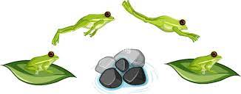
High frequency vocabulary should be carefully selected for explicit teaching from the Early Years, drawing upon the tiered system for targeting words for explicit instruction.

Developing reading comprehension
Reading – and really understanding what you are reading – is a pivotal skill. Teachers across all phases need to understand the way in which reading is taught and how the skills are built over time, moving from decoding to fluency to comprehension.
‘Word reading’ and ‘language comprehension’ are the two foundational elements of reading. Pupils respond best to a balanced approach that addresses both (EEF, 2021b; Savage et al., 2015).
You may have come across the ‘Reading House’ (below) in your initial teacher training. It shows the components that come together to enable full reading comprehension:

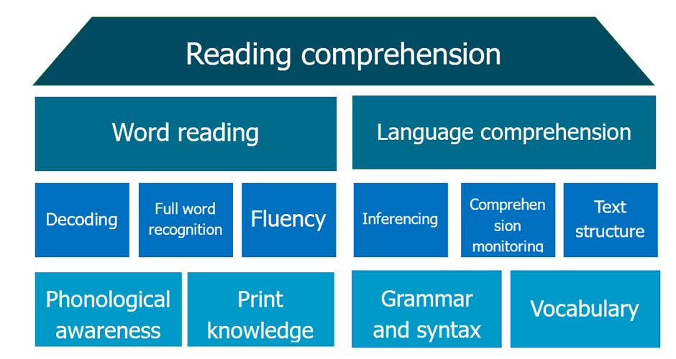
The ‘Reading House’ (EEF, 2021d)
Word reading
Word reading initially involves phonological awareness of the sounds and structures of language that allow pupils to decode and translate written words into the sounds of spoken language. The left side of the Reading House (as seen above) highlights this, showing the importance of phonological awareness and print knowledge as the first building blocks of developing early word reading. Phonological awareness involves understanding language sound structures, while print knowledge relates to knowing how language is represented in writing. These skills enable decoding written words into spoken language sounds, crucial for reading development. Skilled readers recognise words automatically through repeated exposure, enhancing fluency. As you can see early literacy instruction is vital for fostering these skills to develop comprehension and reading proficiency. As pupils become more familiar with words, they should progress to more fluent reading and sight recognition (Scarborough, 2001; EEF, 2021e).
Systematic synthetic phonics
The most effective way to teach pupils to read words is systematic synthetic phonics (Machin, 2018; EEF, 2021a), which uses an organised and comprehensive sequence to explicitly teach children the letter-sound relationships that underpin the English language. This approach focuses on sounding out letters and then blending sounds together to form words (Machin et al., 2018). Structured phonics teaching, which usually takes place daily, will begin when a pupil enters the reception stage, with some activities to develop children’s phonological awareness and interest in sounds having taken place before this. At the end of year 1 pupils will undertake the phonics screening check, designed to see how they are progressing and to identify any pupils who may need additional support.
Language comprehension
The right side of the Reading House depicts the development of robust language comprehension skills. This involves building knowledge of grammar and syntax, expanding vocabulary, making inferences from texts, and self-monitoring comprehension. Understanding text structures and genres is also crucial (Scarborough, 2001; EEF, 2021d). These elements collectively enhance language comprehension by enabling pupils to extract implicit information, recognise text nuances and navigate various types of written material effectively.
Reading fluency
Developing both phonological skills and a rich vocabulary are crucial to pupils’ reading fluency. Fluency is a bridge between effortful decoding and comprehension. A fluent reader can accurately and automatically decode words with minimal use of their cognitive resources. These resources can then be redirected towards comprehending and making sense of what has been read (EEF, 2022).
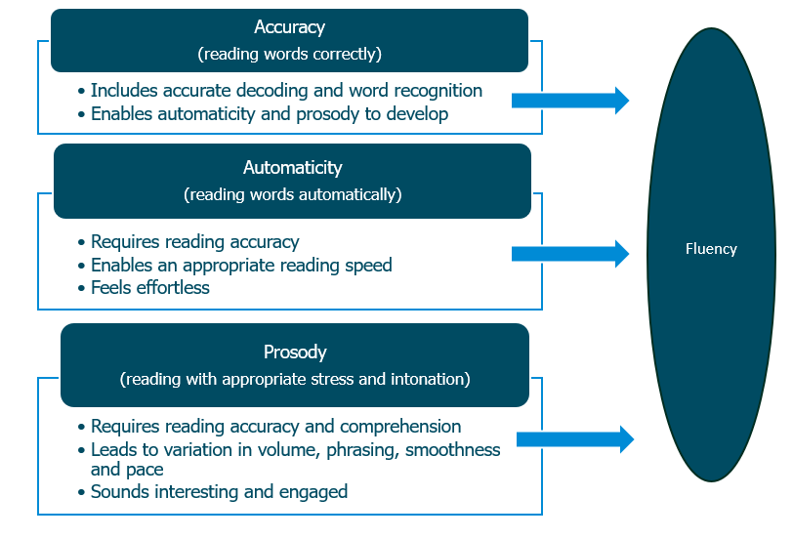
Reading fluency (Adapted from EEF, 2021d)
The diagram above highlights how the three strands of accuracy, automaticity and prosody all feed into reading fluency. Reading with accuracy, automaticity and prosody enables readers to further access the meaning of a text. For some pupils reading fluency can still be a challenge when they enter secondary education, and they may need additional support in this area to ensure they can fully access the curriculum.
Developing writing
It is important that teachers across all phases support pupils to understand the value of the written word. This will be explicitly taught in the Early Years but will need consolidation as pupils move through their education. Pupils should understand:
- Print has meaning
- Print can have different purposes
- Text is read from left to right
- Text is read from top to bottom
- Page sequencing
- The different parts of a book
As you may be familiar with from your initial teacher training, when supporting young children to develop their writing, it is important to recognise that writing is a challenging activity, as it combines the expression of meaning (text generation) with the physical skills of handwriting (transcription) and spelling (EEF, 2021a). As language provides the foundation for effective writing, developing young children's capability to formulate and articulate increasingly sophisticated sentences verbally, in the first instance, provides the springboard for them to express ideas later in writing.
Spelling
Accurate spelling of an extensive vocabulary is a key component of writing fluency and should be explicitly taught (EEF, 2021e). Many of the skills that support word reading will also support spelling, but spelling demands great specificity and has different motor demands (EEF, 2021e). The teaching of spelling is likely to work best when it is related to the content being studied as this will encourage active use of any new spellings in pupils’ writing.
Phonics can provide a foundation for effective spelling, furthermore phonics can be applied alongside other strategies such as focusing on morphemes (EEF, 2021e). Morphemes are the smallest parts of a word that still has a meaning. For example, the word tree is a morpheme, but if you shorten it to ‘tr’ or ‘ee’, it loses all meaning.
Very young pupils will of course not have the spelling skills to correctly spell words. Teachers can encourage pupils to write by allowing them to use invented spelling while they learn spelling skills. When using invented spelling, pupils can attempt to spell a word using existing knowledge about letter and sound patterns (Graham et al., 2012).
Handwriting
It is important to develop the foundations of a fast, accurate and efficient handwriting style which focuses on both product and process (EEF, 2021). For example, a child may be able to accurately form the letter ‘m’ using four separate strokes but begin on the right-hand side; this may lead to a satisfactory product, but the inefficient process will hinder the development of a fluent handwriting style (EEF, 2021).
Extensive practice is needed to develop effective handwriting, so developing children’s motivation to communicate through writing is important (EEF, 2021e). Practice should be (EEF, 2021e):
- Extensive: a large amount of regular practice is required for pupils to achieve fluency.
- Motivating and engaging: achieving the necessary quantity of practice requires pupils to be motivated and fully engaged in improving their writing.
- Supported by effective feedback with teachers providing feedback to help pupils focus their effort appropriately.

Feedback
As mentioned, practice needs to be supported by effective teacher feedback which should (EEF, 2021e):
- Be specific, accurate and clear
- Compare what a pupil is doing right now with what they have done wrong before
- Encourage and support further effort
- Be given sparingly so that it is meaningful
- Provide specific guidance on how to improve
Improving handwriting is something that is possible for all pupils and the development of handwriting skills will continue through secondary education.
Now check your understanding!
Which of the following statements best describes the relationship between word reading and language comprehension in early literacy development?
a) Word reading is the only foundation for reading, and once mastered, language comprehension will naturally follow.
b) Word reading and language comprehension are separate skills that develop independently and do not significantly impact each other.
c) Word reading and language comprehension are both foundational elements of reading, and a balanced approach to addressing both is most effective for pupils.
The correct answer is C. Word reading and language comprehension are both foundational elements of reading, and a balanced approach to addressing both is most effective for pupils.
Explanation: Option C is correct because ‘word reading’ and ‘language comprehension’ are the two foundational elements of reading. The evidence in section 4 emphasises that ‘pupils respond best to a balanced approach that addresses both’. It also notes that supporting pupils to decode words is important, but ‘so is supporting their comprehension and extending their vocabulary’, reinforcing the need for a balanced approach.
Option A is incorrect because it oversimplifies the relationship between word reading and language comprehension. While word reading (decoding words) is an important part of literacy, it is not the sole foundation for reading. Language comprehension (understanding the meaning of words, sentences, and texts) is equally essential. Mastery of word reading does not automatically guarantee comprehension, especially if the reader struggles to understand the meaning of what they read. Both skills must develop together.
Option B is also incorrect because it falsely claims that word reading and language comprehension develop independently. In reality, these skills are deeply interconnected. Word reading (decoding) supports comprehension by enabling the reader to recognize and understand words, while comprehension enhances the ability to make sense of the context and meaning of those words.

Time to reflect
Take a few minutes now to consider the content of this section and reflect on the following:
- Why is it important for teachers of all ages and phases to understand the teaching of early literacy?
- What opportunities have you provided for pupils to develop their oral language skills and vocabulary?
- Consider what opportunities exist within your teaching for pupils to practice reading, particularly fluency. Is this explicitly planned for?
- When planning for reading opportunities within your classroom, to what extent do you consider the cognitive resources needed by the pupils to access the text?
Note your responses and share them with your mentor at your next meeting.

Click here to return to Content page
- Enhancing all pupils’ literacy
Approximate time to complete: 12 minutes
What the evidence says
As you’ll recall from your initial teacher training it is important to take a deliberate approach to the teaching of the three broad areas of literacy – language, reading and writing. As pupils progress through their education enhancing their literacy skills becomes increasingly linked to subject specificity and therefore it is the responsibility of all teachers to prioritise this within their curriculum and classroom practice.
Developing language
The development of oral language skills through instruction combined with frequent exposure to rich oral language opportunities lays the foundation for reading and writing.
Developing high-quality talk
As you’ll already be familiar with, talk, in the form of guided interactions or questioning, is used by all teachers to ascertain pupil understanding. Prioritising high quality talk will not only develop the speaking skills of pupils but also their ability to listen effectively to others.
Often, interactions that take place in classrooms will be in the form of closed questions from the teacher and short responses from the pupils. As we read earlier pupils need to be provided with opportunities to articulate their thinking and to engage in dialogue either with peers or with their teacher. Improving the quality of talk, rather than getting pupils to just talk more, can be done in several ways. Lauren Resnick (2018) developed a model for thinking about discussion known as ‘accountable talk’. This framework highlights the importance of accountability to knowledge (being accurate and true); reasoning (providing justification) and community (listening and showing respect to others). Within this model, it also becomes important for teachers to consider the subject specific features of the discussion. ​

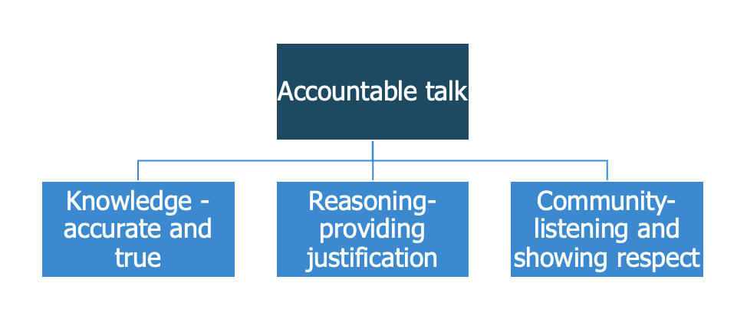
Model for Accountable Talk, adapted from Lauren Resnick (EEF, 2021)
There will, of course, be some pupils who are non-verbal and who will communicate in different ways. Pupils may use gesturing, symbols or pictures to share their ideas, feelings or information with each other. It is important to work with speech and language therapists and specialist practitioners to develop strategies to support the range of pupils within the classroom.
Developing vocabulary
As we saw earlier, teachers need to specifically select words to teach to their pupils to ensure they can access a text and use them in their writing.
The tiered system (Beck & McKeown, 1985) provides structure for selecting words for targeted instruction. In the Early Years Tier 1 will be the focus for both implicit and explicit teaching and as pupils progress through their educational phases and vocabulary becomes more specialised both Tier 2 and Tier 3 words will become more important for explicit teaching.
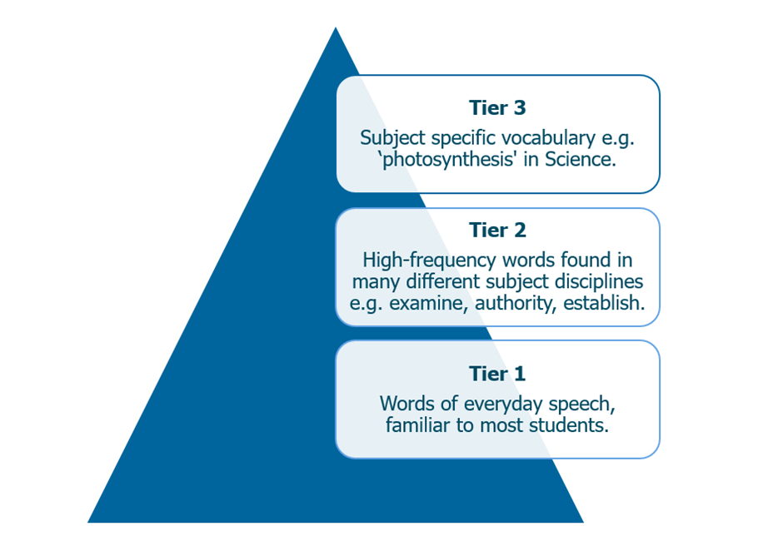
Tiered system for selecting target words for explicit instruction (EEF, 2021c – adapted from Beck & McKeown, 1985)
Teachers need to build varied and purposeful activities into lessons to support the teaching of key vocabulary. The EEF (2023) suggests the following strategies for teaching vocabulary:
- Bespoke definitions – introduce words through explanations in everyday connected language, rather than dictionary definitions.
- Purposeful variation – provide several contexts in which the word can be used purposefully or for alternative meanings.
- Immediate interaction – build opportunities for pupils to interact with word meanings right away e.g. pair two target words, to support interaction with words in novel contexts. For example, ‘can splendour ever be unpleasant to look at?’
- Deep processing – develop activities that require pupils to process the meanings of words in a deep and thoughtful way.
- Active interest – provide examples, situations and questions that are interesting and create discussion.
- Repetition, repetition, repetition – provide many encounters with target words, through various contexts and retrieval activities.
These approaches also link to the Frayer model, the graphic organiser highlighted in section 4.

Developing reading beyond EYFS
As you’ll recall from earlier in the unit The Reading House (EEF, 2021) highlights the individual components that come together to support the development of reading.
A good reader will derive an overall representation of the meaning of the text, known as a mental model (Oakhill et al., 2015). Different types of text require different responses. In the case of fiction, the reader will need to identify the main characters and their motives, since this will usually link to the plot. In the case of informational text, the reader will need to identify the topic focus of the text, follow any argument or structure and pick out the main ideas. Therefore, readers need background knowledge or domain-specific knowledge to comprehend a story or a text in order that they can construct the mental model of what the text means.
The importance of disciplinary literacy
As you’ll recall from your Initial Teacher Training pupils are likely to benefit from discipline-specific literacy support across the curriculum (Scott, 2018). There is evidence that "disciplinary literacy" approaches can improve pupils' outcomes in all subjects and are more promising than generic "whole school" approaches to literacy (EEF, 2021c). For example, teachers should provide explicit vocabulary instruction related to the key language within their subjects and develop pupils' abilities to read and write complex texts – e.g. essays, lab reports, investigations – specific to individual subjects (Beck et al., 2013).
Background knowledge
Background knowledge is essential for making inferences about a text. Words have multiple purposes and meanings, and their meanings in particular instances are cued by the domain knowledge of the reader. Effective readers will continually draw upon a complex wealth of prior knowledge (EEF, 2021d), thinking about what they already know about a topic from both other reading and wider experiences and use this to make meaningful links. This therefore helps them to infer and elaborate, fill in missing information and build a fuller ‘mental model’ (EEF, 2021d).
Word knowledge
As we read earlier comprehension of a written text also relies on being able to understand the words within it. Limitations in vocabulary knowledge are therefore often associated with poor reading comprehension and many interventions for poor reading comprehension involve strategies designed to increase vocabulary knowledge (Beck, 1982).
Deep vocabulary knowledge is important for building those mental models of the context of a text because when words are strung together, certain aspects of their meanings are emphasised more than others. For example, the word ‘blue’ usually refers to a colour but it is not the same blue in contexts such as ‘blue sky’ or ‘blue jeans’ (Oakhill et al., 2015).
Developing comprehension
To support comprehension of a text pupils need to be able to monitor their understanding, therefore, this requires an awareness of whether the text makes sense (Oakhill et al., 2015). This is important because it allows pupils to adjust their reading if they do not understand something. For example, they might adapt their rate of reading if they are finding the text difficult.
To develop reading there are a number of strategies that aim to support active engagement with texts and ultimately improve comprehension, they include:
- inviting pupils to ask questions about a text;
- asking pupils questions that activate prior knowledge relevant to the text;
- asking pupils to summarise aspects of the text;
- asking pupils clarifying questions about a text; and
- prompting pupils to make predictions about a text.
While the potential impact of these approaches is very high, they can be hard to achieve and explicit instruction and extensive practice are required to achieve the intended impact, (EEF 2021d, pg.23).
Examples of how they might manifest in a teachers practice can be seen below (EEF, 2021d)
[Schools may wish to add this table to a separate resource pack].
Reading comprehension strategies
Question | Teacher prompts:  - Ask me questions about any part of the text you are unsure about.  - What would you like to find out more about.  - I wonder why....
Activate prior knowledge | Teacher prompts:  - What do you know about where/when this story is set, or the characters in this book? What do you know already about this topic?  - Have you ever been here/seen this before?  - Have we read any other books about this? Have we studied other related topics?
Summarise | Teacher prompts:  - Put 3 sticky notes on your table, draw a picture for the beginning, middle and end of the book or to summarise the key points.  - Could you recall the information in the text or the story to someone else?  - What are the most important things to remember?
Clarify | Teacher prompts:  - It's important that you understand what we're reading. If you're not sure we can go back and read a section again.  - Can you tell me what happened and why it might have happened? Can you explain the key concept/s?  - Make a list of any words you're not sure about.
Predict | Teacher prompts:  - Look at the front cover and the title, what do you think might happen in this story?  - Look at any images, tables or subheadings, what might the content include?  - That's not what we expected, what do you think now?
Adapted from the Five reading comprehension tactics (EEF, 2021d)
The explicit teaching of reading comprehension strategies works by giving ​‘novice’ readers the tools to think like ​‘experts’ when reading – which is a necessity when pupils face complex academic texts.
Developing writing
As well as developing reading teachers across all phases and subject areas teachers should deliberately develop pupils’ abilities to write
The Simple View of Writing
You may already be familiar with The Simple View of Writing (EEF, 2021c) a framework that explains writing as the result of three key components:
- Transcription refers to the physical act of writing, including handwriting, typing, and spelling.
- Text generation involves forming and expressing ideas through vocabulary, sentence structure, and cohesion.
- Executive functions are the self-regulatory processes like planning, organising, revising, and managing attention or working memory.
The model suggests that writing is a complex process which puts a strain on working memory, as shown in the centre of the diagram below. Teachers need to ensure they consider the complexity of the process of writing and teach each of the components explicitly to support pupils in their writing development.

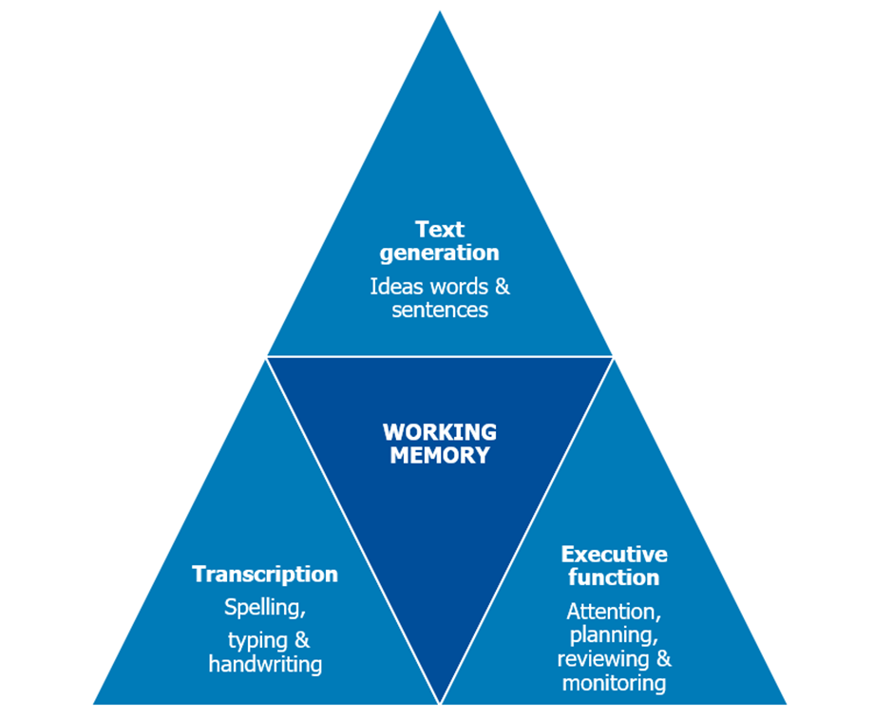
The Simple View of Writing (EEF, 2021c – adapted from Berninger et al, 2002)
Across all phases and subject disciplines each stage of the writing process can be explicitly taught to help support the overall development of writing (EEF, 2021c):
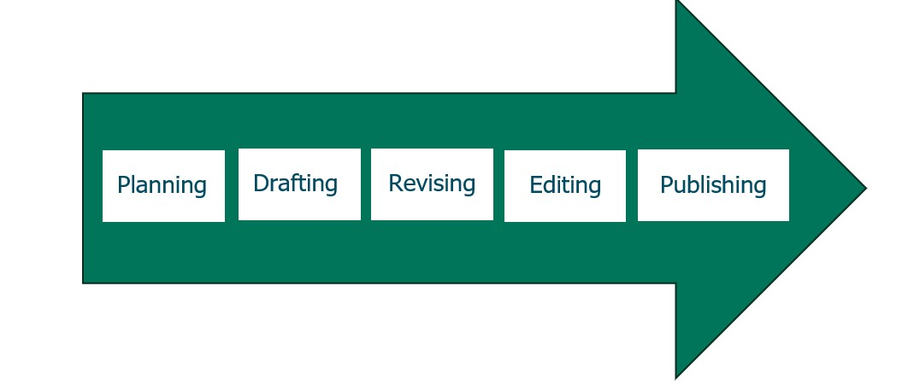
Adapted from The writing process (EEF, 2021c)
The table highlights each stage of the process as well as strategies that teachers could use to support their pupils.
[Schools may wish to add this table to a separate resource pack].
Stage of writing process | Explanation | Example strategy
Planning | Setting goals and generating ideas before the writing begins. Teachers may ask pupils to write down goals to refer to as they write. This stage may also involve gathering information or activating prior knowledge. | Using a graphic organiser, such as a Venn diagram, to generate ideas for a balanced argument.
Drafting | Noting down key ideas, setting out a logical order for points to be covered, and writing out a draft of each section. Although accurate spelling, grammar and handwriting are important they are not the main focus at this stage. | Using checklists to support writing and monitoring progress towards goals. Over time, pupils can be prompted to develop their own checklists before starting to write, instead of using checklists provided by their teacher.
Revising | Making changes to the content of writing considering feedback and self-evaluation. Pupils can be supported to re-read their writing to check whether it makes sense and their goals have been achieved. | Using prompt questions to support pupils when revising their work, for example, ‘Are there any places where it would be helpful to add more information?’
Editing | Making changes to ensure the text is accurate and coherent. At this stage, spelling and grammar assume greater importance and will need to be accurate for readers to engage with it. | Check capital letters and full stops, writing ‘Sp’ beside spelling pupils are unsure of and then checking with a dictionary.
Publishing | Presenting the work so that others can read it. | Displaying work, presenting to other classes and sending copies to parents.
Adapted from Developing the writing process (EEF, 2021c)
The strategies need to be modelled, and the process of shared writing gives the teacher the chance to think aloud and share their thought process for each strategy with the pupils (EEF, 2021).
Now check your understanding!
Which of the following approaches is MOST likely to improve pupils' literacy outcomes across all subjects?
a) Implementing generic, "whole school" literacy initiatives that focus on broad skills.
b) Providing discipline-specific literacy support, including explicit vocabulary instruction and text-based activities tailored to each subject.
c) Focusing primarily on improving pupils' transcription skills like spelling and handwriting across all subjects.
The correct answer is B. Providing discipline-specific literacy support, including explicit vocabulary instruction and text-based activities tailored to each subject.
Explanation: The evidence states that "disciplinary literacy" approaches are more promising than generic "whole school" approaches. This involves providing explicit vocabulary instruction related to key language within subjects and developing pupils’ abilities to read and write complex subject-specific texts.

Time to reflect

Take a few minutes now. Consider the content of this section and reflect on the following:
- To what extent are you using strategies such as activating prior knowledge, summarising, clarifying and predicting to support the development of pupils’ reading comprehension?
- What adaptations are you making to your teaching of writing to ensure you have an inclusive classroom?
- How do you support all three components of the Simple View of Writing?

Make a note of your responses which you may wish to discuss with your mentor.

Click here to return to Content page
Summary
Approximate time to complete: 2 minutes
A well-structured curriculum is essential for effective learning and retention of knowledge, skills, and concepts. The National Curriculum outlines core content, while individual school curricula include pedagogy and assessment strategies to ensure successful delivery. Teachers need secure subject knowledge and pedagogical content knowledge to teach effectively, including recognising misconceptions and selecting appropriate teaching methods. Explicit instruction, which involves breaking down concepts, using examples, and addressing challenges, is vital for helping pupils, especially those with lower prior attainment, master content.
Misconceptions are deeply held beliefs that conflict with what should be learned, often stemming from prior experiences or incomplete learning. These misconceptions, particularly related to foundational concepts, can be challenging to shift but are crucial to address for pupil progress. They can arise from preconceived notions or conceptual misunderstandings. Teachers need deep subject knowledge to anticipate and address these misconceptions, helping pupils build accurate mental models. Addressing misconceptions involves explicit explanations, analogies, evidence that contradicts incorrect beliefs, and activities that support restructuring thinking.
Long-term memory stores knowledge, which expands as new information is linked with prior knowledge. Mental models or "schemas" represent this interconnected web of knowledge. When information is well-organised, it's easier to recall and supports further learning. However, if mental models are underdeveloped, information is more likely to be forgotten or misunderstood. Teachers can strengthen mental models by building on prior knowledge, ensuring secure foundational learning, and using strategies like spaced practice.
The teaching of literacy is the responsibility of all teachers and is a fundamental part of the curriculum. Teachers need to focus on developing all strands of literacy – language, reading and writing and this should begin in the Early Years with the development of high-quality interactions and learning to read through systematic synthetic phonics. As pupils progress through the phases of education, they will be able to accurately decode words and then focus on fluency and comprehension skills. Writing is fundamental to all curriculum areas and pupils need to be supported to develop all aspects of writing. The Simple View of Writing highlights the core components required for successful writing; transcription, text generation and executive function. Writing can place strain on the working memory and as such teachers should plan to teach writing in a way that aligns with how pupils learn.

Click here to return to Content page
Next steps
Approximate time to complete: 2 minutes
Congratulations! You have now completed the core self-study for this module relating to Subject and curriculum. Please look carefully at your next steps.
Personal professional reflection
Schools should plan some form of reflection activity for early career teachers to complete, possibly in collaboration with their mentors. They should have the opportunity to reflect on the content of the core self-study and identify any possible areas for development. This should take around 30 minutes for ECTs to complete. It could include mentor discussion, reviewing notes, referring to their career entry development profile (CEDP) or other ITT targets. They should use the outcomes to select two further elective self-studies to read for this module. The related mentor support materials provide a framework for this discussion.
Mentors and ECTs should use the outcomes to jointly select three further elective self-studies to read for this module.
Elective self-study
Following your personal professional reflection, you should choose 3 elective self-studies from a choice of 5 each relating to different aspects of ‘Subject and Curriculum’. These will provide further examples to ensure you deliver a coherent, well-sequenced curriculum that enables all pupils to build and develop secure and deep subject knowledge. Each elective self-study contains suggested action steps to help develop your practice and you will work on these steps with your mentor.
Click here to return to Content page

Related Initial Teacher Training and Early Career Framework statements
Demonstrate good subject and curriculum knowledge
Learn that…
3.1. A school’s curriculum enables it to set out its vision for the knowledge, skills and values that its pupils will learn, encompassing the national curriculum within a coherent wider vision for successful learning.
3.2. Secure subject knowledge helps teachers to motivate pupils and teach effectively.
3.3. Ensuring pupils master foundational concepts and knowledge before moving on is likely to build pupils’ confidence and help them succeed.
3.4. Anticipating common misconceptions within particular subjects is also an important aspect of curricular knowledge; working closely with colleagues to develop an understanding of likely misconceptions is valuable.
3.5. Explicitly teaching pupils the knowledge and skills they need to succeed within particular subject areas is beneficial.
3.6. In order for pupils to think critically, they must have a secure understanding of knowledge within the subject area they are being asked to think critically about.
3.7. In all subject areas, pupils learn new ideas by linking those ideas to existing knowledge, organising this knowledge into increasingly complex mental models (or “schemata”); carefully sequencing teaching to facilitate this process is important.
3.8. Pupils are likely to struggle to transfer what has been learnt in one discipline to a new or unfamiliar context.
3.9. To access the curriculum, early literacy provides fundamental knowledge; reading comprises two elements: word reading and language comprehension; systematic synthetic phonics is the most effective approach for teaching pupils to decode.
3.10. Every teacher can improve pupils’ literacy, including by explicitly teaching reading, writing and oral language skills specific to individual disciplines.
3.11. Pupils’ positive dispositions and attitudes towards mathematics are associated with positive outcomes on learning.
3.12. Pupils' oral language skills can be supported by teaching new words and how to use and understand words within sentences or longer texts. This can help to address speech and language difficulties, especially for children in their early school years.
Learn how to…
Deliver a carefully sequenced and coherent curriculum, by:
- 3.a. Identifying essential concepts, knowledge, skills and principles of the subject and providing opportunity for all pupils to learn and master these critical components.
- 3.b. Ensuring pupils’ thinking is focused on key ideas within the subject.
- 3.c. Working with experienced colleagues to accumulate and refine a collection of powerful analogies, illustrations, examples, explanations and demonstrations.
- 3.d Using resources and materials aligned with the school curriculum (e.g. textbooks or shared resources designed by experienced colleagues that carefully sequence content).
- 3.e Being aware of common misconceptions and discussing with experienced colleagues how to help pupils master important concepts.
Support pupils to build increasingly complex mental models, by:
- 3.f. Discussing and analysing with expert colleagues the rationale for curriculum choices, the process for arriving at current curriculum choices and how the school’s curriculum materials inform lesson preparation.
- 3.g. Balancing exposition, repetition, practice of critical skills and knowledge.
- 3.h. Revisiting the big ideas of the subject over time and teaching key concepts through a range of examples.
- 3.i. Drawing explicit links between new content and the core concepts and principles in the subject.
Develop fluency, by:
- 3.j. Providing tasks that support pupils to learn key ideas securely (e.g. quizzing pupils so they develop fluency with times tables).
- 3.k. Using retrieval and spaced practice to build automatic recall and application of key knowledge.
Help pupils apply knowledge and skills to other contexts, by:
- 3.l. Ensuring pupils have relevant domain-specific knowledge, especially when being asked to think critically within a subject.
- 3.m. Interleaving concrete and abstract examples, slowly withdrawing concrete examples and drawing attention to the underlying structure of problems.
Develop pupils’ literacy, by:
- 3.n. Demonstrating a clear understanding of systematic synthetic phonics, and the necessary prerequisite knowledge, particularly if teaching early reading and spelling.
- 3.o. Supporting younger pupils, especially those with reading difficulties, to become fluent readers by building automatic and accurate decoding with various texts and repeated reading of texts with modelling and feedback.
- 3.p. Teaching unfamiliar vocabulary explicitly and planning for pupils to be repeatedly exposed to high-utility and high-frequency vocabulary in what is taught.
- 3.q. Modelling strategies that encourage active comprehension by asking questions, making predictions, and summarising when reading.
- 3.r. Promoting reading for pleasure (e.g. by using a range of whole class reading approaches and regularly reading high-quality texts to children).
- 3.s. Teaching, modelling, and requiring high quality oral language, sometimes known as oracy, recognising that spoken language underpins the development of reading and writing (e.g. where appropriate, develop pupils’ responses to questions into full sentences).
- 3.t. Teaching different forms of writing by modelling planning, drafting and editing.
- 3.u. Supporting younger pupils to become fluent writers through explicit teaching and practice of spelling and handwriting, with modelling and feedback, such as addressing both the process and product of letter formation when developing pupils’ handwriting.
Fulfil wider professional responsibilities
Learn how to…
Develop as a professional, by:
- 8.a. Engaging in professional development focused on developing an area of practice with clear intentions for impact on pupil outcomes, sustained over time with built-in opportunities for practice.
- 8.b. Strengthening pedagogical and subject knowledge by participating in wider networks and as part of the lesson preparation process.
- 8.c. Seeking challenge, feedback and critique from mentors and other colleagues in an open and trusting working environment.
- 8.d. Engaging with research evidence by accessing reliable sources, seeking support for how findings can inform practice, and monitoring the impact of applications.
- 8.e. Reflecting on progress made, recognising strengths and weaknesses and identifying next steps for further improvement.

Click here to return to Content page
Further reading
- Deans for Impact, (2015) The science of learning. Deans for Impact. Available at: https://deansforimpact.org/wp-content/uploads/2016/12/The_Science_of_Learning.pdf [Accessed: 24 January 2025]
- Beck, I.L., Mckeown, M.G. and Kucan, L. (2013). Bringing words to life : robust vocabulary instruction. 2nd ed. New York: Guilford Press.
References
- Alexander, R. (2004). Towards Dialogic Teaching: Rethinking Classroom Talk. York: Dialogos.​
- Ball, D. L. (1991). Research on teaching mathematics: Making subject matter knowledge part of the equation. In J. Brophy (Ed.), Advances in research on teaching (Vol. 2, pp. 1-48). JAI Press.
- Ball, D. L., Thames, M. H., & Phelps, G. (2008). Content knowledge for teaching: What makes it special? Journal of Teacher Education, 59(5), 389-407. Available at https://doi.org/10.1177/0022487108324554 [Accessed: 17 February 2025]
- Bjork, E. L. and Bjork, R. A. (2011) Making things hard on yourself, but in a good way: Creating desirable difficulties to enhance learning. Psychology and the real world: Essays illustrating fundamental contributions to society, 2(59-68). Available at: https://www.researchgate.net/publication/284097727_Making_things_hard_on_yourself_but_in_a_good_way_Creating_desirable_difficulties_to_enhance_learning [Accessed: 24 January 2025].
- Breadmore, H. L., Vardy, E. J., Cunningham, A. J., Kwok, R. K. W. and Carroll, J. M. (2019). Literacy Development: Evidence Review, London: Education Endowment Foundation. Accessible from: Literacy Development | EEF [Accessed 31 July 2023].
- Chi, M. T. (2009) Three types of conceptual change: Belief revision, mental model transformation, and categorical shift. In International handbook of research on conceptual change (pp. 89-110). Routledge
- Coe, R., Rauch, C. J., Kime, S., & Singleton, D. (2020). Great Teaching Toolkit: Evidence Review. Evidence Based Education. Available https://www.cambridgeinternational.org/Images/584543-great-teaching-toolkit-evidence-review.pdf. [Accessed 2 December 2024].
- Coe, R., Aloisi, C., Higgins, S., & Major, L. E. (2014). What makes great teaching? Review of the underpinning research. Durham University: UK. Accessible from: What-Makes-Great-Teaching-REPORT.pdf [Accessed 2 December 2024].
- Education Endowment Foundation (2022) Improving Secondary Science. Guidance Report. Education Endowment Foundation. Available at: Improving Secondary Science | EEF [Accessed: 24 January 2025]
- Education Endowment Foundation (2021). Metacognition and Self-Regulated Learning Guidance Report [Online] Accessible from: https://d2tic4wvo1iusb.cloudfront.net/eef-guidance-reports/metacognition/EEF_Metacognition_and_self-regulated_learning.pdf?v=1679054446 [Accessed: 24 January 2025].
- Education Endowment Foundation (2021a). Toolkit: Phonics. [Online] Accessible from: https://educationendowmentfoundation.org.uk/evidence-summaries/teaching-learning-toolkit/phonics/ [accessed 3 January 2025]
- Education Endowment Foundation (2021b). Preparing for Literacy Guidance Report. [Online] Accessible from: Preparing for Literacy | EEF (educationendowmentfoundation.org.uk) [Accessed: 24 January 2025].
- Education Endowment Foundation (2021c). Improving Literacy in Secondary Schools. [Online] Accessible from: Education Endowment Foundation | EEF[ [Accessed: 24 January 2025].
- Education Endowment Foundation (2021d). Improving Literacy in Key Stage 2. [Online] Accessible from: Education Endowment Foundation | EEF [Accessed: 24 January 2025].
- Education Endowment Foundation, (2021e). Improving Literacy in Key Stage 1. [Online] Accessible from: Improving Literacy in Key Stage 1 | EEF [Accessed: 24 January 2025].
- Education Endowment Foundation (2022). Why focus on reading fluency? [Online] Accessible from: https://educationendowmentfoundation.org.uk/news/why-focus-on-reading-fluency [Accessed: 24 January 2025].
- Education Endowment Foundation, (2021c)., Special Educational Needs in Mainstream Schools guidance report. Available at: Special Educational Needs in Mainstream Schools | EEF
- Facione, P. A. (1990). Critical Thinking: A Statement of Expert Consensus for Purposes of Educational Assessment and Instruction. The Delphi Report
- Graham, S., Bollinger, A., Booth Olson, C., D’Aoust, C., MacArthur, C., McCutchen, D. and Olinghouse, N. (2012). Teaching Elementary School Students to Be Effective Writers: A Practice Guide (NCEE 2012-4058), Washington DC: National Center for Education Evaluation and Regional Assistance, Institute of Education Sciences, U.S. Department of Education. Accessible from: Teaching Elementary School Students to Be Effective Writers (ed.gov) [Accessed 23 August 2023].
- Graham, S. McKeown, D., Kiuhara, S. and Harris, K. (2012). A meta-analysis of writing instruction for students in the elementary grades. Journal of Educational Psychology, 104(4), 879–96.
- Harlen, W. & James, M. (1997) Assessment and Learning: differences and relationships between formative and summative assessment, Assessment in Education: Principles, Policy & Practice 4:3, 365-379.
- Heard, G., Trotman, J., & O'Byrne, W. (2020). Critical thinking in the age of technology: How students can use digital tools to enhance learning. Journal of Educational Technology & Society, 23(4), 1-11.
- Kirschner, P. A., Sweller, J., and Clark, R. E. (2006) Why minimal guidance during instruction does not work: an analysis of the failure of constructivist, discovery, problem-based, experiential, and inquiry-based teaching. Educational Psychologist 41 (2) 75-86
- Machin, S., McNally, S., & Viarengo, M. (2018). Changing how literacy is taught: Evidence on synthetic phonics. American Economic Journal: Economic Policy, 10(2), 217–241. https://doi.org/10.1257/pol.20160514. [Accessed: 24 January 2025]
- Myatt, M., 2018. The curriculum: gallimaufry to coherence. Hachette UK.
- National Research Council (1997) Science teaching reconsidered: A handbook. Washington, DC: National Academies Press. Washington
- Oakhill, J., Cain, K.and Elbro, C. (2014). Understanding and Teaching Reading Comprehension: A Handbook. London: Routledge.
- Oates, T. (2011). The Framework for the National Curriculum: A Report by the Expert Panel for the National Curriculum Review. Department for Education.
- Pashler, H., Bain, P.M., Bottge, B.A., Graesser, A., Koedinger, K., McDaniel, M. and Metcalfe, J., (2007). Organizing Instruction and Study to Improve Student Learning. IES Practice Guide. NCER 2007-2004. National Center for Education Research.
- Quigley, A. (2018). Closing the Vocabulary Gap. Routledge.
- Roediger, H.L., & Butler, A.C. (2011). "The critical role of retrieval practice in long-term retention." Trends in Cognitive Sciences, 15(1), 20-27.
- Siraj-Blatchford, I., Clarke, P., & Needham, M. (2002). The Impact of Research on the Early Years Workforce: Final Report. Institute of Education, University of London.
- Savage, R., Burgos, G., Wood, E. and Piquette, N., 2015. The Simple View of Reading as a framework for national literacy initiatives: a hierarchical model of pupil‐level and classroom‐level factors. British Educational Research Journal, 41(5), pp.820-844.
- Scarborough, H.S. (2001) Connecting early language and literacy to later reading (dis)abilities: Evidence, theory, and practice. In S. Neuman & D. Dickinson (Eds.), Handbook for research in early literacy (pp. 97–110). New York, NY: Guilford Press.
- Scott, C. E., McTigue, E. M., Miller, D. M., & Washburn, E. K. (2018). The what, when, and how of preservice teachers and literacy across the disciplines : A systematic literature review of nearly 50 years of research. Teaching and Teacher Education, 73, 1–13. https://doi.org/10.1016/j.tate.2018.03.010. [Accessed: 24 January 2025]
- Shanahan, T. (2005). The National Reading Panel Report: Practical Advice for Teachers. Accessible from: https://files.eric.ed.gov/fulltext/ED489535.pdf [Accessed: 24 January 2025]
- Shulman, L. S. (1987). Knowledge and teaching: Foundations of the new reform. Harvard Educational Review, 57(1), 1-22. Available at https://doi.org/10.17763/haer.57.1.j463w79r56455411 [Accessed: 17 February 2025]
- Simonsmeier, B. A., Flaig, M., Deiglmayr, A., Schalk, L., & Schneider, M. (2022). Domain-specific prior knowledge and learning: A meta-analysis. Educational Psychologist, 57(1), 31–54. https://doi.org/10.1080/00461520.2021.1939700 [Accessed: 17 February 2025]
- Sumeracki, M.A., & Weinstein, Y. (2018). Optimising learning using retrieval practice. Impact: Journal of the Chartered College of Teaching.
- Sweller, J., Van Merrienboer, J.J. and Paas, F.G., (1998). Cognitive architecture and instructional design. Educational psychology review, pp.251-296.
- Wiliam, D. (2013). Principled Curriculum Design. Redesigning Schooling, 3, SSAT. [Online] Available at: https://webcontent.ssatuk.co.uk/wp-content/uploads/2020/03/20105155/Redesigning-Schooling-3-Principled-curriculum-design-Dylan-Wiliam.pdf [Accessed: 24 January 2025].
- Willingham, D. T. (2002). Does knowledge help? American Educator, 26(2), 30-37.
- Willingham, D. T. (2019). How to teach critical thinking. Education: Future Frontiers, 1, 1-17.
Click here to return to Content page

