
ECT programme Y1 Elective self-study 4: Effective grouping and deployment of teaching assistants (TAs)
Adaptive practice
Estimated time to complete: 45 minutes
These self-study materials are intended for use as part of a school-led programme for early career teachers in their first year on the ECT programme. Opportunities for schools or trusts to add exemplification relevant to their context have been identified. It is suggested that further phase- or subject-specific examples be added to reflect the needs of your programme participants.






Introduction
Approximate time to complete: 5 minutes
This elective self-study is part of your personalised pathway in the early career teacher programme. It focuses on helping you group pupils in the classroom and use teaching assistants (TAs) more effectively. This area has been identified for further focus through your reflection and discussions with your mentor.
It builds on the core self-study. You'll look at practical strategies and examples to help you group pupils flexibly. It also highlights the ‘active ingredients’ - the key elements that make a strategy effective – so that, regardless of your subject or phase, you can understand how they work and how to enact them in your own setting.
The elective self-study will be structured into three distinct sections, as outlined in the graphic below. Each section looks at a different part of grouping and using TAs. You'll explore key research, see how it works in practice, and think about how to use the ideas in your own classroom.
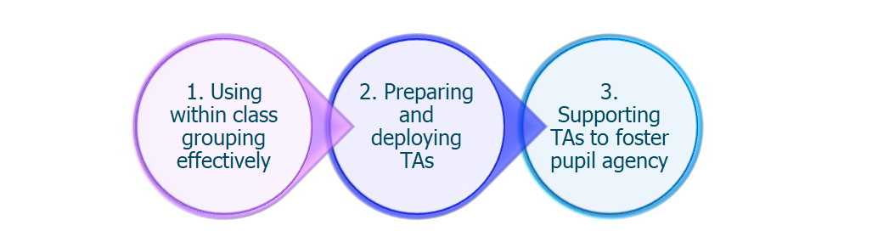
Applying your learning
To support you in this, you will be prompted to apply the content of this self-study to a scenario that you might encounter in your school.
At the end, you’ll reflect on what you’ve learned. You’ll think about how it fits with your own experiences and what you might do differently in future.

EYFS | Primary | Secondary | Specialist - SEND setting | Specialist -Alternative provision

Schools should delete any scenarios that are not relevant to their context.

EYFS scenario
Miss Patel is leading a small-group phonics session in an EYFS learning environment. She has planned for her TA, Mr. Ahmed, to work with a group of children who need extra support blending CVC (consonant-vowel-consonant) words. However, just before the session begins, Mr. Ahmed is called away to deal with a first-aid incident, meaning the children who need the most support are left without additional input. Miss Patel wants to ensure that all pupils stay engaged and make progress in the session, despite the unexpected change.
As you read through this elective self-study, consider how Miss Patel might adapt her approach to ensure that the pupils who need extra support remain included in the lesson. How could she make use of flexible grouping strategies and ensure that Mr. Ahmed is still able to contribute effectively when he returns?

Primary scenario
Mr. Green is teaching a Year 4 maths lesson on fractions. He has planned for his TA, Mrs. Jones, to support a small group of pupils who have been struggling with equivalent fractions. However, during the lesson, he notices that Mrs. Jones is leading the group rather than scaffolding their thinking, giving them step-by-step instructions rather than encouraging them to work independently.
As you read through this elective self-study, consider how Mr. Green might support Mrs. Jones to help pupils take ownership of their learning. What strategies could he use to encourage independence rather than task completion? How might he structure pre-lesson discussions to guide how Mrs. Jones supports the pupils more effectively?

Secondary scenario
Miss Carter is an English teacher working with a Year 9 class during a whole class reading lesson. She is relying on her TA, Mr. Wilson, to support a group of pupils who find reading comprehension challenging. However, Mr. Wilson is unfamiliar with the text and lacks confidence in his own subject knowledge, particularly with more complex fiction analysis. As a result, he is hesitant to engage with pupils beyond basic comprehension questions, leaving them without the depth of support they need.
As you read through this elective self-study, consider how Miss Carter could help build Mr. Wilson’s confidence in supporting pupils with reading comprehension. How could she prepare and brief him before lessons to ensure that he has a clear understanding of the key learning points? What role could structured prompts, or scaffolded discussion, play in helping him to provide more meaningful support?

SEND setting scenario
Mrs. Thomas is leading a science lesson in a specialist SEND setting, where her class includes pupils with a wide range of needs, including those with autism and speech and language difficulties. She relies on one of her TAs, Mr. White, to help a small group of pupils follow multi-step instructions during practical activities. However, she notices that Mr. White is giving instructions too quickly and completing tasks for pupils rather than supporting them to work through each step themselves.
As you read through this elective self-study, consider how Mrs. Thomas might support Mr. White to scaffold learning more effectively. How could she model questioning techniques and structured prompting to encourage greater independence? What pre-lesson strategies could she use to help Mr. White understand how much help to provide at different points in the activity?

Alternative provision scenario
Mr. Blake works in an alternative provision setting with pupils who have disengaged from mainstream education. He has planned for his TA, Ms. Hill, to support the work of a small group of learners, whilst he provides some intensive one to one support for a learner with significant behaviour regulation. However, he notices that Ms. Hill is spending the entire lesson stepping in to correct behaviour rather than allowing the pupils to engage with the task.
As you read through this elective self-study, consider how Mr. Blake might help Ms. Hill balance supporting the pupils’ engagement while also encouraging them to develop self-regulation skills. What strategies could he suggest to gradually reduce the level of TA intervention while still ensuring that the pupils remain engaged?

Content
Section 1: Using within-class grouping effectively | Page 9
Section 2: Preparing and deploying TAs | Page 11
Section 3: Supporting TAs to foster pupil agency | Page 16
Activity: Case study | Page 19
Applying your learning: scenarios | Page 21
Summary | Page 28
Next Steps | Page 30
Related Initial Teacher Training and Early Career Framework statements | Page 32
Use of artificial intelligence | Page 34
References | Page 35
Schools may need to amend the page numbers in this Content table as they may have altered when adding their own examples.

- Using within-class grouping effectively
Approximate time to complete: 6 minutes
A reminder of what the evidence says
Within-class attainment grouping can be utilised to support and challenge for pupils at different levels. Research evidence suggests that this approach can lead to small gains, especially in Primary maths (EEF, 2021f). But the impact depends on how flexible the groups are and how pupils feel about why they’ve been placed in them.
Additionally, research suggests that fixed attainment-based grouping can demotivate pupils (Hallam and Ireson, 2006; Tereshchenko et al., 2018). It found that while some pupils value attainment-based grouping, others, particularly lower-attaining pupils, can feel demotivated if they see their placement as fixed. They valued the fairness and the chance to learn from others. To keep groupings useful, review them often and move pupils between them. This helps prevent pupils from feeling stuck with a ‘high’ or ‘low’ ability label.
Evidence suggests that disadvantaged pupils can suffer from lower teacher expectations which increases their chances of being grouped with lower prior attainers. If groups are not arranged flexibility, and the impact of grouping on pupil engagement and motivation not monitored, within-class grouping could have negative effects for disadvantaged pupils (EEF, 2021f).
You’ll recall from your initial teacher training that formative assessment is key; adjusting groups based on learning needs rather than static ability helps maintain challenge and high expectations for all. Some people still believe pupils should be grouped by learning styles, like ‘visual’ or ‘kinaesthetic’. This is a common myth. Research synthesised by EEF (2021d) and Pashler et al. (2008) found no reliable evidence this improves attainment. Instead, adaptive teaching strategies such as scaffolding, modelling, and targeted support are more effective.
What this looks like in practice
The way you use within-class grouping will look different depending on your phase. In early years, it’s often play-based. In post-16, it’s more subject-focused. In any setting, you may face challenges in keeping groupings flexible, purposeful, and supportive.
Some pupils may feel stuck in a group, especially if they’ve been in it for a long time. Others may lose confidence if they’re always in lower-attaining groups. Higher-attaining pupils may feel limited if mixed-attainment grouping isn’t structured well.
You’ll remember from your training that it’s important to group by learning needs, not fixed ability. This helps maintain high expectations and keeps pupils engaged. Use formative assessment to review and adjust groupings often to maintain engagement and motivation. Make sure pupils know that movement between groups is normal.
Think about how you explain grouping decisions to your class. This can shape how they view themselves as learners. Using short-term groupings for specific tasks helps prevent pupils from feeling labelled as ‘high’ or ‘low’ ability.
Encourage collaboration between pupils with different strengths. This works well in structured peer discussion or problem-solving tasks. When planned carefully, this approach supports motivation and learning for everyone.
Identifying the ‘active ingredients’
The following examples outline practical strategies for implementing effective within-class grouping:
- Setting high expectations for all: ensuring all pupils have access to a challenging curriculum rather than a narrowed or simplified version. This may also include use of stretch tasks for all pupils and demonstrating that groups are flexible and not fixed;
- Use formative assessment to make groupings responsive: this means regularly reviewing and adjust groupings to reflect pupil progress. Assessment may also include observations and discussions with a colleague. It may also mean monitoring frequently pupils’ motivation and confidence levels;
- Engage with parents and carers: sharing how within-class grouping works to reassure parent and carers that groupings are responsive and flexible; and
- Work closely with colleagues, including the SENCO: This could include collaborating with the SENCO and other specialist staff to ensure that pupils with SEND receive the right adaptations. It may also include working with support staff to ensure they provide appropriate levels of support. It could also include actively seeking feedback on whether grouping strategies are supporting engagement and learning outcomes for all pupils.
Examples
Schools should add exemplification relevant to their context to demonstrate how a using within-class grouping could look making explicit links to the ‘active ingredients’ and highlighting how these make it effective.
Examples could include: video exemplification, modelling, a transcript, lesson observations, artefacts or classroom resources.
Video exemplification should last no longer than 2-3 minutes.
Click here to return to Content page
- Preparing and deploying TAs
Approximate time to complete: 7 minutes
Let’s begin by reflection on your experiences of working with TAs. If you’ve worked with a TA before, think about:
- Was their role clear in relation to your teaching?
- Did their support help reinforce learning or lead to over-reliance?
- Was it easy to keep their support aligned with your lesson goals?
If you haven’t yet worked with a TA, that’s completely normal. Many early career teachers find this challenging, especially when the adult supporting them has more experience. You might be wondering:
- How do I lead while building a respectful, professional relationship?
- How can I make sure the TA supports independence, not dependence?
- How do I prepare a TA without adding to my workload?
This section will guide you through practical ways to work with TAs or support staff. You’ll explore how to use structured approaches, set clear expectations, and build positive relationships. With the right preparation, support in your learning environment can be purposeful and reinforce, not replace, teacher-led learning.
A reminder of what the evidence says
The core self-study highlights the importance of preparing and deploying teaching assistants (TAs) in a structured way. TAs should enhance, not replace, your role as the teacher.
Research from the Education Endowment Foundation (2021e, 2025a) and Blatchford et al. (2009) suggests that TAs can make a positive difference when their support is clearly planned and linked to teacher-led instruction. How they are deployed matters.
You may not work with a TA right now. Not all learning environments have regular additional adult support. But knowing how to work well with TAs is still important. You may need these skills in future.
TAs need to be prepared for the lesson. You will remember from your training that TAs are less effective when they do not know the learning goals or content (Blatchford et al., 2009). Many say they do not get enough time to plan with the teacher. To help address this:
- share key content, vocabulary, and objectives before the lesson (EEF, 2021e);
- have short check-ins at the start of the day; and
- ask for feedback after lessons, even if it’s just a quick chat.
You might explore using generative AI to create short summaries or draft prompts. These tools can save time but always check their output for accuracy and suitability.
TAs must not replace teacher instruction. An EEF toolkit suggests that that pupils who receive too much TA support without careful planning may miss out on teacher interaction (EEF, 2021e). To avoid this:
- make sure TAs work across the class, not only with the same pupils;
- use structured roles so pupils still connect with the teacher; and
- keep teacher-pupil contact high, especially for lower-attaining pupils.
This planning takes time, especially in secondary, where you may work with different TAs each day. But a small investment now can lead to better outcomes later. TAs who are prepared can give meaningful support and help pupils make real progress.
What this looks like in practice
You may not always have access to extra adult support. But when you do, whether from a TA, parent volunteer, technician, pastoral staff, or another adult, it’s important to make sure their support is planned and focused on learning.
As you’ll remember from your training year, additional adults can make a big difference when their support is structured and clearly linked to your lesson goals. Without planning, there’s a risk that their role becomes detached from the main teaching or limits pupil independence (EEF, 2025a).
In some settings, adults may be asked to support subjects they are less confident in. They may also support pupils with SEND without specialist training. As the teacher, you should:
- check what subject knowledge or experience the adult has;
- provide simple resources like summaries, scaffolded tasks or key vocabulary;
- explain the learning goals clearly; and
- keep communication open; ask what support they need to feel confident.
Leading another adult may feel new at first, especially while you’re growing your own confidence. But this is about guiding learning, not about having authority. You’re responsible for making sure support helps pupils learn, and that includes helping the adult work effectively.
You can do this by:
- Building trust. Set up a short teacher–TA agreement so roles are clear (EEF, 2020). Respect the adult’s starting point and agree on next steps together.
- Checking in often. Ask what’s going well and what they need from you.
- Sharing your expectations. Remind them that support should help pupils think for themselves, not do the work for them.
- Being clear. Let them know where support is most needed and what that support should look like.
When support is planned and collaborative, it helps everyone, pupils, teachers, and the adults working alongside you.
Many schools find that even a brief ten-minute check-in at the start or end of the day is enough to ensure effective lesson briefing. However, we recognise that access to preparation time may not always be within your control as an early career teacher. It may be helpful to discuss your school’s approach with your mentor and explore whether any of the following strategies are in place:
- adjusting TAs’ working hours (for example: starting early, finishing early);
- using assembly time for preparation discussions; and
- having TAs join teachers for part of Planning, Preparation, and Assessment (PPA) time (EEF, 2021e).
TAs should support, not replace, teacher instruction (EEF, 2025a). As the teacher, you should make the TA’s role clear before the lesson begins. A short conversation or shared planning note can help clarify:
- How support will be given. For example, moving between groups rather than staying with one pupil.
- What effective support looks like. This might include using prompts and questions rather than giving direct answers.
- How support links to the main lesson goals. TA-led support should reinforce, not replace, main teaching.
Using the scaffolding framework
You’ll remember from your training that TAs should give the least amount of help first (EEF, 2025a):
- self-scaffolding: let pupils try for themselves;
- prompting: use open questions like ‘What do you need to do first?’;
- clueing: offer small hints to guide thinking;
- modelling: show an example, then ask the pupil to try; and
- correcting: use only when pupils cannot move forward.
Build in short check-ins after the lesson to help ensure support is focused and flexible:
- reflect on what went well;
- spot challenges or changes needed;
- keep TA support aligned with lesson goals; and
- review whether groupings need to change.

Identifying the ‘active ingredients’
Next, you’ll explore some examples that demonstrate practical approaches to preparing and deploying TAs. As you review the relevant example, focus on these ‘active ingredients’ that can be thought of the as the behaviours or actions of the teacher that effectively put the theory into practice. Support should be based on clear communication. This means:
- sharing the key learning objectives and content before the lesson;
- checking what the TA knows and what support they may need;
- using short check-ins before and after lessons to reflect on what worked;
- Support TAs to use the scaffolding framework. Start with self-scaffolding, then use prompting, clueing, modelling, and only correcting if needed (EEF, 2025a);
- Keep TA support responsive and flexible. Rotate support across the class. Make sure all pupils, especially those with lower prior attainment, still have regular access to teacher input.
These key elements won’t change in themselves and you would expect to see them looking very similar across different phases.
Examples
Schools should add exemplification relevant to their context to demonstrate how a preparation for and deployment of TAs could look making explicit links to the ‘active ingredients’ and highlighting how these make it effective.
Examples could include: video exemplification, modelling, a transcript, lesson observations, artefacts or classroom resources.
Video exemplification should last no longer than 2-3 minutes.
Click here to return to Content page

- Supporting TAs to foster pupil agency
Approximate time to complete: 7 minutes
A reminder of what the evidence says
You’ll remember from the core self-study that effective TA support focuses on promoting pupil independence, not completing tasks for them. The EEF (2025a) highlights that when pupils become too reliant on TA support, especially one-to-one, it can reduce their independence, ownership of learning, and connection with peers.
This often happens when TAs focus on task completion rather than encouraging pupils to think for themselves. If pupils regularly wait for the TA to begin work or rely on their input to complete tasks, it may be time to adjust the scaffolding approach.
To support TAs to effectively supplement the teacher’s role, they need time, guidance, and clear expectations. Planning short check-ins before and after lessons helps keep support focused on learning. Even five minutes can make a difference (EEF 2021e & 2025a).
It’s also important that TAs access relevant training, particularly when supporting learning directly or stepping in at short notice. With the right preparation and clear communication, TA support can promote independence and keep all pupils engaged in meaningful learning (EEF 2021c).
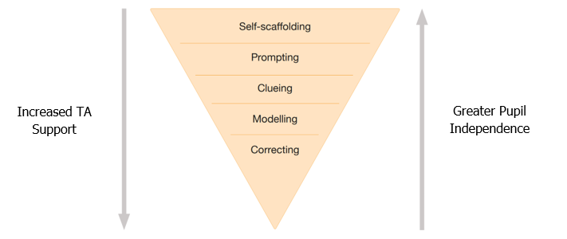

EEF 2025a Deployment of Teaching Assistants
You’ll remember from the core unit that scaffolding starts with the least help first. TAs should:
- allow time for self-scaffolding before stepping in
- use prompting and clueing to guide thinking
- only move to modelling or correcting if needed
This structure supports pupil independence and helps avoid over-reliance on adult support (EEF, 2025a).
What this looks in practice
To effectively foster pupils’ agency, teaching assistants (TAs) should be equipped with clear, structured guidance.
The Education Endowment Foundation’s Deployment of Teaching Assistants guidance report suggests a ‘A Teacher-TA agreement’ (EEF, 2020) that could be used to avoid ambiguity or breakdowns in communication.
This may include the use of question stems, prompts, or scaffolding frameworks designed to encourage independent thinking rather than dependence on adult support. For instance, question stems such as “What might happen if...?” or “Can you think of another way to…?” can guide TAs in prompting pupils to consider alternatives, articulate reasoning, and take ownership of their learning. Such tools ensure that support is purposeful and aligned with the lesson’s learning objectives.
During lessons, it can be valuable to observe how TAs apply these scaffolding strategies in real time. Noting how and when they intervene, the types of questions they use, and the degree of support offered will provide insight into whether pupils are being encouraged to think and act independently. These observations can inform ongoing professional development and enable teachers to adjust the scaffolding framework over time to better meet pupils’ evolving needs. For example, a TA might initially model a thinking process aloud but later shift to prompting pupils to verbalise their own thinking.

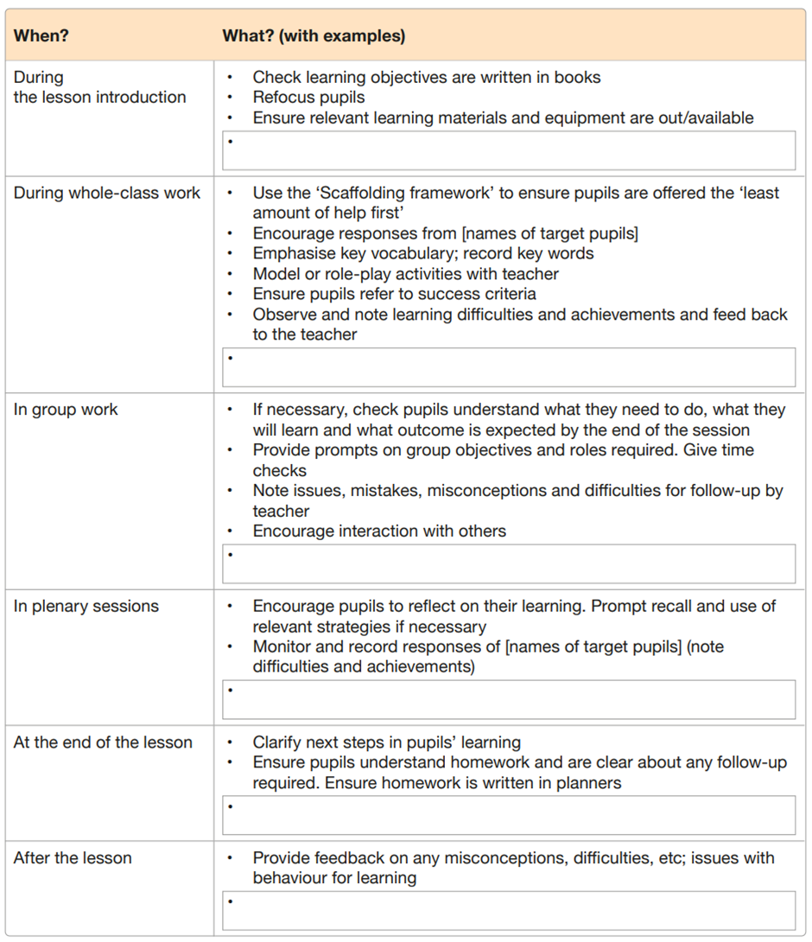
EEF Teacher – TA Agreement Template (EEF, 2020)
Regular feedback and opportunities for post-lesson reflection are essential for helping TAs refine their approaches. Brief debriefs after lessons can be used to discuss what went well, which strategies promoted independent learning, and where adjustments might be needed. This reflective practice fosters a collaborative environment where TAs can share insights and develop more nuanced ways of supporting pupil agency. Importantly, this ongoing dialogue reinforces the principle that the TA’s role is to enhance, not replace, pupil learning by supporting autonomy, curiosity, and problem-solving. When implemented consistently, this approach can transform the TA’s role into one that actively cultivates learners’ independence and confidence.
Identifying the ‘active ingredients’
You will shortly look at some examples that show how teachers across different phases work with TAs to support pupil independence. You’ll see what effective deployment looks like and how to scaffold without creating dependence. As you read, look out for the ‘active ingredients’:
- Clear preparation: TAs need a short, focused check-in before lessons, so they know the learning goal, not just the task. This helps them scaffold thinking rather than completing work for pupils. Use simple prompts or frameworks to guide their support and follow up after lessons to reflect on when and how help was given;
- Structured scaffolding: Ensure TAs observe and give time to process before stepping in. Prompting or clueing nudges can be used to help them recall prior learning or reflect. Model or correct when other steps haven’t worked. Modelling offers a clear example and invites the pupil to try. Correction is used as a last resort, followed by reflection ‘Why do you think that’s the answer?’; and
- Regular communication with your TA: Create shared expectations. Respect the TA’s experience but be clear about how support should work.

Examples
Schools should add exemplification relevant to their context to demonstrate how to support TAs to foster pupil agency could look making explicit links to the ‘active ingredients’ and highlighting how these make it effective.
Examples could include: video exemplification, modelling, a transcript, lesson observations, artefacts or classroom resources.
Video exemplification should last no longer than 2-3 minutes.

Click here to return to Content page

Activity: case study
Approximate time to complete: 8 minutes
The final section of this elective self-study uses a case study to help you reflect on how to lead positive change when a teaching assistant’s (TA’s) approach isn’t yet aligned with evidence-based practice. Whether you’re working in early years, primary, secondary, or alternative provision, this challenge is likely to feel familiar at some point.

Case study
Read the case study and afterwards, listen to the accompanying podcast, where two presenters explore how to lead positive change around TA deployment.
Mr. Daniels is currently working with Mrs. Grant, a highly experienced TA. He notices that her support is heavily focused on keeping pupils ‘on task’, hovering nearby, correcting mistakes quickly, and unintentionally limiting pupils’ interaction with him during key teaching moments.
Instead of challenging this head-on, Mr. Daniels turns to the EEF’s 2025 guidance on Effective Teacher–TA Partnerships. He introduces the Teacher–TA Agreement template to open up dialogue about how their roles should complement each other across different lesson phases. Together, they discuss how to plan for whole-class input, group support, and plenary feedback, agreeing on approaches that allow the teacher to remain the lead practitioner, while the TA supports independence through targeted prompts and feedback.
He also uses the Scaffolding Framework to show how shifting from correcting to prompting can build pupil resilience. Mrs. Grant begins trialling phrases like ‘What do you need to do first?’ and ‘What’s your plan?’ before offering more structured support. These small changes begin to shift her practice, without undermining her expertise or causing tension.
Mr. Daniels models calm confidence and respect throughout. He stays focused on aligning classroom practice with the evidence, while valuing Mrs. Grant’s insight and experience. Together, they co-construct a new approach, one that better supports all pupils and builds independence without increasing workload for either adult.

Case study podcast
Now, listen to the podcast in which two presenters explore the case study of Mr. Daniels and Mrs. Grant in more detail. As you listen, consider how he manages the challenge of improving TA deployment while preserving a strong professional relationship.
Consider how Mr. Daniels opens a constructive dialogue that respects Mrs. Grant’s experience while introducing research-informed ideas.
What lessons can you take from this about working effectively with Teaching Assistants to best support pupils?
You may wish to reflect on the following:
- how you communicate expectations and clarify roles
- how you recognise and value the experience of those who support you and your pupils

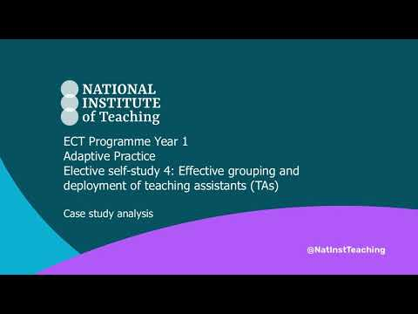
Click here to listen to: Effective grouping and deployment of teaching assistants (TAs)
Please note that this podcast has been created using generative AI. Significant attention was given to ensuring that the generated content was appropriately linked to the original materials and aligned with the framework statements. In developing this AI generated resource, we adhered to strict ethical and legal considerations. Please see the ‘use of artificial intelligence’ section for further details.

Click here to return to Content page

Applying your learning: scenarios
Approximate time to complete: 8 minutes
Now that you’ve completed the elective self-study, revisit the scenarios you examined before engaging with this content. Reflect on the relevant scenario again, considering the strategies and ‘active ingredients’ from the examples provided.
Consider how these elements can also support you in grouping, using TAs, and building pupil independence and discuss your thoughts with your mentor to explore how to apply these approaches effectively in your own context.
EYFS | Primary | Secondary | Specialist - SEND setting | Specialist -Alternative provision

Schools should delete any scenarios that are not relevant to their context.

EYFS scenario
Miss Patel is leading a small-group phonics session in an EYFS learning environment. She has planned for her TA, Mr. Ahmed, to work with a group of children who need extra support blending CVC words. However, just before the session begins, Mr. Ahmed is called away to deal with a first-aid incident, meaning the children who need the most support are left without additional input. Miss Patel wants to ensure that all pupils stay engaged and make progress in the session, despite the unexpected change.
Reflect on the content of the elective self-study as you consider which approaches would help Miss Patel adapt her approach to ensure that the pupils who need extra support remain included in the lesson and ensure that Mr. Ahmed is still able to contribute effectively when he returns.
Here are some options that can support your reflection:
A) Use flexible grouping to ensure all pupils remain engaged. Miss Patel could temporarily rearrange her groupings so that pupils who need extra support work with peers who can model blending strategies. This prevents pupils from missing out on learning and encourages collaborative problem-solving.
B) Provide Mr. Ahmed with a question guide. You could consider using generative AI to create this guide to support workload. When Mr. Ahmed returns, he can use structured prompts such as ‘What sound do we hear at the beginning of this word?’ to encourage independent thinking rather than providing direct answers. Ensuring that due diligence and caution is used for accurate content.
C) Adjust the lesson structure to include whole-class scaffolding. Miss Patel could introduce a quick, whole-class phonics recap, reinforcing the strategies pupils need before moving into small-group work. This ensures that all pupils are supported, even in the absence of the TA.

Primary scenario
Mr. Green is teaching a Year 4 maths lesson on fractions. He has planned for his TA, Mrs. Jones, to support a small group of pupils who have been struggling with equivalent fractions. However, during the lesson, he notices that Mrs. Jones is leading the group rather than scaffolding their thinking — giving them step-by-step instructions rather than encouraging them to work independently.
Reflect on the content of the elective self-study as you consider which approaches would support Mrs. Jones to help pupils take ownership of their learning by encouraging independence and structuring pre-lesson discussions.
Here are some options that can support your reflection:
A) Introduce a Teacher-TA Agreement. This agreement can clarify roles, ensuring that TAs follow the scaffolding framework — prompting pupils first before giving direct support.
B) Shared prompts. By preparing a structured set of prompts such as ‘How did we solve a similar problem before?’, Mrs. Jones can encourage pupils to verbalise their reasoning rather than rely on direct instruction. You may wish to use AI-generated question stems to support your workload.
C) Facilitate post-lesson reflection. After the lesson, Mr. Green could meet with Mrs. Jones to review pupil progress, discussing which scaffolding strategies worked and where further adjustments may be needed.

Secondary scenario
Miss Carter is an English teacher working with a Year 9 class during a whole class reading lesson. She is relying on her TA, Mr. Wilson, to support a group of pupils who find reading comprehension challenging. However, Mr. Wilson is unfamiliar with the text and lacks confidence in his own subject knowledge, particularly with more complex fiction analysis. As a result, he is hesitant to engage with pupils beyond basic comprehension questions, leaving them without the depth of support they need.
Reflect on the content of the elective self-study as you consider which approaches would support Miss Carter with building Mr. Wilson’s confidence in supporting pupils with reading comprehension. What have you learned about how structured prompts or scaffolded discussion could help him to provide more meaningful support?
Here are some options that can support your reflection:
A) Use content summaries. Miss Carter can provide Mr. Wilson with structured notes summarising the key themes and analysis points for each lesson, ensuring he feels prepared to guide discussions. You could use gen AI for this to save you time, ensuring you check the content for accuracy.
B) Introduce scaffolded questioning techniques. Encouraging Mr. Wilson to use open-ended prompts such as ‘Why do you think the author made this choice?’ or ‘What evidence supports that interpretation?’ helps him facilitate deeper analysis.
C) Schedule regular pre-lesson briefings. By having a short, structured discussion before each lesson, Miss Carter can ensure Mr. Wilson is confident in the lesson objectives and how best to support pupil discussion.

SEND school scenario
Mrs. Thomas is leading a science lesson in a specialist SEND setting, where her class includes pupils with a wide range of needs, including those with autism and speech and language difficulties. She relies on one of her TAs, Mr. White, to help a small group of pupils follow multi-step instructions during practical activities. However, she notices that Mr. White is giving instructions too quickly and completing tasks for pupils rather than supporting them to work through each step themselves.
Reflect on the content of the elective self-study as you consider which approaches would support Mrs. Thomas to help Mr. White scaffold learning more effectively.
Here are some options that can support your reflection:
A) Model effective scaffolding. Mrs. Thomas could demonstrate how to break down instructions into smaller steps, ensuring that Mr. White prompts pupils to complete each part independently before intervening.
B) Use structured question prompts. Providing Mr. White with key phrases such as ‘What’s the first step you need to take?’ or ‘Can you explain your thinking before I help?’ ensures he encourages independent problem-solving.
C) Use post-lesson reflections to refine strategies. Regular check-ins between Mrs. Thomas and Mr. White can help identify where pupils need more independence, ensuring that support is gradually faded as they become more confident.

Alternative provision scenario
Mr. Blake works in an alternative provision setting with pupils who have disengaged from mainstream education. He has planned for his TA, Ms. Hill, to support the work of a small group of learners, whilst he provides some intensive one to one support for a learner with significant behaviour regulation. However, he notices that Ms. Hill is spending the entire lesson stepping in to correct behaviour rather than allowing the pupils to engage with the task.
Reflect on the content of the elective self-study as you consider which approaches would help Mr. Blake support Ms. Hill balance supporting the pupils’ engagement while also encouraging them to develop self-regulation skills.
Here are some options that can support your reflection:
A) Implement a structured self-regulation plan. Ms. Hill could gradually withdraw from direct support, using prompts such as ‘What can you try before asking for help?’ to encourage independent behaviour management.
B) Use reflection prompts. Providing structured self-regulation questions like ‘How did you handle that situation?’ or ‘What would you do differently next time?’ ensures that the pupils reflect on their own progress. You might want to use gen AI to generate these but put time aside to check they are accurate and appropriate.
C) Introduce phased support withdrawal. Mr. Blake and Ms. Hill can develop a clear plan for gradually stepping back, ensuring that the pupil builds confidence in managing their own engagement over time.

Reflections:
Now think about your own learning environment, pupils and supporting adults. Consider how you will both use within-class grouping effectively and prepare and deploy TAs effectively.
Consider how you’ve developed in your practice since your initial teacher training and how you can continue to develop in this area.
Share your reflections with your mentor at your next interaction.
Click here to return to Content page

Summary
Approximate time to complete: 2 minutes
Effective within-class grouping
Flexible grouping supports all pupils when based on learning needs rather than fixed ability labels (EEF, 2021f). While attainment-based grouping can yield small gains in mathematics (EEF, 2021f), rigid grouping may lead to disengagement (Hallam & Ireson 2006). Regularly adjusting groups prevents fixed mindsets and ensures that groupings support progress, not define ability. Communicate this clearly to both pupils and parents. Avoid grouping by ‘learning styles’ (EEF, 2021d; Pashler et al., 2008) and ensure all pupils experience appropriate levels of challenge. Collaborate with the SENCO to provide necessary adaptations for pupils with SEND while keeping them integrated into high-quality teacher instruction.
Preparing and deploying TAs effectively
TAs work best when they supplement, rather than replace, teacher instruction (EEF, 2025a; Blatchford et al., 2009). Structured preparation is key. For example, before lessons, meet with your TA to review:
- the core content and skills pupils will develop
- the scaffolding framework to guide pupil learning
- their specific role in supporting, not leading, instruction
Using AI-generated lesson summaries and scaffolded prompts can reduce your workload while equipping TAs with research-informed support strategies. Ensure any AI use complies with school policies and copyright laws. Clear teacher-TA agreements define roles and encourage rotating support across pupils, maintaining access to teacher-led instruction. Regular feedback sessions help refine strategies to meet pupil needs.
Supporting TAs to Foster Pupil Agency
Research finds that TAs are more effective when they support pupils through scaffolding, starting with observation and encouraging self-scaffolding before offering help (EEF, 2025). To promote independence, TAs should:
- allow self-scaffolding so pupils attempt tasks independently first
- use prompting and clueing, ask open-ended questions to guide thinking rather than giving answers
- model approaches when necessary, encouraging active pupil engagement
- use correction only as a last resort, reinforcing problem-solving rather than mere recall
Embedding open-ended questioning enables pupils to develop reasoning and problem-solving skills. Regular teacher-TA planning and feedback sessions ensure that support remains aligned with lesson objectives. AI-generated question stems further scaffold TA questioning, reducing reliance on direct instruction and reinforcing metacognitive strategies.
Click here to return to Content page

Next steps
Approximate time to complete: 2 minutes
The following next steps are suggestions of how early career teachers could implement the learning from this elective self-study and align with the associated Mentor Support materials. Schools may wish to adapt this to meet the needs of their context and their ECTs.
Observing
If possible, arrange an opportunity with your mentor to observe a colleague working in partnership with their TA to ensure that pupils receive structured, well-scaffolded support while developing independence.
As you observe, consider the following:
- How does the TA use the scaffolding framework? Observe where the TA allows self-scaffolding first before moving to prompting, clueing, modelling, and finally correction, ensuring they provide the least amount of help first.
- How is the teacher-TA relationship structured? Look for clear roles and expectations, ensuring that the TA is supplementing rather than replacing teacher input.
- What strategies does the TA use to foster pupil agency? Notice whether they use open-ended questions, prompts, and cues to guide pupil thinking, rather than providing immediate answers.
- How is the TA supported by the teacher? Consider whether the teacher has provided clear lesson notes, structured guidance, question stems, or AI-generated materials to help the TA feel confident in their role, particularly in subject-specific support.
- How does the teacher ensure that all pupils receive exposure to high-quality teacher instruction? Observe how within-class grouping strategies are used to ensure that all pupils engage with teacher-led instruction, rather than becoming overly dependent on TA support.
You may wish to share your observation notes with your mentor at your next meeting to reflect on effective strategies and identify areas to trial in your own practice.
Actions
Identify an upcoming lesson where you will be working with a TA, and consider implementing one or more of the following strategies to ensure that TA support is purposeful, structured, and aligned with evidence-based approaches:
- Plan how you will use within-class grouping effectively. Plan three strategies you will use to establish and maintain effective within-class grouping. Map out how and when you will use them in your lessons;
- Plan how you will prepare and deploy TAs effectively. Plan how you will brief your TA before an upcoming lesson. Identify three specific steps you will take to make sure their support is structured, linked to learning goals, and responsive during the lesson; or
- Plan how you will support TAs to foster pupil agency. Reflect on how you will support your TA to foster pupil agency. Plan out a short pre-lesson conversation you could have, and script an example of the types of prompts or questions you would want the TA to use during pupil interactions.

To help you prepare, discuss these approaches with your mentor at your next meeting, reflecting on how to refine TA preparation and deployment in your learning environment.
Click here to return to Content page

Related Teacher Training and Early Career Framework statements
Adaptive teaching
Learn that…
5.5. Flexibly grouping pupils within a class to provide more tailored support can support learning, but care should be taken to monitor its impact on attainment, behaviour, engagement and motivation, particularly for low attaining pupils.
5.6. There is a common misconception that pupils have distinct and identifiable learning styles. This is not supported by evidence and attempting to tailor lessons to learning styles is unlikely to be beneficial.
5.7. Pupils with SEND are likely to require additional or adapted support; working closely with colleagues, parents/carers, and pupils to understand barriers to learning and identify effective strategies is essential.
Learn how to…
Develop an understanding of different pupil needs, by:
- 5.b. Making use of formative assessment.
- 5.c. Working closely with the Special Educational Needs Co-ordinator (SENCO) and other SEND specialists or expert colleagues.
- 5.f. Utilising existing opportunities to engage with parents and carers to better understand pupils’ individual needs (for example: meetings with parents).
Group pupils effectively, by:
- 5.p. Applying high expectations to all groups, and ensuring all pupils have access to a rich curriculum.
- 5.q. Intentionally grouping in relation to a specific learning outcome, regularly reviewing those groupings, taking care to monitor their impact and avoiding the perception that groups are fixed.
Professional behaviours
Learn that…
8.5. Teaching assistants (TAs) can support pupils more effectively when they are prepared for lessons by teachers, and when TAs supplement rather than replace support from teachers.
8.6. SENCOs, pastoral leaders, careers advisors and leaders and other specialist colleagues also have valuable expertise and can ensure that appropriate support is in place for pupils.
Learn how to…
Build effective working relationships, by:
- 8.g. Seeking ways to support individual colleagues and working as part of a team.
- 8.i. Working closely with the SENCO and other professionals supporting pupils with additional needs, making explicit links between interventions delivered outside of lessons with classroom teaching.
- 8.j. Drawing on guidance from expert colleagues, sharing the intended lesson outcomes with teaching assistants ahead of lessons.
- 8.k. Ensuring that support provided by teaching assistants in lessons is additional to, rather than a replacement for, support from the teacher.
Click here to return to Content page

Use of artificial intelligence
This document includes content created using generative artificial intelligence (gen AI). The original materials were developed by the NIoT team, drawing on a comprehensive evidence base and decades of teaching and leadership experience. Some scenarios, case studies, and example programme materials were generated with the assistance of AI, guided by thoughtfully crafted human prompts informed by extensive expertise and a deep understanding of the framework content. Additionally, AI-generated content was used to create podcast formats. Every output was rigorously quality assured and edited by an expert in early career teaching to ensure accuracy, relevance, and alignment with the framework.
Advisory note on the use of generative Artificial Intelligence (AI) in this unit
Throughout this elective unit, generative artificial intelligence (AI) and large language models (LLMs) will be referenced as potential tools to support your teaching practice. However, it’s important to note that the evidence base for the effectiveness of specific tools in classroom settings is still emerging, and their impact may vary depending on context and use.
You might use generative artificial intelligence to help you plan, support teaching assistants, or create clear resources for pupils. It can’t replace your professional judgement, but it can save time and help you create a more effective learning environment. Whenever AI is mentioned, there are some important considerations to bear in mind: Does it align with your school’s policies? Any use of AI should match your school’s acceptable use and safeguarding policies. If you’re unsure, speak with your mentor or a senior leader first.
- Are you keeping data safe? Don’t input any personal data about yourself, colleagues, pupils, or families. Always check that anything the AI generates doesn’t accidentally breach copyright or data protection laws.
- Have you checked what the AI has produced? Always review, edit and proofread AI-generated content before using it. AI can sometimes provide inaccurate or inappropriate information, even if it looks convincing at first glance.
- Are you clear on how your input is being used? Some tools use what you type in to help improve their systems. Are you comfortable with the prompts or questions you’re putting in, and with how the tool may reuse them? If not, look at the tool’s terms and settings before going ahead.
We would also advocate for all users of AI to have a good understanding of how the technology works before using it. For further information regarding safe and ethical use of gen AI in education, see https://www.gov.uk/government/collections/using-ai-in-education-settings-support-materials
Click here to return to Content page
References

- Aubin G, (2023) EEF ‘Flexible grouping: what is it and why use it?’. Available at: https://educationendowmentfoundation.org.uk/news/eef-blog-flexible-grouping-what-is-it-and-why-use-it
- Blatchford, P., Bassett, P., Brown, P., Martin, C., Russell, A., & Webster, R. (2009) Deployment and impact of support staff in schools: Characteristics, Working Conditions and Job Satisfaction of Support Staff in Schools. DOI: Blatchford_DeploymentAndImpactOfSupportStaffInSchools.pdf
- Education Endowment Foundation (2020), Special Educational Needs in Mainstream Schools: Evidence Review. Available at: EEF_SEND_Evidence_Review.pdf
- Education Endowment Foundation, (2021a)., Improving Mathematics in the Early Years and Key Stage 1 guidance report. Available at: Improving Mathematics in the Early Years and Key Stage 1 | EEF
- Education Endowment Foundation, (2021b)., Preparing for Literacy. Available at: Preparing for Literacy | EEF
- Education Endowment Foundation, (2021c)., Special Educational Needs in Mainstream Schools guidance report. Available at: Special Educational Needs in Mainstream Schools | EEF
- Education Endowment Foundation (2021d) Education Endowment Foundation Teaching and Learning Toolkit, Learning Styles: Available at: https://educationendowmentfoundation.org.uk/education-evidence/teaching-learning-toolkit
- Education Endowment Foundation (2021e) Education Endowment Foundation Teaching and Learning Toolkit, Teaching Assistant Interventions: Available at: https://educationendowmentfoundation.org.uk/education-evidence/teaching-learning-toolkit
- Education Endowment Foundation (2021f) Education Endowment Foundation Teaching and Learning Toolkit, Within Class Attainment Grouping: Available at: https://educationendowmentfoundation.org.uk/education-evidence/teaching-learning-toolkit
- Education Endowment Foundation (2021g) Teacher Feedback to Improve Pupil Learning. Available at: https://educationendowmentfoundation.org.uk/education-evidence/guidance-reports/feedback/
- Education Endowment Foundation (2021h) Metacognition and Self-regulated Learning. Available at: Metacognition and Self-regulated Learning | EEF
- Education Endowment Foundation, (2025a), Deployment of Teaching Assistants. Available at: https://educationendowmentfoundation.org.uk/education-evidence/guidance-reports/teaching-assistants
- Education Endowment Foundation, (2020), Teacher-TA Template Agreement. Available at: TA_Supplementary_Teacher_Agreement.pdf
- Hallam, Susan & Ireson, Judith. (2006). Secondary school pupils' preferences for different types of structured grouping practices. Available at: Download citation of Secondary school pupils' preferences for different types of structured grouping practices
- Pashler, H., McDaniel, M., Rohrer, D., & Bjork, R. (2008) Learning Styles: Concepts and Evidence. Psychological Science in the Public Interest, 9 (3). https://doi.org/10.1111/j.1539-6053.2009.01038.x
- Tereshchenko, A., Francis, B., Archer, L., Hodgen, J., Mazenod, A., Taylor, B., Travers, M. C. (2018) Learners’ attitudes to mixed-attainment grouping: examining the views of students of high, middle and low attainment. Research Papers in Education, 34(4), 425- 444. https://doi.org/10.1080/02671522.2018.1452962
Click here to return to Content page

