
Mentor Programme Introduction
Year 1
This document is intended for those who design and deliver a school-led Early Career Teacher Entitlement (ECTE) programme. It provides materials to introduce the programme to mentors. Opportunities for schools to add details relevant to their context have been identified.

Suggested time to complete: 90 minutes







Introduction
Welcome to the National Institute of Teaching’s (NIoT) Early Career Teacher (ECT) programme.
Who are the NIoT?
Founded by four of the country’s most respected school trusts, The National Institute of Teaching is a teacher and leader training and development provider. We design and deliver Initial Teacher Training, the Early Career Teacher Programme and National Professional Qualifications.
Our professional development programmes are delivered across England from our NIoT campuses as well as our Associate Colleges, a growing network of successful school trusts, enabling us to serve 1 in 10 of every school in the country.
Our aim is to boost the quality of teacher and leader development by generating and interpreting research, applying the insights to the design and delivery of our programmes, and sharing this with the sector.
Why do we exist?
We exist because of a powerful fact: the quality of teaching is the biggest in-school factor influencing children’s educational success. And this effect is even greater for children experiencing the highest levels of disadvantage.
But quality teaching is not evenly distributed across the English school system. The sector doesn’t know enough about the best ways to develop it and it is hampered by persistent challenges with teacher retention and recruitment.
In practice, this means that the children whose lives can be most positively affected by great teaching too often miss out. The National Institute of Teaching exists to change this. Our research will help us get closer to the classroom, give voice to multiple perspectives from within the school system, and help do what all teachers and leaders want: deliver what works for children.
Schools may wish to add their vision and aims here

Overview
​In this introduction, you will have the opportunity to learn more about the following in the Year 1 mentor programme:
Content
The ITTECF and Teacher Standards
The ECT programme from the NIoT
The safe and ethical use of artificial intelligence
Programme Structure – Year 1
Role and responsibilities
Further reading and resources

The Initial Teacher Training and Early Career Framework and Teacher Standards
The new ITTECF combines two previous frameworks:
- the Core Content Framework (CCF), used in Initial Teacher Training and
- the Early Career Framework (ECF) used for the two years following Initial Teacher Training.
The Initial Teacher Training and Early Career Framework (ITTECF) supports new teachers through their training and early years in teaching. It underpins one year of Initial Teacher Training (ITT) and two years of Early Career Teacher (ECT) training (or part-time equivalent). It sets out the evidence-informed knowledge, skills, and behaviours that lead to effective teaching.
Whichever provider new teachers train with, the ITTECF will guide their development across a three-year programme. ECTs will cover the ITTECF in full during their initial teacher training and also during the two-year ECT programme. This is an intentional decision by the Department for Education to ensure that the knowledge, skills, and behaviours gained during Initial Teacher Training can be revisited and consolidated. The new combined ITTECF will support a more cohesive and continuous professional development journey for new teachers as they progress through their early teaching careers.
How does the ITTECF link to the Teachers’ Standards?
New teachers will be familiar with the eight Teachers’ Standards from their ITT. The eight strands of the ITTECF are closely aligned with the Teachers’ Standards. However, it is important to understand that the ITTECF is neither an assessment tool nor a curriculum but an entitlement for all Initial Teacher Trainees and Early Career Teachers. Its purpose is to support their development against the Teachers’ Standards, and for this reason, they are intentionally interwoven.
Along with the Induction Tutor, you will support new teachers in monitoring and reviewing their progress against the Teachers’ Standards. This progress will be reported to the Appropriate Body (see Roles and Responsibilities).

You can see how the ITTECF and the Teachers’ Standards align here:
The ITTECF Framework | Teacher Standards
- High expectations | - Set high expectations
- How pupils learn | - Promote good progress
- Subject and curriculum | - Demonstrate good subject and curriculum knowledge
- Classroom practice | - Plan and teach well-structured lessons
- Adaptive teaching | - Adapt teaching
- Assessment | - Make accurate and productive use of assessment
- Managing behaviour | - Manage behaviour effectively
- Professional behaviours | - Fulfil wider professional responsibilities

Each strand of the ITTECF contains a series of ‘Learn that…’ and ‘Learn how to…’ statements that underpin the weekly activities and action steps that ECTs undertake as part of the two-year ECT programme.
The mentor’s role is to guide ECTs to contextualise the ‘learn that’ elements from their self-study to ‘learn how to’ in your context. Here is an example of some of these statements, taken from the Adaptive Teaching strand:
Adaptive Teaching (Standard 5 – Adapt Teaching)
Learn that… | Learn how to…
- Adapting teaching in a responsive way, including by providing targeted support to pupils who are struggling, is likely to increase pupil success. | Meet individual needs without creating unnecessary workload, by:  k) Making use of well-designed resources (e.g. textbooks, manipulatives).  l) Planning to connect new content with pupils' existing knowledge or providing additional pre-teaching if pupils lack critical knowledge.

Further information regarding the frameworks can be found at:
Initial Teacher Training and Early Career Framework
Teachers’ Standards guidance (publishing.service.gov.uk)

Return to Content page
The ECT programme from the NIoT
The ITTECF sets out what Early Career Teachers (ECTs) are entitled to learn about and learn how to do, when starting their careers as part of their early career teacher entitlement.
The ECT programme provides the opportunity for ECTs to:
- engage in a fully funded two-year programme
- have ongoing support from an ECT mentor who will help them adapt what they learn to their specific context
Schools/trusts may which to add any additional elements that their programme design will offer, for example, live seminars or conferences.

In this two-year ECT programme, you will use the content of the National Institute of Teaching’s programme as you mentor your ECT. This material intentionally builds on the training that ECTs will have received during their ITT. This is to support them to build confidence, expertise and a deeper understanding of how to apply key evidence to develop great practice.
The programme will focus on the following modules in year 1:
- Behaviour and relationships
- Memory and learning
- Planning and delivery
- Subject and curriculum
- Assessment for learning
- Adaptive practice
For full time early career teachers, each module lasts a half term.
Schools may wish to deliver the modules in a different sequence to align with the school or trust’s professional development priorities. However, all ECTs must start with ‘Behaviour and relationships’ to support them to establish a positive, structured learning environment that fosters pupil engagement, wellbeing, and academic success at the very start of the academic year.

Developing inclusive practice
Inclusive practice promotes the high standards and fulfilment of potential for all pupils by removing barriers to learning and ensuring that pupils receive an education appropriate to their needs (EEF, n.d). For this reason, each module on the NIoT’s ECT programme will be also explored through the lens of inclusive practice, ensuring that ECTs consider strategies to meet the diverse needs of all pupils in every element of their training.
Scenario-based learning
The content of the ECT programme provides an opportunity for ECTs to reflect on what they learned during ITT, from a new perspective as qualified teachers. Throughout the first year of the programme, they will engage with different scenarios, allowing them to draw on their previous experience and apply their knowledge and skills in real-school contexts.

Return to Content page

The safe and ethical use of artificial intelligence in education
The technology available to facilitate great teaching and support pupil success is constantly evolving. Consequently, the ITTECF framework does not focus on specific technological innovations. Teachers must remain conversant with technological developments throughout their careers, particularly those that evidence suggests can improve pupil outcomes (Initial Teacher Training and Early Career Framework).
The rapid progress of Artificial Intelligence (AI), however, stands out as unprecedented and may have significant implications for teaching practices. As the programme progresses through each module, you will have opportunities to explore the judicious use of AI—both in supporting pupil progress and enhancing your own working practices.
Return to Content page
Programme structure – Year 1
Programme overview
The ECT and ECT mentor programmes are aligned to ensure there is seamless and consistent support for both mentor and mentee. For example, the online study for ECTs in the first module, Behaviour and Relationships, includes theory-based content on how to maintain high expectations in the classroom. This is mirrored in the support material for mentors in which a summary of the learning is provided. This will help you to facilitate discussions and bridge theory into practice for your ECT.
Programme structure for ECTs in year 1
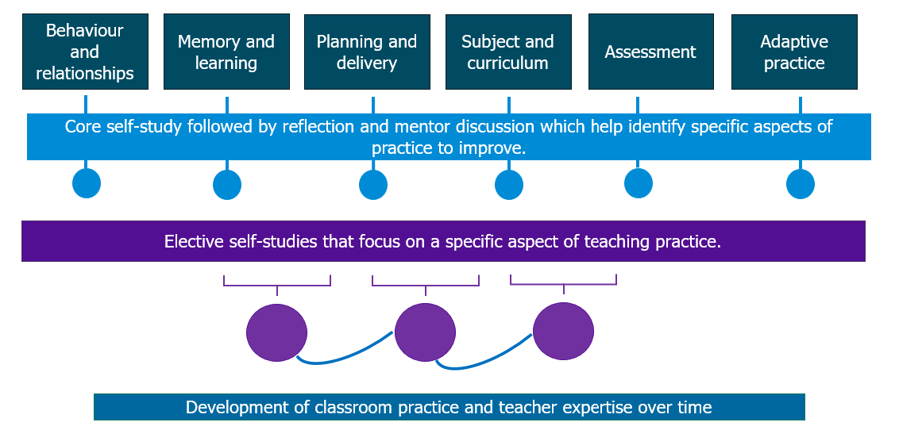

Overview of self-study content
In Year 1, all mentors will have access to Mentor Support materials. The summaries correspond to the ECTs’ half termly core and elective self-studies which will aid you in providing tailored support. This also allows you to access and engage with all the relevant content at a time to suit you. The self-studies will take 90 minutes per half term or 15 minutes per week to complete.
Mentors on a school-led ECT programme are not required to engage in training. However, you may find it helpful to review the Mentor Support materials, which outline active ingredients; recommended actions and a template, to help prepare for your weekly meetings.
Where used, we recommend that you review the content of the relevant material in advance of observing and meeting with your early career teacher.
Core self-study
Early career teachers will complete one core self-study per module. The core self-study acts as a refresher to the knowledge they have gained in that specific element of teaching during their initial teacher training. ECTs complete one core self-study per half-term.
As mentors, you will have a summary of this content as part of your Support Materials. This will take approximately 15 minutes to read.
Elective self-studies
Selection process
Having completed their core self-study, ECTs will use the self-study reflections to guide a discussion with you. Together, you will identify the priority focus areas for their development within a module. Your core self-study includes a prompt sheet to help guide this discussion.
ECTs then select 3 elective self-studies per module – each focused on a more granular aspect of the broader topic. However, for half-term 1 they will only need to complete 2 elective self-studies. This is to give them more time to get settled into the new school year.
Mentor Support Materials include a summary for each of the elective self-studies chosen by their ECT. This will include the ‘active ingredients’ (the components) that make particular elements of practice effective.
The mentor self-studies also include suggested actions that your ECT could take to implement the theory into their own practice in the following week. Each of these self-studies also includes a framework to help you run your weekly ECT meeting.

Schools should outline here how mentors will access their self-study materials.

Example of ECT self-study in a typical module
This diagram illustrates the structure of an ECT’s self-study over a half-term:

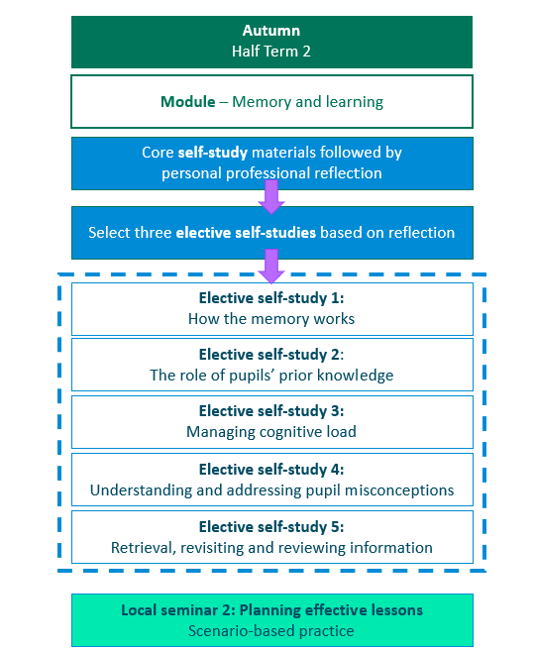

Onboarding
Schools should provide details about any onboarding process they offer which introduces mentors to their role within the ECT programme. NIoT materials for a live seminar also are available or schools may wish to provide their own.

Mentor programme – example of how your time could be spent in year 1
Schools may wish to provide an overview of how mentors’ time will be allocated in year 1. This should include observations and ECT meetings.

Return to Content page
Role and responsibilities
The Early Career Teacher Entitlement provides ECTs with support from several key roles. Your ECT will work more closely with some than others – for example, you as their mentor – but each role plays an important part in supporting the induction process.
Mentor – Mentors provide ECTs with tailored support, applied to address the specific challenges of the school setting and their ECT’s specific needs. They will help ECTs to navigate their induction period and to develop the skills and knowledge needed for long-term success as a skilled classroom teacher.
This includes meeting regularly to provide support and feedback
providing or arranging mentoring and coaching around specific phases and subject areas.
Induction tutor – This role has different responsibilities to a mentor. These include providing or coordinating ECT’s induction programme and carrying out assessments and regular progress reviews. In some cases, for example in smaller schools or settings, the induction tutor may also be the mentor.
Headteacher or Principals – Headteachers and principals have various roles, many of which focus on ensuring compliance. They will oversee the overall induction of ECTs, ensuring both the induction tutor and mentor have the time and ability to provide effect support. They are also responsible for appointing an appropriate body and making the recommendations to them regarding your ECT’s performance against the Teachers’ Standards. See below.
Lead Provider – Lead Providers are responsible for designing and delivering impactful and tailored training for ECTs and their mentors based on the Initial Teacher Training and Early Career Framework (ITTECF). The training can also be delivered by schools themselves and this is known as a ‘school-led route’. Your Mentor programme falls into this category.
Delivery Partners - Educational institutions that are approved to facilitate high quality training to ECTs and their mentors. This can include schools, MATs, hubs, charities, organisations. Their local expertise contributes to the overall improvement of teaching practice within the local community.
Appropriate Body – The appropriate body is responsible for quality assurance within the induction process, ensuring that all aspects are correctly enacted. The headteacher or principal will report to them on your progress and performance against the Teachers’ Standards to them throughout ECT’s two-year induction. Depending on where you work, the appropriate body could be:
- Teaching School Hubs (TSHs)
- Multi-Academy Trusts (MATs) (if authorised)
- Appropriate Body Services from the Independent Schools Teacher Induction Panel (ISTIP) (for independent schools)
You can find out more about each role in Section 5 here: Induction for early career teachers (England) statutory guidance

Your responsibilities as a mentor
Schools should also outline the role of mentors within their own school setting or trust.

You may wish to include:
- details regarding mentor observations including timings and frequency
- any specific observation model being used
- an outline of the purpose and structure of mentor meetings
- how the mentor will support ECTs with pastoral or wellbeing needs

Return to Content page
Further reading and resources
You can read more about the Initial Teacher Training and Early Career Framework here: Initial Teacher Training and Early Career Framework
The National Institute of Teaching (NIoT) has published the findings from the first two stages of its inaugural research project, ‘Mentoring and coaching trainee and early career teachers’. You can read more here: Research – The National Institute of Teaching (niot.org.uk)
You can read more about the statuary guidance around the induction for early career teachers here: Induction for early career teachers (England) statutory guidance

