
ECT Programme Mentor support materials – Core self-study
Memory and learning
​
​These materials are intended for use by those who design and deliver induction as part of a school-led programme for early career teachers. Opportunities for schools or trusts to add detail relevant to their context have been identified.


This self-study material is for use with mentors working with early career teachers (ECTs) in year one of the ECT programme. It provides an outline of the content from ECTs’ core self-study relating to memory and learning so that mentors are familiar with the underpinning research and evidence.






Introduction
Approximate time to complete: 3 minutes
Welcome to these optional Early Career Teacher Programme Mentor Support Materials for those working with Early Career Teachers (ECTs) in year 1 of the programme. This will give you an understanding of what your ECT has been learning about and will help you to support your ECT in selecting their elective self-studies.
In these optional materials you have been provided with an overview of the content that ECTs will be exploring in their core self-study relating to memory and learning. This content will focus on how to ensure teachers teach and embed pedagogy which is underpinned by how pupils learn.
Here’s a reminder of how each of the self-studies for ECTs fit into year one the ECT programme:
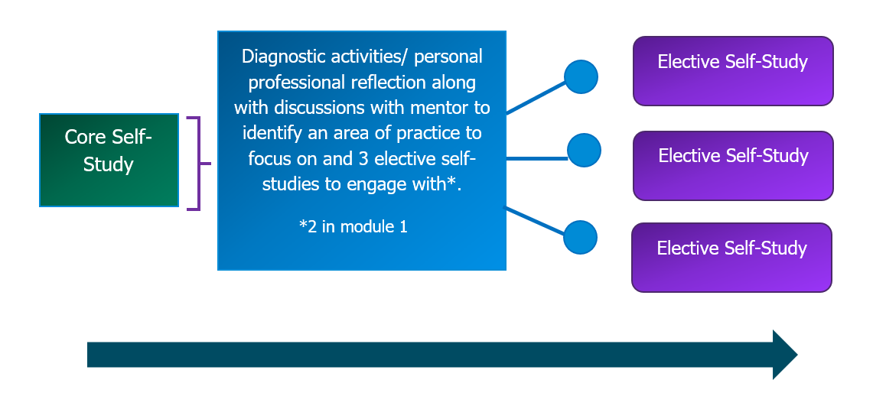
All early career teachers will complete the core self-study. They will then reflect on their current practice and prior experience. This will be followed by a discussion with you, their mentor, in which you will jointly select three of the elective self-studies that they will complete for this module.
Please note, the overview of the ECT self-study material is optional reading. You can go straight to the Next Steps: Working with your ECT to reflect on their practice if you wish.
You should begin by reading these materials relating to the core self-study which outlines the theory and related evidence underpinning the module. You should then read the support materials for each of the elective self-studies that your early career teacher has selected to complete.
An overview of the elective self-studies in this module below:
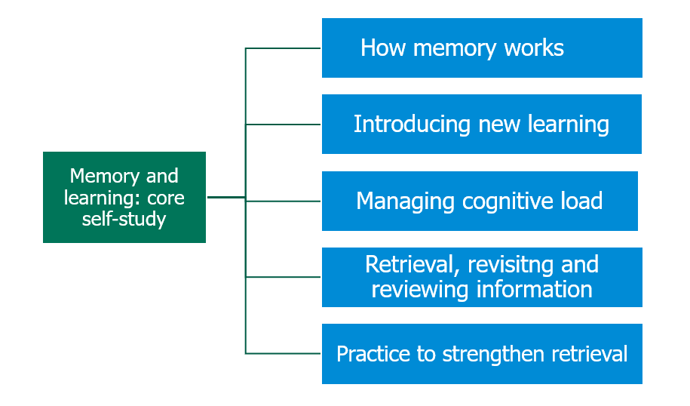
It is suggested that you review the content of the core self-study during week one of the half term and then read the relevant elective self-study support material in advance of observing and meeting with your early career teacher in the subsequent weeks. This will help guide your discussion and provide suggested possible actions for your ECT to develop their practice in their focus area.
Estimated study time: 15 minutes per week/90 minutes per half term
Content
Summary of ECT materials – What does the evidence say about…
How memory works | Page 4
Introducing new learning | Page 5
Manging cognitive load | Page 6
Retrieval, revisiting and reviewing information | Page 7
Practice to strengthen retrieval | Page 8
Next steps: Working with your ECT to reflect on their practice | Page 9
Related ITTECF framework statements | Page 10
References and further reading | Page 12
Appendix | Page 16

Memory and learning
Approximate time to complete: 10 minutes
Summary of content from ECT materials – what the evidence says about…
- How memory works
Learning is only meaningful when it leads to a lasting change in what a pupil knows or can do. Sweller (2011) highlights that if nothing has changed in long-term memory, then no real learning has occurred. It is therefore essential that teachers understand how memory, particularly working and long-term memory, functions in order to design instruction that supports retention and transfer of knowledge.
A common confusion in the classroom is the difference between performance and learning (Bjork & Bjork, 2011). Performance refers to what pupils can do in the moment, often supported by recent exposure or prompts, while learning reflects deeper, lasting changes in understanding. This means that quick improvements in performance don’t always translate into secure, long-term learning. In fact, strategies that feel more effortful and slower in the moment often lead to stronger retention.
Effective teaching must focus on building long-term memory. This includes retention (storing information over time) and transfer (being able to recall and apply that information when needed). Willingham (2009) explains that transfer happens when long-term memories are activated and used in the limited-capacity space of working memory.
Working memory is where active thinking happens, but it can only hold a few pieces of information at once, typically around four "chunks" (Cowan, 2001). It is fragile, easily disrupted by distraction, and easily overwhelmed. This makes cognitive overload a real risk if we try to introduce too much new or complex material at once.
To manage this, teachers should slow down, break learning into smaller steps (Rosenshine, 2012), and use memory aids like visuals, prompts, or worked examples (Willingham, 2009). These supports reduce the pressure on working memory and allow pupils to focus their attention on understanding new ideas.
This is particularly important for pupils with poor working memory, a condition affecting around 10% of learners (Gathercole, 2008). These pupils may appear inattentive, struggle to follow instructions, or forget information mid-task. Without support, they risk falling further behind. Recognising and supporting these learners involves simplifying instructions, repeating key information, using visual supports, and teaching strategies like notetaking and place-keeping.
Overall, the limited capacity of working memory has major implications for lesson planning, instruction, and curriculum sequencing. Teachers need to design learning experiences that avoid overload, promote retrieval, and help pupils make meaningful connections with what they already know.
- Introducing new learning
Introducing new information effectively requires careful planning. The best way to teach complex content is to break it into smaller steps and teach these incrementally. At the topic level, this involves isolating key skills and knowledge, teaching them separately, and only combining them once pupils are confident with each element. Within a single explanation, this approach reduces the strain on working memory and allows teachers to assess understanding and reteach as needed.
Learning happens when new ideas connect to prior knowledge. This prior knowledge, stored in long-term memory as schemas, plays a crucial role in how new information is processed. When pupils have strong prior knowledge, they are better able to understand, retain, and apply new concepts. Conversely, limited prior knowledge can lead to cognitive overload and poor learning outcomes (EEF, 2021b).
The advantage prior knowledge offers cannot be overstated. It enables pupils to learn more efficiently and supports the acquisition of increasingly complex knowledge. This leads to a ‘Matthew effect’, where pupils with more knowledge continue to learn faster, while those with less fall further behind (Simonsmeier et al., 2018).
Assessing prior knowledge is vital before introducing new content. This helps identify what pupils know, what gaps exist, and what misconceptions may need addressing. Methods such as multiple-choice questions, open questions, true/false tests, and self-assessments can all be effective. The best approach depends on what you're assessing and the learners' abilities.
Importantly, prior knowledge can be both beneficial and problematic. While it guides attention and supports learning, it can also lead to misconceptions, selective attention, and inflexible thinking. Teachers must therefore be alert to both the advantages and limitations of what pupils already know.
Chi (2009) outlines three types of prior knowledge conditions: none, incomplete, and incorrect. Each demands a different teaching approach, introducing new ideas, filling gaps, or directly challenging misconceptions. Misconceptions should be anticipated and addressed through deliberate task design.
Breaking down learning into manageable steps is a key teaching strategy. This requires subject and pedagogical knowledge to sequence content logically and in a way that matches pupils’ cognitive capacity. Teaching should activate and build on prior knowledge, using guided instruction that reduces cognitive load (Rosenshine, 2012).
- Managing cognitive load
Cognitive Load Theory (CLT), developed by Sweller (198), is rooted in understanding the limitations of working memory and how learning can be optimised. Working memory can only process around 3–5 items at once, and exceeding this capacity risks cognitive overload, which impairs understanding and retention (EEF, 2018).
CLT posits that information is stored in long-term memory as schemas, structured chunks of knowledge that help reduce cognitive demand. A schema acts like a single element in working memory, allowing learners to process complex ideas more efficiently.
Types of Cognitive Load
- Intrinsic Load: Linked to the complexity of the material and learner expertise. It is necessary but should be managed through clear sequencing and chunking.
- Extraneous Load: Caused by poorly designed instruction, which distracts from learning. Teachers can reduce it by removing irrelevant information, using clear instructions, and minimising distractions.
- Germane Load: Helpful load that supports learning, such as linking concepts to prior knowledge or using worked examples. Good teaching aims to maximise this type.
To manage cognitive load effectively:
- reduce extraneous load by simplifying materials, avoiding cluttered layouts, and using concise instructions
- optimise intrinsic load by sequencing lessons logically, chunking content, and using worked examples
- support germane load by encouraging connections to prior knowledge, using dual coding (combining visuals with verbal explanations), and providing scaffolding
- teachers should not simply minimise cognitive load, but optimise it, ensuring mental resources are focused on learning rather than distractions (EEF, 2021a)
Dual coding, combining verbal explanations with visuals, supports learning by utilising both visual and auditory channels. This is particularly effective for complex or hierarchical content (Caviglioli, 2019).
Worked examples show pupils how to solve problems step-by-step, directing attention to the process rather than forcing them to figure it out independently. These are most effective after new material has been introduced. Good examples should:
- clearly state the problem;
- explain each step explicitly; and
- show the final solution.
To enhance impact, teachers should use multiple examples, alternate with practice, and reduce scaffolding over time, a process called faded worked examples. Pupils can also benefit from identifying errors in examples to deepen understanding.
However, once learners gain expertise, continued use of worked examples may hinder progress, a phenomenon known as the expert reversal effect (Kalyuga, 2007). At this point, support should be gradually withdrawn to promote independent problem-solving.
- Retrieval, revisiting and reviewing information
Retrieval practice, the act of recalling information from memory, is a powerful learning strategy that not only assesses but actively strengthens memory. When pupils retrieve knowledge, they reinforce neural connections, making future recall easier and improving fluency. This frees up working memory for new learning and fosters intrinsic motivation by promoting success.
Retrieval practice can take many forms, including multiple-choice questions, retrieval grids, true/false tasks, and labelling diagrams. While it should be appropriately challenging, teachers must calibrate the difficulty so all pupils, including those with SEND, experience success. Starting with material pupils already know helps build confidence and prevents frustration.
Importantly, retrieval practice is not about assessment but about enhancing learning. It can be particularly beneficial for pupils with lower working memory capacity, helping them consolidate knowledge more effectively.
Two concepts underpin retrieval success: retrieval strength (how easily a memory can be accessed) and storage strength (how deeply embedded that memory is). Although retrieval and storage strength increase with study, the greatest learning happens when retrieval is difficult, low retrieval strength provides the biggest boost to storage strength.
Teachers must guard against the illusion of learning that occurs during massed practice, cramming content in one go. While this can create a false sense of fluency, it typically doesn’t lead to long-term retention.
In contrast, spaced practice, spreading out retrieval sessions over time, is highly effective. It combats the natural forgetting process, as illustrated by the Ebbinghaus Forgetting Curve. By delaying and interleaving review sessions, pupils are forced to retrieve information after partial forgetting, which strengthens memory.
Spaced practice works both across lessons and within them. Within-lesson spacing involves deliberately switching focus and then returning to previously taught material. Though it demands more planning, this approach can reinforce earlier learning and make knowledge more durable.
Retrieval practice is also enhanced when feedback is provided, allowing learners to correct errors and deepen understanding. Moreover, well-designed questions can go beyond factual recall to foster deep thinking and make connections between concepts.
Ultimately, embedding regular, well-calibrated retrieval opportunities, both spaced across time and within lessons, supports lasting learning. For all pupils, and especially those with SEND, consistent use of retrieval practice helps build strong, flexible knowledge that can be readily applied in a variety of contexts.
- Practice to strengthen retrieval
Effective learning involves structured transitions from guided to independent practice, with teachers playing a central role in helping pupils master new material. Initially, teachers introduce small amounts of information, model processes, and guide pupil practice through questioning, elaboration, and constant feedback. This guided practice phase is crucial for deepening understanding, avoiding early errors, and making meaningful connections between new and prior knowledge (Rosenshine, 2012).
As pupils grow in competence, support is gradually withdrawn. Teachers encourage pupils to verbalise strategies, solve problems collaboratively, and eventually take on tasks independently. This process fosters automaticity and embeds knowledge over time, a concept known as "overlearning" (Coe et al., 2020).
Effective practice is not repetitive but consists of structured steps that build independence. It includes regular reviews, feedback, and correction opportunities, ensuring that pupils develop both understanding and long-term retention.
Practice testing is a powerful tool in this process. Low- or no-stakes quizzes help reinforce memory more effectively than rereading, according to Dunlosky et al., (2013). Retrieval strengthens both the retrieval and storage strength of information, especially when pupils understand that the goal is learning, not judgement. Teachers can also encourage pupils to use self-testing strategies, supporting their development as independent learners (Deans for Impact, 2015).
Varied practice conditions, including changing question formats and applying knowledge to new scenarios, further enhance learning. These "desirable difficulties" (Bjork & Bjork, 1992) challenge pupils just enough to trigger effective encoding and retrieval processes. This improves both recall and the flexibility of knowledge across different contexts.
However, difficulty must be calibrated. Challenges are only beneficial when pupils have the foundational knowledge to handle them. Without this, tasks can become demotivating and unproductive. Teachers should explicitly address the discomfort that can come with deeper learning. Helping pupils understand that such discomfort is part of the learning process can motivate them to persist through challenges.
Ultimately, pupils must learn not just what to learn, but how learning works. Rereading and note copying, while comfortable, are ineffective for memory retention. By emphasising retrieval practice, varied challenges, and the productive struggle of desirable difficulty, teachers can equip pupils with the tools and mindset needed for deep, lasting learning.

Click here to return to Content page

Next steps: Working with your ECT to reflect on their practice
Approximate time to complete: 1 minute
Schools or trusts may wish to add further details on how this should be completed, to align with their own mentoring structures and processes.
- Discuss and agree with your early career teacher which 3 elective self-studies they should choose for this half term. You may wish to use the framework in the Appendix to support this discussion.
- Read the mentor session materials for the 3 elective self-studies that your early career teacher has selected. These will:
- outline how the theory looks in practice
- share the ‘active ingredients’ that make the practice effective
- suggest possible action steps for your early career teacher to put the theory into practice
Each self-study will take approximately 15 minutes.

Click here to return to Content page

Related ITTECF framework statements
How pupils learn
Learn that…
2.1. Learning involves a lasting change in pupils’ capabilities or understanding.
2.2. Prior knowledge plays an important role in how pupils learn; committing some key facts to their long-term memory is likely to help pupils learn more complex ideas.
2.3. An important factor in learning is memory, which can be thought of as comprising two elements: working memory and long-term memory.
2.4. Working memory is where information that is being actively processed is held, but its capacity is limited and can be overloaded.
2.5. Long-term memory can be considered as a store of knowledge that changes as pupils learn by integrating new ideas with existing knowledge.
2.6. Pupils have different working memory capacities; some pupils with SEND may have more limited working memory capacity than their peers without SEND.
2.7. Where prior knowledge is weak, pupils are more likely to develop misconceptions, particularly if new ideas are introduced too quickly.
2.8. Regular purposeful practice of what has previously been taught can help consolidate material and help pupils remember what they have learned.
2.9. Requiring pupils to retrieve information from memory, and spacing practice so that pupils revisit ideas after a gap are also likely to strengthen recall.
2.10. Worked examples that take pupils through each step of a new process are also likely to support pupils to learn.
Classroom practice
4.2. Effective teachers introduce new material in steps, explicitly linking new ideas to what has been previously studied and learned.
4.8. Practice is an integral part of effective teaching; ensuring pupils have repeated opportunities to practise, with appropriate guidance and support, increases success.
Learn how to…
Avoid overloading working memory, by:
2.a. Taking into account pupils’ prior knowledge when planning how much new information to introduce.
2.b. Breaking complex material into smaller steps (for example: using partially completed examples to focus pupils on the specific steps).
2.c. Reducing distractions that take attention away from what is being taught (for example: keeping the complexity of a task to a minimum, so that attention is focused on the content).
Build on pupils’ prior knowledge, by:
2.d. Identifying possible misconceptions and planning how to prevent these forming.
2.e. Linking what pupils already know to what is being taught (for example: explaining how new content builds on what is already known).
2.f. Sequencing lessons so that pupils secure foundational knowledge before encountering more complex content.
2.g. Encouraging pupils to share emerging understanding and points of confusion so that misconceptions can be addressed.
Increase likelihood of material being retained, by:
2.h. Balancing exposition, repetition, practice and retrieval of critical knowledge and skills.
2.i. Planning regular review and practice of key ideas and concepts over time (for example: through carefully planned use of structured talk activities).
2.j. Designing practice, generation and retrieval tasks that provide just enough support so that pupils experience a high success rate when attempting challenging work.
2.k. Increasing challenge with practice and retrieval as knowledge becomes more secure (for example: by removing scaffolding, lengthening spacing or introducing interacting elements).
Click here to return to Content page

References
- Adesope, O. O., Trevisan, D. A., & Sundararajan, N. (2017). Rethinking the Use of Tests: A Meta-Analysis of Practice Testing. Review of Educational Research, 87(3), 659–701.
- Agarwal, P. K., Finley, J. R., Rose, N. S., & Roediger, H. L. (2017). Benefits from retrieval practice are greater for students with lower working memory capacity. Memory, 25(6), 764–771.
- Atkinson, R. C., & Shiffrin, R. M. (1968). Human memory: A proposed system and its control processes. The Psychology of Learning and Motivation: Advances in Research and Theory, 2, 89–195.
- Barrett, L. F., & Tugade, M. M. (2004). Individual differences in emotional reactivity. Emotion, 4(3), 268–286.
- Bjork, R. A., & Bjork, E. L. (1992). A new theory of disuse and an old theory of stimulus fluctuation. In A. F. Healy, S. M. Kosslyn, & R. M. Shiffrin (Eds.), From learning processes to cognitive processes: Essays in honor of William K. Estes (Vol. 2, pp. 35–67). Hillsdale, NJ: Erlbaum.
- Bjork, E. L., & Bjork, R. A. (2011). Making things hard on yourself, but in a good way: Creating desirable difficulties to enhance learning. In M. A. Gernsbacher, R. W. Pew, L. M. Hough, & J. R. Pomerantz (Eds.), Psychology and the real world: Essays illustrating fundamental contributions to society (pp. 56–64). Worth Publishers.
- Caviglioli, O. (2019). Dual Coding with Teachers. Crown House Publishing.
- Centre for Education Statistics and Evaluation (2017). Cognitive Load Theory: Research that teachers need to understand. New South Wales Government. [Online] Available at: https://education.nsw.gov.au/about-us/educational-data/cese/publications/literature-reviews/cognitive-load-theory [Accessed 7 July 2023].
- Chi, M.T.H. (2009). Three types of conceptual change: Belief revision, mental model transformation, and categorical shift. In S. Vosniadou (Ed.), Handbook of research on conceptual change (pp. 61-82). Hillsdale, NJ: Erlbaum.
- Coe, R., Rauch, C. J., Kime, S., & Singleton, D. (2020). Great Teaching Toolkit: Evidence Review. Evidence Based Education. Available https://www.cambridgeinternational.org/Images/584543-great-teaching-toolkit-evidence-review.pdf. [Accessed 2 December 2024].
- Cowan, N. (2008). What are the differences between long-term, short-term, and working memory? Progress in brain research, 169, 323-338.
- Deans for Impact (2015). The Science of Learning. [Online] Available at: https://deansforimpact.org/resources/the-science-of-learning/ [Accessed 7 July 2023].
- Dunlosky, J., Rawson, K. A., Marsh, E. J., Nathan, M. J., & Willingham, D. T. (2013). Improving students’ learning with effective learning techniques: Promising directions from cognitive and educational psychology. Psychological Science in the Public Interest, Supplement, 14(1), 4–58.
- Education Endowment Foundation (2021a). Cognitive Science Approaches in the Classroom: A Review of the Evidence. [Online] Available at: https://educationendowmentfoundation.org.uk/education-evidence/evidence-reviews/cognitive-science-approaches-in-the-classroom [Accessed 7 July 2023].
- Education Endowment Foundation (2021b). Metacognition and self-regulated learning: Guidance Report. [Online] Available at: Metacognition and Self-regulated Learning | EEF (educationendowmentfoundation.org.uk) [Accessed 7 July 2023].
- Education Endowment Foundation, (2021b)., Teacher Feedback to Improve Pupil Learning guidance report. Available at: Teacher Feedback to Improve Pupil Learning | EEF
- Education Endowment Foundation, (2021c)., Special Educational Needs in Mainstream Schools guidance report. Available at: Special Educational Needs in Mainstream Schools | EEF
- Education Endowment Foundation (EEF). (2019). Improving Mathematics in Key Stages 2 and 3. Education Endowment Foundation. Retrieved from https://educationendowmentfoundation.org.uk
- Gathercole, S., (2008). Working memory in the classroom. The Psychologist, vol 21 no 5. Available at: https://www.bps.org.uk/psychologist/working-memory-classroom (Accessed 30 March 2023).
- Gersten, R., Beckmann, S., Clarke, B., Foegen, A., Marsh, L., Star, J. R., & Witzel, B. (2009). Assisting students struggling with mathematics: Response to intervention (RtI) for elementary and middle schools (NCEE 2009-4060). Washington, DC: National Center for Education Evaluation and Regional Assistance, Institute of Education Sciences, U.S. Department of Education.
- Kalyuga, S. (2007). Expertise reversal effect and its implications for learner-tailored instruction. Educational Psychology Review, 19(4), 509-539.
- Kirschner, P., Sweller, J., & Clark, R. E. (2006). Why Minimal Guidance During Instruction Does Not Work: An Analysis of the Failure of Constructivist, Discovery, Problem-Based, Experiential, and Inquiry-Based Teaching. Educational Psychologist, 41(2), 75–86. [Online] Available at: https://www.tandfonline.com/doi/abs/10.1207/s15326985ep4102_1 [Accessed 7 July 2023].
- Landauer, T. K., & Bjork, R. A. (1978). Optimum rehearsal patterns and name learning. Practical Aspects of Memory, 625–632.
- Lemov, D. (2015). Teach Like a Champion 2.0: 62 Techniques that Put Students on the Path to College. Jossey-Bass.
- Murre, M. J., Dros, J. (2015). Replication and Analysis of Ebbinghaus’ Forgetting Curve. https://journals.plos.org/plosone/article?id=10.1371/journal.pone.0120644
- Pan, S. C., & Rickard, T. C. (2018). Transfer of test-enhanced learning: Meta-analytic review and synthesis. Psychological Bulletin, 144(7), 710–756.
- Pashler, H., Bain, P., Bottge, B., Graesser, A., Koedinger, K., McDaniel, M., and Metcalfe, J. (2007) Organizing Instruction and Study to Improve Student Learning (NCER 2007-2004). Washington, DC: National Center for Education Research, Institute of Education Sciences, U.S. Department of Education. [Online] Available at: https://files.eric.ed.gov/fulltext/ED498555.pdf [Accessed 7 July 2023].
- Pashler, H., Mcdaniel, M., Rohrer, D., & Bjork, R. (2008). Learning Styles: Concepts and Evidence. Psychological Science in the Public Interest, 9(3).
- Perry (2021): Perry, N. (2021). Metacognition and Learning: A Guide for Students and Educators. Routledge.
- Peterson, L., & Peterson, M. J. (1959). Short-term retention of individual verbal items. Journal of Experimental Psychology, 58(3), 193–198. https://doi.org/10.1037/h0049234
- Roediger, H.L. and Butler, A.C. (2011) The Critical Role of Retrieval Practice in Long-Term Retention. Trends in Cognitive Sciences, 15, 20-27.
https://doi.org/10.1016/j.tics.2010.09.003
- Rosenshine, B. (2012). Principles of Instruction: Research-based strategies that all teachers should know. American Educator, 36, 12–20. https://www.aft.org/sites/default/files/periodicals/Rosenshine.pdf [Accessed: 24 Jan 2023].
- Simonsmeier, B.A., Maja Flaig, Anne Deiglmayr, Lennart Schalk & Michael Schneider (2018). Domain-specific prior knowledge and learning: A meta-analysis, Educational Psychologist, DOI: 10.1080/00461520.2021.1939700.
- Soderstrom, N. C., & Bjork, R. A. (2015). Learning Versus Performance: An Integrative Review. Perspectives on Psychological Science, 10(2), 176–199.
- Sweller, J., van Merrienboer, J.J.G. & Paas, F.G.W.C. (1998). Cognitive Architecture and Instructional Design. Educational Psychology Review 10, 251–296.
- Sweller, J. (2016). Cognitive load theory, evolutionary educational psychology, and instructional design. In D. C. Geary & D. B. Berch (Eds.), Evolutionary perspectives on child development and education (pp. 291–306). Springer International Publishing/Springer Nature.
- Tulving, E. (1972). Episodic and semantic memory. In E. Tulving & W. Donaldson (Eds.), Organization of Memory (pp. 381–403). New York: Academic Press.
- Willingham, D. T. (2009). Why don't pupils like school? A cognitive scientist answers questions about how the mind works and what it means for the classroom. Jossey-Bass/Wiley. [Online] Extract available at: https://www.aft.org/sites/default/files/WILLINGHAM%282%29.pdf [Accessed 3 December 2024].
- Wittwer, J., & Renkl, A. (2010). How Effective are Instructional Explanations in Example-Based Learning? A Meta-Analytic Review. Educational Psychology Review, 22(4), 393–409.

Click here to return to Content page

Appendix
Suggested prompts for mentor and ECT discussion
Mentors should use this framework to guide a reflective discussion with their ECT prior to selecting their elective self-studies. During this discussion, mentors should prompt ECTs to think about the pupils they teach as well as their progress since initial teaching training and current practice.
Reflecting on your current practice
Are there any areas of your current practice that you feel should be prioritised as development areas this half-term? Give reasons why.

Core self-study
Reflecting on the content of the core self-study, was there any evidence that you felt was particularly useful or insightful in relation to your development?
Ask the ECT to share their notes from the reflections in the core self-study. What do they highlight about their current practice and progress since their initial teacher training?

Reflecting on existing developmental targets
Discuss any current targets your ECT has (Career Entry Development Profile or other ITT targets, any current mentor targets or whole-school professional development targets). Do any of these link with the content of this core self-study?

Selecting your elective self-studies
Now, look at the list of elective self-studies with your ECT and, using the reflections from your meeting, agree together which 3 elective self-studies your ECT will complete this half term. Identify the order in which they will be completed.
First choice:
Second choice:
Third choice:

Click here to return to Content page

