
ECT Programme Mentor support materials – Core self-study
Adaptive practice
​
​These materials are intended for use by those who design and deliver a school-led Early Career Teacher programme. Opportunities for schools or trusts to add detail relevant to their context have been identified.


This self-study material is for use with mentors working with early career teachers (ECTs) in year one of the programme. It provides an outline of the content from ECTs’ core self-study relating to the module on planning and delivery so that mentors are familiar with the underpinning research and evidence.






Introduction
Welcome to these optional Early Career Teacher Programme Mentor Support Materials for those working with Early Career Teachers (ECTs) in year one of the programme. These will help you to support your ECT in selecting their elective self-studies.
In these materials you have been provided with an overview of the content that ECTs will be exploring in their core self-study relating to ‘Adaptive practice’.
Here’s a reminder of how each of the self-studies fit into year one of the ECT programme:
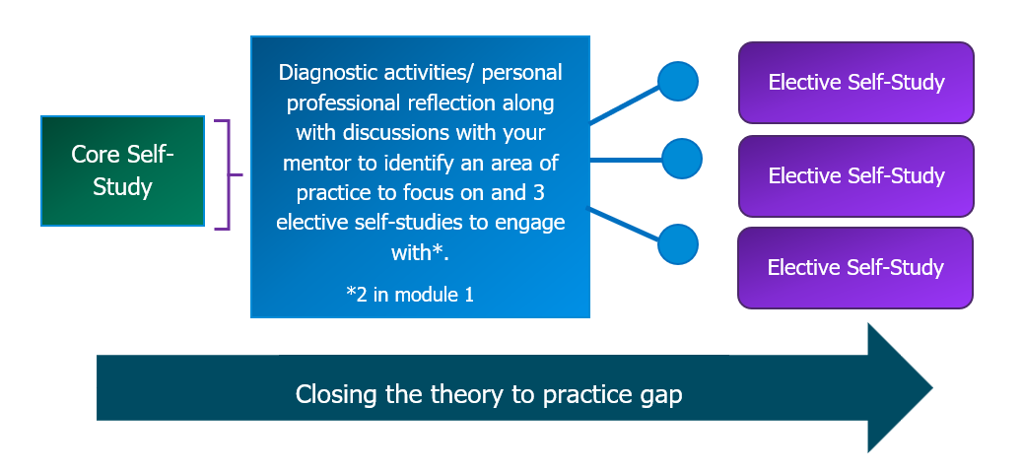
All early career teachers will complete the core self-study. They will then reflect on their current practice and prior experience. This will be followed by a discussion with you, their mentor, in which you will jointly select three of the elective self-studies that they will complete for this module.
Please note, the overview of the ECT self-study material is optional reading. You can go straight to the Next Steps: Working with your ECT to reflect on their practice if you wish.
If you select to read the full self-study, you should begin by reading these materials relating to the core self-study which outlines the theory and related evidence underpinning the module. You should then read the support materials for each of the elective self-studies that your early career teacher has selected to complete.
Here’s an overview of the elective self-studies in this module:
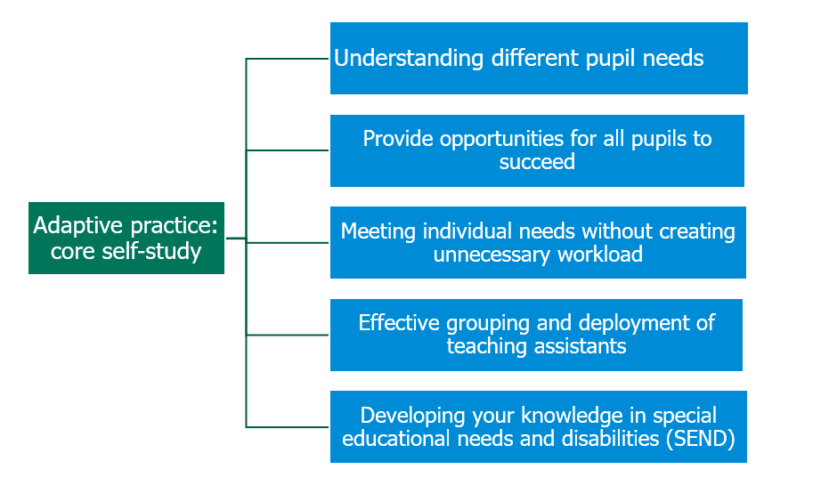
It is suggested that you review the content of the core self-study during week one of the half term and then read the relevant elective self-study support material in advance of observing and meeting with your early career teacher in the subsequent weeks. This will help guide your discussion and provide suggested possible actions for your ECT to develop their practice in their focus area.
Estimated study time: 15 minutes per week/90 minutes per half term

Content
Summary of ECT core materials – What does the evidence say about…
Understanding different pupil needs | Page 5
Providing opportunities for all pupils to succeed | Page 7
Meeting individual needs without creating unnecessary workload | Page 9
Effective grouping and deployment of teaching assistants (TAs) | Page 11
Developing your knowledge in special educational needs and disabilities (SEND) | Page 12
Next steps: working with your ECT to reflect on their practice | Page 14
Related Early Career Framework statements | Page 15
Further reading and references | Page 19
Appendix | Page 26

Adaptive Practice
Summary of content from ECT materials – what the evidence says about…
1. Understanding different pupil needs
Pupils learn at different rates and require varied levels of support. While intelligence significantly contributes to achievement, motivation also plays a vital role (Steinmayr et al., 2023). This means that even pupils who struggle academically can succeed with effective support and sustained motivation. As a teacher, actively fostering motivation can improve outcomes for all learners, regardless of their natural ability.
Research into growth mindset shows similar patterns. While the overall effects of mindset interventions are small, they can be beneficial for pupils from disadvantaged backgrounds or those at risk of underachievement (Sisk et al., 2018). Supporting these pupils to build confidence and resilience is key to improving progress.
As pupils grow older, cognitive ability remains important, but motivation, mindset, self-regulation, and effort become increasingly influential (Malanchini et al., 2024). Struggling pupils may not only have knowledge gaps but may also lack motivation or hold fixed mindsets. Teachers can use strategies such as formative assessment, scaffolding, praising effort, and maintaining high expectations to boost confidence and engagement.
Parental engagement further supports pupil learning. Many parents want to help but may be unsure how. Teachers play a vital role in guiding them. Strategies include modelling how to discuss learning at home, using accessible language, and offering informal workshops. Structured activities like shared reading are particularly effective (EEF, 2021g). Tailored, inclusive approaches are recommended (McMahon, 2023).
For pupils with SEND, collaboration with parents and specialist colleagues is essential. The SEND Code of Practice (DfE, 2014) stresses parental involvement in planning support. Structured communication—such as regular meetings and informal contact—builds shared understanding and trust (EEF, 2021c). Practical guidance from the SENCO helps ensure inclusive, targeted provision.
Working with SENCOs, teaching assistants (TAs), and external specialists supports effective intervention (DfE, 2021). Research shows that interventions are most effective when integrated with whole-class teaching (Davis et al., 2004; EEF, 2021c). Teachers must retain responsibility for progress and ensure interventions are evidence-based and closely linked to classroom learning (Farrell et al., 2010; Ebbels et al., 2019).
Successful collaboration requires shared goals, clear coordination, mutual respect, and TA training (McLeskey et al., 2017; Cullen et al., 2020). Poor collaboration—such as over-reliance on untrained TAs or lack of planning—can hinder progress (EEF, 2025a). Effective support must be purposeful, structured, and inclusive.

Click to return to the Content page

2. Providing opportunities for all pupils to succeed
Adapting teaching in response to pupil need is essential for ensuring progress. Not all pupils progress at the same rate, and some require different levels of support to meet high expectations (Eaton, 2022). Responsive teaching includes using formative assessment to address misconceptions, breaking content into smaller steps (Deunk et al., 2018), and balancing new learning with opportunities to revisit key knowledge (Gallagher et al., 2022).
Adaptive teaching within whole-class instruction is more effective than fixed ability grouping, which can limit progress, particularly for lower-attaining pupils (Deunk et al., 2018). Grouping practices are often shaped by pupils’ prior attainment and learning identities (Tereshchenko et al., 2018).
Individualised support can be powerful when used to complement, not replace, high-quality teaching (EEF, 2025a). Effective individualised instruction is structured, fosters independence, and links closely to classroom learning.
Scaffolding is key to helping all pupils—especially those with SEND—access learning without fostering dependence. Techniques such as modelling, ‘first, now, next’ routines, and consistent expectations build confidence. The timing and level of support matter: too little, and pupils may struggle; too much, and they may become reliant (Van de Pol et al., 2015).
Structured support is particularly important for pupils with SEND. Collaboration with SENCOs, colleagues, and families helps identify barriers and effective strategies (DfE, 2021). Inclusive strategies, rather than isolated interventions, are more effective (Davis et al., 2004). The EEF’s Seven-Step Model (2021b) outlines a framework for building independence, from activating prior knowledge through to reflection.
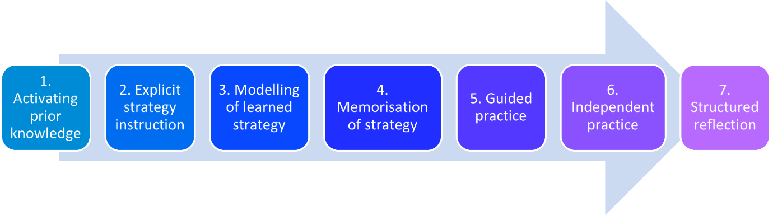
Adapted from EEF: Metacognition and Self-Regulated Learning guidance, 2021

This aligns with Fisher and Frey’s (2004) "I Do, We Do, You Do" model, which gradually shifts responsibility from teacher to pupil, particularly benefiting those with SEND (EEF, 2021a, 2025a).

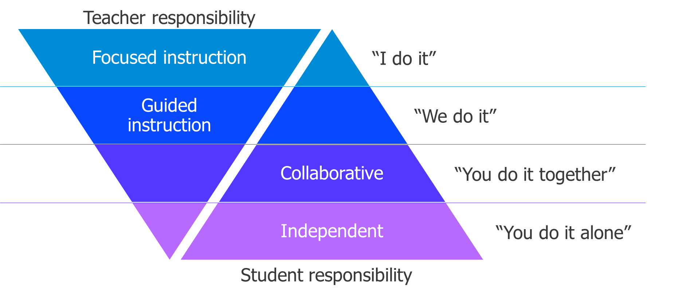
Gradual release of responsibility framework (Fisher & Frey, 2004)
Positive relationships and inclusive environments also enhance outcomes. Teacher attitudes, high expectations, and structured peer collaboration promote both academic and social success (Rix et al., 2009; Cullen et al., 2020). Inclusive settings benefit all pupils; those without SEND also show small academic gains (Szumski et al., 2017).
Assistive technology (AT) can further support access and independence. Tools like text-to-speech and visual aids improve engagement and literacy (EEF, 2019; 2021; House of Lords Library, 2023). When AT is embedded in everyday routines, with training for both teachers and pupils, it boosts confidence, independence, and attainment (DfE, 2024). Clear school policies on AT use, including during assessment, ensure consistent support and long-term impact.
Click here to return to Content page
3. Meeting individual needs without creating unnecessary workload
Effective adaptive teaching does not mean lowering expectations or creating separate lessons (EEF, 2022; Education South West). Instead, it focuses on understanding pupil needs through formative assessment, using scaffolds only when necessary, and making the curriculum do the heavy lifting to minimise workload and avoid fragmenting learning.
A well-structured curriculum helps reduce the need for constant in-lesson adjustments, but teachers must still anticipate and respond to barriers. Practical adaptive strategies include:
- checking understanding through questioning and tasks (EEF & Education South West, 2022);
- clarifying instructions;
- providing temporary scaffolds (e.g. worked examples, sentence stems); and
- ensuring accessibility through pre-teaching, seating adjustments, or reading support.
Unlike traditional differentiation, which often meant creating different activities for different pupils, adaptive practice uses a single high-quality task, with scaffolding added only for those who need it. For instance:
- use one textbook with optional supports (DfE, 2016);
- build practice opportunities into lessons; and
- prepare prompts for varying levels of understanding rather than separate tasks (EEF, 2022).
Connecting new learning to prior knowledge also enhances understanding. Strategies include diagnostic questions, retrieval practice, and pre-teaching key knowledge (EEF, 2021c). Not all teaching needs to be teacher-led; effective practice includes:
- guided practice with scaffolded support;
- high-quality questioning to prompt deeper thinking (Sherrington & Stafford, 2018); and
- independent tasks to consolidate learning (EEF, 2021h).
Technology and high-quality resources can reduce workload while keeping expectations high. The EEF’s 2025 trial found that AI-assisted planning cut planning time by 31% without reducing lesson quality (EEF, 2025b). Caution should be used when using AI however to ensure accuracy and compliance with data protection and your school policy. For further information regarding safe and ethical use of gen AI in education, see https://www.gov.uk/government/collections/using-ai-in-education-settings-support-materials
Assistive technology (AT) also streamlines differentiation and reduces demands on teachers by:
- allowing pupils to access materials independently;
- handling routine tasks like reading or scribing; and
- improving engagement and classroom behaviour (DfE, 2024).
Using existing resources such as textbooks and teacher guides (DfE, 2016) also reduces workload while maintaining quality. These resources often contain built-in scaffolds and clear sequences, allowing teachers to focus on adapting, not reinventing.
Finally, questioning is a powerful way to stretch and support pupils in the same lesson. Reframing questions—e.g., “How did you work that out?”, “Does anyone disagree?”, or “What if this were a different context?”—offers targeted challenge and support without increasing workload (Sherrington & Stafford, 2018).
Click here to return to Content page
4. Effective grouping and deployment of teaching assistants (TAs)
Within-class attainment grouping involves organising pupils by current attainment levels within the same class to tailor challenge and support. Common in primary literacy and maths, all pupils follow the same curriculum but with tasks at different levels of difficulty. When flexible and regularly reviewed, this approach can help adapt teaching without lowering expectations (EEF, 2021d; Tereshchenko et al., 2018).
However, pupils’ perceptions of grouping matter. Lower-attaining pupils may feel demotivated if groupings are seen as fixed. Research shows:
- Lower-attaining pupils often prefer mixed-attainment classes for collaboration and access to advanced thinking.
- Higher-attaining pupils have mixed views—some benefit from peer explanation, others feel held back.
- Disadvantaged pupils often favour mixed groups for the sense of equality.
- Some pupils express concern about pace and behaviour in mixed groups (Tereshchenko et al., 2018).
The EEF (2021d) reports a small positive impact from within-class grouping (+2 months’ progress), especially in primary maths, but little effect in secondary or literacy. Flexibility and careful structuring are essential to avoid reinforcing negative self-perceptions.
Avoid grouping by learning styles (e.g. visual, kinaesthetic), as there’s no reliable evidence this improves learning (Pashler et al., 2008; EEF, 2021d). In fact, it can limit confidence and self-efficacy. Instead:
- Focus on prior knowledge and barriers;
- Use adaptive teaching (e.g. modelling and scaffolding);
- Provide high-quality feedback; and
- Monitor how support affects motivation and progress.
Teaching Assistants (TAs) can have a significant impact, but only when used effectively. They should supplement, not replace the teacher. The EEF (2025a) and Blatchford et al. (2009) highlight that pupils, especially those with SEND or low attainment, can lose valuable teacher interaction when TAs lead learning without planning or training.
Effective TA deployment includes:
- Supporting during whole-class teaching;
- Using structured roles to identify who needs teacher input;
- Reinforcing learning via guided practice, not leading instruction;
- Rotating support so all pupils engage with the teacher.
Regular collaboration between teacher and TA is vital:
- Set clear goals before lessons;
- Debrief after lessons to adjust support;
- Connect intervention work back to the main curriculum.
To promote independent learning, TAs should:
- Avoid over-helping, rushing in, or repeating teacher instructions;
- Use open-ended questions and encourage thinking time;
- Focus on understanding, not just task completion (EEF, 2025a).
When well-prepared and used strategically, TAs can significantly enhance inclusive, high-impact teaching.
Click here to return to Content page
- Developing your knowledge in special educational needs and disabilities (SEND)
Not all professional development (PD) has equal impact. High-quality PD improves pupil outcomes, particularly when it is sustained over time and closely linked to classroom practice (Sims et al., 2021; Cordingley et al., 2015).
Teachers benefit most from PD that is practical, manageable, and embedded in their day-to-day teaching. Approaches such as instructional coaching, peer observation, and focused input from SENCOs can support the development of inclusive, adaptive strategies. Effective PD is not a one-off event; it is a process that requires ongoing reflection, feedback, and the opportunity to revisit and refine approaches (EEF, 2021m; Sims & Fletcher-Wood, 2021).
Attitudes and relationships also play a crucial role in shaping inclusive learning environments. Research shows that teachers who adopt positive views of inclusion and use inclusive strategies—such as peer mentoring and mixed-ability group work—can significantly enhance the sense of belonging for pupils with SEND (Heyder et al., 2020). Inclusion is not only structural but also social: the way teachers speak about inclusion, the strategies they model, and the collaborative relationships they build—particularly with TAs and SENCOs—can shape whether all pupils feel valued and supported (Monsen et al., 2014).
Engagement with research is most useful when it goes beyond reading and leads to practical application. The EEF’s CLAIMS framework (2024) supports critical engagement with evidence, helping teachers assess the reliability, applicability, and limitations of studies. It outlines six key questions to help you assess the quality of any study. These are:
- Conclusions – does the research only report findings that support one viewpoint while ignoring contradictory evidence?
- Limitations – are any weaknesses clearly stated (for example: small sample size or other explanations for the findings)?
- Applicability – are the findings being stretched beyond their original scope (for example: applied to different phases or subjects)?
- Independence – is the research free from commercial or other interests that might affect its conclusions?
- Methods – are the methods appropriate and clearly explained?
- Sample Population – does the study draw from a representative group of pupils?

However, to bring research into practice, teachers need structured opportunities to experiment and reflect. The expansive learning cycle (Engeström & Sannino, 2010) offers a helpful model:
- Identify a classroom challenge;
- Trial a small, targeted change;
- Use lesson observations or pupil work to assess impact;
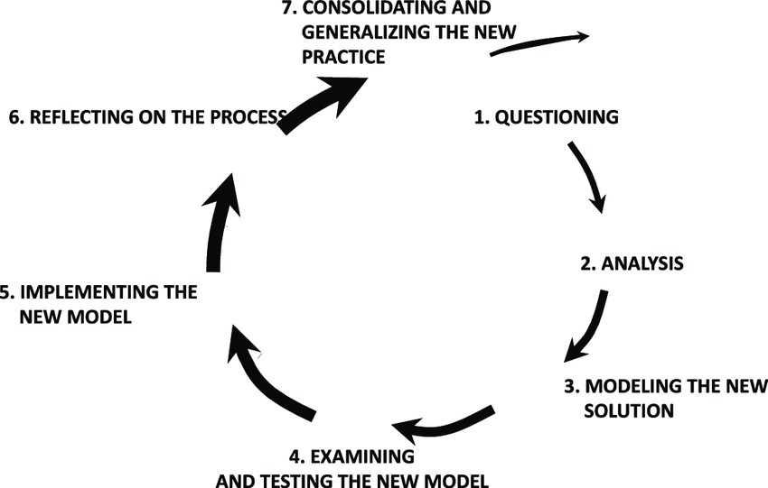
- Reflect and adjust in response to what’s learned.

The cycle of expansive learning (Engeström & Sannino, 2010)
Mentors and colleagues can support this process by acting as sounding boards—helping ECTs question evidence, plan small-scale implementation, and evaluate impact in a way that is sensitive to workload.
Ultimately, strong professional learning is about more than just acquiring strategies. It helps teachers build confidence, motivation, and a shared sense of purpose around inclusion. Teachers who see themselves as ongoing learners are better positioned to create classrooms where all pupils feel they belong (Heyder et al., 2020).
Click here to return to Content page

Next steps: working with your ECT to reflect on their practice
Approximate time to complete: 1 minute
- Discuss and agree with your early career teacher which 3 elective self-studies they should choose for this half term. You may wish to use the framework in the appendix to support this discussion.
- Read the mentor support materials for the 3 elective self-studies that your early career teacher has selected. These will:
- outline how the theory looks in practice
- share the ‘active ingredients’ that make the practice effective
- suggest possible action steps for your early career teacher to put the theory into practice.
Each self-study will take approximately 15 minutes.

Click here to return to Content page

Related Initial Teacher Training and Early Career Framework statements
Adaptive Practice
Learn that…
5.1. Adapting teaching in a responsive way, including by providing targeted support to pupils who are struggling, is likely to increase pupil success.
5.2. Pupils are likely to learn at different rates and to require different levels and types of support from teachers to succeed.
5.3. Seeking to understand pupils’ differences, including their different levels of prior knowledge and potential barriers to learning, is an essential part of teaching.
5.4. Adaptive teaching is less likely to be valuable if it causes the teacher to artificially create distinct tasks for different groups of pupils or to set lower expectations for particular pupils.
5.5. Flexibly grouping pupils within a class to provide more tailored support can support learning, but care should be taken to monitor its impact on attainment, behaviour, engagement and motivation, particularly for low attaining pupils.
5.6. There is a common misconception that pupils have distinct and identifiable learning styles. This is not supported by evidence and attempting to tailor lessons to learning styles is unlikely to be beneficial.
5.7. Pupils with SEND are likely to require additional or adapted support; working closely with colleagues, parents/carers, and pupils to understand barriers to learning and identify effective strategies is essential.
5.8. High quality teaching for all pupils, including those with SEND, is based on strategies which are often already practised by teachers, and which can be developed through training and support.
5.9. Technology, including educational software and assistive technology, can support teaching and learning for pupils with SEND.
Learn how to…
Develop an understanding of different pupil needs, by:
- 5.a. Identifying pupils who need new content further broken down.
- 5.b. Making use of formative assessment.
- 5.c. Working closely with the Special Educational Needs Co-ordinator (SENCO) and other SEND specialists or expert colleagues.
- 5.d. Working closely with the Designated Safeguarding Lead.
- 5.e. Supporting pupils with a range of additional needs and using the SEND Code of Practice: 0 to 25 years, which provides guidance on effective school systems and approaches for identifying and supporting the special educational needs of pupils with SEND.
- 5.f. Utilising existing opportunities to engage with parents and carers to better understand pupils’ individual needs (for example: meetings with parents).
Provide opportunity for all pupils to experience success, by:
- 5.g. Adapting lessons, whilst maintaining high expectations for all, so that all pupils have the opportunity to meet expectations.
- 5.h. Balancing input of new content with the revisiting of prior learning so that pupils master important concepts.
- 5.i. Making effective use of teaching assistants and other adults in the learning environment.
- 5.j. Making effective and judicious use of specialist technology to support pupils with SEND.
Meet individual needs without creating unnecessary workload, by:
- 5.k. Making use of well-designed resources (for example: textbooks, manipulatives).
- 5.l. Planning to connect new content with pupils' existing knowledge or providing additional pre-teaching if pupils lack critical knowledge.
- 5.m. Building in additional practice or removing unnecessary expositions.
- 5.n. Reframing questions to provide greater scaffolding or greater stretch.
- 5.o. Considering carefully whether intervening within lessons with individuals and small groups would be more efficient and effective than planning different lessons for different groups of pupils.
Group pupils effectively, by:
- 5.p. Applying high expectations to all groups, and ensuring all pupils have access to a rich curriculum.
- 5.q. Intentionally grouping in relation to a specific learning outcome, regularly reviewing those groupings, taking care to monitor their impact and avoiding the perception that groups are fixed.
Professional Behaviours
Learn that…
8.1. Effective professional development is likely to be sustained over time, building knowledge, motivating staff, developing teaching techniques, and embedding practice.
8.2. Reflective practice, supported by feedback from and observation of experienced colleagues, professional debate, and learning from educational research, is also likely to support improvement.
8.3. Teachers can make valuable contributions to the wider life of the school in a broad range of ways, including by supporting and developing effective professional relationships with colleagues.
8.4. Building effective relationships with parents, carers and families can improve pupils’ motivation, behaviour and academic success.
8.5. Teaching assistants (TAs) can support pupils more effectively when they are prepared for lessons by teachers, and when TAs supplement rather than replace support from teachers.
8.6. SENCOs, pastoral leaders, careers advisors and leaders and other specialist colleagues also have valuable expertise and can ensure that appropriate support is in place for pupils.
8.7. Engaging in high quality professional development can help teachers improve.
8.8. Teacher attitudes towards inclusion and SEND are a key determinant in the school experience of pupils with SEND.
8.9. Research evidence can vary in its level of reliability, which is determined by how the research was conducted and other factors that might introduce bias, such as the level of independence. High quality research communicates methods and limitations transparently.
Learn how to…
Develop as a professional, by:
- 8.a. Engaging in professional development focused on developing an area of practice with clear intentions for impact on pupil outcomes, sustained over time with built-in opportunities for practice.
- 8.b. Strengthening pedagogical and subject knowledge by participating in wider networks and as part of the lesson preparation process.
- 8.c. Seeking challenge, feedback and critique from mentors and other colleagues in an open and trusting working environment.
- 8.d. Engaging with research evidence by accessing reliable sources, seeking support for how findings can inform practice, and monitoring the impact of applications.
- 8.e. Reflecting on progress made, recognising strengths and weaknesses and identifying next steps for further improvement.
Build effective working relationships, by:
- 8.f. Contributing positively to the wider school culture and developing a feeling of shared responsibility for improving the lives of all pupils within the school.
- 8.g. Seeking ways to support individual colleagues and working as part of a team.
- 8.h. Communicating with parents and carers proactively and making effective use of parents’ evenings to engage parents and carers in their children’s schooling.
- 8.i. Working closely with the SENCO and other professionals supporting pupils with additional needs, making explicit links between interventions delivered outside of lessons with classroom teaching.
- 8.j. Drawing on guidance from expert colleagues, sharing the intended lesson outcomes with teaching assistants ahead of lessons.
- 8.k. Ensuring that support provided by teaching assistants in lessons is additional to, rather than a replacement for, support from the teacher.
- 8.l. Knowing who to contact with any safeguarding, or any pupil mental health concerns.
Manage workload and wellbeing, by:
- 8.m. Using and personalising systems and routines to support efficient time and task management.
- 8.n. Understanding the right to support (for example: to deal with misbehaviour, or support pupils with SEND).
- 8.o. Collaborating with colleagues to share the load of planning and preparation and making use of shared resources (for example: textbooks).
- 8.p. Protecting time for rest and recovery and being aware of support available to support good mental wellbeing.
Click here to return to Content page
Further reading
- https://assets.publishing.service.gov.uk/media/5a7f1c3a40f0b6230268d7fa/Eliminating-unnecessary-workload-around-planning-and-teaching-resources.pdf
- EEF Supporting the recruitment and retention of teachers in schools with high proportions of disadvantaged pupils: understanding current practice around managing teacher workload (2023)
- https://d2tic4wvo1iusb.cloudfront.net/production/documents/projects/Review-of-teacher-workload-management-approaches.pdf?v=1741253187
- https://my.chartered.college/research-hub/how-probing-questions-can-help-students-to-develop-their-understanding-and-ideas/
- https://educationendowmentfoundation.org.uk/projects-and-evaluation/projects/choices-in-edtech-using-generative-ai-chatgpt-for-ks3-science-lesson-preparation-2024-teacher-choices-trial
- https://educationendowmentfoundation.org.uk/news/moving-from-differentiation-to-adaptive-teaching
- Chartered College: https://my.chartered.college/research-hub/how-probing-questions-can-help-students-to-develop-their-understanding-and-ideas/ Chartered College - https://my.chartered.college/impact_article/using-assistive-technology-to-give-send-learners-independence/
- EEF - https://educationendowmentfoundation.org.uk/projects-and-evaluation/projects/choices-in-edtech-using-generative-ai-chatgpt-for-ks3-science-lesson-preparation-2024-teacher-choices-trial
- EEF - https://educationendowmentfoundation.org.uk/news/moving-from-differentiation-to-adaptive-teaching
- Research Schools - https://researchschool.org.uk/news/moving-forward-with-technology-in-the-classroom
- Sherrington T (2019) ‘Mindsets vs Metacognition’. Available at: https://teacherhead.com/2019/09/15/mindsets-vs-metacognition-two-eef-reports-and-a-clear-conclusion/

References
- Ausubel D., (1968) Meaningful Learning. Available at: Meaningful Learning—David P. Ausubel | SpringerLink
- Belland, B. R., Walker, A. E., & Kim, N. J. (2017) A Bayesian Network Meta-Analysis to Synthesize the Influence of Contexts of Scaffolding Use on Cognitive Outcomes in STEM Education. Review of Educational Research, 87(6), 1042- 1081. https://doi.org/10.3102/0034654317723009.
- Blatchford, P., Bassett, P., Brown, P., Martin, C., Russell, A., & Webster, R. (2009) Deployment and impact of support staff in schools: Characteristics, Working Conditions and Job Satisfaction of Support Staff in Schools. Available at: Blatchford_DeploymentAndImpactOfSupportStaffInSchools.pdf.
- Cattrall R., (2024) ‘Why bother with retrieval?’. Available at: https://educationendowmentfoundation.org.uk/news/eef-blog-why-bother-with-retrieval
- Cordingley, P., Higgins, S., Greany, T., Buckler, N., Coles-Jordan, D., Crisp, B., Saunders, L. & Coe, R. (2015) Developing Great Teaching. Accessible from: https://tdtrust.org/about/dgt.
- Cox S (2021) ‘Five ways to use diagnostic assessment in the mathematics classroom’. Available at: https://educationendowmentfoundation.org.uk/news/eef-blog-five-ways-to-use-diagnostic-assessment-in-the-mathematics-classroom
- Cullen, M. A., Lindsay, G., Hastings, R., Denne, L., & Stanford, C. (2020) Special Educational Needs in Mainstream Schools: Evidence Review. Available at: Cullen_SENDEvidenceReview.pdf.
- Cumming M., (2022) ‘The ‘ShREC’ approach in practice’ Available at: https://educationendowmentfoundation.org.uk/early-years/shrec-approach
- Davis, P., Florian, L., Ainscow, M., Dyson, A., Farrell, P., Hick, P., Rouse, M. (2004) Teaching Strategies and Approaches for Pupils with Special Educational Needs: A Scoping Study. Available at: Davis_TeachingStrategiesAndApproachesForPupilsWithSEND.pdf.
- Department for Education, 2014 (updated 2024) ‘SEND code of practice: 0 to 25 years. Available at: https://www.gov.uk/government/publications/send-code-of-practice-0-to-25
- Department for Education, (2016) Teacher Workload Survey 2016’. Available at: https://assets.publishing.service.gov.uk/media/5a80bcb7e5274a2e8ab51dfe/TWS_2016_FINAL_Research_report_Feb_2017.pdf
- Department for Education, (2019) Ways to reduce workload in your school(s). Available at: https://assets.publishing.service.gov.uk/media/5da053dee5274a595bf5daf6/Tips_for_school_leaders_.pdf
- Department for Education, (2021) SEN support: Findings from a qualitative study. Available at: https://assets.publishing.service.gov.uk/media/61af936fd3bf7f055c4b77bb/SEN_support_-_Findings_from_a_qualitative_study.pdf
- Department for Education, (2024) Assistive Technology (AT) Training for Schools. Available at: https://assets.publishing.service.gov.uk/media/66ded22ca9ef9bb0060aa640/Assistive_Technology_Course_Evaluation_Report.pdf
- Deunk, M. I., Smale-Jacobse, A. E., de Boer, H., Doolaard, S., & Bosker, R. J. (2018) Effective Differentiation Practices: A systematic review and meta-analysis of studies on the cognitive effects of differentiation practices in primary education. Educational Research Review, 24(February), 31–54. https://doi.org/10.1016/j.edurev.2018.02.002
- Eaton J, (2022) ‘Moving from ‘differentiation’ to ‘adaptive teaching’. Available at: EEF blog: Moving from ‘differentiation’ to ‘adaptive teaching’ | EEF
- Ebbels et al, (2017) ‘Evidence‐based pathways to intervention for children with language disorders’. Available at: https://www.researchgate.net/publication/324776515_Evidence-based_pathways_to_intervention_for_children_with_language_disorders
- Education Endowment Foundation, (2015)., Making Best Use of Teaching Assistants guidance report. Available at: Making Best Use of Teaching Assistants | EEF
- Education Endowment Foundation, (2019) ‘Changing mindsets – second trial’. Available at: Changing Mindsets - second trial | EEF
- Education Endowment Foundation, (2020) Special Educational Needs in Mainstream Schools: Evidence Review. Available at: EEF_SEND_Evidence_Review.pdf
- Education Endowment Foundation, (2021a)., Improving Mathematics in the Early Years and Key Stage 1 guidance report. Available at: Improving Mathematics in the Early Years and Key Stage 1 | EEF
- Education Endowment Foundation, (2021b)., Preparing for Literacy. Available at: Preparing for Literacy | EEF
- Education Endowment Foundation, (2021c)., Special Educational Needs in Mainstream Schools guidance report. Available at: Special Educational Needs in Mainstream Schools | EEF
- Education Endowment Foundation (2021d) Teaching and Learning Toolkit, Learning Styles: Available at: https://educationendowmentfoundation.org.uk/education-evidence/teaching-learning-toolkit.
- Education Endowment Foundation (2021e) Teaching and Learning Toolkit, Teaching Assistant Interventions: Available at: https://educationendowmentfoundation.org.uk/education-evidence/teaching-learning-toolkit
- Education Endowment Foundation (2021f) Teaching and Learning Toolkit, Within Class Attainment Grouping: Available at: https://educationendowmentfoundation.org.uk/education-evidence/teaching-learning-toolkit.
- Education Endowment Foundation (2021g) Working with Parents to Support Children’s Learning. Available at: https://educationendowmentfoundation.org.uk/education-evidence/guidance-reports/supporting-parents
- Education Endowment Foundation (2021h) Metacognition and Self-regulated Learning. Available at: https://educationendowmentfoundation.org.uk/education-evidence/guidance-reports/metacognition
- Education Endowment Foundation (2021i) Using Digital Technology to Improve Learning. Available at: https://educationendowmentfoundation.org.uk/education-evidence/guidance-reports/digital
- Education Endowment Foundation (2021j) ‘Teacher Feedback to Improve Pupil Learning’. Available at: https://educationendowmentfoundation.org.uk/education-evidence/guidance-reports/feedback
- Education Endowment Foundation (2021k) ‘Improving Literacy in Key Stage 2’. Available at: https://educationendowmentfoundation.org.uk/education-evidence/guidance-reports/literacy-ks2
- Education Endowment Foundation (2021m) ‘Effective Professional Development’. Available at: Effective Professional Development | EEF
- Education Endowment Foundation (2021n) ‘Improving Literacy in Secondary Schools’. Available at: Improving Literacy in Secondary Schools | EEF
- Education Endowment Foundation, (2022), Improving Secondary Science. Available at: https://educationendowmentfoundation.org.uk/education-evidence/guidance-reports/science-ks3-ks4
- Education Endowment Foundation, (2024), Using research evidence. Available at: https://d2tic4wvo1iusb.cloudfront.net/production/documents/using_research_evidence_-_a_concise_guide.pdf?v=1743769342
- Education Endowment Foundation, (2025a), Deployment of Teaching Assistants. Available at: https://educationendowmentfoundation.org.uk/education-evidence/guidance-reports/teaching-assistants
- Education Endowment Foundation, (2025b) ‘ChatGPT in lesson preparation – Teacher Choices trial’. Available at: https://educationendowmentfoundation.org.uk/projects-and-evaluation/projects/choices-in-edtech-using-generative-ai-chatgpt-for-ks3-science-lesson-preparation-2024-teacher-choices-trial
- Engeström, Y. & Sannino, A. (2010) ‘Studies of expansive learning: Foundations, findings and future challenges’. Available at: Studies of expansive learning: Foundations, findings and future challenges - ScienceDirect
- Farrell et al (2010), ‘The impact of teaching assistants on improving pupils’ academic achievement in mainstream schools’. Available at: https://www.tandfonline.com/doi/abs/10.1080/00131911.2010.486476
- Fisher, D., & Frey, N. (2004). Better Learning Through Structured Teaching: A Framework for the Gradual Release of Responsibility
- Gallagher, M. A., Parsons, S. A., & Vaughn, M. (2022). Adaptive teaching in mathematics: A review of the literature. Educational Review, 74(2), 298-320. https://doi.org/10.1080/00131911.2020.1722065.
- Heyder, A., Südkamp, A., Steinmayr, R. (2020). How are teachers' attitudes toward inclusion related to the social-emotional school experiences of students with and without special educational needs? Learning and Individual Differences, 77. https://doi.org/10.1016/j.lindif.2019.101776
- Kirschner, P., Sweller, J., Kirschner, F. & Zambrano, J. (2018) From cognitive load theory to collaborative cognitive load theory. In International Journal of Computer-Supported Collaborative Learning, 13(2), 213-233. Available at: https://doi.org/10.1007/s11412-018-9277-y.
- Lancashire Research School (2025) ‘Scaffolding Interactions in the Early Years’. Available at: RS Network | Building Foundations: Scaffolding Interactions in the…
- Malanchini M., et al (2024) ‘Genetic associations between non-cognitive skills and academic achievement over development’. Available at: https://www.nature.com/articles/s41562-024-01967-9
- McLeskey et al. (2017) High-leverage practices in special education. Arlington, VA: Council for Exceptional Children and CEEDAR Center. Available at: McLeskey_High-LeveragePracticesInSpecialEducation.pdf.
- McMahon S., 2023 ‘Promoting positive partnerships with parents’. Available at: https://educationendowmentfoundation.org.uk/news/eef-blog-promoting-positive-partnerships-with-parents
- Monsen, J. et al (2014) ‘Teachers’ attitudes towards inclusion, perceived adequacy of support and classroom learning environment’. Available at: https://www.researchgate.net/publication/260529619_Teachers'_attitudes_towards_inclusion_perceived_adequacy_of_support_and_classroom_learning_environment
- Mulholland K (2022) ‘TOLD: Four Evidence-informed principles to promote high-quality talk in Maths’. Available at: https://educationendowmentfoundation.org.uk/news/eef-blog-told-four-evidence-informed-principles-to-promote-high-quality-talk-in-maths
- Nasen (2022) ‘Adaptive Teaching in an Inclusive Classroom’. Available at: https://asset.nasen.org.uk/adaptive_teaching_in_an_inclusive_classroom.pdf
- Nowicki E. (2003) ‘A Meta-Analysis of the Social Competence of Children with Learning Disabilities Compared to Classmates of Low and Average to High Achievement’. Available at: A Meta-Analysis of the Social Competence of Children with Learning Disabilities Compared to Classmates of Low and Average to High Achievement
- OECD (2015) Pisa 2015 Result: Policies and Practices for Successful Schools: How Schools and Teaching Practices Shape Students’ Performance In and Dispositions Towards Science. Accessible from: https://doi.org/10.1787/9789264267510-en.
- Pashler, H., McDaniel, M., Rohrer, D., & Bjork, R. (2008) Learning Styles: Concepts and Evidence. Psychological Science in the Public Interest, 9 (3). https://doi.org/10.1111/j.1539-6053.2009.01038.x.
- Rix et al (2009) ‘What pedagogical approaches can effectively include children with special educational needs in mainstream classrooms? A systematic literature review.’ Available at: https://www.researchgate.net/publication/42799118_What_pedagogical_approaches_can_effectively_include_children_with_special_educational_needs_in_mainstream_classrooms_A_systematic_literature_review
- Sharma & Salend (2016) ‘Teaching Assistants in Inclusive Classrooms’. Available at: https://www.researchgate.net/publication/309313726_Teaching_Assistants_in_Inclusive_Classrooms_A_Systematic_Analysis_of_the_International_Research
- Sherrington T., & Stafford s., (2018) ‘Memory and thought: make sure your engaging activities don’t detract from what students need to learn’. Available at: https://my.chartered.college/research-hub/memory-and-thought-make-sure-your-engaging-activities-dont-detract-from-what-students-need-to-learn/
- Sims, S., Fletcher-Wood, H., O'Mara-Eves, A., Cottingham, S., Stansfield, C., Van Herwegen, J., & Anders, J. (2021). What are the characteristics of teacher professional development that increase pupil achievement? A systematic review and meta-analysis. Available at: Sims_WhatAreTheCharacteristicsOfTeacherProfessionalDevelopment.pdf.
- Sisk, V. F., Burgoyne, A. P., Sun, J., Butler, J. L., & Macnamara, B. N. (2018) To What Extent and Under Which Circumstances Are Growth Mind-Sets Important to Academic Achievement? Two Meta-Analyses. Psychological Science, 29(4), 549–571. https://doi.org/10.1177/0956797617739704.
- Sweller, J., van Merrienboer, J. J. G., & Paas, F. G. W. C. (1998) Cognitive Architecture and Instructional Design. Educational Psychology Review, 10(3), 251–296. http://dx.doi.org/10.1023/a:1022193728205.
- Sweller, J. (2016) Working Memory, Long-term Memory, and Instructional Design. Journal of Applied Research in Memory and Cognition, 5(4), 360–367. http://doi.org/10.1016/j.jarmac.2015.12.002.
- Szumski, Smogorzewska & Karwowski, (2017) ‘Academic achievement of students without special educational needs in inclusive classrooms’. Available at: https://www.sciencedirect.com/science/article/abs/pii/S1747938X17300131
- Tereshchenko, A., Francis, B., Archer, L., Hodgen, J., Mazenod, A., Taylor, B., Travers, M. C. (2018) Learners’ attitudes to mixed-attainment grouping: examining the views of students of high, middle, and low attainment. Research Papers in Education, 34(4), 425- 444. https://doi.org/10.1080/02671522.2018.1452962.
- Van de Pol, J., Volman, M., Oort, F., & Beishuizen, J. (2015). The effects of scaffolding in the classroom: Support contingency and student independent working time in relation to student achievement, task effort and appreciation of support. Instructional Science, 43(5), 615–641. doi:10.1007/s11251-015-9351-z
Click here to return to Content page

Appendix
Suggested prompts for mentor and ECT discussion
Mentors should use this framework to guide a reflective discussion with their ECT prior to selecting their elective self-studies. During this discussion, mentors should prompt ECTs to think about the pupils they teach as well as their progress since initial teaching training and current practice.
Reflecting on your current practice
Are there any areas of your current practice that you feel should be prioritised as development areas this half-term? Give reasons why.

Core self-study
Reflecting on the content of the core self-study, was there any evidence that you felt was particularly useful or insightful in relation to your development?
Ask the ECT to share their notes from the reflections in the core self-study. What do they highlight about their current practice and progress since their initial teacher training?

Reflecting on existing developmental targets
Discuss any current targets your ECT has (Career Entry Development Profile or other ITT targets, any current mentor targets or whole-school professional development targets). Do any of these link with the content of this core self-study?

Selecting your elective self-studies
Now, look at the list of elective self-studies with your ECT and, using the reflections from your meeting, agree together which 3 elective self-studies your ECT will complete this half term. Identify the order in which they will be completed.
First choice:
Second choice:

Third choice:

Click here to return to Content page

