
Mentor Programme
Seminar A: Supercharge your ECT’s progress
Session outline
This document is intended for those who design and deliver a school-led Early Career Teacher (ECT) programme. The session is aimed at mentors working with early career teachers and provides learning intentions focused on maximising observations and feedback to enable ECTs to make effective progress. It also offers suggested activities and durations, as well as recommended references to support design and facilitation. Opportunities for schools or trusts to add detail relevant to their context have been identified in red font.






Title of seminar: Seminar A: Supercharge your ECT’s progress
Duration
90 minutes
Delivery details
This session is intended for face-to-face live session
Content
Session overview | Page 2
Learning intentions | Page 2
Session inputs | Page 3
References | Page 8
Appendix | Page 9

Session overview
This seminar is the first seminar for early career teacher (ECT) mentors and focuses on how to ensure that the weekly actions set by mentors are the ones that will elicit the greatest impact – the highest leverage. The aim is to support and develop mentors’ understanding and skills at using observation data effectively to pinpoint exactly what their ECT needs most and use this to set effective and precise weekly actions.
Designed to last 90 minutes, this session is suitable for both new and experienced mentors and the seminar can be adapted to suit different contexts and needs. It is recommended that phase or subject specific examples are provided as appropriate throughout.
Learning intentions
- To consider how observation notes inform the focus and structure of weekly meetings between mentors and early career teachers.
- To consider how to select the highest leverage action step to support early career teachers in developing their practice.
- To explore how mentors can set precise action steps.
- To practice identifying and sharing a highest leverage action step.

Click here to return to content page
Session inputs
Introduction
Suggested timing: 15 minutes
This section of the session should be used to set expectations and share the learning intentions for session. It could also be used as an opportunity for mentors to check-in with their peers and link the session to school or trust level information.
Suggested check in questions:
- How do you select the weekly action for your ECT?
- What evidence or data do you use to inform your decision?
- What do you do if your ECT has more than one area for development?
Section 1: Writing notes during observations
Suggested timing: 20 minutes
The first session should begin with a recap of the observation and feedback model being used by mentors for working with ECTs. The model used by the National Institute of Teaching (NIoT) draws on the work of Bambrick-Santoyo (2016). An overview has been included in the appendix here. [Alternatively, the model used within the school or trust should be referred to].
Next, mentors should reflect on how they currently prepare for their weekly meeting with their ECT.
Suggested activity
Begin by asking mentors how they prepare for their weekly meeting, taking the observation and feedback model into consideration.
The following suggestions align with the model used by the NIoT. Schools or trust may wish to incorporate these into the activity:
- Write notes during observation ​– these are crucial to provide data and evidence.
- Review notes​ - mentors should review their notes, noting any trends, gaps or other areas of practice that need further probing and praise.
- Identify praise – using the notes, mentors should select areas where their ECT has achieved a prior target or demonstrated effective practice.
- Plan questions for probe – using the notes again, mentors should use trends or gaps to plan some probing questions to discuss with their ECT. This should be in the form of a dialogue to establish the rationale or aims behind the ECT’s decision-making. They should not feel judgmental but framed as a key part of the coaching process. Mentors may want to establish this as part of their first meeting.
- Refine action step – prior to the meeting, mentors might want to consider the likely action step for their ECT based on their notes and the data. It is possible that this action could change or be adapted during the meeting, based on the probing questions. However, if the observation notes are accurate, mentors are more likely to have selected an appropriate action.
- Develop success criteria for planning – based on the action step, mentors should develop some success criteria. You may want to highlight that mentors will look at how to create a precise action step in the next section of the session.
- Plan model/select exemplar for practice – finally, mentors should outline a model or example that they would share during the mentor/ECT meeting.
For the next part of the section, move on to outlining what makes effective observation notes. Drawing on the work of Jim Knight (2007, 2009), the criteria is as follows:
- Descriptive, neutral and factual​
- Use of students’ names, initials and location
- What the teacher is doing and saying
- What the pupils are doing and saying
- Use of timestamps – when did key events occur?
- Use of symbols
Further detail can be found in the appendix here.
Suggested activity
Mentors can then engage in an activity where they watch a video recording of an extract from a lesson, make observation notes using the specified criteria and share their notes with a partner. Prompt questions can be shared to guide the discussion such as:
- What was the same about your notes and your partner’s? What was different?
- Did your notes meet the criteria identified earlier?
- Did you identify any strengths in your note taking?
- Did you identify any areas for development in your note taking?
The focus is on the skill of taking notes rather than on identifying areas for development in the teacher.
A note on the use of video examples:
If possible, share a relevant video example filmed within the school or trust of classroom practice. This will ensure greater contextualisation. If a video example from within the trust or school is not available, resources are available free of charge from Clips from the Classroom | Research Schools Network.
End the session by allowing time for mentors to discuss and share their reflections on the activity as a group.
Key takeaways from this part of the session could be shared to summarise what has been covered so far.
Section 2: Setting precise action steps
Suggested timing: 15 minutes
The second section of the session should build on section one and links to what will also be covered in section three two. It should make use of the same video clip seen in section one as a vehicle for mentors to discuss which highest leverage area of development they would choose for the ECT. They should then consider how to ensure their action steps are precise and not generic, making them more actionable and less ambiguous.
If a video from Clips from the Classroom | Research Schools Network has been used in section one, participants should do the same, but it should be acknowledged that the teacher in the clip is not an ECT.
Suggested activity
Begin by sharing a series of action steps that are generic in nature, such as:
- Give precise praise to pupils during feedback
- Ensure you move around the room to monitor pupils during independent practice.
Discuss these action steps and prompt mentors to discuss with a partner whether they are:
- Observable and practicable: the action can be seen or heard during the observation and is achievable for an ECT.
- Highest leverage: the action that will make the biggest impact on their practice at this time.
- Bite-sized: granular enough to be achieved before the next observation or drop in.
- How not just what: the criteria are outlined so that ECTs understand how to put the action into practice as well as knowing what they need to do.
Share a model of what an effective action step would look like, ensuring it meets the above criteria. You may wish to share the example below for using the ‘Cold Call’ strategy which meets this criteria:
- Use ‘Cold Call’ during questioning by first telling pupils that you are using ‘Cold Call’. Share the question and allow for ‘’wait time’ for pupils to consider their answer before you name a pupil to respond.
Move on and ask mentors to consider how the generic action steps can be made more precise. This will allow them to consider the effectiveness of the action steps they are setting for their own ECTs.
End the session by allowing time for mentors to reflect upon both their understanding and their use of precise actions.
Section 3: Selecting the highest leverage action step
Suggested timing: 35 minutes
In the final section, mentors should explore what is meant by ‘highest leverage action step’ (see below) using a scenario to practice identifying them. They then apply their learning to a new scenario in a deliberate practice activity. They should script how they would share the action step with an ECT, highlighting why it has been chosen as the highest leverage and the ‘what’ and the ‘how’.
Suggested activity
Begin with a quote taken from Paul Bambrick Santoyo:
“The smaller & more precise the action step, the quicker the growth. The most effective coaches narrow their focus to the highest leverage action step”. (Bambrick-Santoyo, 2018, p.139)
Break down, through discussion, what is meant by highest leverage, before sharing the following criteria:
- Help the teacher to develop quickly and effectively – great action steps are granular; they can be practiced and implemented immediately, but they also build on each other logically.
- Prioritise the crucial skills of teaching – consider which factors are crucial to effective teaching practice and supporting pupils to learn.
- Balance classroom management AND the rigour of instruction – often surface level features are easily observed, but the highest-level action step considers the quality of instruction.
- Share that to supercharge progress steps need to be observable and practicable, explain ‘how’ not just ‘what’ and be bite-sized so it can be changed in a week.
Provide a scenario which includes a description of a section of a lesson. An example has been provided in the appendix here. [Schools or trusts should adapt the scenario to suit their specific context, focus and needs]
Mentors should then work collaboratively to identify the highest leverage action step for the teacher in the scenario based upon the success criteria listed.
Suggested activity
The main activity in the section allows mentors to put their learning and understanding into practice and you may wish to use deliberate practice for this. The National Institute of Teaching model for deliberate practice has been shared in the appendix here.
Provide a new scenario (phase or subject specific as required) which includes elements of a lesson where areas for development can be identified, for example, the ECT has attempted to use turn and talk but this has not been done effectively and the task has descended into low level disruption.
Mentors should work with a partner to identify the main ‘problem’ in the lesson before deciding upon the highest leverage action step for the ECT.
Re-share the model for an effective action step. Mentors should then write a script, independently, outlining word for word how to carry out the action step.
The section will end by giving mentors an opportunity to engage in some reflection where they consider the content of this section; how they will use this with their own ECT in their next meeting and whether there are any areas of practice that they need to develop further.
Next steps
Suggested timing: 10 minutes
Give participants time to reflect on their learning from the session and identify some actions they will take to develop their practice as a result.
This is also an opportunity to flag next steps on the programme and take any remaining questions.
Click here to return to content page
References
- Bambrick-Santoyo, P. (2018). Leverage leadership 2.0: A practical guide to building exceptional schools. John Wiley & Sons.
- Bambrick-Santoyo, P. (2016). Get better faster: A 90-day plan for coaching new teachers. John Wiley & Sons
- Deans for Impact, (2015). The science of learning. Deans for Impact. Available online at: https://deansforimpact.org/wp-content/uploads/2016/12/The_Science_of_Learning.pdf [Accessed 13 April 2026]
- Lemov, D, (2021) Teach Like A Champion. Wiley.
- Knight, J. (2007) Instructional coaching: A partnership approach to improving instruction. Thousand Oaks, CA: Corwin Press.
- Knight, J. (ed.) (2009) Coaching: Approaches and perspectives. Thousand Oaks, CA: Corwin Press
Click here to return to content page

Appendix
Section 1
National Institute of Teaching observation and feedback model
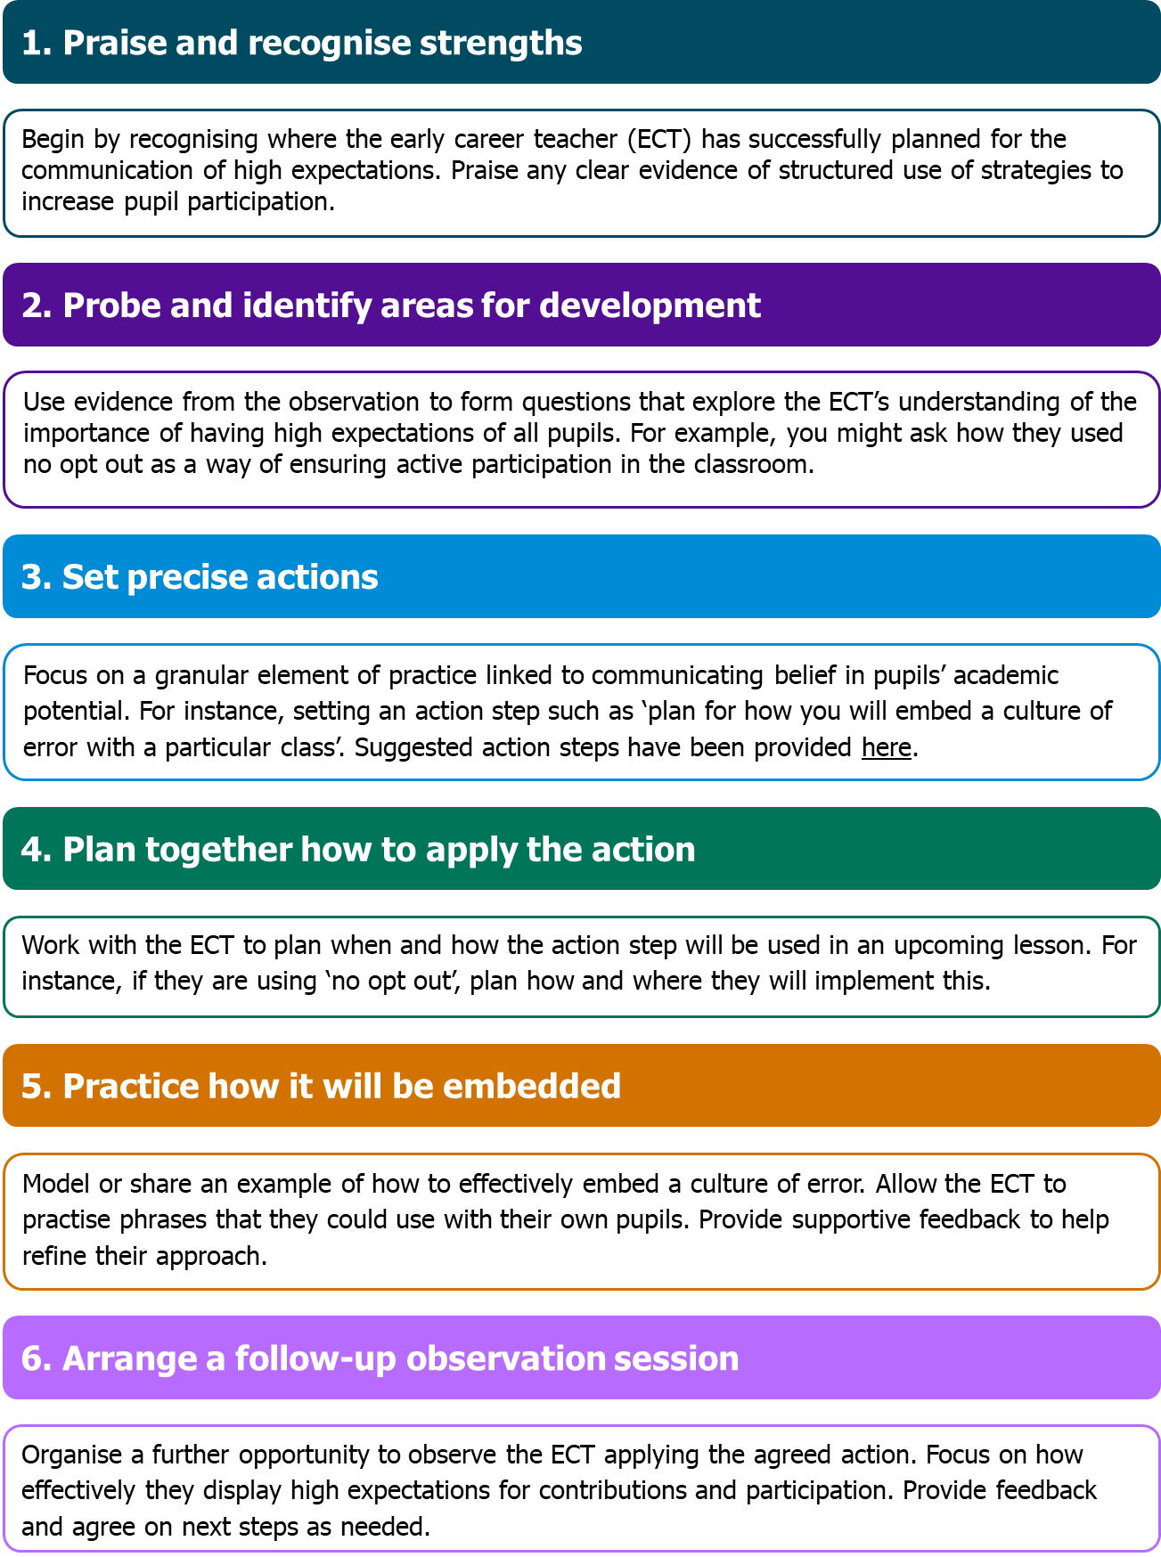
Bambrick-Santoyo (2016)
Click here to return to content page

Writing notes during observations
An observation serves no purpose if the notes that mentors make are not moving the learning of pupils and development of their ECT on. It is therefore important to explore the success criteria for effective note-taking.
Notes should be an accurate record of what took place but do not try to record every event. They should be descriptive, neutral and factual​. Mentors should use their knowledge of their ECT (prior action steps/current development areas) to pinpoint what they are looking for. Notes should not be personal. The culture of trust and maintaining positive relationships is important. Jim Knight (2009) talks about this emotional connection and that it is vital that notes don’t disrupt that connection by being personal.
1. Notes as a relational tool, not a judgment tool
When a mentor observes an early-career teacher, the way notes are taken and used can either build trust or erode it. Knight’s partnership approach (2007, 2009) stresses that coaching should be non-evaluative. If notes are written in a way that feels like a “report card” or a critique, the teacher may feel judged, which damages trust and inhibits honest reflection.
Instead, notes should:
- Focus on specific behaviours and student outcomes, not personal shortcomings.
- Highlight high-leverage action steps (small, actionable improvements) rather than overwhelming feedback.
- Record questions, reflections, and observations neutrally, preserving teacher autonomy.
2. Notes support dialogue and reflection
Knight emphasises dialogue and co-construction of learning. Observation notes should serve as prompts for reflective conversation, not just as documentation. For example:
- A note might say: “Students struggled with this concept; consider a model or example next time” rather than “You didn’t explain this well.”
- During feedback, the mentor can refer to notes to guide discussion, letting the teacher interpret and decide on next steps.
This reinforces mutual respect and choice, key principles in Knight’s partnership model.
3. Notes maintain psychological safety
Early-career teachers are particularly sensitive to evaluation. Notes that are objective, focused on growth, and kept confidential maintain psychological safety (Knight, 2009). Teachers are more likely to take instructional risks if they trust that notes will not be used punitively, aligning with Knight’s insistence on separating coaching from formal evaluation.
4. Notes help track incremental growth
Knight highlights the value of small, precise action steps for accelerating teacher development. Thoughtful note-taking can capture these incremental changes over time, reinforcing progress and maintaining a positive, motivating coaching relationship.
Section 2
Scenario
You enter a science lesson as the teacher is introducing the lesson objective: "Today we are going to watch a video about plants. Before we do, I want each of you to grab a sticky note from my desk and write down what you already know about plants. When you finish writing, stick it up here on the whiteboard Ready? Go"
The pupils all rise at once to reach the one pack of sticky notes at the front of the room. There is a fair amount of jostling, and some students complain about being elbowed or pushed. It takes a few minutes for each pupil to get a note, and by the time the last one gets one, many students have already finished writing. A few minutes later, everyone has put a sticky note up on the board and quietened down.
The teacher reads aloud each of the notes: "A plant needs water, soil, and sunlight to grow." "A plant needs water and sun to grow." "Wow," says the teacher. "This is great: you already know a lot about plants! We're now going to watch a video about what plants need to grow. As soon as the teacher is finished, he starts the video. You see an image of a plant and hear the narrator saying: "Plants don't grow the same way we do. They use water and sunlight as their food, and that makes them grow." He hears one pupil say: “That’s what I put on my sticky note,” and another telling their friend, “I already know this!”

Deliberate Practice
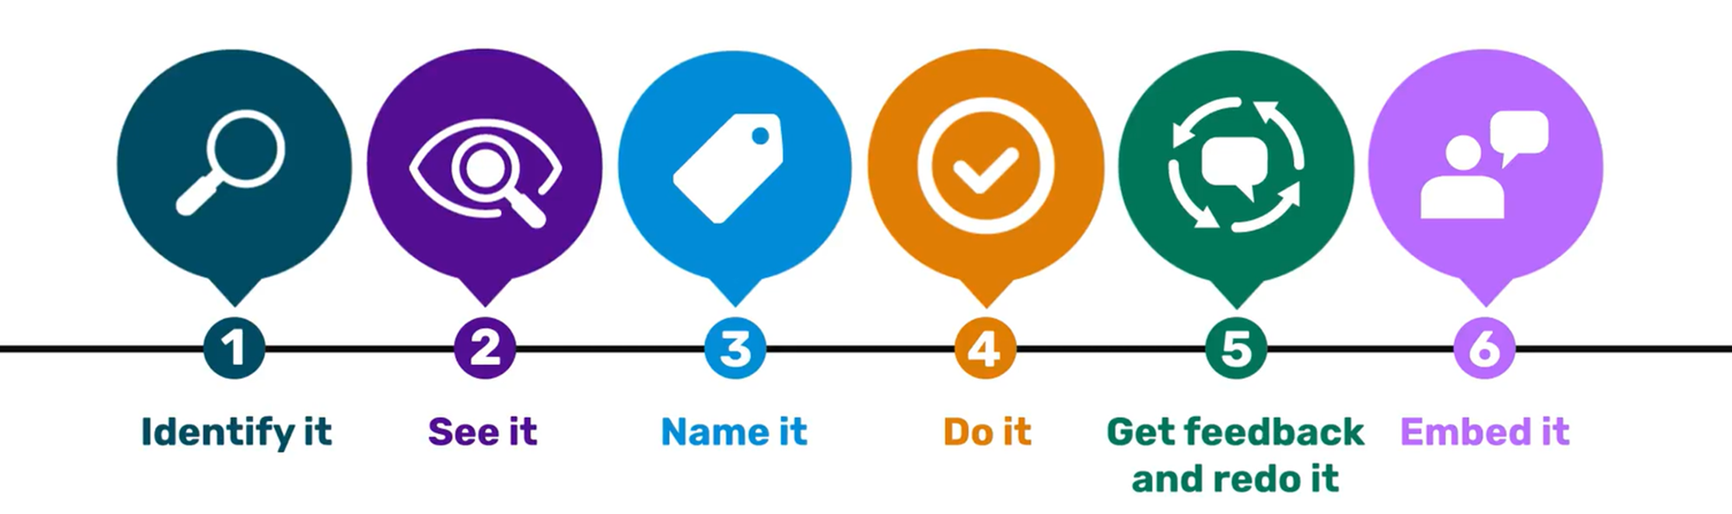
National Institute of Teaching model (2025) – adapted from Deans for Impact (2016) and Banbrick-Santoyo (2018)
Identify it
Identify an element of (teaching) practice you want to improve, acknowledging why it is important.
See it
See what that element of great teaching or leadership or mentoring looks like.
Name it
Name the active ingredients that are making this work. We call these ‘success criteria’ and it’s the key actions that make the effective work every single time.
Do it
Practise this element.
Get feedback and re-do it
Get feedback and act on that feedback, re-doing your practice. Repeat as necessary.
Embed it
Apply your practice into your teaching or leadership or mentoring, reflecting, evaluating and refining. Keep consciously applying until it has become habit and automatised.

Section 3
Cold Call
‘Cold Call’ is a teaching technique popularised by Doug Lemov in his book Teach Like a Champion (2021). It’s a structured questioning strategy where the teacher calls on students to answer questions regardless of whether they have volunteered.
Lemov describes ‘Cold Call’ as a way to:
- Keep all students engaged, since anyone may be asked to respond
- Increase accountability
- Check understanding more accurately across the whole class
- Set a positive, academic tone by normalising participation
Doug Lemov notes that teachers should Cold Call:
- Systematically (asking a wide range of students)
- Predictably (so students see it as routine, not punitive)
- Supportively (ensuring the tone is calm, friendly, and academic)

