
ECT Mentor Programme: Delving into deliberate practice
Estimated time to complete: 30 minutes
​
​These materials are intended for use by those who design and deliver a school-led Early Career Teacher programme. Opportunities for schools or trusts to add detail relevant to their context have been identified in red font.


This self-study material is for mentors supporting early career teachers.






Introduction
Approximate time to complete: 1 minute
This self-study is aimed at mentors who are new to deliberate practice or who feel like refresher training is needed.
You may already be familiar with some approaches to deliberate practice, but it is important that we develop a shared understanding of what we mean by deliberate practice as well as using a common language to support our early career colleagues.
Whether you are an experienced mentor or are new to mentoring you will bring with you a range of expertise. It is this expertise that will be invaluable as we support our colleagues joining the profession to develop their professional practice.

Overview
​ This self-study is structured to guide your learning, with dedicated content sections, checks to reinforce your understanding, and suggestions for further reading.
Content
Developing teacher expertise | Page 3
Forms of practice | Page 8
Six principles of deliberate practice | Page 10
Deliberate practice in action | Page 13
Further reading and references | Page 15
Appendix | Page 16

Note that these page numbers may need updating following any amendments or additions made by schools.

Developing teacher expertise
Approximate time to complete: 7 minutes
“The quality of teaching is hugely important to the outcomes of young people, and great teaching can be learnt.
Raising the quality of teaching within existing schools is probably the single most effective thing we could do to promote both overall attainment and equity.”
(Coe et al.,2020, p.8)
If great teaching can be learnt, then your role as a mentor really matters. The best way we can improve outcomes for all pupils is by helping more teachers become great ones. But to do that well, we need to be clear on what expert teaching actually looks like… and how you help someone move towards it.
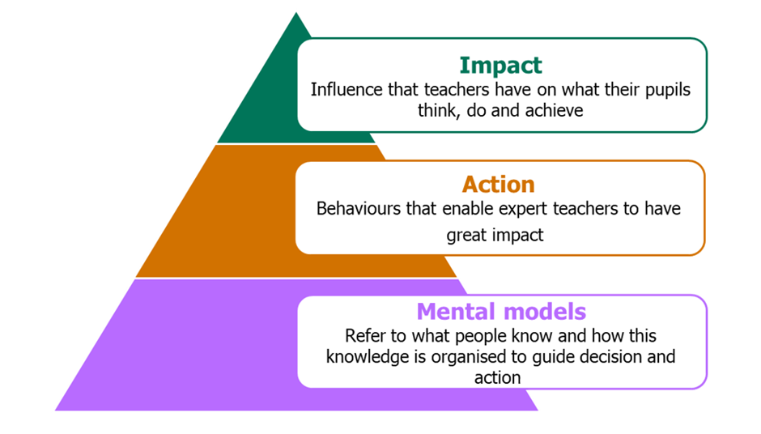
Adapted from Mccrea (2018)
There are several ways to think about the challenge of identifying teacher expertise.
Expertise as impact
There’s more than one way to think about what makes a teacher ‘expert’. One way is to look at their impact: the influence they have on what pupils know, can do and understand.

You might hear people talk about this in terms of exam results or test scores. That makes sense: we want pupils to achieve more, and great teaching helps that happen.
But outcomes don’t tell the whole story. They don’t show how that learning happened or what the teacher did to make it possible. Pupil performance is influenced by lots of different factors, so it’s hard to pin it all on teaching alone.
That’s why if we want to grow expertise, we need to go deeper. We need to look beyond the end result and understand the decisions, behaviours and thinking that expert teachers bring into the learning environment every day. ​
Expertise as action
Another way to understand expertise is by looking at what expert teachers actually do.
They often notice things others might miss. They read the room quickly and adjust their teaching in real time. They’re thinking ahead too: playing out different options in their minds and weighing up which one will work best for their pupils.
To the outside observer, they might look calm or even less busy. That’s because many parts of their teaching have become second nature. The basics are automatic, which gives them more space to think clearly and act with purpose when something unexpected happens.
So if we want to grow expertise in others, it helps to look at these expert actions. But it’s not enough to copy them. We also need to understand the knowledge and thinking that drives those actions and that’s where mental models come in. ​
Expertise as mental models
Expertise isn’t just about what teachers know. It’s also about how they organise and use that knowledge in the moment to make decisions and take action.
Think about what an expert teacher knows. They’ve got a deep understanding of the curriculum; not just what to teach, but the best way to sequence it. They know their pupils: what motivates them, where they struggle, how they behave. They know about pedagogy and how learning works. And they know themselves; when to push, when to pause, and how to manage their own emotions under pressure.
All of this knowledge connects together in their mind to form what we call a mental model. It helps them make sense of what’s happening in the learning environment and decide what to do next.
These mental models are like a growing map in their long-term memory. When they come across something new, their brain searches for anything they already know that might help. If it finds something useful, it links it to what they’ve just learned. Over time, this web of knowledge grows stronger, deeper and easier to use and that’s what helps expert teachers respond so fluently in real time.
So when we talk about developing teacher expertise, we’re really talking about building and strengthening those mental models.
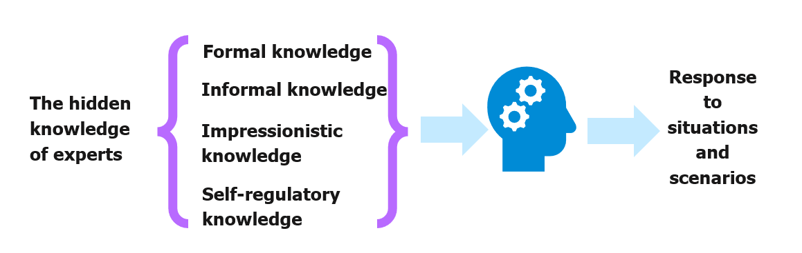
Bereiter and Scardamalia, 1993
The mental models that expert teachers build are made up of different types of knowledge. It’s not just what you know; it’s how that knowledge is used and applied. There are four key forms to be aware of:
- Formal knowledge – This is the codified stuff: what you might read in a textbook or research summary. It’s precise, organised and often theory-based.
- Informal knowledge – Sometimes described as ‘expert common sense’. It blends what you’ve read with what you’ve lived and observed in the classroom.
- Impressionistic knowledge – These are the feelings and instincts you build up through experience. They help you notice when something’s off, even if you can’t name it straight away.
- Self-regulatory knowledge – This is about knowing yourself: how you manage your time, energy, reactions and decisions in the moment.
It’s the combination of all these that builds a rich, responsive mental model. And it’s this model that helps expert teachers handle tricky moments, make confident decisions, and adapt to different contexts.
So what does a strong mental model look like?
- Extensive – you’ve got a broad, connected understanding of what effective teaching looks like and why it works
- Actionable – you can apply that knowledge in real time and adapt it to suit your pupils and your context
- Fluent – you can draw on what you know quickly and easily, often without needing to consciously think it through
- Meaningful – your knowledge is rooted in your values and the purpose behind your teaching
This is why we say developing expertise is about more than reading theory. It’s about growing a mental model that helps you notice, decide and act effectively — all in the service of better outcomes for your pupils.
Well-developed mental models underpin the impact and actions of expert teachers.
Mental models and in turn expertise can be developed and built through:

- Study – Help your ECT build a clear, evidence-informed picture of what effective teaching looks like. This might be through discussing examples, revisiting frameworks like Rosenshine’s principles, or exploring specific research together.
- Practise – Support them to try out specific techniques in their own lessons, with clear goals in mind. Repeated, focused practice helps them move from clumsy first attempts to fluency and confidence.
- Iterate – Encourage them to reflect on what worked, what didn’t, and why. Help them connect the dots between teaching decisions and pupil outcomes. Over time, this refines their judgement and strengthens their mental mode

Reflect
How might you apply this knowledge to work with early career teachers in developing their mental models and expertise?
Schools and trusts may wish to adapt these reflective questions to best suit their focus and setting

Click here to return to Content page

Forms of practice
Approximate time to complete: 3 minutes
Practice is important in the development of expertise and mental models.
“Practice is essential to learning new facts, but not all practice is equivalent.”
Deans for Impact (2016, p.5)
You might have come across the idea that it takes 10,000 hours to become an expert. That idea came from Malcolm Gladwell’s book Outliers, where he describes 10,000 hours as the “magic number” for mastery.
But the number of hours isn’t the full story. It’s not just about how much you practise… it’s about how well you practise. Gladwell’s version misses this crucial point.
As a mentor, it’s worth keeping this in mind. Your early career teacher won’t become more expert just by spending more time in the classroom. Instead, it’s the type of practice — deliberate, focused, and well-supported — that helps them grow.
This is where your role becomes pivotal. Helping your ECT identify clear goals, break them into manageable steps, and reflect on what’s working and why, will make their practice more purposeful. And the more you model this kind of approach yourself, the more likely they are to embed it in their own development.
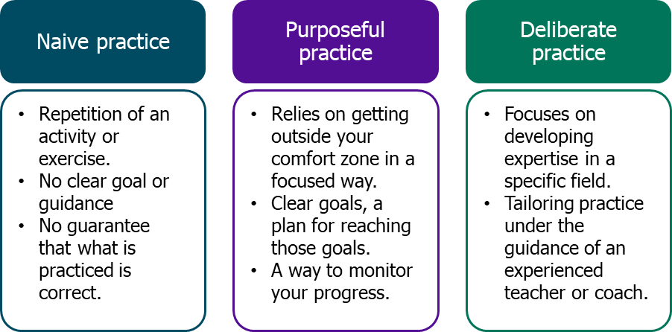
Ericsson & Pool (2016)

Deliberate practice builds on purposeful practice
You’ll remember from your own experience that improvement doesn’t come from just repeating the same thing. It comes from working on one specific element, getting feedback, and trying again. That’s what deliberate practice is all about.
Here’s how it works:
- Focus on one specific aspect of teaching. We don’t just say, “You need to get better at teaching.” That’s too broad to be useful. Instead, we isolate one small area; for example, introducing a new concept using an analogy.
- Make it even more precise: Once you’ve chosen the area, help your ECT narrow it down further. Maybe you both decide to focus on one lesson. You might script part of the explanation together, rehearse it, and then test it out.
- Guide and refine: Your support matters. Deliberate practice isn’t just about setting a goal and walking away. It means offering feedback, modelling alternatives, and helping your ECT reflect on how things went. A second pair of eyes, especially one with more experience, can make all the difference.
That’s where you come in. As a mentor, you’re helping your ECT practice with purpose; not just repeat but refine.
Reflect
Reflecting on what you have read, what do you consider to be the most significant elements of deliberate practice that support teachers to develop expertise compared to other forms of practice?
Schools and trusts may wish to adapt these reflective questions to best suit their focus and setting

Click here to return to Content page

Six principles of deliberate practice
Approximate time to complete: 7 minutes
When you’re working with an early career teacher, one of the most powerful things you can do is help them focus. That means breaking down what expert teaching looks like into small, manageable parts and then helping your ECT practise those parts, step by step.
This is where deliberate practice comes in.
You’ll already be familiar with this idea: isolating a specific skill, modelling it clearly, and designing a simple way for your ECT to rehearse and improve it. Whether you’re working on lesson starts, questioning, or explanations, it’s about choosing one thing, practising it well, and sticking with it until it’s embedded.
The model used by the National Institute of Teaching builds on two well-known approaches:
- Deans for Impact (2016) – This focuses on practising with purpose: setting a clear goal, getting feedback, and adjusting your approach.
- Bambrick-Santoyo (2018) – This adds a structure: See it, Name it, Do it. You show what success looks like, break it down, and then help your ECT try it for themselves.
Your role as a mentor is to guide this process — to help your ECT get clear on what they’re working on, see strong examples, practise it with your support, and revisit it until it sticks. That’s how growth happens.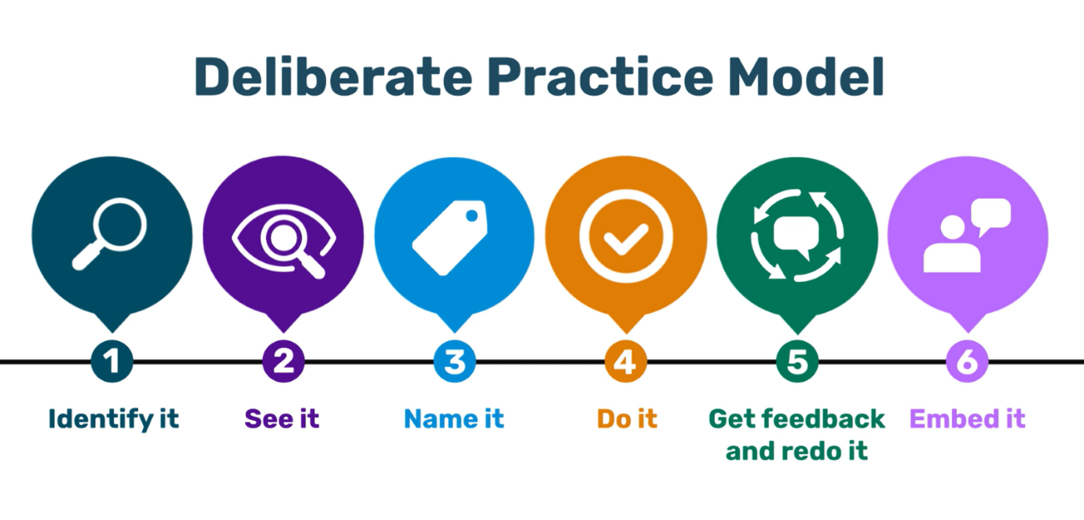
National Institute of Teaching model (2025) - adapted from Deans for Impact (2016) and Bambrick-Santoyo (2018)
For further detail on The National Institute of Teaching model for Deliberate Practice see appendix one here.
Schools and trusts should include their preferred model for deliberate practice if they are not using The National Institute of Teaching Model. This should include an explanation of the different stages as well as the principles behind it.

As a mentor working with an early career teacher, you may already use deliberate practice each week as part of your meeting. The National Institute of Teaching uses the six-step observation and feedback model (Bambrick-Santoyo, 2016) and deliberate practice fits into the fifth stage of this model.
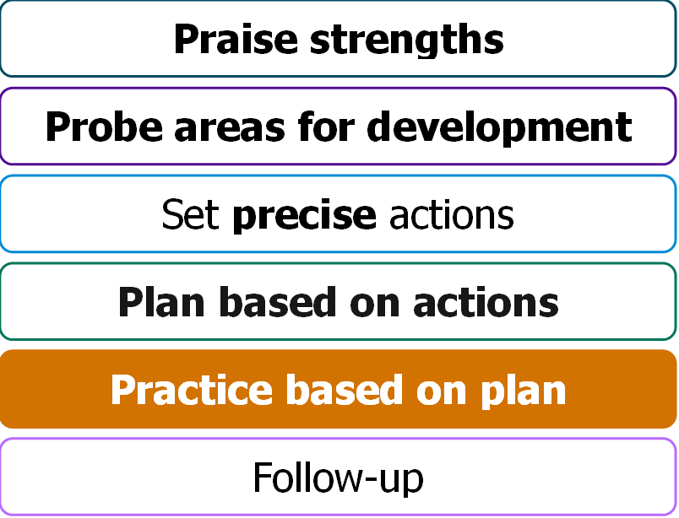

Schools and trusts should include their preferred model for observation and feedback.

What are the limits of deliberate practice?
So far in this module we’ve explored how deliberate practice is a key way to build expertise. It’s structured, specific and targeted and it works best when paired with timely feedback and repeated rehearsal.
But it’s not a magic solution.
Harry Fletcher-Wood (2018) has highlighted a few important limitations that you’ll want to keep in mind as a mentor.
1. It’s not the whole story: deliberate practice plays a role in developing expertise — but it’s not the only factor. For example:
- a large review of evidence found that deliberate practice only accounts for around 4% of performance differences in education
- other factors like working memory, personality, prior experience and even timing can matter just as much — sometimes more
- some of the top performers in domains like chess and athletics master their craft faster than the ‘10,000 hour’ rule suggests
This means you need to look beyond practice when supporting your ECT. Their starting point, confidence, and how they respond emotionally also matter. Motivation and wellbeing influence how much they’re able to practise and what they get out of it.
2. The definition isn’t always clear: different studies define deliberate practice in different ways. Some say it must involve a coach or teacher, others say it doesn’t need to. This can make it tricky to know exactly what counts as deliberate practice and what doesn’t.
The takeaway here? Focus less on labels, and more on the principles. Ask yourself:
- is the practice focused on a clearly defined skill?
- is it targeted to the ECT’s current needs?
- is there a chance to rehearse, get feedback, and refine?
If yes, you’re still creating value, even if it’s not textbook ‘deliberate practice’.
3. Not everything can be ‘drilled’: deliberate practice works best for skills that can be isolated, repeated and refined. For example: giving clear instructions, modelling a worked example, or cold calling.
But teaching isn’t just a list of techniques. Some elements (like building trust, responding to a child’s emotional needs, or navigating complex classroom dynamics) are harder to practise in the same way. These things develop through experience, reflection and dialogue, not just rehearsal.
So don’t rely on deliberate practice alone. Use it where it fits but balance it with space for professional judgement and discussion.
Why this matters for you as a mentor
You’re supporting someone at the very beginning of their career. Deliberate practice is a powerful part of that, especially when it helps them focus, rehearse and refine. But it won’t work for every skill, and it won’t replace the broader support and coaching you offer.
Use deliberate practice flexibly and thoughtfully and always be alert to the person behind the practice. That’s where your expertise as a mentor really shines.
Deliberate Practice in Action
Approximate time to complete: 7 minutes
The following clip begins in a Year 6 lesson where the teacher (and ECT Mentor) is preparing the pupils for a “think, pair, share” activity. You will notice that the ECT is also in the lesson observing the practice.
The clip then moves to a mentoring session between the mentor and the ECT. The mentor is giving the ECT feedback on the use of “think, pair, share” observed in a previous lesson and as seen, the ECT has subsequently visited a lesson where the mentor has used “think, pair, share”, giving the ECT the opportunity to see expert practice in action.
The conversation that follows enables the ECT to develop a mental model of what effective practice looks like, including the use of deliberate practice, scripting out the use of “think, pair, share” for an upcoming lesson and receiving feedback and enabling her to re-do where needed.
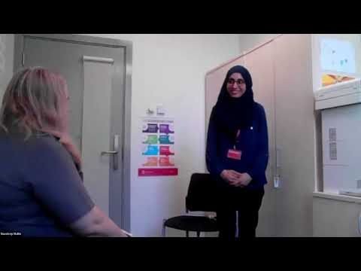
Deliberate Practice in Action

Schools and trusts may wish to use an alternative video or other forms of exemplification to show the process of deliberate practice as it aligns with their chosen model.

Reflect
Reflecting on the content of this session, consider:
- How could the principles of deliberate practice be useful as you develop your knowledge and expertise as a mentor?
- How could you draw upon this learning to support and guide you to shape your own approach to deliberate practice as a mentor?
Schools and trusts may wish to adapt these reflective questions to best suit their focus and setting.

Click here to return to Content page

Further reading and references
- Bambrick-Santoyo, P. 2018. Leverage leadership 2.0: A practical guide to building exceptional schools. John Wiley & Sons.
- Bereiter, C., & Scardamalia, M. 1993. Surpassing ourselves. An inquiry into the nature and implications of expertise. Chicago: Open Court.
- Coe, R., Rauch, C. J., Kime, S., & Singleton, D. 2020. Great Teaching Toolkit: Evidence Review.
- Deans for Impact, 2015. The science of learning. Deans for Impact. Available online at: https://deansforimpact.org/wp-content/uploads/2016/12/The_Science_of_Learning.pdf [Accessed 13 April 2026].
- Deans for Impact. 2016. Practice with Purpose: The Emerging Science of Teacher Expertise. Available online at: practice-with-purpose.pdf. [Accessed 13 April 2026].
- Ericsson, A. and Pool, R., 2016. Peak: Secrets from the new science of expertise. Houghton Mifflin Harcourt.
- Fletcher-Wood H., 2018 ‘Problems with deliberate practice’ Available from: Problems with deliberate practice: can we use it in teacher education? – Improving Teaching [Accessed 13 April 2026].
- Gladwell, M., 2008. Outliers: The story of success/Malcolm Gladwell.
- Mccrea, P., 2018. Expert teaching: What is it, and how might we develop it. Institute for Teaching. https://www.researchgate.net/publication/324759008_Expert_Teaching_What_is_it_and_how_might_we_develop_it_Peps_Mccrea [Accessed 13 April 2026].

Click here to return to Content page

Appendix
Deliberate Practice
Identify It
Deliberate practice starts with knowing where to focus. That means identifying one small, specific part of teaching that your early career teacher can improve; something that will make the biggest difference to pupils.
This is what we mean by the highest leverage action. It’s not about fixing everything. It’s about asking: what’s the one thing that, if improved, would make the biggest impact right now?
As Deans for Impact (2016) point out, deliberate practice only works when the challenge pushes someone just beyond what they can currently do. That’s why your role as a mentor is vital — to help your ECT choose the right focus, guide them as they step outside their comfort zone, and make that learning feel safe.
You’ll be exploring how to identify the highest leverage action in more detail during your first live seminar.
In the meantime, think about how you currently help your ECT spot priorities. Are you picking the area that will shift pupil learning the most? Are you narrowing the focus clearly enough? And are you creating a space where your ECT feels safe to take risks and try something new?
See It
Earlier, we looked at how expert teachers rely on strong mental models to guide their decisions. As a mentor, part of your role is to help your ECT build those same models, especially when they’re trying something new.
This is just like what happens in your own classroom: when you’re teaching a new skill, you don’t just explain it, you show it. You might use a worked example, a model answer, or success criteria to help pupils see what ‘good’ looks like.
Mentoring works the same way. If your ECT is trying to improve their use of modelling, for example, don’t just talk about it; show them what it looks like in practice. Use frameworks, lesson clips, or real examples from your own experience.
The clearer the model, the more confident they’ll feel in trying it for themselves.

Name It
Once you've shared an example with your ECT, the next step is to break it down. What makes that example work? What are the key behaviours or choices that lead to success?
These are often called the ‘active ingredients’: the things your ECT will need to include in their own practice to make it effective.
For instance, if you’re helping your ECT improve how they give instructions for classroom transitions, you might agree that the ‘active ingredients’ are:
- get pupils’ attention using an agreed phrase or signal (for example, “1,2, 3 all eyes on me”)
- wait for all pupils to be silent and looking at you
- use non-verbal prompts to encourage compliance
- share no more than 3 instructions using bite-sized phrases (for example, “On 3, pens down, stand up, books away. 1, 2, 3”)
- share an agreed signal
- monitor compliance using non-verbal prompts to encourage and praise
These ‘active ingredients’ should be clearly visible in the model used during the ‘See It’ phase, and you might want to highlight exactly where these exist to really embed the understanding.
Do it
Deliberate practice needs focus. It can’t just happen in the gaps between other tasks; it works best when there’s time set aside and both people are fully present.
For early career teachers, that focused time is crucial. It lets them build skills through two useful approaches:
- Decompositions: breaking teaching down into smaller parts. For example, working just on how to manage transitions between activities, rather than trying to improve the whole lesson at once.
- Approximations: practising something that’s close to the real task, but in a lower-stakes way. Think of it like a rehearsal — the context is realistic, but the pressure is lower.
These practice opportunities can take two broad forms:
- Product-based practice: where the ECT creates something they’ll use in the lesson. For instance, they might design a hinge-point question for an upcoming lesson. This gives you both a chance to talk about how it checks understanding and what to do with the responses.
- Performance-based practice: where the ECT practises a specific element of teaching with you. For example, they might script and rehearse giving instructions for a group task, so that the wording is tight and purposeful.
In both cases, you’re helping them move one step closer to fluency. It’s about getting specific, building confidence, and making it easier to apply in the real learning environment.
Feedback and Re-do it
To get better, you need feedback — and the same is true for your early career teacher (ECT). But not just any feedback. For deliberate practice to work, feedback needs to be:
- Timely – ideally straight after the practice. That way, the ECT can fix any issues before they become habits.
- Specific – linked to the goal you set and the action they practised. Focus on one or two key things that will help them improve.
- Clear and practical – use any success criteria or examples you agreed beforehand to anchor the feedback.
Once you’ve given feedback, give them time to go again. That might mean rephrasing their instructions, practising a new routine, or rehearsing how they’ll check understanding. It doesn’t have to take long, but it does need space.
It’s this loop (feedback, redo, refine) that helps practice turn into progress.
Embed it
Deliberate practice doesn’t just improve performance, it helps shape how early career teachers (ECTs) think about their teaching.
At first, your ECT will be developing key pieces of knowledge. As they practise, get feedback and apply that learning, they start to build stronger mental models. These models help them:
- notice more in the moment
- make quicker, more confident decisions
- judge what’s working and what’s not
As a mentor, you can support this by:
- helping them spot what effective teaching looks like
- practising that with them in focused ways
- following up by watching it in action
Over time, this makes them more fluent. They’ll rely less on you and more on their own mental models to guide what they do. That’s what we’re aiming for; growing teachers who can think clearly, teach confidently, and keep getting better.
Click here to return to Content page

