
ECT Mentor Programme: Beyond the basics of deliberate practice
Estimated time to complete: 30 minutes
​
​These materials are intended for use by those who design and deliver a school-led Early Career Teacher programme. Opportunities for schools or trusts to add detail relevant to their context have been identified in red font.


This self-study material is for mentors supporting early career teachers.






Introduction
This self-study unit is designed for those mentors who already have a good understanding of deliberate practice and some experience of using it to support professional development. This unit will focus on deepening your understanding of how to maximise the effectiveness of deliberate practice with Early Career Teachers (ECTs). Moving beyond the fundamentals, you’ll have the opportunity to apply your knowledge to examples to help you to support your ECTs in refining their teaching skills, overcoming challenges, and embedding effective practices in their classrooms.
Deliberate practice is about identifying high-leverage actions that lead to meaningful growth. It involves isolating specific aspects of teaching, setting measurable goals, and providing structured opportunities for ECTs to practice and improve. As mentors, your role is pivotal in guiding this process by creating a safe environment for experimentation, offering constructive feedback, and fostering a culture of reflective improvement.

Overview
​ This self-study is structured to guide your learning, with dedicated content sections, checks to reinforce your understanding, and suggestions for further reading.
Content
The principles of deliberate practice – a recap | Page 3
Different types of deliberate practice | Page 7
Deliberate practice in action | Page 9
Activity | Page 11
Further reading and references | Page 12

The principles of deliberate practice – a re-cap
Approximate time to complete: 4 minutes
Reflect
Let’s start by taking a moment to reflect on how you have used deliberate practice in the past. Use these questions to guide your thinking:
- Who have you used deliberate practice with?
- How did it help them to develop or improve their mental models?
- What was the impact on their classroom practice?
- How did it improve pupils’ outcomes?
- What challenges did you face when using deliberate practice and how did you overcome these?
Make a note of your responses and consider them as you complete this self-study.
Schools and trusts can adjust the reflective questions to suit their specific context and focus.

Defining deliberate practice
As you’ll know, practice is important in the development of expertise and mental models.
“Practice is essential to learning new facts, but not all practice is equivalent.”
Deans for Impact (2016)
Practice is indeed an important stepping stone toward expertise, but not just any kind of practice will do.
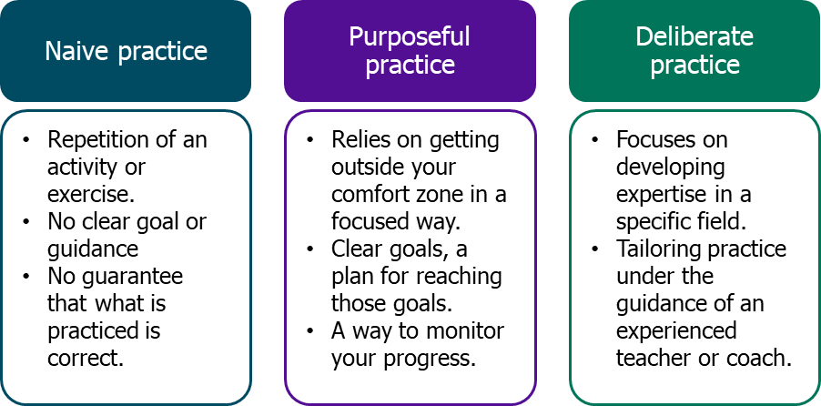
Adapted from Ericsson & Pool (2016)
Deliberate practice builds on purposeful practice
What makes deliberate practice different is the way it focuses on specific elements of teaching and targets the things that will make the biggest difference for pupils.
Here’s what that means in practice:
- It isolates the skill: you don’t just say, “Let’s work on behaviour management.” You pinpoint the precise action that needs developing. For example, “Let’s work on how you frame the transition from carpet to table in the first five minutes.” It’s that clear.
- It zooms in: let’s say your ECT is working on making explanations clearer. That’s still quite broad. So, you agree to narrow the focus down to introducing new concepts using analogies. You might script it together, try it out, tweak it, and then rehearse again until it lands just right.
- It’s done with guidance: having clear goals and success criteria is important. But feedback from someone experienced, you, makes all the difference. You’ll help your ECT spot what’s working, what’s not yet secure, and how to improve. It’s this combination of structure and support that makes deliberate practice so powerful.
What this means for you as a mentor
Your role isn’t to fix everything at once. It’s to help your ECT get better at the next small thing that will unlock progress. That might mean:
- breaking down a broad issue into something specific they can practise
- helping them rehearse out loud (not just talk about it)
- giving live feedback and another go
- building their confidence as well as their skill
That’s what moves practice from generic to deliberate and from ‘try harder’ to ‘teach better’.
The principles of deliberate practice
When working with early career teachers it is important to use the principles of deliberate practice to help isolate the key features of expert teaching, breaking these features down into the key knowledge and skills required, modelling them so that teachers can see what effective teaching looks like and designing practice activities to support the novice teachers to develop their practice.
The model used by the National Institute of Teaching is adapted from the work of the Deans for Impact (2016) and Bambrick-Santoyo (2018).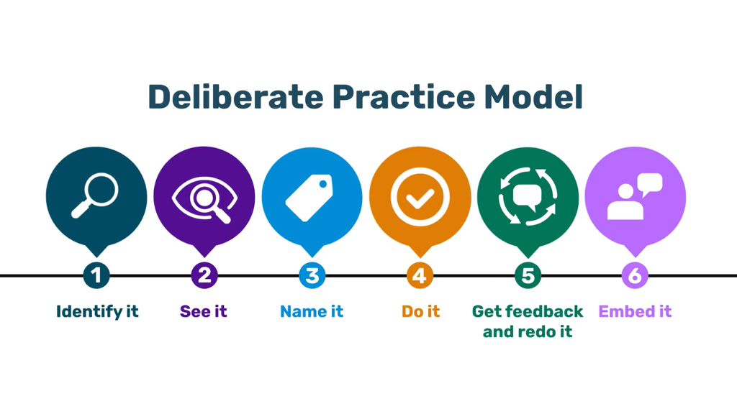
National Institute of Teaching model (2025) - adapted from Deans for Impact (2016) and Bambrick-Santoyo (2018)
Schools and trusts should include a recap of their preferred model for deliberate practice if they are not using The National Institute of Teaching Model.

Task
Reflect on how you would explain the six principles of deliberate practice to a Year 1 early career teacher that you have just started mentoring. Imagine your ECT has just asked: “What does that stage mean for me?” Your explanations should be plain, practical, and geared towards classroom improvement.
Schools and trusts should adjust the task reflective questions to suit their specific context and focus as well as their chosen model of deliberate practice

Click here to return to Content page

Different types of deliberate practice
Approximate time to complete: 2 minutes
As your mentoring deepens, it’s worth revisiting the two forms of practice you’re likely using and asking: how deliberate is this, really?
There are two main types of deliberate practice that you can draw on when supporting early career teachers:
1. Product-based practice: this focuses on what your ECT creates. That might be:
- a lesson plan with a clear explanation sequence
- a hinge-point question designed to check understanding
- or a resource scaffolded for pupil independence
Your role here is to help them focus on one precise element, not “create a better lesson plan”, but “tighten the worked example to reduce cognitive load”. Feedback during the design process matters just as much as the final product. That’s what shifts it from drafting to deliberate product practice.
2. Performance-based practice: this is all about how your ECT delivers. Think:
- giving instructions clearly and checking they’ve landed
- narrating transitions calmly and with control
- modelling writing using live commentary
These are best practised in low-stakes, supportive settings. For example, standing at the board in an empty classroom while you observe and guide. The aim isn’t roleplay for its own sake, it’s to build fluency and confidence in the real thing.
Mechanisms that make practice work: decomposition and approximation
Whatever the type of practice, two mechanisms can help you deepen its impact:
- Decomposition: break the skill down. If your ECT is struggling with questioning, don’t say, “Ask better questions.” Instead, isolate the first cold call of the lesson, or how they follow up on partial answers. Help them zoom in.
- Approximation: create safe simulations. You might ask them to rehearse transitions with you as the class or practise the first 60 seconds of a tricky explanation. This builds automaticity — they’re not just planning, they’re doing.
You’re not just pointing things out. You’re curating the conditions for purposeful, focused improvement. That means:
- giving precise, timely feedback while the ECT is still inside the learning moment
- allowing for redo — not as a judgement, but as a learning loop
- building habits that will stick when the stakes are high in a real lesson
This is where deliberate practice really earns its name — not just because of the repetition, but because of the intention behind every decision.
Reflect
Consider your past experience of using deliberate practice. To what extent have you included a range of examples of both product and performance based deliberate practice? Have you used one form more frequently?
Schools and trusts can adjust the reflective question to suit their specific context and focus.

Click here to return to Content page

Deliberate practice in action
Approximate time to complete: 8 minutes
This section focuses on deepening knowledge of deliberate practice through looking at a range of examples and non-examples.
Examples
Schools and trusts may wish to use video or other forms of exemplification relevant to their setting to show how deliberate practice could be used with early career teachers, giving mentors the chance to identify a high leverage action from an example of classroom practice and then mapping out how they would work through the model of deliberate practice with their ECT.

Non-example
Look now at this non-example of deliberate practice and consider why this will be less effective at supporting an early career teacher.
Schools and trusts may wish to contextualise this non-example to best suit their focus or needs.

A mentor is working with an Early Career Teacher (ECT) who struggles with giving clear and concise instructions during lessons, particularly when managing transitions between activities. The mentor has noticed that pupils often seem confused or hesitant after instructions, leading to delays in starting activities and at times some low-level disruption.

In their next meeting, the mentor begins by stating: “I’ve noticed that your instructions aren’t always clear in your lessons, especially when you’re transitioning from one activity to another. It’s really important that your instructions are clear, so the pupils understand what to do immediately.”

The mentor doesn’t provide any specific examples of what was unclear or why the instructions failed. Instead, the mentor offers a broad, generalised statement about the importance of clarity without diving into specifics.

Mentor: “To fix this, you should just be clearer when you talk. Maybe try speaking slower or repeating things. I’m sure you’ll get the hang of it.”

The mentor continues with vague, non-specific advice that lacks actionable steps.

Mentor: “When you give instructions, maybe ask a couple of pupils to repeat back what you said to make sure they understood. That way, you’ll know it’s clear.”

Why this is not effective deliberate practice
Lack of Specific, Measurable Goals: the mentor fails to help the ECT set clear, focused, and measurable goals. There is no specific benchmark for improvement, such as reducing the time it takes for pupils to begin the next activity or ensuring 100% pupil participation in the instructions.
No Focused, Low-Stakes Practice: the mentor does not provide an opportunity for the ECT to rehearse or practice giving clear instructions before using them in the classroom. There is no scripting, rehearsal or targeted practice where the ECT can refine their skill.
No Concrete Feedback or Reflection: feedback is vague and non-specific. The mentor does not observe moments or behaviours that could be improved and does not provide actionable, targeted feedback to help the ECT refine their practice.
Failure to Break Down the Skill: the mentor does not break down the task of giving instructions into smaller, more manageable components, such as word choice, pacing, or checking for understanding. No time is taken to identify the ‘active ingredients’ of the approach.
No Follow-Up or Embedded Practice: there is no structured plan for the ECT to continue refining their skills after the initial feedback session. The mentor does not support the ECT in setting up future opportunities for practice or reflection, and no strategies are in place to track progress or build on small successes.

Click here to return to Content page

Activity
Approximate time to complete: 15 minutes
Schools and trusts should include some activities for mentors to complete which enables them to put into practice their knowledge and understanding of deliberate practice.

The first activity could include:
- Sharing a short video clip from a lesson with a specific focus in mind such as cold calling.
- The mentor designs an input that they would use as part of their weekly interaction with their ECT to model “cold calling” as a questioning strategy.

The second activity could include a scenario in which a mentor is struggling to engage their ECT in deliberate practice, with them being reluctant to take part.
Mentors could then plan out how they would respond to this using the content of the session.

Click here to return to Content page

Further reading and references
- Bambrick-Santoyo, P. 2018. Leverage leadership 2.0: A practical guide to building exceptional schools. John Wiley & Sons.
- Deans for Impact, 2016. The science of learning. Deans for Impact. Available online at: https://deansforimpact.org/wp-content/uploads/2016/12/The_Science_of_Learning.pdf [Accessed 19 January 2026].
- Ericsson, A. and Pool, R., 2016. Peak: Secrets from the new science of expertise. Houghton Mifflin Harcourt.
- Mccrea, P., 2018. Expert teaching: What is it, and how might we develop it. Institute for Teaching. https://www.researchgate.net/publication/324759008_Expert_Teaching_What_is_it_and_how_might_we_develop_it_Peps_Mccrea [Accessed 19 January 2026].

Click here to return to Content page

