
ECT Mentor Programme: Unlocking effective adaptive teaching
Estimated time to complete: 30 minutes
​
​These materials are intended for use by those who design and deliver a school-led Early Career Teacher programme. Opportunities for schools or trusts to add detail relevant to their context have been identified in red font.


This self-study material is for mentors supporting early career teachers.






Introduction
This self-study is aimed at mentors who want to support early career teachers to make smart, responsive adjustments to teaching, without lowering expectations or creating extra workload.
You’ll remember from your own training that pupils learn best when support is flexible and expectations remain high. Adaptive teaching helps teachers do just that. It avoids the pitfalls of older ‘differentiation’ models and instead focuses on noticing what pupils need in the moment, responding quickly, and using high-quality curriculum resources.
Whether you’re new to mentoring or more experienced, this module gives you space to reflect on how you support ECTs to develop adaptive practice now, and how your understanding of what makes it effective has changed over time.
Overview
​ This self-study is structured to guide your learning, with dedicated content sections, checks to reinforce your understanding, and suggestions for further reading.
Content
Differentiation and adaptive teaching | Page 3
Unlocking adaptive teaching: the power of micro adaptation | Page 6
From planning to practice: supporting adaptive teaching across phases | Page 12
Embedding effective adaptive teaching | Page 17
Further reading and references | Page 19

Note that these page numbers may need updating following any amendments or additions made by schools.

Differentiation and adaptive teaching
Approximate time to complete: 7 minutes
What’s the difference, and why does it matter?
You’ll recognise from your own teaching and training that the term differentiation has been part of classroom language for decades. A NASEN (2021) article explains, that differentiation covers any change a teacher makes to content, presentation, environment, or expectations to meet pupil needs. It might be planned, like setting up group tasks in different formats, or it might be responsive, like simplifying a question or adapting the pace of a lesson. For pupils with SEND, differentiation is more than a choice, it’s a statutory expectation. The SEND Code of Practice (2015) makes it clear that high-quality teaching must be both differentiated and personalised as the first step in removing barriers to learning (DfE, 2015, p.99).
Why does the word 'differentiation' often come with baggage?
Over time, differentiation has sometimes been interpreted in ways that assume it involves giving some pupils easier tasks or preparing multiple separate activities for each lesson. There is also a risk that it can be associated with low expectations, rigid grouping, and unmanageable workload. This is where adaptive teaching can offer you as a mentor the chance to reframe the conversation with your early career teacher.
In a blog written in 2022, The Education Endowment Foundation (EEF) outline that traditional differentiation has become problematic because it can encourage unnecessary complexity and lowered expectations. Adaptive teaching, as set out in Initial Teacher Training and the Early Career Framework (ITTECF), builds on the core principles of differentiation, but with a tighter focus and a more practical frame. Where differentiation often led to pre-planning different versions of the same lesson, adaptive teaching is more about noticing and responding to what’s happening in the moment. It’s grounded in formative assessment, responsive teaching, and maintaining high expectations for all.
In that sense, adaptive teaching isn’t a complete rejection of differentiation, it’s an evolution. It’s about shifting from a model that risks over-complication or lowered challenge, towards one that puts shared learning goals at the centre, with flexible support around them. Instead of tailoring the task, we adapt the route pupils take to succeed, based on a strong knowledge and understanding of the individual pupils in front of us.
Task
Consider now how you would explain the difference between differentiation and adaptive teaching to your early career teacher.
How can you define the difference?
Now, read the following and consider how far these simple explanations align with what you wrote in the previous task:
- differentiation in practice has a broad meaning and often meant modifying content, preparing different resources or presentations in advance (Nasen, 2021)
- adaptive teaching means teaching responsively, using what you see and hear to adjusting teaching to better match pupil need (EEF, 2022)
That might mean using scaffolds only when they’re needed and removing them when they’re not. It might involve adapting how you ask questions, or when you model a process. It means using the curriculum as the backbone of your teaching, so you’re not reinventing the wheel, but you are ready to adjust as pupils’ needs change.
Micro adaptations
Quigley (2023a) makes a helpful distinction between micro adaptations and significant adaptations. Micro adaptations are the small, responsive moves you make during a lesson, like rephrasing an instruction, giving a worked example on the spot, or regrouping pupils for peer support. These tend to be the most common and are part of what great teaching often looks like.
Significant adaptations, on the other hand, may be needed for pupils with more complex needs and could involve coordinated support, like additional adult help or adjusted tasks. Knowing when a moment calls for a subtle tweak or something more substantial is part of what makes adaptive teaching so powerful and so demanding and also relies on secure knowledge of the pupils.
As a mentor, you don’t need to throw out everything you ever knew about differentiation. In fact, many of its original principles, such as starting from where the pupil is, or anticipating barriers, are still sound. But by framing it through the lens of adaptive teaching, you can help your ECT keep expectations high, stay responsive to pupils, and make their planning and teaching more sustainable over time.
Isn’t adaptive teaching just ‘good teaching’?
One might posit that adaptive teaching is just another name for ‘good teaching’, the kind that’s always been responsive. However, as Quigley (2023a) points out, it’s often the hardest kind of teaching to get right. It relies on deep subject knowledge, clear curriculum thinking, and real-time decision making. It’s not about abandoning your plan; it’s about knowing when and how to flex it.
As pupil needs become more complex, through rising SEND diagnoses, gaps in learning, or uneven attendance, the demands on adaptive teaching are growing, not shrinking (DfE, 2025) and it is vital that all teachers understand the needs of their individual pupils. That’s why your role in supporting early career teachers to master adaptive teaching is so vital.
Reflect
How have you spoken about differentiation in your own practice? How has your understanding shifted? And how confident do you feel in explaining the difference to your early career teacher now?
Schools and trusts may wish to adapt these reflective questions to best suit their focus and setting

Click here to return to Content page

Unlocking adaptive teaching: the power of micro adaptation
Approximate time to complete: 8 minutes
Teaching rarely unfolds exactly as anticipated and Dylan Wiliam (2015) suggests that while teachers are aware of this, lesson preparation is often based on the assumption that plans will run smoothly.
Adaptive teaching isn’t about rewriting the lesson plan every five minutes. It’s about micro adaptation; those subtle, moment-to-moment shifts that help more pupils access and succeed with the learning. It’s about noticing when something needs adjusting and responding quickly and deliberately.
What do we mean by micro adaptive teaching?
Lyn Corno (2018) draws a distinction between:
- macro-adaptations: larger changes such as adjusting groupings, modifying curriculum content, or making formal interventions
- micro-adaptations: moment-by-moment tweaks during teaching based on what you observe and hear in real time
It’s the latter, micro-adaptations, that underpin expert teaching. Noticing isn’t just about scanning for disengagement, it’s about tuning in to surprising interpretations, missed connections, or partially formed ideas that open the door for meaningful adaptation (Quigley, 2023b).
These are often subtle: a rephrased question, a scaffold added for just a few minutes, or a short pause to revisit a misunderstood word. They are also deliberate. While they may appear instinctive, they are built on professional judgment, strong subject knowledge, and an understanding of your pupils. This may be an area where early career teachers need support with one or all of these factors.
Understanding the “teaching ground” - and setting the record straight
Corno also introduces the idea of the teaching ground: a symbolic middle space where the greatest number of pupils can benefit from shared instruction (Corno, 2018).
However, adaptive teaching does not mean lowering challenge or only teaching to the middle. It means starting with high expectations for all and using real-time decisions to bring more pupils into that space of success.
Imagine three overlapping spaces:
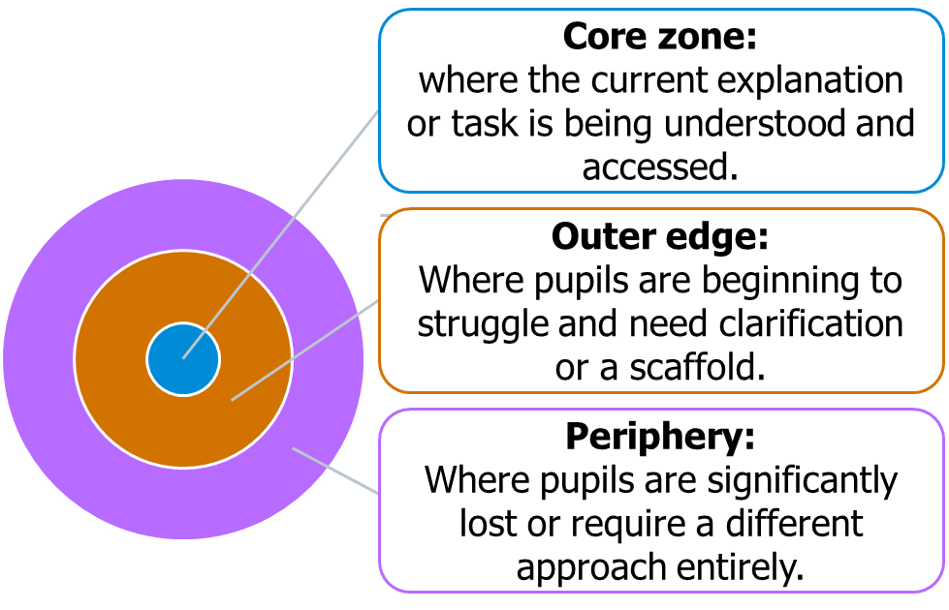
Adapted from Corno. L, (2018) ‘On Teaching Adaptively’
The role of micro-adaptation is to pull pupils into the core zone; not by simplifying the learning, but by using tailored support at the point it’s needed.
Corno (2018) emphasises that teachers regularly make small, responsive adjustments during lessons, based on how pupils are engaging. These adaptations are part of the natural flow of teaching, helping pupils stay on track without lowering the level of challenge.
Five adaptive teaching principles in action
Here are five principles that underpin effective micro-adaptive teaching, bringing together Corno’s (2018) theory and Wiliam’s (2015) practical insights.
1. Adaptive teaching starts with noticing: you can only respond if you first notice something is going wrong, or right. This is the first layer of micro-adaptation. Wiliam’s first principle is clear: you need a response from every pupil. If you’re relying on hands-up, you’re only seeing a fraction of the class. Instead, whole-class response systems (like mini-whiteboards, ABCD cards or finger voting) let you scan the room and make informed decisions.

Reflect
When observing your early career teacher, what signs will indicate they are effectively noticing learning across the whole class, and how could you guide them to respond to what they see?
Schools and trusts may wish to adapt these reflective questions to best suit their focus and setting

2. Check understanding quickly - and move fast: extended classroom discussions can be rich, but they’re not always practical when you need a fast check on a key concept. Wiliam (2015) advocates for hinge questions: short, focused tasks designed to elicit a precise understanding at a critical point in the lesson. These checks matter most when tackling concepts pupils might misapply, interpret differently, or half-understand. Plan your checks at these so-called pressure points. The question isn’t just ‘Did they get it?’, but ‘What might they be mis-seeing here, despite all I’ve said?’ (Quigley, 2023b)
Reflect
How can you help your early career teacher balance the richness of classroom discussion with the need for fast, targeted checks of pupil understanding, especially at so called pressure points?
Schools and trusts may wish to adapt these reflective questions to best suit their focus and setting

3. Plan for the decision, not just the activity: when talking about formative assessment one of Wiliam’s most practical insights is this: ‘You’re not collecting evidence for the sake of it. You’re collecting it to decide: do we move forward, or do we go back?’ (Wiliam, 2015). This reinforces a broader point: effective adaptive teaching is not reactive firefighting, it’s responsive decision-making, planned in advance and deployed as needed.
Reflect
How could you support your early career teacher to plan lesson checks with specific decision points in mind, rather than collecting evidence without a clear next step?
Schools and trusts may wish to adapt these reflective questions to best suit their focus and setting
4. Design questions that uncover real understanding: not all pupil answers are created equal. A right answer for the wrong reason is still a misunderstanding. Good hinge questions reveal thinking, not just recall. Wiliam (2015) recommends:
- including plausible distractors based on common misconceptions
- using multiple correct answers to reduce the chance of guessing
- testing reasoning as well as knowledge
For example: if pupils think an adverb always follows the verb, they may get an example right by accident. Rearranging the sentence can reveal whether the concept has truly stuck.
Reflect
How might you help your early career teacher design questions that deliberately surface common misconceptions, rather than only checking for recall or procedural accuracy?
Schools and trusts may wish to adapt these reflective questions to best suit their focus and setting

5. Micro adaptation includes pre-teaching, modelling, and vocabulary work: many adaptations happen before a task starts. You’re likely already doing some of this:
- pre-teaching: for example, previewing a text or concept to reduce cognitive load
- modelling: making the thinking process visible, not just the outcome
- vocabulary work: diagnosing gaps and breaking down key terms
These techniques can be powerful because they reduce the likelihood that you'll need to re-teach or change tack later. As Wiliam suggests, the stronger your initial plan, the less often you need a backup. Quigley (2023b) explains adaptive expertise as the ability to blend well-established routines with in-the-moment adjustments. It's this that often makes expert teaching seem effortless—not because it's mistake-free, but because it’s flexible and responsive.
Whether it’s priming vocabulary, using hinge questions, or spotting a moment where a rephrase is needed, each micro-adaptation you make is a step towards better, more inclusive teaching. And when you can talk about that confidently, you make it easier for your ECT to see it, try it, and grow into it too.
Reflect
How can you help your early career teacher plan and implement micro-adaptations—such as pre-teaching, modelling, and vocabulary work—so that lessons run more smoothly and pupils’ understanding is supported from the outset?
Schools and trusts may wish to adapt these reflective questions to best suit their focus and setting

Click here to return to Content page

From planning to practice: supporting adaptive teaching across phases
Approximate time to complete: 8 minutes
Now that you've explored what adaptive teaching means and why micro-adaptation matters, let’s look at how this translates into everyday practice, both in primary and secondary settings.
You’ll recognise many of the strategies described here from your own teaching. The aim is to bring them into sharper focus, so you can support your early career teacher to notice them, plan them in deliberately, and refine them over time. The EEF (2021) highlights that adaptive teaching works best when it's grounded in assessment – both in advance through planning, and in the moment through responsive adjustments.
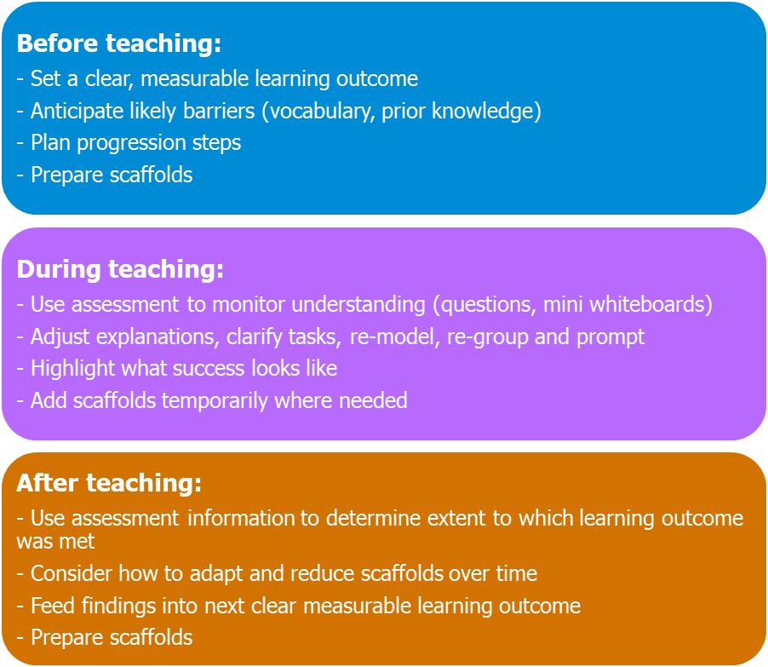
Adapted from Education Endowment Foundation & Education South West - Understanding Adaptive Teaching (EEF, 2021)
This diagram has been adapted from guidance published by the Education Endowment Foundation and Education South West (2021). It draws together their recommendations on adaptive teaching into a simple, three-phase model: before teaching, during teaching, and after teaching. The original material emphasised the importance of how effective adaptive practice is unlocked when it is planned for first.
Practical approaches in primary settings
Primary schools often have greater flexibility in grouping, curriculum pace and use of resources. That opens up different opportunities for adaptive practice:
- start with a measurable outcome
- use progression steps to chunk the learning
- make success criteria visible and accessible
Examples of adaptive practice:
- Maths: use the same challenging task for all but introduce manipulatives (like fraction tiles) only when needed. This avoids labelling and keeps the focus on understanding.
- Reading: rather than use fixed ability groups, create temporary, needs-based groupings based on a specific reading strategy (for example: inference, summarising, decoding).
- Writing: use paired writing, where one pupil verbalises their thinking and the other writes, then swaps roles. This can be effective for EAL learners or pupils with working memory challenges.
Schools and trusts may wish to contextualise these examples to best suit their focus or needs.

Practical approaches in secondary settings
As you might anticipate, secondary teachers face different challenges when trying to unlock the power of adaptive teaching: less opportunities to interact with the same pupils, faster-paced content, tighter timetables. However, adaptive teaching still has a crucial role.
In the planning phase:
- collaborative planning in departments to spot where pre-teaching or flexible grouping might help
- disciplinary literacy focus; especially in subjects like science or history, where key terms can be a major barrier
- rigorous success criteria that keep expectations high but allow varied support
During lessons:
- use mini-whiteboards or digital tools for real-time feedback
- introduce intermediate goals so pupils don’t lose track in multi-step tasks
- use peer tutoring or modelling; for instance, ask a confident pupil to explain how they tackled a maths problem
Schools and trusts may wish to contextualise these examples to best suit their focus or needs.

Practical approaches in specialist SEND setting
Adaptive teaching is crucial in SEND settings, where pupils may have diverse learning profiles, varying communication needs, and different sensory or cognitive processing styles.
In the planning phase:
- Collaborative planning across the team to identify where pre-teaching, multi-sensory supports, or flexible grouping might help. For example, introducing new vocabulary using visual symbols or tactile objects before a lesson.
- Communication and literacy scaffolds, such as simplified text, symbols, or PECS (Picture Exchange Communication System), particularly in subjects with abstract concepts like science or social studies.
During lessons:
- Real-time feedback using visual or digital tools, such as interactive tablets, mini-whiteboards, or gesture-based responses, to assess understanding and adjust instruction immediately.
- Breaking tasks into small, sequential steps, with frequent checks for understanding, so pupils with processing or attention difficulties stay on track.
- Multi-sensory approaches, such as hands-on manipulatives in maths, textured materials for tactile learning, or interactive storyboards in literacy, to meet varied sensory needs.
Schools and trusts may wish to contextualise these examples to best suit their focus or needs.

Practical approaches in specialist Alternative Provision setting
In alternative provision settings adaptive teaching is important in supporting pupils who may have disrupted prior learning and require highly personalised support to engage with the curriculum.
In the planning phase:
- Flexible collaborative planning, with staff sharing key information about pupils’ current levels, stimulus or situations that could dysregulation, and interests to identify where pre-teaching, scaffolding, or short-term flexible grouping may help.
- Tailored literacy and communication supports, such as simplified instructions, visual timetables, or audio prompts, particularly for pupils who have gaps in literacy or struggle with abstract concepts.
- Success criteria that are adaptable, keeping expectations high but allowing for different ways to demonstrate learning, such as oral explanations, drawings, or practical demonstrations.
During lessons:
- Real-time assessment using low-stakes tools, such as mini-whiteboards, gesture responses, or quick digital quizzes, to adjust teaching immediately for pupils who may arrive mid-topic or disengage quickly.
- Breaking tasks into very small, sequential steps, with frequent checks for understanding, so pupils can engage meaningfully even if they have missed previous lessons.
Schools and trusts may wish to contextualise these examples to best suit their focus or needs.

Refining your own practice to support adaptive teaching
As you come to the end of this section, take a moment to consider your own habits as a teacher and mentor. You’ve seen that adaptive teaching isn’t about designing three levels of every task or creating bespoke materials for every pupil. Instead, it’s about starting with ambition and planning for flexibility as well as knowing your pupils. It's about building routines that help you notice, respond and adjust, before, during and after a lesson.
If you want your ECT to feel confident in developing this way of working, the first step is to model it clearly. That starts with refining how you talk about your own planning and classroom decision-making.
You might begin by reflecting on how often you:
- start with a challenging learning outcome and adapt the support, not the goal
- use assessment to inform decisions in real time, not just at the end of a lesson
- plan for known barriers and actively look for unknown ones as learning unfolds
- use quick, simple tools like questioning, paired talk, and mini-whiteboards to guide in-the-moment adaptations
- help pupils reflect on their own strategies and learning decisions
Schools and trusts may wish to contextualise these examples to best suit their focus or needs.

As a mentor, you’re not just explaining adaptive teaching, you’re showing it. Through your questions, your feedback, and your reflections, you’re helping your ECT learn how to notice, respond and make decisions that bring more pupils into the learning. That’s what unlocking effective adaptive teaching looks like in practice and you’re already on the path.
Reflect
Reflecting on what you have read, are there any areas of your own practice you could refine to help make this more visible to your ECT?
Schools and trusts can adjust the reflective question to suit their specific context and focus.

Click here to return to Content page

Embedding Effective Adaptive Teaching
Approximate time to complete: 7 minutes
Schools and trusts may wish to use video or other forms of exemplification to show how adaptive teaching can be embedded coherently across a whole setting.

The exemplification should demonstrate how a school draws on a wide range of information—such as transition data, baseline assessments and real-time classroom observations—to inform both planned and responsive adaptations.

Framing adaptive teaching in this way highlights that it is not only about what happens in the moment; it is also about the systems, structures and expectations that enable teachers to make small, purposeful adjustments that improve pupil access and engagement.

By showing how broad data is interpreted and translated into classroom practice, the exemplification can make visible the connection between whole-school processes and day-to-day micro-adaptations.

Exemplification may vary depending on phase and context, the underlying principles should highlight the following:
- Noticing and early identification
- Using assessment to inform adjustments
- Planning for adaptive decision-making
- Making adaptations visible and usable

Click here to return to Content page

Reflect
Drawing on your learning from this self-study, identify three specific actions you could implement in your mentoring practice. For each action, consider:
- What you will do – describe the action clearly and concretely.
- Why it matters – link it to pupil learning, adaptive teaching principles, or effective formative assessment and to your ECTs needs.
- How you will know it’s effective – outline the evidence or indicators you will look for to evaluate its impact.
Schools and trusts can adjust the reflective question to suit their specific context and focus.

Click here to return to Content page

Further reading and references
- Corno L, (2018) ‘On Teaching Adaptively’. Available from: corno-2008-on-teaching-adaptively.pdf [Accessed 22 April 2026]
- Department for Education, (2015) ‘SEND Code of practice’. Available from: https://assets.publishing.service.gov.uk/government/uploads/system/uploads/attachment_data/file/398815/SEND_Code_of_Practice_January_2015.pdf [Accessed 22 April 2026]
- Department for Education, (2025), ‘Special Educational Needs in England’ Available from: Special educational needs in England, Academic year 2024/25 - Explore education statistics - GOV.UK [Accessed 22 April 2026]
- Education Endowment Foundation, (2021) ‘Assess, adjust, adapt – what does adaptive teaching mean to you?’. Available from: EEF Blog: Assess, adjust, adapt – what does adaptive teaching… | EEF [Accessed 22 April 2026]
- Education Endowment Foundation, (2022) ‘Moving from differentiation to adaptive teaching’. Available from: EEF blog: Moving from ‘differentiation’ to ‘adaptive teaching’ | EEF [Accessed 22 April 2026]
- Education South West & Education Endowment Foundation (2021) ‘Understanding Adaptive Teaching’ Available from: Understanding Adaptive Teaching v11 [Accessed 22 April 2026]
- NASEN (2021) ‘Differentiation – why and how’. Available from: https://bromleyeducationmatters.uk/Pages/Download/0ba078b3-cfef-4888-81a5-0b1eec585b61/PageSectionDocuments [Accessed 22 April 2026]
- Quigley A, (2023a) ‘Adaptive teaching: What is it anyway?’ Available from: Adaptive teaching: What is it anyway? [Accessed 22 April 2026]
- Quigley A, (2023b) ‘Adaptive Teaching and Vocabulary Instruction’ Available from: Adaptive Teaching and Vocabulary Instruction [Accessed 22 April 2026]
- Wiliam D, (2015) ‘Designing Great Hinge Questions’ Available from: Designing Great Hinge Questions [Accessed 22 April 2026]

Click here to return to Content page

