
ECT Mentor Programme: Putting belonging at the heart of pedagogy
Estimated time to complete: 30 minutes
​
​These materials are intended for use by those who design and deliver a school-led Early Career Teacher programme. Opportunities for schools or trusts to add detail relevant to their context have been identified in red font.


This self-study material is for mentors supporting early career teachers.






Introduction
This self-study is aimed at mentors who want to explore how a sense of belonging can support early career teachers (ECTs) to create inclusive and supportive learning environments.
Whether you’re new to mentoring or experienced, your insight is key as we revisit how belonging shapes engagement, motivation, and wellbeing. You’ll recall from your own training that pupils thrive when they feel accepted and supported.
In this module, you’ll reflect on how your mentoring helps ECTs notice, build, and prioritise belonging in their classroom culture. You’ll also consider how your understanding of belonging has developed, and where you’ve seen it make a difference.
Overview
​In this self-study you will have the opportunity to learn more about the following:
Content
What early relationships teach us about belonging | Page 3
High leverage practice for inclusive pedagogy | Page 8
Using belonging as a lens: noticing where it breaks down and rebuilding it | Page 12
Functional behaviour assessment in action | Page 17
Further reading and references | Page 19

Note that these page numbers may need updating following any amendments or additions made by schools.

What early relationships teach us about belonging
Approximate time to complete: 8 minutes
You’ll already know from your work that relationships make the biggest difference to how children learn. But we now understand much more about why that is, especially in the early years.
John Bowlby’s (1988) attachment theory helps us look underneath behaviour. His research showed that when children form strong emotional bonds with caregivers, they feel safe enough to explore the world around them. He called this a secure base. You’ll see this in action every day in early years classrooms: a child checks in with an adult before heading off to play or seeks comfort after a bump or a falling-out. But this isn't only about toddlers. Adolescents, and even adults, still benefit from that emotional anchoring. As a mentor, you’ll recognise when your ECTs provide that kind of safety in the learning environment:
- steady presence
- predictable routines
- responses that regulate rather than escalate.
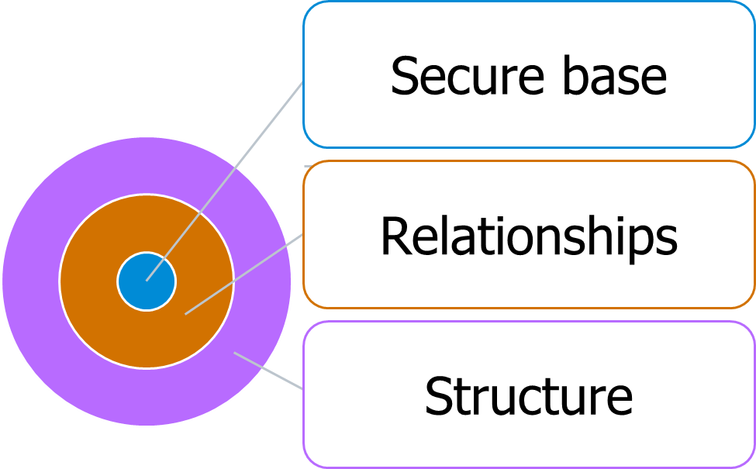

Adapted from Bowlby, 1988, ‘Attachment Theory’
The concept of a safe haven, a place to return to when things go wrong, is just as vital. Bowlby (1988) and later researchers observed that young children signal distress through crying, clinging, or withdrawal. Sensitive adults respond, offering comfort and helping the child return to a state where they can learn again. It’s easy to see this in early years. However, it also matters when you’re working with a teenager who’s shut down in your lesson, or a pupil in AP who responds with aggression. The behaviour might look different, but the need is the same.
So, what does this mean for you as a mentor?
Let’s break it down using our three-pillar model: structure, relationships, and responsiveness. Then we’ll show how lessons from early years can be used across all settings.
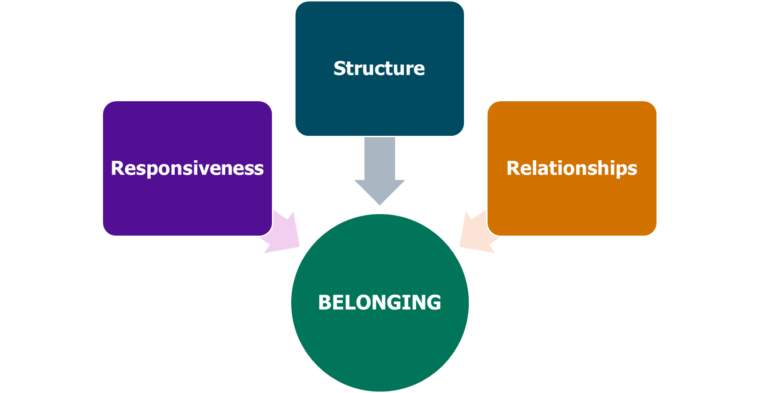

Adapted from CEEDAR Center (McLeskey et al., 2017)
Structure: Predictability builds trust. In early years, structure isn’t just about routines, it’s about making those routines visible, teachable, and soothing. Children know where they belong because they know what’s coming next, and what’s expected of them. June O’Sullivan (2023) explains that belonging needs to be woven through your pedagogy.
Sally Adams’ (2024) work reinforces this. In EYFS, transition work like home visits and story times before term starts help children build familiarity and reduce fear. These structures provide a scaffold that pupils can lean on emotionally as well as practically. For mentors across phases, this raises key questions:
- Are routines co-constructed, modelled, and embedded, or simply told?
- Do pupils see patterns and consistency across staff and spaces?
- Do classroom expectations reduce cognitive load, or add to it?
Whether you're in a mainstream secondary setting or working with a pupil in a PRU, the absence of structure creates uncertainty, and uncertainty undermines belonging.
Relationships: Schools that have belonging at the heart of their pedagogy ensure pupils feel seen and safe. Bowlby’s (1988) work stated that the internal working model, the blueprint for how we relate to others, is formed through early relationships. When children experience consistent, sensitive responses, they begin to believe the world is safe, that they matter, and that adults can be trusted. As Sally Adams (2024) explains, this belief is the fuel that keeps their learning flame alight.
In early years, this is often achieved through key person systems, informal play-based interactions, and nurturing language. For example, Adams (2024) describes a nursery memory filled with soft rugs, vanilla cupcakes, and familiar songs. These aren’t extras, they’re cues of safety and care. They shape how a child feels about themselves in relation to school. As a mentor, encourage ECTs to:
- Prioritise relational consistency, not just behaviour consistency.
- Use non-contingent warmth (e.g. smiles, greetings, interest) that doesn’t depend on performance.
- Reflect on which pupils might not be receiving positive adult attention and why.
In secondary or Alternative Provision, it might mean noticing who always slips into the room quietly and offering intentional moments of connection. In specialist settings, it might mean adapting how proximity and interaction are managed for pupils with sensory or social communication needs. In all settings, the principle holds: connection must come before correction.
Responsiveness: One of Bowlby’s (1988) central insights was that when a child is dysregulated, emotionally overwhelmed or distressed, they can’t learn. And they can’t “snap out of it” alone. They need co-regulation: an attuned adult who notices, responds, and helps them return to a state of calm. This isn’t just a matter of behaviour, it’s neurobiology.
O’Sullivan (2023) describes staff who heard children say, “We don’t like playing in that corner, it’s too dark.” This wasn’t dismissed as fussiness. Instead, it became feedback that prompted change. The same kind of listening is needed across all phases. In AP, it might be a pupil saying, “This room makes me feel boxed in.” In Year 7, it might be a drop in participation or a sharp tone that signals discomfort. Responsiveness means tuning into those signals and adjusting accordingly. For you as mentors, this might involve:
- Supporting ECTs to reflect not just on what happened, but what might have been communicated.
- Helping them differentiate between defiance and distress.
- Reinforcing that regulation strategies are not ‘optional extras’—they are part of the learning design.
Building on early years practice
The research and evidence base that has informed this module offers concrete strategies that mentors can use to shape conversations with early career teachers.
- Involve children in the space. Whether it’s classroom layout, rules, or displays, belonging grows when pupils shape their environment.
- Use home links purposefully. Grandparent Teas won’t suit all phases but finding ways to connect school to home matters—even in secondary, this could be inviting family to celebrate success or share stories.
- Promote reflective practice. O’Sullivan urges staff to be reflective and listen to children. Use your mentor meetings to ask your ECTs not just what happened, but what they noticed, and how they responded. (O’Sullivan, 2023)
- Create a family feel. What makes a room feel welcoming? Adams suggests that a warm tone, shared rituals and adult availability make all the difference.
- Champion transition work. This could be termly class handovers, transition postcards from new teachers, or welcome videos. They signal care before content.
- Model a shared vision. When all staff model care and calm, pupils experience predictability. That’s especially important for pupils with adverse childhood experiences or unmet attachment needs. (Adams, 2024)
- Understand the importance of safe base and safe haven. Help your ECTs see that their job is not to be a therapist, but they do provide a key attachment figure for some pupils, especially those who’ve experienced disruption.
- Challenge over-compliance or disengagement. Detachment isn’t always calm; it can be a sign of chronic stress or unmet need. Support consistency. Bowlby’s work shows how attachment patterns are shaped by repeated experiences. The more consistent and emotionally available the adult, the more secure the child becomes over time. (Bowlby, 1988)
Belonging is a biological and pedagogical priority
Whether you work in early years, primary, secondary or alternative provision, you’re supporting children whose sense of self is shaped by the relationships around them. Bowlby’s (1988) theory reminds us that children aren’t blank slates. They come with experiences, expectations, and biological needs for safety, trust, and connection. When those needs aren’t met, learning shuts down. When they are met, belonging, and learning, can flourish.
Belonging doesn’t just make school feel nicer. It creates the emotional safety needed to take risks, recover from mistakes, and engage deeply. As a mentor, the more you understand these foundations, the more powerfully you can support your early career teachers to build safe, responsive, and inclusive learning environments.
Reflect
How does the concept of a ‘secure base’ apply to your mentoring practice? What have you noticed about how your ECTs either provide, or struggle to provide, emotional safety in their classrooms?
Schools and trusts may wish to adapt these reflective questions to best suit their focus and setting.

Click here to return to Content page

High leverage practice for inclusive pedagogy
Approximate time to complete: 8 minutes
You’ve already seen how early years settings prioritise belonging through warmth, routine and responsive care. But you’ll know from your own teaching experience that belonging isn’t something that just happens, it’s something that’s built, moment by moment, in every setting. It’s not only about relationships. It’s about how pupils are welcomed, how the day is structured, how expectations are taught, and how feedback is used to connect, not just correct.
That’s especially important for pupils with additional needs. The most inclusive classrooms, whether in primary, secondary, early years, or specialist provision, are those where every pupil feels safe, valued and part of a shared journey.
This section introduces four evidence-informed principles from the High-Leverage Practices in Special Education framework (CEEDAR, 2017). These principles are grounded in years of research, but their power lies in their practicality. They give you, as a mentor, a shared language and a clear set of actions to help foster belonging; not just for pupils, but for early career teachers too.
1. Belonging begins with predictable, respectful environments
Predictability matters. Pupils are more likely to feel they belong when the learning environment feels calm, clear and consistent. That’s as true for a three-year-old finding their peg in nursery as it is for a Year 10 pupil navigating a school day across eight different classrooms.
The CEEDAR guidance is clear: routines like entering the room, transitioning between activities, and responding to instructions should be taught explicitly and revisited regularly. Expectations should be positively framed, limited to five or fewer, and supported with examples and non-examples.
This isn’t about rigid control, it’s about reducing uncertainty. For pupils who are anxious, neurodivergent or have limited working memory, it’s those small cues and structures that make the day feel navigable.

Reflect
As a mentor, you’re already modelling this—how can you help your early career teacher recognise that clarity, consistency and kindness work together, and that structure isn’t just behaviour management but belonging in action?
Schools and trusts may wish to adapt these reflective questions to best suit their focus and setting.

2. Feedback that reinforces connection, not just compliance
We often think of feedback as a tool for improving work. But it’s just as powerful for reinforcing identity and trust. Feedback isn’t neutral; it shapes how pupils feel about themselves, their learning and their place in the room.
The CEEDAR report reminds us that feedback should be timely, specific and relational. That means not just saying what’s right or wrong but linking it to shared expectations: ‘I can see you’re helping your group stay focused, that’s a brilliant example of teamwork.’
Importantly, it also means noticing effort, not just outcomes. The guidance suggests a 4:1 ratio of positive to corrective feedback, not as a gimmick, but to ensure pupils are emotionally safe enough to take risks and try again.
Reflect
As a mentor, how often do your comments build trust and confidence? And how can you help early career teachers develop feedback habits that make pupils feel capable, not just compliant?
Schools and trusts may wish to adapt these reflective questions to best suit their focus and setting.

3. Social behaviour must be taught, not assumed
Pupils aren’t born knowing how to take turns, manage frustration or ask for help. These skills need teaching; clearly, explicitly, and with practice. And for many pupils, especially those with SEND or those in alternative provision, these aren’t extras. They’re essentials.
The CEEDAR framework recommends using a tell–show–practice approach: explain the skill, model it, then give pupils chances to use it in real situations. That could mean showing what a respectful disagreement sounds like in Year 4 or helping a Year 11 pupil practise asking for clarification in a one-to-one session.

Adapted from: CEEDAR Center, (2017) ‘High-Leverage Practices in Special Education’
This principle reminds us that challenging behaviour is often unmet need or unspoken communication.
Reflect
As a mentor, you’ll already have developed your own lens for understanding this—how can you support early career teachers to move from reacting to behaviour towards proactively teaching social development as part of everyday learning?
Schools and trusts may wish to adapt these reflective questions to best suit their focus and setting.

4. Behaviour support that maintains dignity and addresses need
When behaviour escalates, belonging is at risk. Pupils may feel exposed, ashamed or excluded. The CEEDAR report is clear: behaviour support must be proactive, respectful and needs-led. This means avoiding one-size-fits-all sanctions and instead asking, ‘What is this behaviour trying to tell me?’ Using approaches like Functional Behaviour Assessment (FBA) allows staff to understand what a behaviour is achieving for a pupil, and what could be taught or changed to meet that same need in a more appropriate way. The shift here is from ‘fixing the behaviour’ to supporting the pupil. It’s a shift that protects dignity, upholds inclusion and builds trust.
Reflect
As a mentor, how can you reflect on the way your school talks about behaviour—considering whether staff language conveys curiosity or judgement, whether responses are calm, consistent and kind—and how can you support your early career teacher to align their approach with these same values?
Schools and trusts may wish to adapt these reflective questions to best suit their focus and setting.

What this means for your mentoring
These four high-leverage practices aren’t just good SEND strategies. They’re powerful tools for building connection, inclusion and identity in every learning environment:
- predictable routines;
- feedback that builds confidence;
- explicit teaching of social behaviour; and
- behaviour responses that protect dignity.
Each one reinforces the idea that belonging isn’t a feeling we hope pupils have, it’s something we deliberately create. As a mentor, you’re not just passing on these strategies. You’re modelling them in your conversations, your coaching, your classroom and your care.
Reflect
Which current routines, behaviours or expectations in your practice most actively foster a sense of belonging and where might you introduce more consistency, clarity or care to strengthen that further?
Schools and trusts may wish to adapt these reflective questions to best suit their focus and setting.

Click here to return to Content page

Using belonging as a lens: noticing where it breaks down and rebuilding it
Approximate time to complete: 8 minutes
You’ll most likely already know that a pupil’s sense of belonging underpins so much of what they’re able to do in the learning environment. When a pupil feels safe, seen and supported, they’re more likely to engage, persist, and take risks. What we’ve explored so far, starting with early years practice and reinforced by inclusive high-leverage strategies, shows that belonging isn’t abstract. It’s visible in routines, in how we speak, in how we respond to behaviour, and in what we choose to prioritise in our teaching.
But for mentors, there’s a further challenge. It’s not just about creating belonging. It’s about learning to spot when it’s missing and working out why.
The EEF (2024) highlights belonging as a crucial foundation for attendance, particularly for pupils who may have fewer protective factors in their lives. Their 2024 guidance on Supporting School Attendance is clear: making pupils feel seen, understood and safe is a key starting point for improving engagement. It reminds us that the emotional climate of a school is not just about how pupils feel, it directly affects whether they show up.
To support you in identifying what’s really going on when a pupil disconnects, we’re using the same framework that was introduced in Section 1 ‘What early relationships teach us about belonging’: the importance of structure, relationships, and responsiveness. These three pillars form the architecture of effective practice. We’ve also embedded the four principles of inclusive pedagogy from the CEEDAR framework: social behaviour is taught, feedback reinforces connection, behaviour support must maintain dignity, and inclusion is non-negotiable. The EEF’s attendance guidance strengthens and echoes each of these points, especially in its emphasis on proactive behaviour, inclusive relationships, and designing environments where all pupils feel they belong.
1. Structure: when the day becomes unpredictable
You’ve already seen how structure in early years gives children a sense of emotional safety and how, across all phases, it reduces anxiety and supports inclusion. The EEF (2024) reminds us that positive behaviour for learning relies on structure too. Clear routines, shared expectations, and consistent teaching of learning behaviours contribute to a school culture where pupils know how to behave, what to expect, and where they stand.
The national picture reminds us why this matters. In ImpactEd’s 2024 dataset, nearly 40% of secondary pupils said they don’t feel safe at school. That’s not a minor point. It’s a sign that structure is not being experienced as protective. And without that, belonging starts to slip. As a mentor, reflect on how structure is held across your setting:
- In early years: are visual cues and songs reinforcing predictable routines?
- In primary: are transitions smooth, calm, and consistent across classes?
- In secondary: are there shared expectations and consistent reinforcement from lesson to lesson?
- In AP or specialist settings: are sensory regulation strategies, safe spaces, and key adult connections clearly built into the day?
2. Relationships: when trust fades
The EEF (2024) places positive relationships at the heart of inclusion. They note that teachers’ attitudes towards inclusion shape the quality of interactions and that positive, relational teaching benefits all pupils, not just those with SEND.
This echoes what you’ve already seen in CEEDAR’s guidance and in early years literature. Relationships don’t just support behaviour, they shape how safe pupils feel to show up, to try, and to keep coming back. ImpactEd’s data underlines the stakes: 46% of secondary pupils said they didn’t trust their teachers, and peer trust amongst girls was worryingly low by Year 9. The message is simple: if pupils don’t feel seen, they disengage.
What does this mean for mentors?
- In early years and primary: are staff engaging in sustained shared thinking with children? Are they making time for play-based relationship building?
- In secondary: do early career teachers have routines that help them notice pupils’ mood and presence, not just their progress?
- In AP: are key workers and mentors holding consistent, emotionally available relationships?
These aren’t add-ons. They’re foundational. As the EEF (2024) reminds us, the overall climate for learning improves when pupils know their teachers care.
3. Responsiveness: when needs go unnoticed
Responsiveness builds on structure and relationships. The EEF (2024) stresses that managing misbehaviour doesn’t guarantee learning. In fact, pupils might become quiet without ever feeling connected or supported. Their guidance points towards teaching self-regulation and social behaviours as a more effective and inclusive route; something already reinforced in the CEEDAR framework.

The ImpactEd figures show how quickly disengagement can develop. Between autumn and spring of Year 7, engagement scores dropped from 7.7 to 6.3. Pupils with SEND and white working-class pupils reported the lowest agency; feeling the least able to influence their own learning.
So, what does responsiveness look like in practice?
- In early years: noticing dysregulation and co-regulating before re-engaging.
- In primary: responding to confusion with slower pace, partner talk, or adaptive questioning.
- In secondary: pausing a lesson to reteach a concept based on a hinge question outcome.
- In AP: recognising that silence might mean emotional overload, not disinterest.
For mentors, this means encouraging early career teachers to
- be curious before reacting;
- adapt in the moment, not just after and
- look for patterns that might reveal a lack of connection, not just a lack of progress.
4. Identity and inclusion: when pupils feel invisible or unsafe
The EEF makes clear that inclusion must be part of the school’s design, not something that happens on the margins. They urge leaders and staff to understand how school culture is shaped in every part of the day; not just in classrooms, but in corridors, canteens, and quiet corners.
This matches what we explored earlier about inclusive pedagogy: belonging is built or broken in every interaction. The data is again a prompt for action (ImpactEd 2025):
- Black pupils were the least likely to report being treated equally
- FSM-eligible pupils consistently reported lower inclusion scores
Inclusion doesn’t just mean provision. It means practice. It means seeing who is consistently over-corrected, under-represented, or left out of conversation. In your role as mentors you can:
- Early Years: check that books, home-corner materials, and displays reflect the full range of children’s identities and home experiences.
- Primary: co-plan opportunities with ECTs that bring diverse stories and pupil voice into the curriculum.
- Secondary: scrutinise grouping patterns, seating plans, and who gets picked to speak.
- AP: ensure trauma-informed practice is embedded in how feedback is given and support accessed.
Belonging as a diagnostic lens
Throughout this module, you’ve seen how belonging connects emotional safety, teaching quality and inclusion. The EEF’s work on attendance only strengthens the case. When pupils don’t feel they belong, they disengage, from the work, the relationships, and sometimes from school itself. That’s why this matters. Belonging isn’t abstract. It’s a daily diagnostic.
Reflect on these questions and use them to guide your mentoring:
- Is the environment structured, calm and predictable?
- Are relationships genuine, warm and reciprocal?
- Are needs noticed early, with teaching that adapts?
- Is every pupil’s identity reflected, respected and included?
Schools and trusts may wish to adapt these reflective questions to best suit their focus and setting.

The research from ImpactEd and the EEF suggests that belonging is more likely to break down when:
- Structure is unpredictable or inconsistent.
- Relationships are weak or mistrustful.
- Responses are rigid rather than adaptive.
- Identity is ignored or treated as a problem.
Conversely it is more likely to be rebuilt or strengthened when:
- Structure creates calm.
- Relationships create trust.
- Responsiveness creates safety.
- Inclusion reflects who pupils are.
As a mentor, you don’t have to do everything. But you do set the tone. What you notice, how you respond, and what you model for early career teachers makes a difference, lesson by lesson, day by day.
Reflect
In your current role, where do you see the greatest risk of belonging breaking down? Which small, consistent actions, routines, feedback, relationships or inclusion, are helping hold it together?
Schools and trusts may wish to adapt these reflective questions to best suit their focus and setting.

Click here to return to Content page

Functional behaviour assessment in action
Approximate time to complete: 5 minutes
So far in this module, you’ve explored how belonging is shaped by structure, relationships and responsiveness and how inclusive teaching practices like those in the CEEDAR framework can help early career teachers create environments where every pupil feels safe, respected and ready to learn.
The following example shows what this looks like in practice. You’ll see how a functional behaviour assessment (FBA), introduced earlier in the section on high-leverage practice, can be used to understand a pupil’s experience, reduce exclusionary responses and rebuild connection.
Schools and trusts may wish to use context specific exemplification here to show what this looks like in practice alongside an analysis. This could relate to a functional behaviour assessment (FBA), introduced earlier in the section on high-leverage practice.

Understanding Tyler’s behaviour through an FBA lens

Tyler is a Year 4 pupil who has recently been withdrawn and disruptive during maths lessons. He often calls out, makes jokes that distract the class, and has started refusing to come in from lunch. His teacher, Mrs Hassan, knows that this isn’t typical for him. After several weeks of escalating incidents and missed learning, she meets with the school’s SENCO and pastoral lead to complete a functional behaviour assessment.

The FBA process highlights some key patterns. Tyler’s behaviour is most likely to happen after lunch, during independent maths tasks. It never occurs during science, which is more hands-on. Mrs Hassan realises that Tyler’s jokes and refusals often follow a worksheet being handed out and that he settles more easily when sat next to a confident peer.

Through the interview process, Mrs Hassan also learns that Tyler’s parents have recently separated. He’s moved between homes twice in the past two months. At home, he’s refusing to do homework and has started staying up late watching YouTube on his mum’s phone. The team identify that his disruptive behaviour is helping him avoid feeling ‘stuck’ in front of peers during written tasks, particularly when tired.

Together, they form a clear hypothesis: Given recent family disruption (setting event) and when asked to complete extended written tasks (antecedent), Tyler calls out and avoids work (behaviour) to escape tasks he finds overwhelming and preserve status among peers (function).

The team introduce some light-touch changes: a reduced writing load in maths, a pre-lesson check-in, and a new role as a ‘maths explainer’ where Tyler can model oral answers before writing. Over time, the calling out stops and Tyler starts to re-engage.

Reflect
Think about a pupil you’ve supported, now or in the past, whose behaviour seemed challenging or unpredictable. If you were to look at that behaviour through the lens of belonging, what might change?
- What setting events or slow triggers may have been missed at the time?
- How could an early career teacher be guided to notice the patterns and functions behind the behaviour, not just the behaviour itself?
- How do your current systems make space for curiosity and collaboration when behaviour becomes a barrier to learning?
Belonging can be rebuilt but only when we understand what’s threatening it in the first place. How might your own mentoring practice make more space for that kind of insight?
Schools and trusts may wish to adapt these reflective questions to best suit their focus and setting.

Click here to return to Content page

Further reading and references
- relationships: creating a sense of belonging in the early years’ Available from: https://researchschool.org.uk/exchange/news/the-power-of-positive-relationships-creating-a-sense-of-belonging-in-the-early-years [Accessed 20 April 2026]
- Bowlby J, (1988) ‘Attachment Theory’ Available from: John Bowlby's Attachment Theory [Accessed 20 April 2026]
- CEEDAR Center, (2017) ‘High-Leverage Practices in Special Education’ Available from: https://ceedar.education.ufl.edu/wp-content/uploads/2017/07/CEC-HLP-Web.pdf [Accessed 20 April 2026] Education Endowment Foundation (2024) ‘Supporting School Attendance’ Available from: https://educationendowmentfoundation.org.uk/education-evidence/leadership-and-planning/supporting-attendance [Accessed 20 April 2026]
- ImpactEd, Professor J Jerrim (2025) ‘Mind the Engagement Gap: A National Study of Pupil Engagement in England’s Schools’ Available from: https://cdn.prod.website-files.com/67598d731746d234ae3577da/682d84ebff9afdaadb41c882_ImpactEd%20May%20TEP%20Report%20FULL_Digital.pdf [Accessed 20 April 2026] Lemon N, (2023) ‘Pedagogy of Belonging: Pausing to be human in higher education’ Available from: (PDF) Pedagogy of Belonging: Pausing to be human in higher education [Accessed 20 April 2026]
- National Children’s Bureau, (2024), ‘School Belonging’ Available from: School Belonging - A Literature Review 2024_2.pdf [Accessed 20 April 2026]
- Sullivan J, (2023) ‘ Health & Wellbeing: How to give children a sense of belonging’ Available from: Nursery World - Health & Wellbeing: How to give children a sense of belonging [Accessed 20 April 2026]
Click here to return to Content page

