
ECT Mentor Programme: Navigating opportunity conversations
Estimated time to complete: 30 minutes
​
​These materials are intended for use by those who design and deliver a school-led Early Career Teacher programme. Opportunities for schools or trusts to add detail relevant to their context have been identified in red font.


This self-study material is for mentors supporting early career teachers.






Introduction
This self-study is aimed at mentors who want to grow their confidence in holding conversations that move practice forward, even when they feel a bit uncomfortable.
You’ll know from your own experience that mentoring isn’t always about praise and positivity. Sometimes, it’s about stepping into honest, thoughtful conversations that unlock growth. This module encourages you to reframe these moments, not as ‘difficult conversations’, but as opportunity conversations. They’re a chance to build trust, strengthen your relationship with your early career teacher (ECT), and support real professional learning.
You’ll reflect on how you currently approach these conversations and explore practical ways to stay open, empathetic and focused, even when the topics feel challenging or uncomfortable.
Overview
​In this self-study you will have the opportunity to learn more about the following:
Content
Reframing challenge as opportunity | Page 3
Preparing for opportunity conversations with clarity, care and challenge | Page 8
Designing and sustaining opportunity conversations | Page 13
Opportunity conversations in action | Page 18
Further reading and references | Page 20

Note that these page numbers may need updating following any amendments or additions made by schools.

Reframing challenge as opportunity
Approximate time to complete: 7 minutes
You may know your own experience that not every conversation with an ECT or teacher trainee feels easy. Some feel uncertain, some feel high-stakes, and others leave you wondering whether to speak up at all. These are the moments we often call ‘difficult conversations’, but in this self-study, we’re calling them ‘opportunity conversations instead. Why? Because the goal isn’t to avoid discomfort, it’s to embrace it as a catalyst for growth.
Susan Scott (2004) highlights that the quality of your conversations will ultimately define the quality of the relationship. How you approach these key interactions – with calmness, clarity, and consistency – will shape the mentoring relationship not just in the moment, but over time. You might work with this trainee for a year, two years, or even again as they move into new roles. That’s why each conversation counts. And it’s why the tone, purpose, and structure of opportunity conversations are worth considering carefully.
Why these conversations matter
We all want our trainees to improve, but improvement requires feedback. And feedback only sticks when it’s specific, actionable and timely. That means you’ll need to raise concerns early; not out of criticism, but out of care. Handled well, opportunity conversations benefit everyone:
- The individual becomes clearer on how to grow.
- The pupils benefit from better teaching.
- The subject, phase or department gets stronger.
- The school moves towards a culture of consistency, what’s often described as applying standards ‘without fear or favour’.
- Your own mentoring reputation builds: when trainees and colleagues see you as fair, consistent and growth-oriented, they’re more likely to trust your feedback and respect your judgement.
There’s also a deeper benefit: for many early career teachers, these conversations are a rare moment of honest reflection. Without them, it’s easy to assume everything is going well, or to assume the opposite, and spiral into self-doubt. A timely, well-structured conversation cuts through that fog and opens up the space for change.

Planning for the right moment
Timing really matters. A conversation that’s rushed, crammed into a lunch break, or tacked on at the end of the day is more likely to feel reactive and pressured. Here are a few practical things to keep in mind before you even sit down together:
- Choose the moment carefully: Don’t open the conversation when your trainee is dashing off to collect their own children, heading into a class, or visibly stressed. Plan a protected time when you both have the mental space to engage.
- Create a comfortable space: It doesn’t have to be formal, just somewhere quiet and free from interruptions. The message here is: “I value this time and I value you.”
- Check in with yourself: As the mentor, you set the tone. If you’re feeling reactive, frustrated or distracted, take a moment to reset. Even a few deep breaths and a quick note of the key point you want to raise can help you enter the conversation calmly.
These simple steps are what Susan Scott (2004) would describe as ‘showing up’ fully. They communicate presence, respect and seriousness; not in a punitive way, but in a way that says, “This matters, and I’m here for it.”
Active listening as a foundation
Once the conversation begins, your role isn’t just to talk, it’s to listen. That means resisting the urge to fill silences or jump in with solutions. The MOREPIES framework is a helpful tool here (College of Policing, 2020):
- Minimal encouragers – small verbal cues like “mm” or “go on”
- Open-ended questions – “What do you think happened there?”
- Repetition – Reflect back key words or phrases
- Emotional labelling – “That sounds frustrating.”
- Paraphrasing – “So you’re saying the pupils seemed disengaged?”
- I-messages – “I noticed there was some off-task behaviour when…”
- Effective pauses – Give space to think
- Summarising – “Let’s recap what we’ve said and what the next step might be.”
Used well, these tools help the conversation feel like a partnership. You’re not just issuing feedback, you’re co-constructing understanding.
Structuring feedback clearly and fairly
Clarity matters just as much as empathy. That’s where a simple structure like the AID model can help. AID stands for:
- Action: Describe what you observed. Be specific and objective. “In the Year 8 lesson on Monday, I saw that pupils were slow to respond when asked to work independently.”
- Impact: Name the consequence. “This meant that learning time was reduced, and some pupils started chatting off-task.”
- Desired outcome: Suggest or co-construct a change. “It might help to give a clear countdown, or model what focused work looks like.”
What’s important here is that you depersonalise the feedback. You’re not saying “you’re disorganised” — you’re describing a specific behaviour, its effect, and a better alternative. This lowers defensiveness and keeps the focus on improvement.
Navigating emotional cues
Part of what makes these conversations hard is that emotions can run high; not just for your trainee, but for you too. This is why non-verbal cues matter so much. As you enter into an opportunity conversation, consider:
- Am I maintaining a calm, open posture (for example: arms relaxed, shoulders down)?
- Have I positioned myself at a comfortable angle, not directly face-on or looming?
- Am I offering appropriate eye contact that feels warm but not intense?
- Have I silenced and put away any distractions like my phone or watch?
- Am I nodding and using minimal affirmations (‘mm-hmm’, ‘I see’) to show I’m listening?
- Do I notice if my trainee is shifting in their seat, avoiding eye contact, or becoming tense?
  - If I spot those signs, am I pausing, checking in, or adjusting my tone and pace? A calm presence can defuse defensiveness and encourage honesty.
Be alert to the cues you’re receiving. Avoided eye contact, clenched posture, short answers; these might signal discomfort, anxiety or even shame from your trainee. That’s your cue to slow down, soften your tone, or simply ask, “How are you feeling about what I’ve said so far?”
Making it a dialogue, not a monologue
This may be the most important point in this whole section: opportunity conversations are two-way. Your role is not to lecture. It’s to guide.
That’s why open questions matter. So does patience. Let your trainee speak. Resist the urge to correct them mid-sentence. The more they talk, the more you learn and the more they process their own thinking aloud.
And if there’s a difference of perspective? That’s okay. Ask why. Explore their thinking. As Friedrich Glasl’s conflict model shows, tension escalates when one party feels unheard. But when a mentor listens, genuinely and non-judgmentally, the chances of staying at the ‘win-win’ stage are much higher (Jordan, 2000).
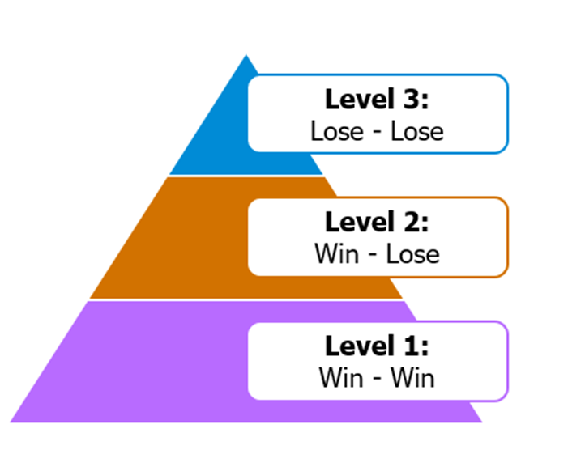
Adapted from Glasl’s Conflict Model, (Jordan, 2000)
- Win – Win: At the first level, both sides are focused on resolving the issue constructively. Think of it as a shared enquiry into what will help the ECT improve.
- Win – Lose: If the mentor makes their point in a way that leads to the trainee feels dismissed, the conversation can shift into the second level. Here the trainee may start defending themselves rather than engaging with feedback.
- Lose – Lose: If frustration builds on both sides, it risks slipping into lose–lose territory, where the relationship, not the performance, becomes the problem.
That’s why we don’t call these difficult conversations. We call them opportunity conversations, because that’s what they are. They’re a chance to grow trust, build understanding, and support development.
By planning carefully, structuring feedback clearly and fairly, tuning into emotional and nonverbal cues, and genuinely listening, you help ensure these conversations stay where they belong: at level 1, the win – win space:
- Where the focus is on improvement, not conflict
- Where your ECT feels heard, supported and challenged
- Where, together, you make progress.
Reflect
Reflect on the content in this section and consider:
- How do you currently prepare for conversations that feel uncomfortable, and to what extent are you creating the conditions for a win–win outcome?
- What might you need to change in your approach, in terms of timing, structure, tone or listening, to ensure these become true opportunity conversations that support your ECT’s growth?

Schools/trusts can adjust the reflective questions to suit their specific context and focus.

Click here to return to Content page

Preparing for opportunity conversations with clarity, care and challenge
Approximate time to complete: 7 minutes
In the first section, we explored why reframing ‘difficult conversations’ as opportunity conversations can have a transformative effect on your mentoring relationships. This second section turns to the practical tools that can help you do this well, particularly when the issue at hand involves performance, mindset or habits that need to shift.
Being purposeful, not reactive
Before diving into strategies and tools, it’s worth reinforcing a key message from Susan Scott’s work on ‘Fierce Conversations’ (2004): the quality of your relationships is determined by the quality of your conversations. And the more sustained your professional relationship with your early career teacher (ECT), the more critical this becomes.
Rather than seeing an opportunity conversation as a one-off moment, think about it as one tile in a long mosaic of conversations that will shape how this teacher sees themselves, their practice, and their profession. Scott reminds us that “our work, our relationships, and our lives succeed or fail one conversation at a time.”
Therefore, as you enter these moments, resist the pressure to fix everything all at once. Instead, ask:
- What outcome am I aiming for?
- What change do I hope to see?
- What kind of relationship do I want to build from here?
Clarifying the goal and desired change
Remember: opportunity conversations should always be anchored in a clear goal. That means you need to do the thinking beforehand, what change do I actually want to see? And does the ECT understand what success looks like?
This is where Peps Mccrea’s (2025) ‘six essential ingredients’ of professional development offer a useful lens:
- GET IT – Can the ECT explain the issue in terms of learning and teaching?
- SEE IT – Have they seen a clear example of what effective practice looks like?
- TRY IT – Do they know what to practise and how?
- KEEP IT – Are we helping them repeat and embed that improvement?
- FIT IT – Is the guidance tailored to their needs, pupils and subject?
- OWN IT – Are they invested in making the change?

Asking yourself these questions before the conversation, and encouraging the ECT to do the same, can make the exchange more productive and lead to sustainable improvement.
Choosing the right level of challenge
One of the risks in opportunity conversations is misjudging the level of challenge you bring to the discussion. You may worry about being too forceful, or not holding the line clearly enough. The Thomas-Kilmann Conflict Mode Instrument (TKI) offers a practical way to reflect on this balance by looking at how people typically respond to conflict or discomfort.
The TKI uses two axes:
- Assertiveness: how strongly you pursue your own agenda or point of view.
- Cooperativeness: how much you try to meet the needs or concerns of the other person.
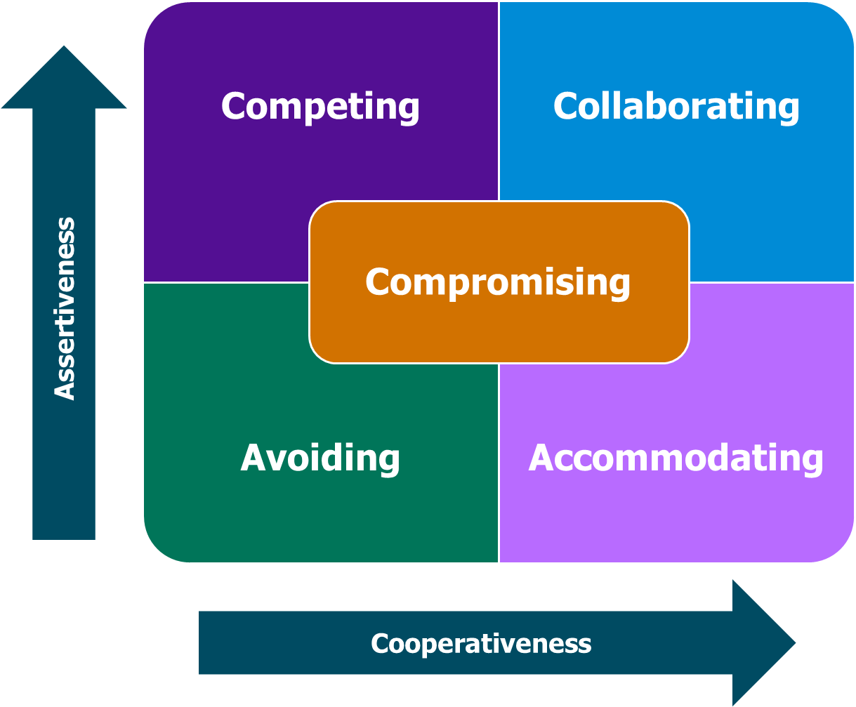
Adapted from: Thomas-Kilmann Conflict Mode Instrument (1976)
Where these two intersect, we get five different conflict-handling styles. Each has its place, but only some are helpful for growth-focused mentoring conversations.
Here's how they map out:
- Competing (High Assertiveness, Low Cooperativeness): You push your point firmly and expect it to be followed. This might be appropriate if a pupil safeguarding issue has been mishandled and there’s no room for debate, but used too often, it can create defensiveness and reduce your ECT’s sense of agency.
- Accommodating (Low Assertiveness, High Cooperativeness): You go along with your ECT’s perspective to preserve harmony. Sometimes this builds trust, but if used too often, it can mean you let things slide that really do need addressing.
- Avoiding (Low Assertiveness, Low Cooperativeness): You sidestep the issue entirely. This might be necessary if the timing or emotions aren’t right, but if you never come back to it, it becomes a missed opportunity for development.
- Collaborating (High Assertiveness, High Cooperativeness): This is the ideal zone for opportunity conversations. You’re upfront about the need for change, but you bring your ECT into the discussion, co-constructing a way forward. This aligns closely with the Radical Candour space described earlier.
- Compromising (Medium Assertiveness, Medium Cooperativeness): You look for a ‘middle ground’. It can be helpful when time is short or when priorities compete, but it might dilute the message if not handled carefully.
Task
Review the conversations you’ve had with your ECT, ask yourself:
- Where do you tend to sit on this graph?
- Have there been moments where avoiding a conversation felt easier?
- Have you gone too quickly into ‘compete’ mode without giving the ECT space to reflect and respond?
The goal here isn’t to always collaborate. Sometimes time, context or risk demand a different approach. But if every conversation becomes a battle, or is too softly pedalled, then the ECT’s growth can stall. The TKI can help you plan not just what you say, but how you say it.
Balancing care and challenge
You’ll have seen already how opportunity conversations depend on both strong relationships and high expectations. This is where Radical Candor, a model developed by Kim Scott (2017), can help you reflect on the tone and impact of the conversations you’re having with your early career teacher (ECT).
Radical Candor is built on two axes: Care Personally and Challenge Directly. When both are present, the feedback you give is more likely to be heard, trusted and acted upon. It’s the foundation for developmental conversations that feel respectful but uncompromising. But Scott is clear, when either of those two components is missing, the tone and outcome of the conversation can shift unhelpfully.

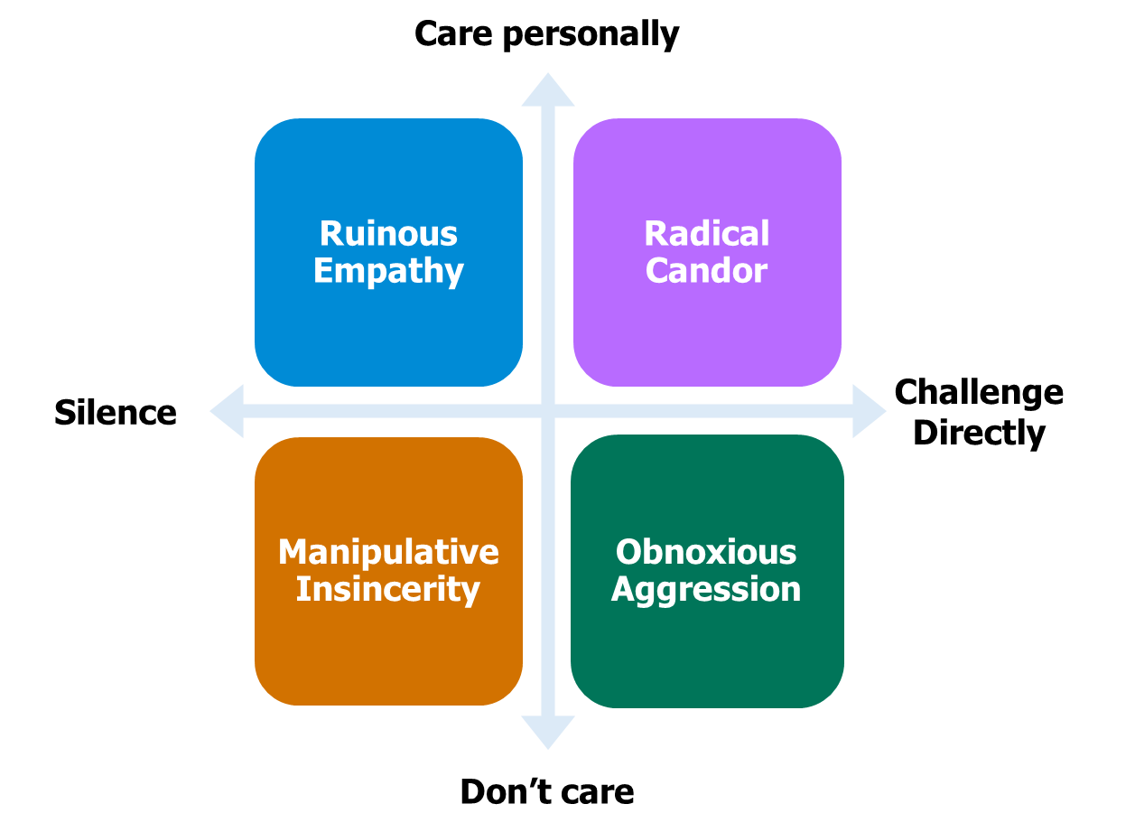
Adapted from Scott (2017)
Here’s a breakdown of the four quadrants:
- Radical Candor (Care Personally + Challenge Directly): This is the sweet spot for mentoring. You communicate clearly and specifically about what your ECT needs to improve, but you do so in a way that demonstrates you believe in their ability to grow. For example, you might say, “I noticed that pupils were unclear on what to do during the group task — let’s look at how to tighten up your instructions. I know this is something you can get really sharp on.” Here, the tone is calm, curious and focused on development. Your ECT feels both supported and stretched.
- Ruinous Empathy (Care Personally + Don’t Challenge Directly): You know something isn’t working in your ECT’s practice, but you avoid addressing it directly. Maybe you feel it would knock their confidence, or you’re worried about damaging your relationship. So instead of saying, “We need to work on your behaviour management routines,” you say, “That was a tough class, they’re a tricky group.” While your empathy is genuine, your silence means the ECT misses a vital learning opportunity. Over time, this can reinforce ineffective habits and slow their development.
- Obnoxious Aggression (Don’t Care Personally + Challenge Directly): This is where feedback is technically correct but delivered with little regard for how it lands. You might say something like, “Your questioning was really poor today, you need to fix that.” The ECT may leave the conversation feeling shamed or demoralised rather than empowered to improve. Even if your intention was to help, the absence of relational care makes it harder for them to hear or act on the message. Trust can quickly erode.
- Manipulative Insincerity (Don’t Care Personally + Don’t Challenge Directly): This is where feedback becomes vague or sugar-coated to avoid discomfort. You might say, “Everything’s going fine,” even when you know your ECT needs urgent support with pace or behaviour. Often this happens when mentors feel under pressure or disconnected from the process, they say what feels easiest rather than what is most helpful. But this leaves ECTs confused, unsupported, and at risk of underperforming without realising why.
This quadrant framework can be a useful tool to reflect on your own instincts. If you’re leaning too much towards empathy and avoiding challenge, your ECT might feel supported but not stretched. If you’re driving hard on challenge but haven’t yet built relational trust, it can feel like judgement rather than development.
The goal is to stay in that Radical Candor space, especially when conversations are hard. It’s how you show respect for your ECT’s growth and your belief in what they can become.
Reflect
Reflecting on this section, ask yourself:
- When planning your next opportunity conversation, how will you ensure you strike the right balance between care and challenge, so your ECT feels both supported and stretched?
- To what extent are you anchoring your conversations in clear, developmental goals, and are you confident your ECT understands what success will look like and why it matters?
Schools/trusts can adjust the reflective questions to suit their specific context and focus.

Click here to return to Content page
Designing and sustaining opportunity conversations
Approximate time to complete: 9 minutes
Schools/trusts can adjust this section to suit their specific context and focus and the model for deliberate practice they use.

Before we step into practical application, let’s anchor this section in deliberate practice. The opportunity conversations you hold as a mentor should mirror the same structure that helps ECTs grow their expertise.
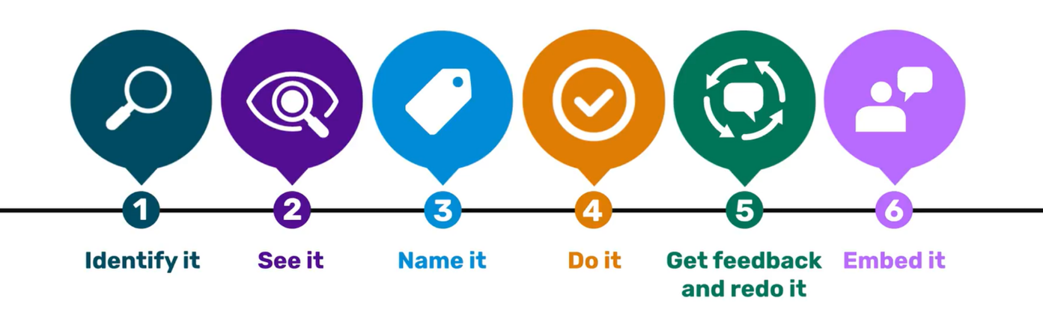
The National Institute of Teaching model (2025) - adapted from Deans for Impact (2016) and Bambrick-Santoyo (2018)
Here’s how each element of deliberate practice connects:
- Identify it: Ensure the element of teaching practice you are discussing is clearly identified, acknowledging why it is important. This will give the meeting a focus, ensuring there is a shared understanding of the aims.
- See it: Opportunity conversations ultimately lead to growth and a key part of this is sharing a model of what the great teaching actually looks like. Sharing a model will mitigate any chance of misinterpreting what is expected from your ECT.
- Name it: When working with your ECT, naming the active ingredients that make the practice effective is crucial. Why? It reduces ambiguity and enables feedback focused on an agreed set of criteria.
- Do it: It’s time to let your ECT take the lead and practice. This could mean creating a resource; scripting an explanation or planning what to say to a parent. Framing is crucial here – the earlier steps of the Deliberate Practice model will create a secure environment with clear expectations in which your ECT feels safe and confident to ‘have a go’.
- Get feedback and redo it: Don’t assume one conversation is enough. Revisit, reinforce and adapt. Just as teaching habits need to be repeated to become fluent, so too do mentoring habits.
- Embed it: Make sure there’s clarity about the next steps. What will the ECT be trying out in the days ahead? When will you revisit it? What evidence will show it’s improved?
When influencing is needed
Sometimes, opportunity conversations can become emotionally charged or feel at risk of stalling. That’s when influencing skills can support you in keeping the conversation productive, respectful, and anchored in shared goals.
Robert Cialdini’s work on influence (Robson, 2024) is widely used in both leadership and education development, and outlines seven core principles of influence. These can be especially helpful when you’re trying to secure commitment, overcome resistance, or reframe a problem without triggering defensiveness.
Let’s look at how these might apply in the context of opportunity conversations:
Reciprocity: People are more receptive when they feel the relationship is balanced and generous. For mentors, this might mean starting the conversation by recognising what the ECT is doing well, even if the main topic is about what needs to change. For example:
- “Before we talk through your questioning strategy, I just want to say how well your routines at the start of the lesson have landed, the calm start is really working.”
- This kind of praise, when specific and sincere, shows fairness and helps ensure any challenge feels earned, not arbitrary.
Commitment and consistency: We’re more likely to follow through on something if we’ve committed to it ourselves, especially if we’ve said it aloud. That’s why co-constructing next steps with your ECT is powerful. For instance:
- “You mentioned wanting your pupils to do more of the talking in lessons. What do you think would be one realistic change to help that happen next week?”
- Once the ECT has identified their own action, they’re more likely to follow through. You’re guiding, not dictating.
Social proof: Teachers often take comfort in knowing that their challenges are common. You can use examples of peers to remove stigma or fear:
- “Another ECT I worked with last year really struggled with cold calling at first. It felt awkward, but with practice, she found it built better engagement. Can I show you what we tried together?”
- This makes the problem feel solvable — and reminds the ECT they’re not alone.
Authority: Credibility doesn’t come from being the loudest voice in the room, it comes from grounding feedback in clear evidence. As a mentor, you might:
- Share pupil work that illustrates gaps in understanding
- Reference a known framework (for example:. Rosenshine’s principles)
- Use a short clip from lesson footage to model or unpick a teaching move
For example:
- “When you asked for full sentence responses, I noticed three pupils gave one-word answers. Would you like to watch that back and think about what we could try to secure that step?”
- This keeps the conversation rooted in shared reality, not opinion.
Liking: Feedback lands best in the context of a strong relationship. This doesn’t mean avoiding challenge (Scott, 2017), it means your ECT knows you care. Checking in on their wellbeing before launching into critique can make a difference:
- “How are you feeling after the double this morning? I know that group can be tough.”
- Small, consistent acts of relational investment build trust — which makes opportunity conversations feel safer, even when the message is tough.
Scarcity: Framing an opportunity as timely or unique can spur action. You might say:
- “You’ve got Year 8 for a double this week, that’s a great chance to embed this before the next assessment.”
- “This half-term is a great window to build that habit. Once mocks start, your focus will shift.”
These messages create gentle urgency, not pressure, but a sense that now is the right time to act.
Unity (Cialdini, 2021 update): Unity is about shared identity — people respond more positively when they feel you’re in it together. In mentoring, use we, not you vs me. For example:
- “We both care about those pupils getting the best from every task.”
- “This is something we all work on, I still catch myself rushing feedback sometimes too.”
- “In our department, we’re trying to be more deliberate with questioning, this is something we’re all building.”
These phrases position the mentor and ECT as allies with a common goal, rather than as evaluator and subject.
This sense of shared purpose and identity can disarm defensiveness and foster a more collaborative tone, essential when the conversation is challenging. Unity doesn’t replace the need for clarity and direction, but it can powerfully amplify your message, making it more likely that the ECT sees the feedback as something done with them, not to them.
In opportunity conversations, influence isn’t about persuasion for its own sake. It’s about leading thoughtfully, choosing language, structure, and tone that help your early career teacher move forward without losing trust or motivation. These seven principles provide you with practical options when a conversation gets stuck or feels high stakes, helping you navigate towards growth, together.
Strengthening your own expertise
Opportunity conversations don’t just offer a chance for your ECT to develop — they’re also rich opportunities for you to grow as a mentor. Each conversation is a moment of deliberate practice for you too: a chance to plan with purpose, act with clarity, and reflect on your own mentoring approach.
Just as we expect early career teachers to learn from feedback, you also need regular insight to refine your own practice and build your mental model of expert mentoring. But that insight can’t just come from line managers or peer discussions. Some of the most powerful feedback may come from the very person you're supporting.
Task
Ask yourself:
- What is it about your approach that’s helping your ECT grow?
- What do they find less helpful or unclear?
- What do they wish you’d do more (or less) of to support them more effectively?
Schools/trusts can adjust the reflective questions to suit their specific context and focus.
Opportunity conversations are one of the best times to invite this feedback; not just at the end of a cycle or term, but in the moment. These conversations build trust when they’re seen as a two-way dialogue. They show your ECT that you’re modelling the same openness, humility, and commitment to improvement that you ask of them.
To make this part of your regular mentoring practice, consider using a simple three-question reflection at the end of each half-term. You could introduce it verbally in a debrief, include it in a shared mentoring log, or build it into a short-written task:
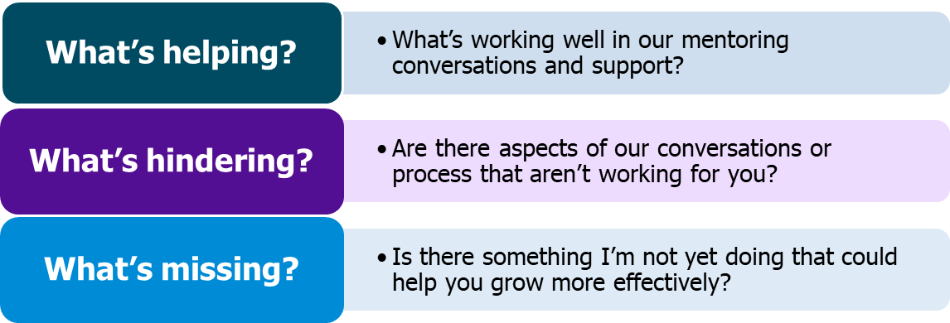
This process doesn’t just improve your mentoring relationship, it sharpens your professional judgment. It helps you recognise when to coach, when to challenge, when to listen and when to lead. Over time, these micro-insights accumulate, helping you embed more responsive, expert-informed mentoring habits.
Each opportunity conversation, then, becomes a chance not just to support your ECT, but to rehearse, refine, and evolve your own practice too.
Reflect
Reflecting on this section, ask yourself:
- How will you begin to treat opportunity conversations not just as a space for your ECT to grow, but as deliberate practice for your own development too?
- In what ways are you already gathering feedback from your ECT and how might you make this a more regular, intentional part of your mentoring cycle?
effectively?
Schools/trusts can adjust the reflective questions to suit their specific context and focus.

Click here to return to Content page
Opportunity conversations in action
Approximate time to complete: 5 minutes
Now that you’ve explored the purpose, structure, and mindset behind opportunity conversations, your next step is to put that understanding into action. This task invites you to rehearse the design of a high-leverage opportunity conversation with your early career teacher (ECT). Think of this as deliberate practice for yourself — an opportunity to refine how you plan, prepare and approach these moments with clarity, empathy and impact.
Schools and trusts should include a scenario based task here to give mentors the opportunity to put their understanding into action. The task could give mentors the chance to design a high leverage opportunity conversation with an ECT following these steps:
- Choose a scenario – a realistic issue that your ECT is currently facing or might face.
- Design the conversation use the following or a similar structure:
  - Clarify the goal
  - What specific improvement do you want your ECT to make?
  - What does ‘success’ look like — for them, for pupils, and for you?
- Choose your approach
  - How will you balance challenge and care?
  - Where do you want to sit on the Radical Candour grid (Scott, 2017)?
  - What’s the right conflict mode to adopt here (Thomas-Kilmann)?
- Plan your influence strategy
  - Which of Cialdini’s (2021) influence principles might support this conversation? (for example:. reciprocity, unity, authority)
- Script a short sample exchange
  - Write a short dialogue (6–10 lines) between you and your ECT that shows:
    - Active listening (for example:. using elements of MOREPIES)
    - Use of the AID model (Action, Impact, Desired Outcome)
    - A moment where the ECT is invited to reflect or co-construct the next step
- Close the loop
  - How will you check in with your ECT after this conversation?
  - What will you do to seek feedback on how you handled the conversation and how will you use that to improve?

Reflect
Once complete, reflect on your design using this question:
- How does this opportunity conversation reflect the deliberate mentoring habits you're trying to build?
- In what ways does it stretch your practice, and where might you still want support or refinement?
- effectively?
Schools/trusts can adjust the reflective questions to suit their specific context and focus.

Click here to return to Content page

Further reading and references
- College of Policing, (2020) ‘Conflict Management Skills’ Available from: Conflict management skills | College of Policing [Accessed 22 April 2026]
- Education Endowment Foundation, (2022) ‘Effective Professional Development’ Available from: EEF-Effective-PD-Mechanisms-Poster.pdf [Accessed 22 April 2026]
- Jordan T., (2000) ‘Glasl’s Nine Stage Model of Conflict Escalation’ Available from: (PDF) Glasl's Nine-Stage Model Of Conflict Escalation [Accessed 22 April 2026]
- Kilman R., (1976) ‘Thomas-Kilmann conflict MODE instrument’ Available from: (PDF) Thomas-Kilmann conflict MODE instrument [Accessed 22 April 2026]
- Mccrea, P., (2025) ‘Essential ingredients of PD’ Available from: Essential ingredients of PD [Accessed 22 April 2026]
- Robson D., (2024) ‘Influence: The unseen key behind powerful persuasion’ Available from: Influence: The unseen key behind powerful persuasion - BBC Future [Accessed 22 April 2026]
- Scott K., (2017) ‘Radical Candor’ Available from: Our Approach: Kim Scott's Feedback Framework | Radical Candor [Accessed 22 April 2026]
- Scott S., (2017) ‘Fierce Conversations’ Available from: Fierce Conversations: Achieving success in work and in life, one conversation at a time: Amazon.co.uk: Scott, Susan: 9780349417363: Books [Accessed 22 April 2026]
- Steplab, (2022) ‘The Evidence and Rationale Behind Steplab’ Available from: The Evidence and Rationale Behind Steplab [Accessed 22 April 2026]

Click here to return to Content page

