
ECT Programme – How to use school-led materials
2026/27 delivery
This guidance is intended for use by those who design and deliver school induction as part of a school-led programme for early career teachers.
It outlines how to use the materials from the National Institute of Teaching (NIoT).







Introduction
Thank you for choosing to use these school-led materials from the National Institute of Teaching’s (NIoT) Early Career Teacher (ECT) Programme to support the induction of early career teachers in your school.
The intention is for schools or trusts to use these materials to design and plan content for both ECTs and mentors. This forms part of the Early Career Teacher Entitlement (ECTE) within the ECT programme.
This guidance provides an overview of the NIoT programme, along with advice for induction tutors on how to use the materials as part of their early career entitlement offer.

Content
Overview | Page 3
Year 1 programme | Page 6
Year 2 programme | Page 8
Mentor Training programme | Page 12
Using the NIoT school-led materials | Page 13
Next steps | Page 19
Appendices | Page 20

Overview
The NIoT Early Career Teacher Programme nurtures the aspirations and confidence of new teachers to enable them to continue a fulfilling career in education. The first year of the programme helps ECTs to build on what they have learnt from their teacher training with mentor support. The second year allows them to dive deeper into the latest research and apply longer term strategies to the benefit of their schools and the pupils they serve.
Our Mentor Training Programme is designed and influenced by what mentors tell us they need to do the best job. The programme is not just for ECT mentors, but designed to support teachers and leaders who are mentoring and coaching others to progress their skills and understanding so they can implement them flexibly in your school as well as giving them the benefit of the underpinning framework and cutting-edge research evidence from the ECTE.
A flexible approach to the Early Career Teacher Programme
In both years of the programme, ECTs will study six modules each, one per half term, underpinned by the domains in the ITTECF. In response to feedback from the education sector, our ECT programme offers schools or trusts some flexibility around the order in which ECTs complete some modules in the programme.
In both years of the programme, the modules are:
- Behaviour and Relationships
- Memory and Learning
- Planning and Delivery
- Subject and Curriculum
- Assessing Learning
- Knowing your Learners
The first module that all ECTs complete is Module A – Behaviour and Relationships. This will support ECTs to establish a positive, structured learning environment that fosters pupil engagement, wellbeing, and academic success at the very start of the academic year
After that, schools can deliver Modules B-F in any order that they choose. This flexibility enables schools and trusts to align ECTs’ study and personal development with their own professional development priorities.
If you work in a multi-academy trust, you may need to liaise with colleagues to clarify whether the module sequence is being agreed at a whole-trust or whole-school level.

Example of a flexible sequence
Here’s an example of an adapted module sequence and the school’s rationale behind their selection.
School A is part of a MAT where adaptive teaching has been prioritised as an area for whole-school professional development for the next academic year. Therefore, they have adapted the sequence of modules so that all ECTs, trust-wide, will complete the ‘Knowing your Learners’ module in Autumn half term 2.
The Induction Lead has previously raised concerns that some early career teachers lack confidence in planning and teaching, particularly in using assessment to guide their future planning. Therefore, in the Spring, ECTs will begin by studying ‘Planning and Delivering’ before moving on to ‘Assessing Learning’.
In the final term, all ECTs will explore ‘Memory and Learning’ before finishing the year with ‘Subject and Curriculum’. This will align with a whole-staff professional development package already planned around long-term curriculum planning and subject enhancement.
Following consultation between the MAT’s Teaching and Learning Lead and Induction Lead, a decision has been made to adapt the sequence as follows:

Autumn Half term 1 | Autumn Half term 2 | Spring Half term 1 | Spring Half term 1 | Summer Half term 1 | Summer Half term 1
Behaviour and Relationships | Knowing your Learners | Planning and Delivering | Assessing learning | Memory and Learning | Subject and curriculum

Schools or trusts with multiple ECTs
In schools or trusts where there is more than one ECT, we recommend that all participants complete the modules in the same sequence. This will ensure a consistent school or trust-wide approach and provide opportunity for peer-support. This consistency also allows induction leads and mentors to deepen their expertise in key topics, streamline discussions, and tailor guidance more precisely.
Live seminars
Our materials include outlines for live seminars for you to create in-person sessions should you wish. If used, these should be delivered in the original sequence as they are not anchored to the individual modules. The seminars are designed to be delivered to groups. However, you can adapt the content for 1:1 delivery.
Our holistic approach to seminar-design means the content of each session will support the development of all ECTs regardless of their programme sequence or the personalised pathways of study within each module.
Return to Content page

Year 1 programme
Programme Introduction Materials
The programme begins with an asynchronous study and live seminar in which early career teachers are introduced to the ECT programme.
The seminar lasts 180 minutes and schools can contextualise the contents to reflect their own policies and approaches. The self-study takes around 90 minutes.
Self-study
Each of the six modules, is made up of one core self-study and five elective self-studies and lasts half a term for full-time ECTs.
ECTs complete one core self-study that revisits the evidence and theory that they first explored as an initial teacher trainee.
Having completed their core self-study, ECTs will undertake a personal reflection followed by a mentor discussion. This will help guide them to select three elective self-studies to complete. The electives offer a personalised pathway of study that will support ECTs’ understanding of how to put the theory into action in their own classroom practice. Note that in the first module of the year, all ECTs will select only 2 electives. This is to give them more time to get settled into the new school year.
In the school-led programme, each elective self-study contains opportunities for schools to add their own context specific examples to demonstrate what the theory looks like in practice. You can read more on this in Using the NIoT materials.
Here is an example of a typical half-term’s study for ECTs taken from Module C, Planning and Delivering.
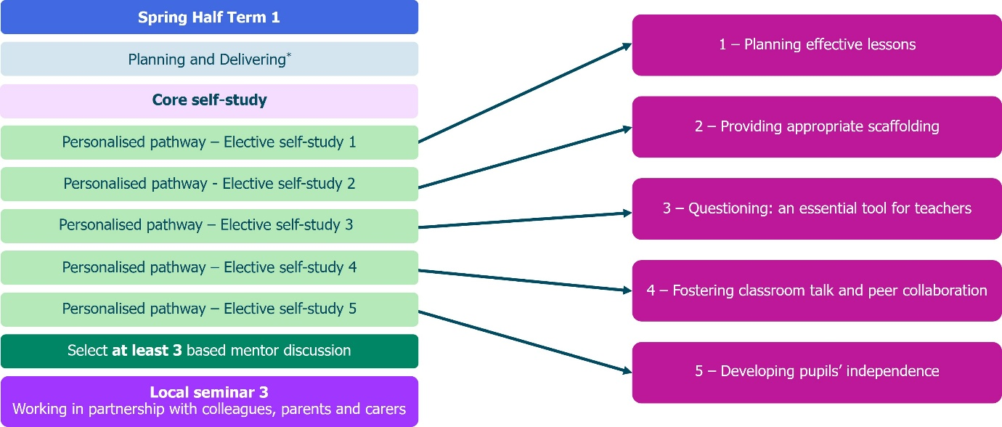

You can see a list of the focus areas within each module in Appendix 1 by clicking here.
Seminars
There are six seminars in year one – one per half term. These last 90 minutes.
The seminars are developed using feedback from ECTs, mentors, school and trust leaders. They are scenario-based and integrate statements from multiple areas of the framework, showing the interrelated nature of teaching practice. The sessions enable ECTs to deepen their understanding of the research and engage in practice activities to prepare for implementing evidence-informed teaching strategies.
Seminar overviews are provided and you can read more about how to use them here.
Seminar titles for year 1 of the programme are:
Autumn half-term 1 | Ensuring safe and predictable learning environments
Autumn half-term 2 | Planning effective lessons
Spring half-term 1 | Working in partnership with stakeholders
Spring half-term 2 | Checking prior knowledge and addressing misconceptions
Summer half-term 1 | Assessment literacy and analysis to inform teaching and learning
Summer half -term 2 | Integrating technology into classroom practice to support adaptive teaching

Year 1 programme overview
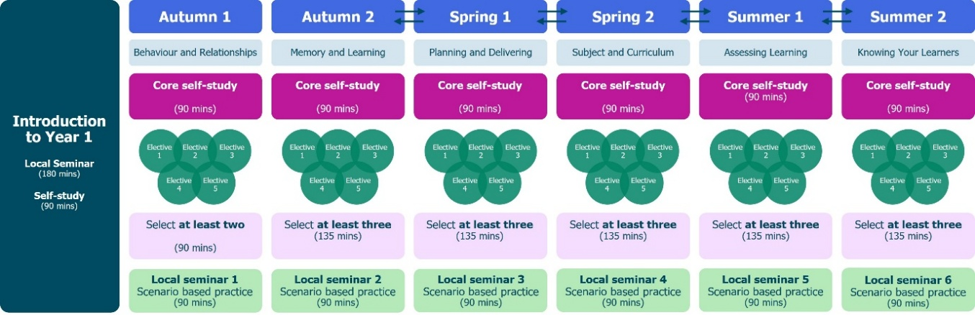
Return to Content page
Year 2 programme
Year 2 of the NIoT ECT Programme supports early career teachers to develop their research literacy and apply the theory to their practice with a small-scale implementation cycle each half-term.
Programme Introduction Materials
As with the first year of the programme, year 2 begins with an asynchronous study and live seminar which outlines how the content builds on the previous year’s materials.
The live seminar lasts 180 minutes and, as with year 1, schools can adapt the content to ensure contextualisation. The self-study will take ECTs around 90 minutes to complete.
Self-study
In year 2, ECTs will complete one 60-minute self-study per half-term.
The self-study is in two sections and the first mentor meeting of the half-term should take place after ECTs complete section 1. See Personal Professional Development Cycle for more information on mentor support in year 2.
Section 1
ECTs read three short summaries of research papers relating to the module, for example, assessment. They then complete a short reflection task related to each of the summaries and their current teaching practice. This takes around 20 minutes.
With their mentor, they will then identify their area for development for the half-term, drawing on the reflections. This will guide their personalised pathway for the rest of the self-study.
Section 2
ECTs will critically engage with the research paper related to their focus for the half-term. The materials provide an opportunity for them to:
- consider what the research tells us about teaching and improving practice;
- reflect on the limitations of the evidence;
- see phase-specific examples of how the theory might look in practice;
- explore how the research supports their own development as a teacher; and
- plan how it will guide their personal cycle of improvement this half-term.
This section will take around 35-40 minutes to complete.

Here is an overview of the modules and how the self-study process works in year 2.
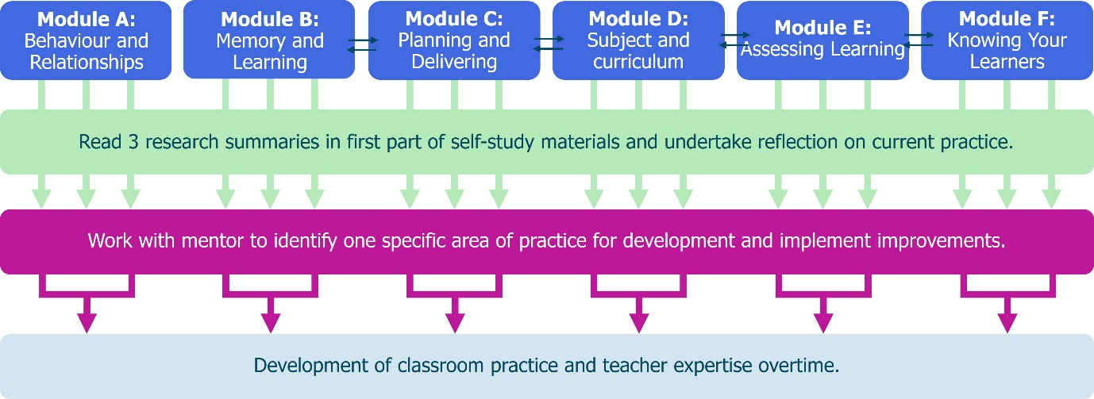
For an overview and summary of the readings in year 2, see Appendix 2
Seminars
ECTs have six seminars in year 2 – one per half term. These last 90 minutes.
Three of the seminars are designed to be delivered in subject or phase specific groups but you can deliver them all in this format if you wish.
Seminar overviews are provided and you can read more about how to use them here.
Seminar titles for year 2 of the programme are:
Autumn half-term 1 | Embedding high expectations, expectancies and routines in the classroom
Autumn half-term 2  Subject/phase specific | Enhancing instructional design through understanding how the memory works
Spring half-term 1 | Understanding how to support pupils to plan and deliver effective lessons
Spring half-term 2  Subject/phase specific | The importance of subject knowledge to support all pupils' learning
Summer half-term 1  Subject/phase specific | Using assessment to move learning forward
Summer half -term 2 | Adaptive teaching strategies to support all pupils to make progress

The Personal Professional Development Cycle
In year 2, the weekly actions are replaced by the Personal Professional Development Cycle. Once the focus area for the half-term has been identified, mentors and ECTs devise a plan of how to implement this improvement(s) into their teaching practice, within their unique context using the cycle as a framework.
Each mentor meeting of the half-term has a specific focus that will help put the plan into action, ensuring ECTs are supported every step of the way.
This approach enables ECTs to take more of a lead in their personal development journey. The model enables mentors to provide support or stretch their ECTs depending on their individual needs.
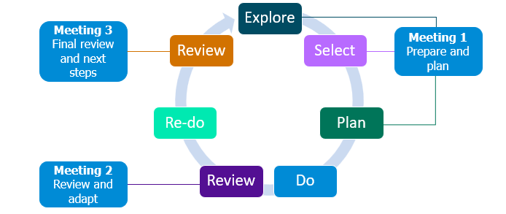

Meeting 1 Prepare and Plan
- Conducted in the first week of the half-term, ideally, ECTs meet with the mentor to engage in the explore, select and plan aspect of the professional development model
- They explore the specific element within that domain that they wish to improve based on their reflections and review any lesson drop-in data or current targets.
- Mentors will support ECTs to select the specific element they will focus on improving for the rest of the half term, using the theory in their self-study to guide this process.
- Together they will devise a plan of how to implement this improvement(s) into their teaching practice, within their unique context using the Personal Professional Development Cycle as a framework.
ECTs then put this in to practice during the ‘do’ phase of the cycle. They will make minor adaptations and adjustments as they go, making notes to bring to their 2nd mentor meeting.
Meeting 2 Review and Adapt
- Here ECTs and mentors will review and reflect on the experience so far and consider any adaptions that have been made or need to be made to support all learners.
- They will consider how the experience so far aligns with what the evidence says and probe why things may look different.
- They will use the conversations in this meeting to then refine the ECT’s practice in the ‘re-do’ phase, continuing to gather data and reflections.
Meeting 3 Final review and next steps
- In the final meeting of the half term, mentors and ECTs review the experience as a whole to inform future adjustments and refinements in their teaching practice.
- Again, they will consider how far it aligned with the evidence and why they may have needed to make adjustments.
The Personal Professional Development Cycle serves as a guide to support the ECT’s journey to becoming a confident, evidence-informed practitioner– not just during year 2, but also as model they can use independently as a year 3 teacher and beyond.
Mentor support materials
Optional mentor support materials are available that outline the ECT study, provide suggested action steps that can be implemented as part of the Personal Professional Development Cycle. They also provide helpful guidance to help mentors prepare for each of their mentee meetings.
Year 2 programme overview
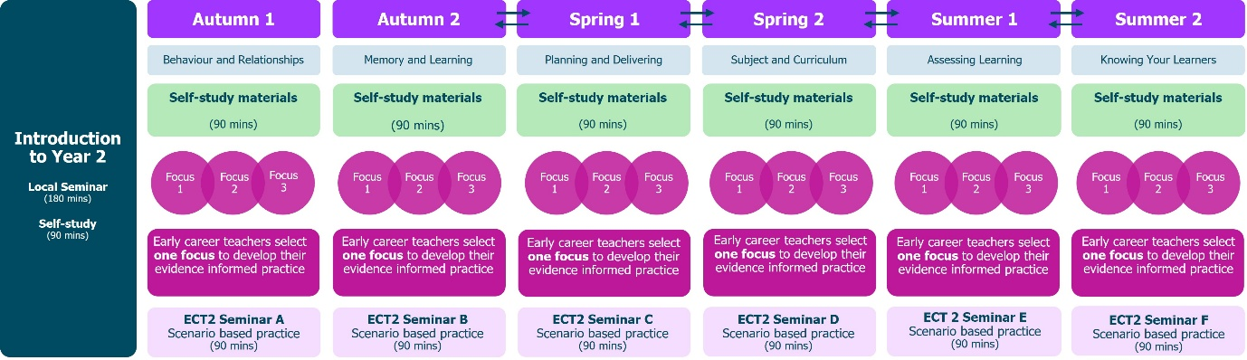
Return to Content page
Mentor Training Programme
The NIoT Mentor Training Programme is aimed to develop mentors as coaches working not only with ECTs but with other colleagues to develop their practice.
Areas covered include the implications of AI in education, deepening understanding of adaptive teaching, how to put belonging at the heart of teaching and the differences between pedagogy and andragogy.
The programme is made up of asynchronous study and seminars.
Self-study
Mentors complete one self-study per term and these take around 30-minutes to complete. There is a choice of six different topics to choose from which allows mentors to select the focus that most closely meets their development needs. Mentors can complete more if they choose, however.
We recommend that mentors start the programme with the self-study on Deliberate Practice which is a cornerstone of all our programmes. Two options are available for mentors to choose from depending on prior experience of Deliberate Practice: novice and expert.
For a summary of the Mentor Training Programme self-study topics click here.
Seminars
There are three 90-minute seminars all designed to develop mentors’ understanding, expertise and confidence in key areas of pedagogy in the sector.
Mentor Training Programme Overview
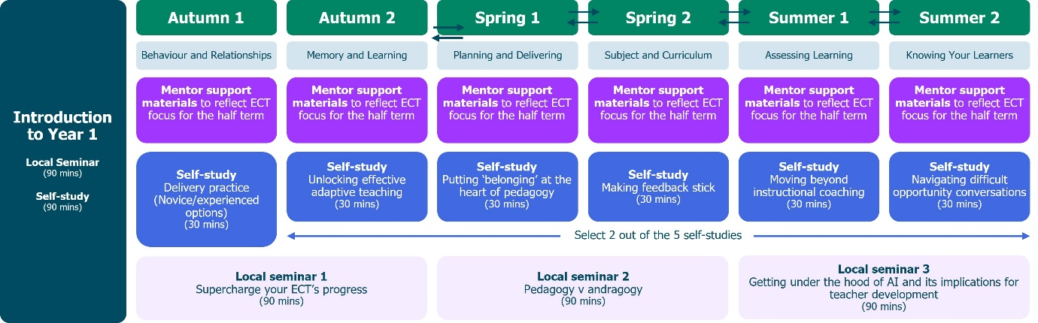

Return to Content page

Using the NIoT school-led materials
Documents are provided in editable versions which should be downloaded. You can then edit or adapt the materials to meet your own school or trust needs. The careful design of the NIoT materials means that the contents provide full coverage of the ITTECF. For this reason, we suggest that schools only edit or adapt content where relevant opportunities have been signposted throughout the materials. This will avoid any unintentional gaps in framework coverage.
Year 1
What materials do we provide?
The following materials have been provided to help you design your own induction programme for ECTs in the first year of their Early Career Teaching Entitlement.
- Introductory materials comprising 1 self-study and 1 live seminar outline
- Core self-study x 6 modules
- Elective self-studies x 6 modules
- Live seminar outlines
For mentors, we have provided introductory materials as well as optional support materials for mentors of Early Career Teachers in year 1 of the ECT Programme.
Introductory Materials
A self-study and live seminar outline for both early career teachers and mentors has been provided. These provide an overview of the Early Career Teacher Programme. You should edit these to reflect how the programme will be implemented in your school or trust. Prompts are provided within the materials to indicate where you should do this. Both the live seminar and self-study last 90 minutes.
Self-study content
- Core self-study
ECTs will complete one core self-study per module. This will take approximately 60 minutes to complete per half-term.
There are limited opportunities for schools to adapt the core self-studies. This is intentional because the core self-study acts a refresher to the knowledge ECTs will have gained in that specific element of teaching during their initial teacher training. Each core-study is rooted in the ITTECF evidence base and provides the underpinning theory that all ECTs must learn as part of their entitlement.
- Elective self-studies
Having completed their core self-study and Reflection activities, ECTs then select 3 elective self-studies per module. Each elective self-study will take approximately 45 minutes to complete. Each of these is focused on a more granular aspect of the broader topic and this is where ECTs are able to see how the theory looks in practice. For half-term 1, they only need to complete 2 elective self-studies to give them more time to get settled into the new school year.
The half-termly structure gives ECTs approximately two weeks to plan, implement and reflect on the reading they have completed. The intention is to make their workload more manageable and it's likely that they will revisit the self-study content throughout the fortnight to guide your next steps with you mentor.
- Scenario-based approach
Each elective self-study uses a scenario-based approach for ECTs to consider as they progress through the content. They should select the most relevant one for them. This will allow ECTs to consider how they will apply their learning in their own practice. You may wish to adapt the scenarios to align with practices in your school or trust, however you should ensure that any changes still allow ECTs an opportunity to apply what they have learned. There is no expectation for ECTs to look at them all and you may wish to remove scenarios that are not relevant to your school.
- Active ingredients
Each section of the elective self-study includes a short review of the evidence and an outline of what this could look like in practice. This is followed by a list of ‘active ingredients’ (the components) that make particular elements of practice effective. The active ingredients should not be edited or amended as these reflect how the theory is enacted in the classroom. They are the bridge between theory and practice.
- Examples
For each section of the elective self-study, you should provide examples for ECTs to see what the theory looks like in practice. This will be clearly signposted in the materials. Examples embedded within the content could include:
- Video recordings
- Artefacts or resources
- Transcripts
You may also support ECTs’ asynchronous study with examples that include:
- Live observations of others
- Modelling (for example live demonstrations)
It is crucial that the examples used demonstrate how the active ingredients are put in practice through an explanation or analysis. ECTs should not be left to make this connection themselves.

- ECT weekly actions
Elective self-studies include suggested action steps to support ECTs in applying the theory into practice, following discussion with their mentor at their weekly meeting. You can edit or adapt these to align with practices in your school or trust. However, these should still enable ECTs to enact the active ingredients so we recommend that you consider keeping the suggestions as outlined in the NIoT materials.
ECT Personal professional reflections
Having completed their core self-study, ECTs should be guided to use their personal reflections from the study, along with their Career Entry Development Profile (CEDP) or other targets from their ITT, to guide a discussion with their mentor. Each elective self-study has a suggested framework to help guide this conversation. Together, they will identify the priority focus areas for development within a module. This should take around 30 minutes.
Live seminar outlines
Outlines of live seminars have been provided in Word format. The outlines can be used to create slideshows or other content to use in live sessions with ECTs. Live seminars should last 90 minutes with one per half-term. The outlines include an overview of the underpinning theory for each section of the session. Suggested activities are highlighted in the outlines.
Mentor support materials
Optional materials are provided to help mentors to support their ECTs’ development. For each core and elective self-study, there is an associated mentor self-study. These take 15 minutes per week or 90 minutes per term to read. These provide:
- Overview of the ECT materials
- Active ingredients (elective self-studies)
- Suggested weekly actions (elective self-studies)
- Suggested weekly meeting framework to help plan meetings.
We suggest that any exemplification used in ECT content, is shared with mentors to ensure a shared understanding.

Year 2
What materials do we provide?
The following materials have been provided to help you design your own induction programme for ECTs in the first year of their Early Career Teaching Entitlement.
- Introductory materials comprising 1 self-study and 1 live seminar outline
- Core self-study x 6 modules
- Live seminar outlines
For mentors, optional support materials for mentors of Early Career Teachers in year 2 of the ECT Programme.
Introductory Materials
A self-study and live seminar outline for early career teachers has been provided. These provide an overview of year 2 of Early Career Teacher Programme. You should edit these to reflect how the programme will be implemented in your school or trust. Prompts are provided within the materials to indicate where you should do this. The seminar lasts 180 minutes and self-study takes 90 minutes.
Self-study content
Each of the six self-studies includes guidance on where schools can add or adapt content. However, schools should not made amendments to the sections on theory or evidence.
- Active ingredients
As with year 1 self-study content, each study includes a list of ‘active ingredients’ that make particular elements of practice effective. The active ingredients should not be edited or amended as these reflect how the theory is enacted in the classroom. They are the bridge between theory and practice.
- Examples
For each personalised pathway in the year 2 self-study, you should provide examples for ECTs to see what the theory looks like in practice. This will be clearly signposted in the materials. Examples embedded within the content could include:
- Video recordings
- Artefacts or resources
- Transcripts
You may also support ECTs’ asynchronous study with examples that include:
- Live observations of others
- Modelling (for example live demonstrations)
It is crucial that the examples used demonstrate how the active ingredients are put in practice through an explanation or analysis. ECTs should not be left to make this connection themselves.
- ECT actions in Year 2
The self-studies include suggested action steps to support ECTs in applying the theory into practice and implanted using the Personal Professional Development Cycle. You can edit or adapt these to align with practices in your school or trust. However, these should still enable ECTs to enact the active ingredients so we recommend that you consider keeping the suggestions as outlined in the NIoT materials.
Live seminar outlines
As with year 1, overviews of live seminars have been provided in Word format. These outlines can be used to create slideshows or other content to use in live sessions with ECTs. Live seminars should last 90 minutes with one per half-term. The outlines include an overview of the underpinning theory for each section of the session. Suggested activities are highlighted in the outlines.
As outlined earlier, three of the seminars are designed to be delivered in subject or phase specific groups but you can deliver them all in this format if you wish.
Mentor support materials
Optional materials are provided to help mentors to support their ECTs’ development. For each self-study, there is an associated mentor self-study. These take 15 minutes per week or 90 minutes per term to read. These provide:
- Overview of the ECT materials
- Active ingredients
- Suggested actions
- Suggested meeting framework to plan mentor meetings
We suggest that any exemplification used in ECT content, is shared with mentors to ensure a shared understanding.

Mentor Training Programme
Self-study content
As with ECT self-study content, areas where schools can amend or alter the material are identified with red text or boxes.
We suggest that all mentors begin Term 1 with self-study 1a or 1b, both related to Deliberate Practice. Mentors can self-select based on their prior experience and confidence at using Deliberate Practice.
Mentors should then complete one further self-study from the remaining five in Terms 2 and 3.
Live seminar outlines
Overviews of live seminars have been provided in Word format. They can be used to create slideshows or other content to use in live sessions with ECTs. Live seminars for mentors should last 90 minutes with one per term.
The outlines include an overview of the underpinning theory for each section of the session. Suggested activities are highlighted in the outlines.

Return to Content page

Next steps
- Discuss with relevant colleagues whether modules B-F will be delivered in a revised sequence. Agree on the sequence you will follow to guide your planning of the programme delivery.
- Download the content required from the NIoT website.
- Review the content, making adaptations and additions where required.
- Use the materials to design your ECT programme.

Thank you for choosing to use the materials from the National Institute of Teaching to deliver your ECT programme.
Return to Content page

Appendix 1
Year 1 modules and associated self-studies
Module | Elective self-studies in this module
A Behaviour and Relationships | 1 | Communicating belief in pupils' academic potential
A Behaviour and Relationships | 2 | Establishing effective routines and expectations
A Behaviour and Relationships | 3 | Creating a positive, predictable, and safe learning environment
A Behaviour and Relationships | 4 | Building effective relationships
A Behaviour and Relationships | 5 | Motivating pupils
B Memory and Learning | 1 | How the memory works
B Memory and Learning | 2 | The role of pupils’ prior knowledge
B Memory and Learning | 3 | Managing cognitive load
B Memory and Learning | 4 | Understanding and addressing pupil misconceptions
B Memory and Learning | 5 | Retrieval, revisiting and reviewing information
C Planning and Delivering | 1 | Explanations, modelling and examples
C Planning and Delivering | 2 | Scaffolding and increasing challenge
C Planning and Delivering | 3 | Planning effective practice, including homework
C Planning and Delivering | 4 | Questioning as an essential tool for teachers
C Planning and Delivering | 5 | Fostering classroom talk and peer collaboration
D Subject and Curriculum | 1 | Delivering a carefully sequenced curriculum
D Subject and Curriculum | 2 | Anticipating misconceptions
D Subject and Curriculum | 3 | Building increasingly complex mental models
D Subject and Curriculum | 4 | Developing early literacy
D Subject and Curriculum | 5 | Enhancing all pupils' literacy
E Assessing Learning | 1 | Designing effective assessment
E Assessing Learning | 2 | Checking prior knowledge and understanding
E Assessing Learning | 3 | Providing high-quality feedback
E Assessing Learning | 4 | Making marking and feedback manageable
E Assessing Learning | 5 | Developing your practice in relation to assessment and feedback
F Knowing your Learners | 1 | Understanding different pupil needs
F Knowing your Learners | 2 | Providing opportunities for all pupils to succeed
F Knowing your Learners | 3 | Meeting individual needs without creating unnecessary workload
F Knowing your Learners | 4 | Effective grouping and deployment of teaching assistants (TAs)
F Knowing your Learners | 5 | Developing your knowledge in special educational needs and disabilities (SEND)

Return to Modules overview
Return to Content page

Appendix 2
Year 2 – Overview of focus areas
Each focus area links to a piece of research from the ITTECF. ECTs will select one and read a summary of the paper before they critically reflect on the evidence.
Module | Focus area 1 | Focus area 2 | Focus area 3 | Focus area 4
Module A Behaviour and Relationships | ‘The Pygmalion Effect’ and teacher expectancies | Using ante-cedent strategies to manage behaviour proactively | Strategies and approaches to motivate pupils
Module B Memory and Learning | Deepening understanding of working memory | Instructional designs and Cognitive Load Theory | ‘The Testing Effect’ – how to use feedback as part of retrieval practice
Module C Planning and Delivering | Exploring the role of scaffolding | Using worked examples as part of instructional design | How to develop pupils as self-regulated learners
Module D  Subject and Curriculum | Understanding ‘inflexible knowledge’ | Using corrective feedback to address misconceptions | Developing pupils’ critical thinking
Module E Assessing Learning | Deepening understanding of using formative assessment to move learning forwards | Understanding how and when to use different focus areas of feedback | Planning to use formative assessment effectively
Module F Knowing Your Learners | Strategies and approaches for pupils with communication SEN | Strategies and approaches for pupils with cognition and learning SEN | Strategies and approaches for pupils with BESD | Strategies and approaches for pupils with sensory or physical SEND

Module A | Reading | Summary overview
Behaviour and relationships | Reading 1  Questioning Pygmalion in the twenty-first century: the formation, transmission, attributional influence of teacher expectancies  Lisel Alice Murdock-Perriera and Quentin Charles Sedlacek (2018) | This paper reviews research into teacher expectancies and their impact on pupil outcomes, focusing on how teachers’ beliefs and assumptions about pupils can shape interactions and influence achievement. The authors discuss the Pygmalion Effect, which suggests that pupils often perform in line with teachers’ expectations, highlighting how subtle cues such as feedback, time allocation, and classroom climate can reinforce these expectations. The paper also explores how teacher beliefs can form and persist through shared information, data, and prior experiences, sometimes leading to self-fulfilling prophecies. While acknowledging limitations in the evidence base, the authors argue that teachers should act deliberately to interrupt negative expectancy cycles, using reflective and equitable practices. Overall, the paper reinforces the need for teachers to be conscious of their own biases and how these may unconsciously affect pupils’ motivation and achievement.
Behaviour and relationships | Reading 2  Antecedent Strategies to Promote Appropriate Classroom Behaviour  Lee Kern and Nathan H. Clemens (2007) | This paper by Kern and Clemens (2007) explores the use of antecedent strategies to prevent behavioural and academic challenges by focusing on modifying the classroom environment rather than reacting to pupil behaviour after it occurs. The authors argue that prevention through structure, clarity, and predictability is more effective than punitive responses. They present a range of class-wide and individual strategies, such as establishing clear routines, matching tasks to pupils’ ability levels, providing choices, and incorporating pupils’ interests into lessons. These approaches promote positive behaviour by reducing triggers for off-task conduct and increasing engagement. The paper concludes that antecedent strategies are most effective when used as part of a wider school and classroom approach that includes clear instruction and consistent expectations.
Behaviour and relationships | Reading 3  Motivation interventions in education: A meta-analytic review  Rory A. Lazowski and Chris S. Hulleman (2016) | This paper by Lazowski and Hulleman (2016) presents a meta-analysis of 74 studies exploring how different motivational interventions can improve pupil engagement and achievement. Drawing on research involving over 38,000 pupils, the authors identify 15 theoretical frameworks, including self-efficacy, goal setting, expectancy value, and self-determination, each highlighting distinct factors that influence motivation. The study finds that well-designed interventions can positively impact pupil outcomes and are often inexpensive to implement. It also emphasises that combining approaches, such as helping pupils set challenging goals while fostering a sense of belonging, may lead to stronger results. However, the authors note that teachers need a solid understanding of motivation theory to apply these strategies effectively in classrooms.

Module B | Reading | Summary overview
Memory and learning | Reading 1:  Working Memory: Looking Back and Looking Forward  Alan Baddeley (2003) | In this paper, Baddeley (2003) revisits and critically evaluates his original three-part model of working memory (Baddeley and Hitch, 1974), reflecting on developments in cognitive science over the preceding decades. Drawing on an extensive review of research in cognitive psychology, psycholinguistics, and communication disorders, he explores how the phonological loop, visuospatial sketchpad, and central executive operate and interact. Baddeley acknowledges limitations in the original model and integrates alternative theories and evidence to refine his understanding of working memory processes. A key addition to his model is the episodic buffer, introduced in his 2000 work, which functions as a temporary storage system that integrates information from the phonological loop and visuospatial sketchpad into coherent episodes for long-term retention. Throughout the paper, Baddeley situates his revised framework within broader academic debate, recognising both the value and the evolving nature of theories explaining how working memory functions.
Memory and learning | Reading 2:  Cognitive load theory, evolutionary educational psychology, and instructional design  Sweller et al. (1998) | In this paper, Sweller et al. (1998) explore how understanding how the mind works can improve how we design lessons and materials, introducing Cognitive Load Theory (CLT) as a key framework. They explain that working memory has limited capacity and that effective learning depends on how information is presented and connected to what pupils already know. The paper distinguishes between intrinsic load (the natural difficulty of content), extraneous load (caused by poor presentation or unnecessary information), and germane load (the mental effort used to build and strengthen schemas). Schemas—mental structures that store and organise knowledge—help reduce cognitive load by allowing learners to process information more efficiently. Sweller et al. highlight that thoughtful instructional design, such as using worked examples, gradually increasing difficulty, and avoiding split attention, can reduce unnecessary load and make learning more effective.
Memory and learning | Reading 3:  The critical role of retrieval practice in long-term retention  Henry L. Roediger and Andrew C. Butler (2011) | In this paper, Roediger and Butler (2011) review research on retrieval practice—the process of recalling information from memory without re-studying it—and its impact on long-term learning. They argue that retrieval practice, such as quizzes or self-testing, is more effective for retention than simply re-reading material, as the act of recalling strengthens memory pathways. The paper highlights that retrieval is most beneficial when some forgetting has occurred between tests and when practice is spaced out over time. Feedback, especially when delayed, further enhances learning by reinforcing correct knowledge. Overall, the authors conclude that incorporating retrieval practice into teaching can significantly improve long-term memory and support knowledge transfer, helping learners apply what they know to new situations.

Module C | Reading | Summary overview
Planning and delivering | Reading 1  How effective are instructional explanations in example-based learning? A meta-analytic review  Jörg Wittwer and Alexander Renkl (2010) | In this paper, Wittwer and Renkl (2010) explore how instructional explanations influence pupils’ learning when using worked examples. Worked examples—problems that include the full solution process—are shown to help pupils, particularly novices, understand complex concepts more effectively than problem-solving alone. However, the authors found that adding teacher explanations to these examples produces mixed results. Their meta-analysis revealed that instructional explanations can support conceptual understanding when pupils are new to a topic but may be less effective, or even unhelpful, for more experienced learners. They conclude that effective teaching should strike a balance between providing guidance and encouraging pupils to generate their own explanations, depending on their level of prior knowledge and the learning goal.
Planning and delivering | Reading 2  The effects of scaffolding in the classroom: support contingency and student independent working time in relation to student achievement, task effort and appreciation of support  Janneke Van de Pol, Monique Volman, Frans Oort and Jos Beishuizen (2015) | In this paper, Van de Pol et al. (2015) examine how different levels of scaffolding affect pupils’ learning, motivation, and engagement. Scaffolding refers to the tailored support teachers provide to help pupils complete tasks they could not manage independently, gradually reducing help as pupils gain confidence and skill. The study found that high-contingency scaffolding—where teachers adapt support precisely to pupils’ needs—led to higher achievement, greater appreciation of teacher help, and more independent working time. However, low-contingency scaffolding, which offers more general support, was more effective in keeping pupils on task for shorter periods. The authors conclude that effective scaffolding involves balancing support to prevent overload or disengagement, ensuring pupils remain challenged while building autonomy.
Planning and delivering | Reading 3  Becoming a self-regulated learner: an overview  Barry J. Zimmerman (2002)  Building on prior knowledge | In this paper, Zimmerman (2002) presents a framework for understanding self-regulated learning, describing how pupils can actively manage their learning through goal-setting, monitoring, and reflection. He explains that self-regulated learning develops over time and involves three key phases: forethought (planning and goal-setting), performance (implementing strategies and maintaining focus), and self-reflection (evaluating progress and adapting approaches). Pupils who can self-regulate are more motivated, confident, and capable of improving their performance, while those who cannot often struggle with organisation, persistence, and self-belief. Zimmerman emphasises that these skills are not innate but can be explicitly taught and modelled by teachers, supporting pupils to become independent, life-long learners.

Module D | Reading | Summary overview
Subject and curriculum | Reading 1  Ask the Cognitive Scientist. Inflexible Knowledge: the first step to expertise.  Daniel T Willingham (2002) | In this article, Daniel Willingham (2002) explores why pupils often appear to learn new material by rote, even after engaging lessons. He distinguishes between three types of knowledge—rote, inflexible, and flexible—arguing that inflexible knowledge is a natural and necessary stage in developing expertise. Initially, pupils grasp only the surface features of new concepts, but through varied examples, problem-solving, and repeated practice, they begin to recognise deeper structures and apply knowledge more flexibly. Willingham explains that flexible knowledge enables pupils to transfer learning to new contexts, while inflexible knowledge provides the foundation for this growth. He concludes that teachers should value and build upon inflexible knowledge by designing lessons that connect new ideas to prior learning and gradually increase complexity to support the move towards expertise.
Subject and curriculum | Reading 2  Belief in Corrective Feedback for Common Misconceptions: Implications for Knowledge Revision  Rich et al. (2017) | In this paper, Rich et al. (2017) investigate how belief in corrective feedback influences pupils’ ability to revise misconceptions and how explanations can strengthen that belief. Through two experiments, participants were given either simple refutations or refutations with explanations for common misconceptions and later tested on their understanding. The study found that providing explanations alongside corrections led to greater belief in the feedback and more accurate knowledge revision over time. This suggests that learners are more likely to replace incorrect ideas when they understand why their misconception is wrong, not just that it is wrong. The researchers conclude that effective feedback must include clear, credible explanations that help pupils make sense of new information and trust its validity.
Subject and curriculum | Reading 3  How to teach critical thinking  Daniel T Willingham (2019) | In this paper, Daniel Willingham (2019) explores how critical thinking can be effectively taught in schools, arguing that it must be rooted in subject knowledge rather than taught as a generic skill. He highlights that while explicit teaching of critical thinking can work within specific domains, evidence shows limited transfer to unrelated contexts because analysis and evaluation look different across disciplines. Willingham stresses that critical thinking depends on strong subject knowledge, as this frees up working memory and allows pupils to recognise deeper patterns and connections. He proposes a four-step framework for teachers: explicitly teach domain-specific critical thinking skills, identify essential content, carefully sequence learning, and revisit key skills for long-term retention. Ultimately, he concludes that developing pupils’ critical thinking is a gradual, content-driven process requiring sustained practice over time.

Module E | Reading | Summary overview
Assessing learning | Reading 1  Working Inside the Black Box: Assessment for learning in the classroom  Black et al. (2004) | In this paper, Black et al. (2004) build on their earlier research to explore how formative assessment, or assessment for learning, can raise pupil achievement by making classroom processes more interactive and feedback-driven. They define formative assessment as any assessment used to adapt teaching and learning in real time to meet pupils’ needs. The paper outlines four key strategies for effective practice: using purposeful questioning to assess understanding, providing feedback through comments rather than grades, embedding peer and self-assessment, and using summative assessments formatively. The research shows that when pupils understand their learning goals, receive constructive feedback, and actively reflect on their progress, they become more engaged, independent, and motivated learners.
Assessing learning | Reading 2  The Power of Feedback  John Hattie and Helen Timperley (2007) | In this paper, Hattie and Timperley (2007) present a model explaining how effective feedback drives learning by reducing the gap between a learner’s current understanding and their desired goal. They argue that powerful feedback answers three key questions: Where am I going? (clarifying goals), How am I going? (evaluating progress), and Where to next? (identifying next steps). The paper outlines four levels of feedback—task, process, self-regulation, and self-level—emphasising that the first three have the greatest impact on learning when used appropriately. Feedback is most effective when it focuses on understanding and strategies rather than praise, is given in a supportive classroom climate, and encourages pupils to take greater control of their learning.
Assessing learning | Reading 3  Formative Assessment and The Design Of Instructional Systems  Royce Sadler (1989) | In this paper, Royce Sadler (1989) establishes formative assessment as a process central to improving learning by helping pupils understand and close the gap between their current performance and the desired goal. He argues that effective formative assessment depends on three key conditions: pupils must know what quality work looks like, be able to compare their current work to that standard, and know how to improve it. Sadler highlights that feedback alone is not enough; pupils need to be taught how to self-assess and regulate their own learning. Through developing these evaluative and self-regulatory skills, pupils become more independent and better equipped to monitor, adjust, and improve their work. His work continues to influence how formative assessment and feedback are used to promote self-regulated learning and long-term progress.

Module F | Reading | Summary overview
Knowing your learners | Reading 1  Communication and interaction in Teaching Strategies and Approaches for Pupils with Special Educational Needs: A Scoping Study  Davis et al (2004) | In this paper, Davis et al. (2004) explore strategies to improve communication and interaction for pupils with Special Educational Needs (SEN), focusing on conditions such as autism spectrum disorder (ASD), speech and language communication needs (SLCN), and profound learning difficulties. The study highlights the importance of early identification, tailored interventions, and collaboration between teachers, families, and external professionals. It outlines practical approaches such as using visual aids, structured routines, and sensory-based activities to support communication and engagement. Evidence-based methods like Applied Behaviour Analysis (ABA) and TEACCH are identified as particularly effective for pupils with ASD. The paper concludes that inclusive classrooms depend on teachers’ ability to adapt strategies to meet individual needs, enabling all pupils to communicate, participate, and learn successfully.
Knowing your learners | Reading 2  Cognition and learning in Teaching Strategies and Approaches for Pupils with Special Educational Needs: A Scoping Study  Davis et al (2004) | Davis et al. (2004) explore effective teaching strategies for supporting the cognition and learning of pupils with Special Educational Needs (SEN) within inclusive education settings. The paper highlights that pupils with SEN may experience challenges with attention, memory, reasoning, and metacognition, which require tailored instructional approaches. The study concludes that no single strategy is sufficient; instead, a flexible combination of approaches—such as explicit instruction, scaffolding, and metacognitive support—proves most effective. The authors also emphasise the importance of assessment-informed teaching, ongoing adaptation, and collaboration with families to promote inclusion and sustained progress. Overall, the research calls for teachers to develop responsive, evidence-based practices that meet individual learning needs across different phases of education.
Knowing your learners | Reading 3  Behavioural, emotional and social development in Teaching Strategies and Approaches for Pupils with Special Educational Needs: A Scoping Study  Davis et al (2004) | Davis et al. (2004) explore strategies that support the behavioural, emotional, and social development of pupils with Special Educational Needs, recognising how these areas affect learning and engagement in the classroom. The paper identifies three key perspectives for understanding behaviour: behavioural, cognitive behavioural, and systemic, each offering ways to address difficulties. Effective strategies include peer mentoring, positive reinforcement, self regulation techniques, and collaboration with families. The study highlights the importance of early intervention, consistency, and supportive environments where behaviour management fosters both learning and emotional well being. Overall, the research encourages teachers to see behaviour as a form of communication that requires empathy, structure, and thoughtful planning.

Return to Content page

Appendix 3
Mentor self-study overviews
Mentors will complete one per term. We recommend they choose between 1a or 1b as their first study, depending on their prior experience.
Study | Title | Overview of content
Self-Study 1a | Delving into Deliberate Practice | An introduction to using Deliberate Practice with colleague to develop and build effective mental models.
Self-Study 1b | Beyond the Basics of Deliberate Practice | For those familiar with Deliberate Practice, a chance to explore different ways to embed it into practice.
Self-Study 2 | Unlocking Effective Adaptive Teaching | Exploring how to support others to embed adaptive teaching strategies into their practice.
Self-Study 3 | Putting Belonging at the Heart of Pedagogy | Focusing on inclusive practice and the importance of making pupils feel noticed, seen and heard as part of a community.
Self-Study 4 | Making Feedback Stick | How to ensure that your feedback as a mentor is understood and acted upon.
Self-Study 6 | Moving Beyond Instructional Coaching | Exploring different forms of coaching.
Self-Study 6 | Navigating opportunity conversations | How to manage difficult conversations and reframe them as ‘opportunity discussions’.

Return to Content page

