
ECT Programme Introduction
Year 2
​This document is intended for those who design and deliver a school-led Early Career Teacher Entitlement (ECTE) programme. It provides materials to introduce the programme to ECTs on their second year of the Early Career Teacher Programme (ECTP). Opportunities for schools to add details relevant to their context have been identified.

Suggested time to complete: 90 minutes







Introduction
In this introduction, you will have the opportunity to learn more about the following in the Year 2 ECT programme:

Content | Page
The ECT programme from the NIoT | Page 2
Programme Structure – Year 2 | Page 4
Roles and responsibilities | Page 7
Developing expertise | Page 10
Using research to inform practice | Page 13
Personal Professional Development Cycle | Page 16
Looking after your your well-being | Page 18
Suggested next steps | Page 20
Further reading and resources | Page 24

The ECT programme from the NIoT
The Initial Teacher Training and Early Career Framework (ITTECF) sets out what you, as an ECT, are entitled to learn about and learn how to do when continuing your career as part of your early career teacher entitlement. It underpins both your initial teaching training year and your entitlement for two years of professional development, designed to help you develop your practice, knowledge and working habits (DfE, 2022).
The ITTECF ensures consistency from Initial Teacher Education (ITE) through the first two years of teaching, building on core knowledge and practice so that you continue to grow with structured support.
In this second year of the ECT programme, you will use the content of the National Institute of Teaching’s programme for ECTs. This material intentionally builds on the training that you will have received during your ITT course and year 1 of the ECT programme. This is to support you to build confidence, expertise and a deeper understanding of how to apply key evidence to develop great practice.
In Year 2 the modules covered are as follows, with one area addressed each half term:
- Behaviour and Relationships
- Memory and Learning
- Planning and Delivering
- Subject and Curriculum
- Assessing Learning
- Knowing your Learners
For full time early career teachers each module lasts a half term.
Schools/trusts may wish to deliver the modules in a different sequence to align with the school or trust’s professional development priorities. However, all ECTs must start with ‘Behaviour and relationships’ to support them to establish a positive, structured learning environment that fosters pupil engagement, wellbeing, and academic success at the very start of the academic year.

The ECT programme provides the opportunity for you to:
- engage in a fully funded two-year programme
- have ongoing support from an ECT mentor who will help you adapt what you learn to your specific context

Schools may wish to add any additional elements that their programme design will offer, for example, live seminars or conferences.

Developing your inclusive practice
Inclusive practice promotes the high standards and fulfilment of potential for all pupils by removing barriers to learning and ensuring that pupils receive an education appropriate to their needs (EEF, n.d). For this reason, each module on the NIoT’s ECT programme will be also explored through the lens of inclusive practice, ensuring that you will consider strategies to meet the diverse needs of all pupils in every element of your training.

Click here to return to the contents page.
Programme Structure Year 2
In Year 2 of the ECT programme you’ll explore a different module each half term by engaging with self-study materials.

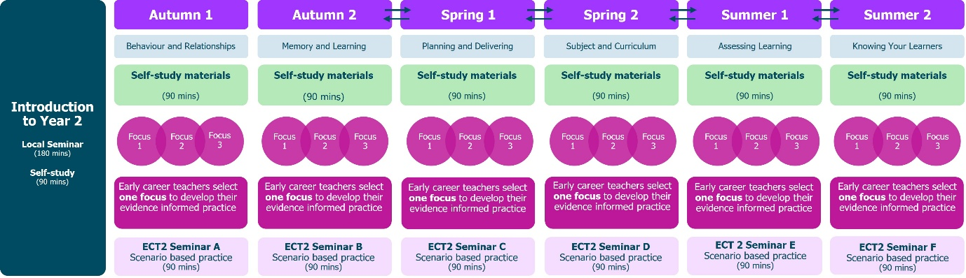

Onboarding
Schools should provide details about any onboarding process they offer which introduces early career teachers to the ECT programme. NIoT materials for a live seminar are available or schools may wish to provide their own.

Mentoring
Schools should outline how weekly interactions between ECTs and mentors will take place including observations and feedback. They should ensure that this aligns with the minimum entitlement set out in the early career framework.
Schools should also outline the role of mentors within their own school setting or trust.
You may wish to include:
- details regarding mentor observations including timings and frequency
- any specific observation model being used
- an outline of the purpose and structure of mentor meetings
- how the mentor will support ECTs with pastoral or wellbeing needs

Self-study
Schools should outline here how ECTs will access their self-study materials

Your self-study content in Year 2 is separated into two parts. Section 1 should be completed before your first mentor meeting and Section 2 completed after the meeting.
Section 1
You should plan to complete this at the beginning of the half term. It will take around 20 minutes in total and is made up of 2 parts.
- You’ll read three short summaries of research papers relating to the module, for example, assessment. This will take you around 10 minutes.
- Then, you will complete a short reflection task related to each of the summaries and your current teaching practice. It will take around 10 minutes to complete.
You’ll share your reflections with your mentor at your first mentor meeting, so it’s important you plan your time to complete this section before that meeting.
During the first meeting, you’ll agree which of the three research summaries you will focus your remaining study and development on for the rest of the half-term. You’ll find out more about the structure of your fortnightly mentor meetings later on.
Once you’ve completed Mentor Meeting 1, you’ll return to your self-study and complete Section 2.
Section 2
For this final part, you’ll critically engage with the research paper you’ve chosen as your focus for the half-term. The materials will give you the opportunity to:
- consider what the research tells us about teaching and improving practice;
- reflect on the limitations of the evidence;
- see phase-specific examples of how the theory might look in practice; and
- explore how the research supports your own development as a teacher; and
- plan how it will guide your personal cycle of improvement this half-term.
This section will take you around 35-40 minutes to complete. You don’t have to do it all in one go, however, it should be completed before week 3 of the half-term.
Local and subject/phase seminars
If they are being offered to ECTs, schools should add details here about the structure of live seminars or sessions. The live seminar outlines are available to support you with the planning of these.

If you are using the NIoT seminar materials, you may want to include the information below.
Year 2 of the ECT programme has an increased subject/phase specialism focus. Local network seminars take place once per half term, or once per module, and will last 90 minutes. Whereas in Year 1 these covered general pedagogical strategies and understanding, this year, three of the six sessions will be delivered in subject/phase specific groups. Highly qualified subject specialists will lead these groups to enhance your knowledge and understanding further.

ECT programme – how your time will be spent in year 2
Schools may wish to provide an overview of how early career teachers’ time will be allocated in year 2. This could include mentoring activities, observing colleagues, self-study and attending any seminars.
Ensure that this aligns with the minimum entitlement outlined in the statutory guidance for early career teachers. More information can be found here (pp. 9 and 12): Induction for early career teachers (England) statutory guidance

Part-time ECTs
Schools should add details here about how the programme will be adapted for part-time ECTs.

Click here to return to the contents page.
Roles and Responsibilities
Your responsibilities as an ECT
Schools may wish to outline their expectations ECTs here in order to maximise the impact of the programme. This could include:
- reading and engaging with self-study materials
- weekly mentor observations
- attending mentor meetings and actively engaging with them
- reflecting and responding to feedback to develop their practice

Mentoring
Schools should update and amend the approach to mentoring as needed.
You’ll continue to be supported to apply and embed your learning with the support of an experienced colleague in the role of mentor. Your mentor will observe and meet with you every two weeks. During your meetings, you’ll share your reflections from the programme materials, such as live seminars. Mentors will continue to provide regular feedback focusing on supporting you to develop your practice and help you to identify further opportunities for professional development.
Mentors also have a responsibility to provide pastoral support for ECTs. If you have any concerns or feel that you are struggling with your well-being, you should share this with your mentor as soon as possible so that they can provide the appropriate support for you.
Fortnightly interactions with your mentor in Year 2 should include a lesson drop-in of no more than 15 minutes in which your practice will be observed. This will be followed by a 60-minute follow up discussion using the observation and feedback model to support you in developing your practice. In Year 2, the focus of the observation will be linked to your Personal Professional Development Cycle. This replaces your weekly actions in Year 2 and you’ll read more about that later on.
Who else will support me?
Schools may wish to add named individuals below where appropriate
Your early career teacher entitlement includes a number of support roles. You will work more closely with some, such as your mentor, but all will play an important part in supporting your induction process.
Mentor – Responsible for supporting your development whilst you’re on the two-year programme. This includes meeting regularly to provide support and feedback, providing or arranging mentoring and coaching around specific phases and subject areas.
Induction tutor – This role has different responsibilities to a mentor. These include providing or coordinating your induction programme and carrying out assessments and regular progress reviews. In some cases, for example in smaller schools or settings, the induction tutor may also be the mentor.
Headteacher or Principals – Headteachers and principals have various roles, many of which focus on ensuring compliance. They will oversee your overall induction, ensuring both your induction tutor and mentor have time and ability to support you effectively. They are also responsible for appointing an appropriate body and making the recommendations to them regarding your performance against the Teachers’ Standards.
Lead Provider – Lead Providers are responsible for designing and delivering impactful and tailored training for ECTs and their mentors based on the Initial Teacher Training and Early Career Framework (ITTECF). The training can also be delivered by schools themselves and this is known as a ‘school-led route’. Your Early Career Teaching Entitlement falls into this category.
Delivery Partners - Educational institutions that are approved to facilitate high quality training to ECTs and their mentors. This can include schools, MATs, hubs, charities, organisations. Their local expertise contributes to the overall improvement of teaching practice within the local community.
Appropriate Body – The appropriate body is responsible for quality assurance within the induction process, ensuring that all aspects are correctly enacted. Your headteacher or principal will report to them on your progress and performance against the Teachers’ Standards to them throughout your two-year induction. Depending on where you work, the appropriate body could be:
- Teaching School Hubs (TSHs)
- Multi-Academy Trusts (MATs) (if authorised)
- Appropriate Body Services from the Independent Schools Teacher Induction Panel (ISTIP) (for independent schools)
You can find out more about each role in Section 5 here: Induction for early career teachers (England) statutory guidance
ECT Entitlement
ECTs have specific entitlements to support their induction. One of these is a reduced timetable. In your second year on the programme this should be no more than 95% (or the equivalent for part-time ECTs).
This reduction is in addition to the standard planning, preparation and assessment (PPA) time all teachers receive. The allocated time off-timetable is specifically for ECTs to engage in induction activities such as mentor meetings, completing self-study work or observing colleagues. You can check what this means for you by speaking to your Induction Tutor.

Click here to return to the contents page.

Developing expertise
You may already be familiar with this model from Peps Mccrea (2018). It demonstrates how to build teacher expertise. In year 2 of the ECT programme, you will continue to develop your expertise by engaging more closely with research.
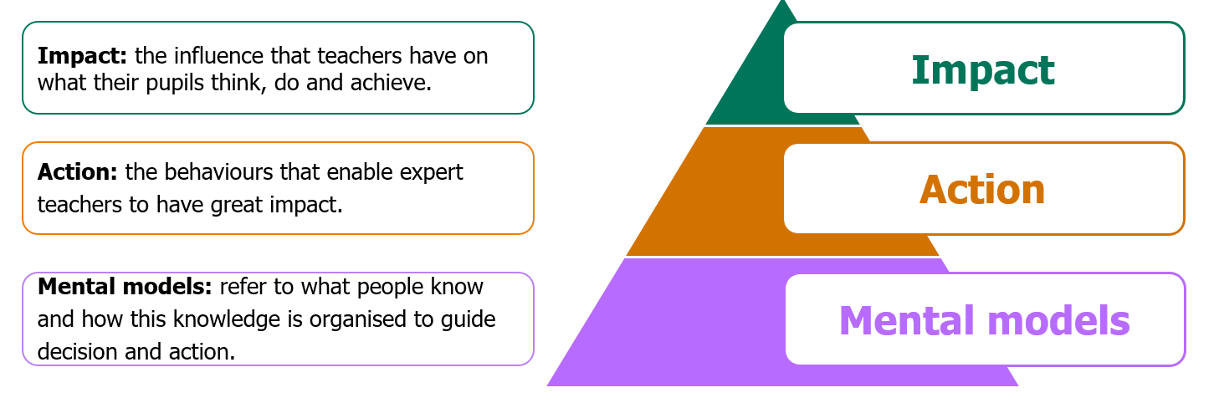

Adapted from Mccrea (2018)
Let’s unpack this model, starting at the top of the pyramid and working backwards.
Expertise as impact
You may recall that the final layer of expertise can be seen through its impact: the influence that teachers have on what their pupils think, do and achieve. This can be problematic however, as impact is a result of many different factors and isolating the impact of teaching alone is difficult.
Year 2 of the ECT programme supports you to explore this complexity further and to develop strategies that strengthen your professional impact in a sustainable way. This can be achieved, for example, by continuing to build strong relationships with pupils and by shaping the expectations they hold about learning and behaviour.
Expertise as action
The supporting layer directly below impact is made up of the actions and behaviours of expert teachers that lead to pupil outcomes. Expert teachers’ perception allows them to see their classrooms in a different way. They can also simulate what will happen in the classroom in response to a series of actions, helping them to stay a number of steps ahead of the pupils.
Expertise as mental models
In order to have this expert perception and set of actions in place, teachers need to have developed stronger mental models. Why? Having clear mental models means they are able to make quicker and more effective decisions. This enables them to appear less busy in the classroom, as their actions are deliberate and leave space to think, reflect, and respond with the most appropriate course of action.
Year 2 of the ECT programme helps you develop these habits by giving you space to reflect on your classroom decisions and by providing support to refine the actions that most positively influence pupil learning.
Unpacking mental models
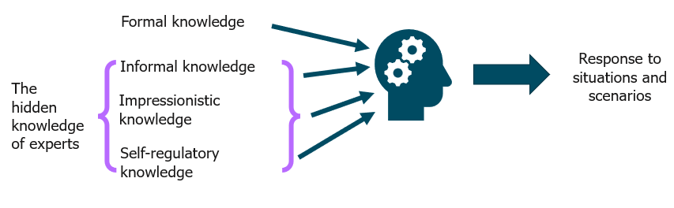
You will already be familiar with the idea that expertise is not just about what teachers know but also about how that knowledge is organised to guide decision-making and inform actions.
Bareiter and Scardemalia (1993)
These mental models consist of different forms of knowledge. There is formal knowledge (the type of knowledge that can be explicitly stated, codified and written into books or documents). Then there are three additional forms:
- Informal knowledge – the knowledge that is described as “expert common sense” combining formal knowledge and lived experience.
- Impressionistic knowledge – feelings that allow us to form opinions.
- Self-regulatory knowledge – managing yourself and doing your job.
It is the blend of formal and informal knowledge that develop expert mental models, which allow educators to make sense of and tackle common and persistent challenges in their context to positively impact pupil outcomes.​
Expertise is a result of not just what teachers know but also how that knowledge guides their perception, decision and action. Expert mental models are:
- Extensive – meaning there is a comprehensive understanding that is connected, and evidence informed.
- Actionable – this means the knowledge is interconnected but aware of local context and interactions with pupils.
- Fluent – the knowledge can be accessed with minimal effort.
- Meaningful and intertwined with personal and professional values.
Well-developed mental models underpin the impact and actions of expert teachers.
As you know from Year 1, mental models can be built through the following:

- Study – Build an evidence-informed understanding of the components of effective teaching.
- Practise – Put this evidence to work in their context and repeatedly implement building towards fluency and fidelity.
- Iterate – Continually evaluate (against pupil impact) and improve their mental models, adaptive expertise and actions.
Developing your mental models will take time, effort and deliberation. Year 2 of the ECT programme supports this by giving you opportunities to revisit and extend what you learned in Year 1, while applying it more independently in your own classroom. It encourages you to reflect on how your knowledge is organised and to test out new approaches with the support of your mentor.
You’ll learn how to understand where to focus your efforts to develop your mental models and how research evidence alongside input from your mentor can support you in this.

Click here to return to the contents page.
Using research to inform practice
In Year 2 of the ECT programme, you are encouraged to consider how different types of evidence can support your teaching, and how to judge the quality and relevance of the research you engage with.
Watch the video below, where Dr Rob Nash, Head of Psychological Research at the National Institute of Teaching, explains why engaging with research evidence is important.
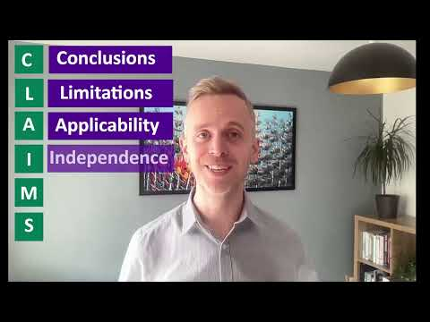
Click here to watch on YouTube: Engaging with research evidence

Now that you’ve heard Dr Rob Nash discuss the importance of engaging with research evidence, it’s useful to consider the different types of research you may encounter.
The table below outlines the different types of research evidence, along with their use and limitations:
Research type | Useful for: | Potential Limitations
Systematic reviews | Providing a comprehensive review of current evidence on a particular question. | Limitations and methodology - findings can be limited by little or no high-quality data. It can be difficult to collate evidence due to inconsistent methods in studies.
Meta-analyses | Providing an indication of whether an approach has a positive impact on specific outcomes. | Applicability - meta-analyses provide an ‘overall’ effect and cannot explain when or where certain practices work effectively.
Experiments | Compares the impact of one teaching approach with an alternative or no intervention at all. | Applicability - experiments do not always take into consideration contextual factors such as geographical location or socio-economic backgrounds.
Secondary data analysis | Identifying relationships between two or more variables. | Conclusions - correlation does not mean causation. What this means is that the analysis is unlikely to provide clear evidence of cause and effect.
Survey and interviews | Providing information about attitudes, opinions and experiences of certain groups. | Conclusions & applicability - they explore views and perceptions but may not accurately reflect the effectiveness of an approach.
Case studies | Providing rich, contextualised information to build a picture of practice in a particular setting. | Applicability - it can be difficult to easily apply findings to a different context.
Adapted from Using Research Evidence: A Concise Guide. EEF (2024)
Reflect
- What sources of research have you already used when considering evidence-informed approaches related to teaching?
- To what extent are you critical of research evidence when encountering it?
- How might an engagement with research evidence support you in continuing to develop your teaching?

Schools may wish to add their own reflective questions in line with their own focus/context.

Click here to return to the contents page.
Personal Professional Development Cycle
Your action steps will be put into practice using the Personal Professional Development Cycle. It’s a model of professional development especially designed by the NIoT for ECTs in their second year of the ECT programme. It is intended to personalise your experience, making it supportive and appropriately challenging.
The cycle aligns closely with the fortnightly mentoring meetings and lesson drop-ins, ensuring that you continue to receive structured mentor support throughout the year.

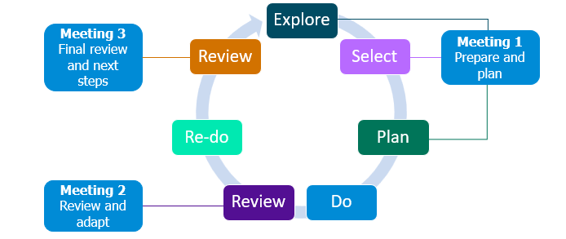

Meeting 1 Prepare and Plan
- Conducted in the first week of the half-term, ideally, you’ll meet with your mentor to engage in the explore, select and plan aspect of the professional development model
- You will explore the specific element within that domain that you personally wish to improve based on your reflections and review any lesson drop-in data.
- Mentors will support you to select the specific element you will focus on improving for the rest of the half term.
- Together you will devise a plan of how to implement this improvement(s) into your teaching practice, within your unique context using the Personal Professional Development Cycle as a framework.
You’ll then put this in to practice during the ‘do’ phase of the cycle. You will make minor adaptations and adjustments as you go, making notes to bring to your 2nd mentor meeting.

Meeting 2 Review and Adapt
- Here you and your mentor will review and reflect on the experience so far and consider any adaptions that have been made or need to be made to support all learners.
- You will consider how the experience so far aligns with what the evidence says and probe why things may look different.
- You will use the conversations in this meeting to then refine your practice in the ‘re-do’ phase, continuing to gather data and reflections as you go.
Meeting 3 Final review and next steps
- In the final meeting of the half term, with your mentor, you will review the experience as a whole to inform future adjustments and refinements in your teaching practice.
- Again, you will consider how far it aligned with the evidence and why you may have needed to make adjustments.
The Personal Professional Development Cycle serves as a guide to support your journey to becoming a confident, evidence-informed practitioner– not just during your ECT year 2, but also as model you can use independently as a year 3 teacher and beyond.

Click here to return to the contents page.

Looking after your well-being
It is essential that, as you move into your second year of teaching, you actively consider how you are maintaining your well-being and work with your mentor to discuss well-being and workload throughout this second year where your timetable is likely to have increased.
Strategies to manage your well-being
There are several approaches that you might find helpful when considering how you manage your own well-being as you enter the second year of teaching. ‘What Works Wellbeing’, in partnership with the DfE, have identified that for teachers there are 5 key drivers of well-being for teachers (What Works Wellbeing, 2023).
These are:
- Health: including the importance of maintaining both physical and mental health.
- Relationships: including with your line manager and colleagues as well as considering factors such as how well communication is maintained within your school.
- Security: including a consideration of factors such as workplace bullying and feelings of safety at work as well as financial security.
- Purpose: including factors such as your engagement and feelings of motivation towards your role as well as sense of career development and progression.
- Environment: including the physical workspace you encounter each day as well as the wider organisational culture permeating the school.
Factors that can support your ongoing well-being
Factors that can support your ongoing well-being can include how you:
- Achieve a work/life balance through carefully applied time management strategies.
- Ensure that you seek out professional support from colleagues when you need it.
- Prioritise your health through factors such as diet and exercise.
- Engage with any employer workplace support schemes, including any health benefits that are offered.
- Communicate clearly with your line manager and workplace colleagues to support the growth of positive relationships at work.
Exactly what strategies will best support your well-being depends on several factors personal to you and relative to the context in which you are working. Engagement with the NIoT well-being tool can help to support you as you enter your second year of teaching.
Practical strategies:
There are many strategies that you can adopt to try and maintain your well-being. You may already have some strategies that you practice regularly. Here’s some that you might wish to explore:
- Meditation and mindfulness: taking the time to meditate, even for a few minutes each day can support increased relaxation and allow you to switch off. There are lots of apps that help you to do this.
- Develop routines and boundaries: consider for example what time you leave school each day. Set reasonable boundaries around your time and workload and stick to them.
- Reward yourself: find meaningful ways of rewarding yourself for reaching a goal.
- Develop good sleeping habits: this can include monitoring your screen time before bed, developing a good evening routine or considering your caffeine intake.
- Focus on kindness and gratitude: acts of appreciation or kindness provoke positive emotions, stronger social connections and improved well-being. Consider three good things that have happened each day.
Finding out what works for you and then working it into your day-to-day routine is more likely to benefit you over the medium to long term.
Reflect
Think about how you have managed your wellbeing so far on the ECT programme.
- What strategies have helped you maintain a healthy balance between work and personal life?
- What challenges have you faced in managing your workload or wellbeing?
- What is one small change you could make this term to strengthen your wellbeing?
You may wish to jot down your thoughts and share them with your mentor.

Schools may wish to add their own reflective questions in line with their own focus/context.

Click here to return to the contents page.

Suggested next steps
As you reflect on the content of this self-study, draw on your classroom experience from Year 1 of the ECT programme to shape your next steps. As you move into Year 2, you may wish to consider the actions below to continue developing your practice. If you are remaining in the same school, some of these may already be familiar to you. This list is not exhaustive and is intended to guide your ongoing professional growth.
EYFS | Primary | Secondary | Specialist - SEND setting | Specialist - Alternative Provision

Schools may wish to add their own questions in line with their own focus/context.

EYFS
- Have you scheduled appropriate time within your timetable to engage with the content of the self-study each week? This might include observing colleagues.
- Have you set out a time in your timetable to meet with your mentor each week?
- You may wish to spend some time in your first meeting with your mentor or induction tutor finding looking at the following areas:
  - Revisit, or find out, how you communicate with parents and carers and reflect on what has been most effective in your practice.
  - Discuss how you are developing and embedding systems for routines, transitions, and managing behaviour.
  - Review how you adapt provision for pupils with SEND or medical needs.
  - Consider how you continue to use and adapt school resources to plan purposeful learning.
  - Reflect on your approach to duties and outdoor provision and how you handle challenges as they arise.
  - You may wish to take moment to note any other questions you may wish to ask your mentor.

Primary
- Have you scheduled appropriate time within your timetable to engage with the content of the self-study each week? This might include observing colleagues.
- Have you set out a time in your timetable to meet with your mentor each week?
- You may wish to spend some time in your first meeting with your mentor or induction tutor finding looking at the following areas:
    - Review and refine strategies for communicating with parents and carers.
    - Reflect on how you are developing the use of the rewards and sanctions in your classroom, in line with whole school policy.
    - Consider how you adapt lesson resources to meet the needs of your pupils.
    - Explore how you effectively use pupil information to inform your planning and practice.
    - Revisit routines for duties, transitions and classroom management, considering what is working well and what can be improved.
You may wish to take moment to note any other questions you may wish to ask your mentor.

Secondary
- Have you scheduled appropriate time within your timetable to engage with the content of the self-study each week? This might include observing colleagues.
- Have you set out a time in your timetable to meet with your mentor each week?
- You may wish to spend some time in your first meeting with your mentor or induction tutor finding looking at the following areas:
    - Reflect on your use of behaviour and rewards systems: what patterns do you notice and how might you adapt?
    - Consider how you work with additional adults, such as TAs, and how this can be developed further.
    - Review your communication with parents and carers and identify next steps.
    - Revisit how you plan and adapt resources, especially for pupils with SEND.
    - Reflect on how you manage duties and wider responsibilities, considering how your role is developing across the school.

You may wish to take moment to note any other questions you may wish to ask your mentor.
SEND settings
- Have you scheduled appropriate time within your timetable to engage with the content of the self-study each week? This might include observing colleagues.
- Have you set out a time in your timetable to meet with your mentor each week?
- You may wish to spend some time in your first meeting with your mentor or induction tutor finding looking at the following areas:
  - Reflect on how you work with other adults in the classroom to maximise pupil learning.
  - Revisit communication with parents and carers and how to sustain positive relationships.
  - Review your use of resources and adaptations: what has been most effective and what needs developing further?
  - Consider how you manage duties and transitions, focusing on strategies to support pupils consistently.
You may wish to take moment to note any other questions you may wish to ask your mentor.
Alternative Provision
- Have you scheduled appropriate time within your timetable to engage with the content of the self-study each week? This might include observing colleagues.
- Have you set out a time in your timetable to meet with your mentor each week?
- You may wish to spend some time in your first meeting with your mentor or induction tutor finding looking at the following areas:
  - Reflect on how you work with other adults in the classroom to maximise pupil learning.
  - Revisit communication with parents and carers and how to sustain positive relationships.
  - Review your use of resources and adaptations: what has been most effective and what needs developing further?
  - Consider how you manage duties and transitions, focusing on strategies to support pupils consistently.
You may wish to take moment to note any other questions you may wish to ask your mentor.

Congratulations! You have now completed your introduction self-study.
Next steps Schools may wish to adapt this list but it could include:
- Speak to your Induction Tutor to confirm your module sequence for year 1
- Begin your self-study for the module on Behavior and relationships
- You may also wish to arrange a time to meet with your mentor to discuss any questions you may have

Click here to return to the contents page.

Further reading and resources
- You can read more about the Initial Teacher Training and Early Career Framework here: Initial Teacher Training and Early Career Framework
- Education Endowment Foundation (2024) Using research evidence. Available at: https://educationendowmentfoundation.org.uk/education-evidence/more-resources-and-support/using-research-evidence [Accessed 27 April 2026]

References:
- Bereiter, C. and Scardamalia, M. (1993) Surpassing ourselves: An inquiry into the nature and implications of expertise. Chicago, IL: Open Court
- McCrea, P. (2018) Expert teaching: What is it and how might we develop it? Available at: https://www.researchgate.net/publication/324759008_Expert_Teaching_What_is_it_-and_how_might_we_develop_it_Peps_Mccrea (Accessed 27 April 2026).
- What Works Wellbeing (2023). Available on line at: DfE Resource - updated graphics July 2023 (Accessed 27 April 2026)

Click here to return to the contents page.

