
ECT Programme
Seminar: Programme Introduction for Year 2 early career teachers
Session outline
This document is intended for those who design and deliver a school-led Early Career Teacher Entitlement (ECTE) programme. It provides materials to introduce the programme to Year 2 ECTs. It also offers suggested activities and durations, as well as recommended references to support design and facilitation







Seminar title: Programme introduction
Suggested duration
180 minutes
Delivery details
This session is intended for face-to-face live session

Content
Session overview | Page 2
Learning intentions | Page 2
Related Initial Teacher Training and Early Career Framework statements | Page 3
Session inputs | Page 4
References | Page 10
Appendix | Page 11

Session overview
This seminar intends to introduce Year 2 early career teachers (ECTs) to the second year of their Early Career Teacher Entitlement (ECTE) programme. It comprises four sections that address the programme model, thinking critically about research, taking ownership of personal professional development and continuing to manage well-being and workload. Each section focuses on one of these areas through a combination of presentations, discussions, practice, feedback, and reflection activities.
Designed to last 180 minutes, the seminar can be adapted to suit different contexts and needs. It is recommended that phase or subject specific examples are provided as appropriate throughout.
Learning intentions
- To review the structure of the National Institute of Teaching (NIoT) programme for Early Career Teachers (ECT) in Year 2.
- To discuss the role and responsibilities of a year 2 ECT.
- To think critically about research and apply it to classroom practice.
- To explore the personal professional development model used within the NIoT ECT programme and consider what it means to be a reflective practitioner.
- To consider how ECTs can continue to manage their well-being with the support of the NIoT and their colleagues.

Related ITTECF framework statements
Professional Behaviours
8.1 Effective professional development is likely to be sustained over time, building knowledge, motivating staff, developing teaching techniques, and embedding practice.
8.2. Reflective practice, supported by feedback from and observation of experienced colleagues, professional debate, and learning from educational research, is also likely to support improvement.
8.3. Teachers can make valuable contributions to the wider life of the school in a broad range of ways, including by supporting and developing effective professional relationships with colleagues.
8.7 Engaging in high quality professional development can help teachers improve.
8.9. Research evidence can vary in its level of reliability, which is determined by how the research was conducted and other factors that might introduce bias, such as the level of independence. High quality research communicates methods and limitations transparently.
8a. Engaging in professional development focused on developing an area of practice with clear intentions for impact on pupil outcomes, sustained over time with built-in opportunities for practice.
8b. Strengthening pedagogical and subject knowledge by participating in wider networks and as part of the lesson preparation process.
8c. Seeking challenge, feedback and critique from mentors and other colleagues in an open and trusting working environment.
8d. Engaging with research evidence by accessing reliable sources, seeking support for how findings can inform practice, and monitoring the impact of applications.
8e. Reflecting on progress made, recognising strengths and weaknesses and identifying next steps for further improvement.
8m. Using and personalising systems and routines to support efficient time and task management.
8p. Protecting time for rest and recovery and being aware of support available to support good mental wellbeing.
Return to content page
Session inputs
Introduction
Timing: 15 minutes
This section of the session should be used to set expectations and share the learning intentions for session. It could also be used as an opportunity for Year 2 early career teachers to check-in with their peers and discuss how these issues are approached within their school or Trust. Any particular school or Trust documentation could be highlighted at this stage.
Section 1: Programme model
Timing: 15 minutes
This section of the session focuses on the structure of the ECT programme in Year 2.
Suggested activity
Provide ECTs with an overview of year 2 of the programme. Include a breakdown of how each module is structured with regards to self-studies and live sessions and how they should allocate their time.
The programme will focus on the following modules in year 2 with one area addressed each half term:
Module A: Behaviour and relationships | This module will cover behaviour and relationships with a specific focus on the influence of teacher expectancies, pre-emptive strategies to promote appropriate classroom behaviour and the role of motivation.
Module B: Memory and learning | In this module, focused on memory and learning, the topics of working memory, cognitive load theory and the impact on instructional design and the importance of retrieval practice for long term retention.
Module C: Planning and delivering | In Module C the focus is on the role of instructional explanations in example-based learning, the effects of different types of scaffolding in the classroom and becoming a self-regulated learner.
Module D: Subject and curriculum | The focus in Module D is on developing pupil expertise through building different types of knowledge, anticipating and addressing misconceptions and teaching of critical thinking.
Module E: Assessing learning | In this module, the focus turns to assessing learning focusing on understanding formative assessment, the power of effective feedback and using formative assessment to develop self-regulation.
Module F: Knowing your learners | Module F focuses on knowing your learners, specifically looking at how different types of special education needs and disabilities may present in pupils, including communication and interaction, cognition and leaning, behavioural, emotional and social development and sensory and or physical needs.

Provide ECTs with an opportunity to reflect upon the importance of developing integrated practice, encouraging them to make links between each of the different domain within the ITTECF. This will ultimately lead to integrated practice whereby all the components are holistically applied in a seamless way through their teaching. Reinforce with ECTs that year 2 of the programme should focus on how they are continuing to integrate the different building block of their training and practice into a more cohesive and confident approach.
Any particular school documentation could be highlighted at this stage. As outlined in the Programme Guidance, schools may wish to deliver the modules in a different sequence to align with the school or trust’s professional development priorities. However, all ECTs must start with ‘Behaviour and relationships’ to support them to establish a positive, structured learning environment that fosters pupil engagement, wellbeing, and academic success at the very start of the academic year.

Provide ECTs with guidance around completing their ECT course materials, including self-studies, attending seminars as well as their regular mentor meetings.
See Appendix for more information.
Section 2: Thinking critically about research
Timing: 45 minutes (including break)
The second section of the seminar will continue to develop the ECTs’ understanding of how to engage critically with different types of research evidence, using tools such as the CLAIMS model, so they can apply evidence more effectively to inform and improve their classroom practice.

Suggested activity
Begin with a quotation from Using Research Evidence: A Concise Guide from the Education Endowment Foundation (2024) to engage ECTs with the idea of the importance of evidence informed practice: “While reading and evaluating research evidence can provide excellent insights into what has worked in the past, this alone is unlikely to improve practice and pupil outcomes. For improvements to be made, we need to actively apply research evidence by making changes to what we do.”
Allow time for ECTS to reflect on what is meant by ‘evidence informed practice’ and discuss with colleagues and to reflect upon the different types of research they will come across:
- Case studies
- Systematic reviews
- Surveys and interviews
- Secondary data analysis
- Meta-analyses
- Experiments
Encourage the ECTs to reflect upon where they have engaged with different types of research so far and why and how it has (or has not) influenced their classroom practice. Remind them that opportunities to draw on a wider range of evidence will continue to grow as they develop their practice.
Remind ECTs of the CLAIMS model shared within their self-study material. This could be set up as a retrieval activity. See Appendix for more information.
Share an example from a research paper with ECTs. An example has been provided in the Appendix. (Please note the example is a fictional extract)
Schools/trusts may wish to include their own example to best suit their needs/context/focus.

Give ECTS the opportunity to consider the research paper in relation to the CLAIMS model:
- How likely are you to use this research to inform decision-making about your teaching?
- Are there any red flags that stand out to you?
- What further information do you need to inform your choices about this paper?
Schools/trusts may wish to include their own questions to best suit their needs/context/focus.

End this section of the session with a summary of the main points:
- Engaging with research can support informed decisions around planning, teaching, assessment and behaviour.
- When considering applying research evidence to your practice and context it is useful to use the CLAIMS model.

Section 3: Taking ownership of your personal professional development
Timing: 45 minutes
The third section of the seminar introduces the format of the personal professional development model used by the NIoT and considers how ECTs will engage with that model over the course of year 2.
Suggested activity
Begin by sharing the model for personal professional development, emphasising that the second year of the ECT programme In the second year of the ECT programme, a primary focus is empowering ECT’s to take ownership of their professional development journey. Each half term they will focus on a specific domain (element) of teaching.
See Appendix for more information.
Once the model has been introduced to the ECTs give them the opportunity to reflect upon it and discuss their reflections with their peers.
- Have you come across any similar models before in your practice?
- Which aspects of the model are you most looking forward to and why?
- Are there any potential challenges you foresee and how might you overcome them?
Schools/trusts may wish to include their own questions to best suit their needs/context/focus.

Allow ECTs time to reflect on the transition from year 1 to year 2 by returning to the personal professional reflection model.
This year 2 model is different in structure to year 1 because it no longer follows the structure of engaging with a self-study then a weekly action. They are now enacting change across a whole half term rather than weekly.
Therefore, ECTs should take some time to consider how they will work with their mentor to ensure this model embedded into their practice.
Introduce ECTs to the idea of a reflection model that be used to help develop strategies for becoming a reflective practitioner. The model use by the NIoT has been adapted from Gibbs (1998). Further information can be found in the appendix.
Schools/trusts may wish to use their own reflection model to best suit their needs/context/focus.

ECTs should reflect before discussing with peers a recent classroom experience using the reflection model as the structure.
End this section of the session with a summary of the main points:
- Reflection is most powerful when it leads to concrete actions and professional growth.
- The personal professional development model structures your progress across each half term.
- Using a reflective model helps you unpack experiences and identify clear next steps.
- Building reflective habits now will support your development not just in year 2, but throughout your teaching career.
Section 4: Continuing to manage well-being and workload
Timing: 45 minutes
The final section of the seminar considers the continued importance of managing well-being and considers strategies to help ECTs manage workload and well-being in year 2.
Suggested activity
Begin by referring to the work of the OECD on the importance of teacher well-being, focusing on the core dimensions of teachers’ well-being.
See appendix for more information.
Allow time for ECTs to reflect and then discuss their own successes with their workload and well-being in year 1 as well as the elements they have found challenging.
Review some of the factors shaping teacher well-being and give ECTs time to reflect upon these. See appendix for more information.
The session then moves into deliberate practice. Begin with a recap of the model of deliberate practice used. If necessary, remind ECTs of the model for deliberate practice. Provide ECTs with a scenario focusing on teacher well-being.
An example of a scenario that can be used has been provided in the appendix.
Schools/trusts may wish to use their own scenario to best suit their needs/context/focus.

Allow time for ECTS to reflect on the problems affected the teacher’s well-being and to consider specific strategies that could be taken to address this. ECTs should then reflect upon this scenario and create their own self-care plan, before sharing this with a partner to receive feedback and re-do the pan where necessary.
Complete this section by giving ECTs the opportunity to reflect upon this part of the session.
Next steps
Timing: 15 minutes
Give participants time to reflect on their learning from the session and identify some actions they will take to develop their practice as a result.
This is also an opportunity to flag next steps on the programme including dates for any seminars and take any remaining questions.

Return to content page
References
Gibbs, G. (1998) Learning by Doing: A Guide to Teaching and Learning Methods. Oxford: Further Education Unit, Oxford Polytechnic.
Mulholland, K. (2024) Using Research Evidence: A Concise Guide. London: Education Endowment Foundation. Available at: https://d2tic4wvo1iusb.cloudfront.net/production/documents/using_research_evidence_-_a_concise_guide.pdf [Accessed: 27 April 2026]
OECD (2020) Supporting teacher professionalism: Insights from TALIS 2018. OECD Publishing. Available at Teachers’ well-being (EN) [Accessed: 27 April 2026]

Return to content page
Appendix
Section 1
Additional information on programme structure:
Each half-term, full time ECTs will engage with a self-study and reflect on the content. The reading covered and the result of the reflection will guide discussions between the ECT and mentor. ECTs will have the opportunity to critically engage with research by selecting a particular research paper from within each module.
If they are being offered to ECTs, schools should add details here about the structure of live seminars or sessions. The live seminar outlines are available to support you with the planning of these.
If you are using the NIoT seminar materials, you may want to include the following information:
The seminars will adopt a scenario-based approach in which you will have the opportunity to connect different aspects of your teaching - such as planning, assessment, and behaviour management - into a more cohesive and effective practice. By integrating these elements, you will develop your adaptive expertise supporting you to make better-informed decisions in real time and making your teaching more responsive to individual needs.
Section 2
Source: Using research evidence. A concise guide. EEF 2024: Using research evidence | EEF
Conclusions – as you read research it should be clear what evidence has been used to draw conclusions. Ask yourself, could this data have been influenced by any other factors? Also be wary of one-sided conclusions that only support one theory and ignore others.
Limitations – any limitations within research should be clear to see. This may be that only a small number of pupils were used in the research, or certain students were excluded. Limitations that are not clear would mean it is difficult to interpret how results have been affected and draw meaningful conclusions.
Applicability – considering applicability is important when reflecting on your personal professional development. Selecting research that is considering pupil attainment when you are exploring student engagement is not going to be useful. Other red flags to be wary of are findings that are extended beyond the setting or situation they are intended for. For example, a study in primary setting could be applied to a secondary setting but further investigations should take place.
Being aware of author bias is always an important consideration and is covered by the independence statement. Think carefully about who has funded the research or would there be a commercial gain from a programme being successful.
Methodology should be clear when reviewing research evidence. A red flag would be unclear methods that could not easily be repeated or analysis that does not seem appropriate to the questions that were posed.
Finally, the sample population within the study should ideally be large and represent the target population. Groups taking part in the research should be balanced and be representative of the target population.
Example research paper
The following research paper considered responses to a questionnaire from 20 teachers working in secondary schools in rural locations.
The questionnaire focused on pupils’ preferred ways of learning and how this was linked to pupil outcomes. The questionnaires were sent to staff emails with each question having a free response box.
The researchers analysed responses for common themes across all the responses and were able to draw the following conclusions:
- Primary pupils who preferred working in a visual way had higher outcomes than those who preferred working in an auditory or kinaesthetic way.
- Secondary pupils preferred to work in a kinaesthetic way. Those pupils who worked in this way had higher outcomes.
Section 3
The Personal Professional Development Cycle has been developed to guide you as you implement research-informed improvements into your teaching practice. You’ll be familiar with this cycle from your programme introduction. A reminder of the model has been included below.
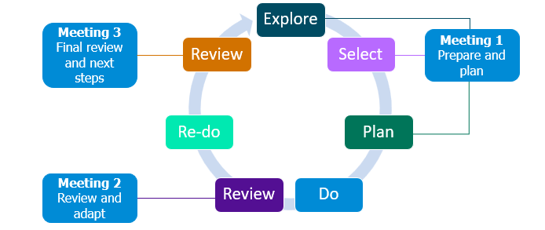

Each half term they will complete a self-study, starting with section 1 reading 3–4 short research summaries linked to the module to help inform their focus for the half-term. After completing a short reflection, they will agree on a focus with their mentor and select one of the readings to explore further. In Section 2 of the self-study, they will then dive deeper into the chosen paper. Mentors and ECT’s will meet fortnightly. Each meeting will have a specific focus.
In Meeting 1, ECTs will explore the specific element within a domain they personally wish to improve. With their mentor’s support, they will then select the element to focus on for the rest of the half term and also select a reading focus. Together they will create a plan for how to implement this improvement in their own teaching context.
During the do phase, ECTs will put their plan into practice, keeping notes, reflecting on the impact, and making adjustments as needed. A reflective guide will support them through this process.
In Meeting 2, ECTs will review the impact so far with their mentor, using their reflections to identify any changes needed to ensure all pupils are making progress. They will then re-do the practice, continuing to monitor impact and reflect at each stage.
In Meeting 3, at the end of the module, ECTs will review and reflect on the experience of implementing their chosen improvement. This reflection will inform future refinements to their teaching practice.
The personal professional development model serves as a guide to support ECTs not only in year 2, but also as a framework they can use independently in year 3 and beyond
Reflection model
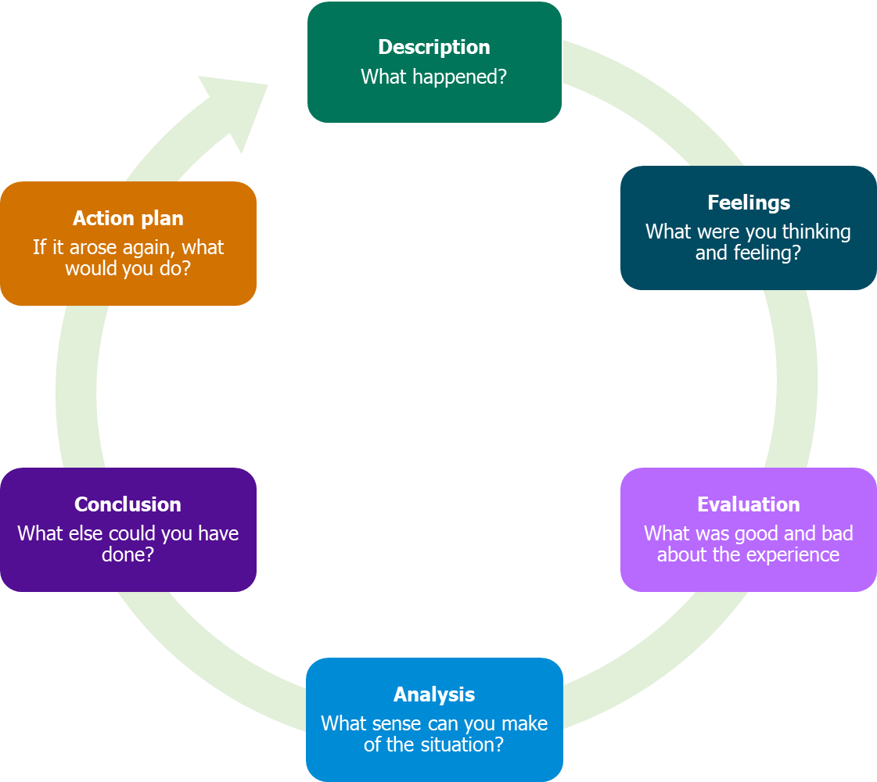

Gibbs' Reflective Cycle (1988) is a structured model for reflection and could be used by teachers to analyse experiences and improve their practice as suggested by the EEF (2021b). By working through each stage, you can identify strengths, address challenges, and plan for future improvements.
Source: Gibbs, G. (1998) Learning by Doing: A Guide to Teaching and Learning Methods. Oxford: Further Education Unit, Oxford Polytechnic.

Section 4
Source: OECD (2020) Supporting teacher professionalism: Insights from TALIS 2018. OECD Publishing. Teachers’ well-being (EN)
- Teacher shortages and high turnover are growing global challenges.
- Early career teachers are most at risk of leaving within the first five years.
- Stressful working conditions can lower motivation and job commitment.
- Supporting teacher well-being improves retention and teaching quality.
The Core Dimensions of Teachers’ Well-being (OECD, 2020)
Cognitive well-being – How you think and process at work
- Involves focus, problem-solving, and decision-making.
- Linked to self-efficacy – confidence in managing classrooms, delivering lessons, and engaging pupils.
- Strong cognitive well-being supports motivation, innovation, and effective teaching practice.
Subjective well-being – How you feel about your role and purpose
- Encompasses emotional states, job satisfaction, and sense of purpose.
- Teachers with higher job satisfaction and fulfilment are more committed, motivated, and resilient.
- Recognising both the positives and pressures of teaching helps maintain balance.
Physical and mental well-being – How your body and mind respond to work demands
- Reflects stress levels, fatigue, and psychosomatic symptoms such as headaches or poor sleep.
- Long hours and workload can affect both physical health and mood.
- Awareness helps teachers recognise when demands outweigh resources and take steps to restore balance.
Social well-being – The quality of your relationships at work
- Focuses on positive relationships with pupils, colleagues, and school leaders.
- A supportive school culture and strong professional trust improve well-being and confidence.
- Collaboration and positive relationships also enhance teaching quality and student outcomes.
Workload: Excessive hours, especially time spent on non-teaching administrative tasks.
Multiple Roles: Expectations to handle tasks beyond teaching, such as school management, extensive parent communication, or counselling students.
Classroom Composition: Working with a high proportion of students who are low academic achievers or have behavioural problems or special needs can negatively impact satisfaction.
Disciplinary Climate: Disruptive student behaviours are major causes of psychological strain, stress, and burnout.
Physical Learning Environment: Disagreeable environments (e.g., poor lighting, high noise, lack of specialized facilities) have been associated with teacher burnout.
These are aspects that help reduce job demands, are functional in achieving goals, and stimulate personal growth and development.
Social Support: Support from colleagues and principals is a major resource. Principal support may have the biggest impact on increasing job satisfaction and reducing burnout risk.
Work Autonomy: Having freedom to choose teaching methods, educational strategies, and content within curriculum limits. Autonomy is linked to higher job satisfaction.
Training and Professional Opportunities: Access to continuous professional learning (e.g., mentoring, peer collaboration) gives you the knowledge and skills needed for effective work and relates to increased job satisfaction.
Appraisal and Feedback: Receiving clear, performance-based feedback acts as an important job resource to help you cope with demands.

Managing well-being
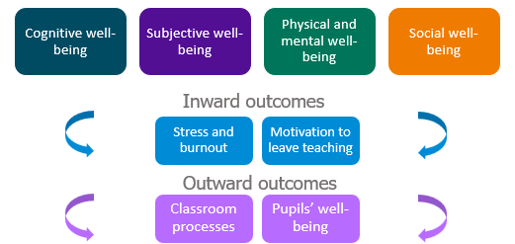
Inward Outcomes (Personal):
- Low well-being and high job demands lead to increased Stress and Burnout. Burnout has negative effects on school performance, organizational commitment, and leads to high turnover and absenteeism.
- It also increases the Motivation to Leave Teaching, which negatively impacts self-efficacy and student outcomes.
Outward Outcomes (Professional Impact on Pupils):
- Your well-being influences the effectiveness of your instruction and the Quality of Teaching.
- Classroom Processes: Higher well-being correlates with practices such as providing active support to students, effective use of feedback strategies, maintaining a positive classroom social climate, and effective teacher co-operation.
- Student Well-being: Teachers who create a supportive classroom environment contribute to higher levels of student well-being, increased motivation, and enhanced student self-efficacy and achievement. Student anxiety is considerably reduced when they feel supported by their teachers.

Deliberate Practice
Scenario
Sarah is navigating the challenges of her first year in teaching, where long hours spent planning, marking, and attending meetings often leave little room for personal time. The pressure to perform well blurs the boundaries between work and life, adding to her fatigue. In the classroom, she faces a mix of disruptive behaviour and students needing extra support, which demands constant adaptation and adds to her stress. On top of this, the expectation to meet academic standards and ensure pupil progress weighs heavily, fuelling anxiety and self-doubt. At times, Sarah questions whether she’s making a real impact, and imposter syndrome begins to affect her confidence

Return to content page

